AMERICA
by Loic Kurzweil

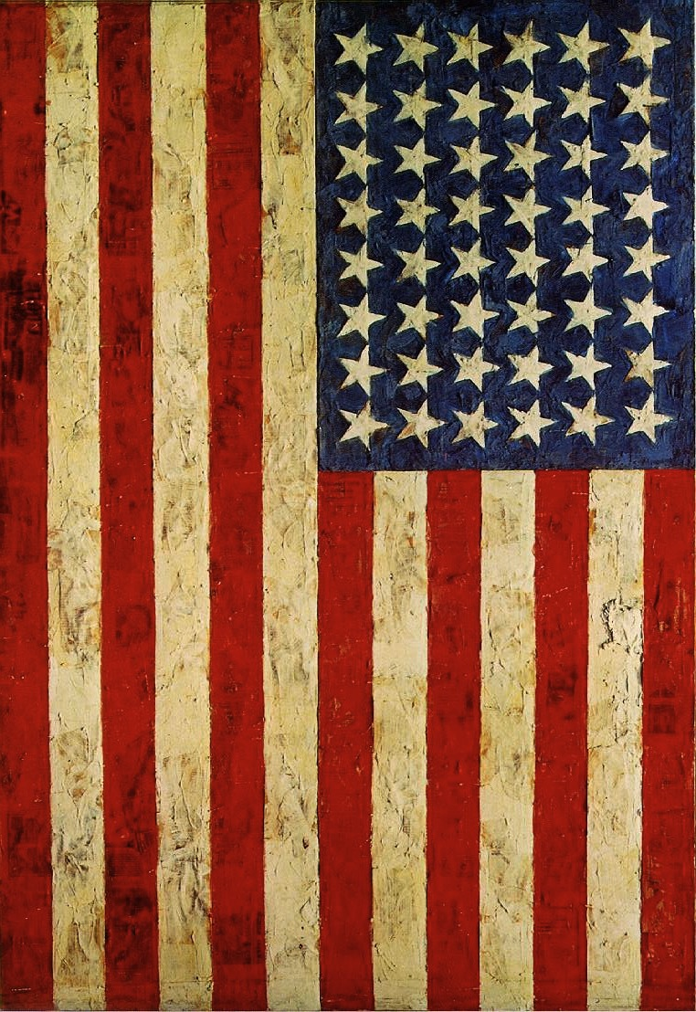
Kansas City

Arrival Day/First impressions:

Although we were all exhausted from the long travel, actually arriving in the United States immediately woke us up again – at least me. Some of our luggage has been searched by the U.S. Officials, which meant all my presents for the host family were completely unpacked. That already gave me an impression about how officials in America act. Nevertheless I was thrilled to be in America and when we finally got in the school bus that picked us up at the airport to take us to Pembroke Hill High School none of us could hide their excitement anymore. During the bus ride we already saw parts of the city – Kansas City is a really nice city!
Our host family were already waiting for us at the school and most of us went home soon. Although I was completely worn out, I still enjoyed getting to know my host's mother. Unfortunately my host himself had to go to a school tutoring thing so I couldn't get to know him a little yet.
Still, I'm very excited to be in America!

Foto von kansas city (bus)

Day 2:

One thing that I noticed about my host family is that they don't sit down to take breakfast. They don't really take breakfast at all, they just grab a very quick snack that they often finish in the car. Well, I don't know if that applies to all americans, if that's a typical american habit but I first found it kind of interesting.

The first day in school was also quite interesting. We got to know a typical american High School which was exactly like I've imagined it. The number of people sitting in one classroom was rather small, the classes themselves had very good quality. I really got the impression that those teenagers at Pembroke Hill are very well educated. The interesting thing was that the teachers there were very similar to ours in Austria. However the school system in America is very different from that we know in Austria. I found it interesting that american students within one year (like Sophomore Year or Junior Year) aren't divided into classes as we are. Also every student has an individual timetable. What I also liked is that there is a lot of sports programs offered from the school, so basically every student is doing sports frequently.

Later we walked (my host mother was actually startled when I told her that) to the Nelson Atkins Museum of Contemporary Art. I thought that it was very interesting because the guide was very good. I liked the interactive way of the guide to talk to us about a certain piece of art so that we can come to the meaning ourselves.

In the evening we went to a Lacrosse game between Pembroke Hill and some other school. There I again I found it interesting that so many students are in a sports team and actually represent the school.

After the game I experienced the highlight of american food: Oklahoma Joe's.
There is a french restaurant critic that travelled around the world to find 13 places where you have to eat before you die. Oklahoma Joe's is one of them. Also Kansas City is considered the city with the best Barbecue. And Oklahoma Joe's being the best BBQ-restaurant in KC, that makes it the best in the entire world. I can really relate to these opinions. It may seem weird that I write that much about food, but it I wouldn't if the food wasn't outstanding and truly delicious.

Day 3:

Unfortunately it was raining today. Therefore we couldn't walk around the Plaza as it was planned, but instead we spent the morning partly at Panera Bread and later the Bender's house (my host family) until we went for the afternoon program.

We went to eat at Oklahoma Joe's greatest rival Arthur Bryant's. As Mrs.Bender had already predicted Arthur Bryant's was really good too but couldn't beat Oklahoma Joe's by far.

After lunch we went to the Jazz Museum and the Negro League Baseball Museum which I both enjoyed very much. It was interesting to hear about when and where african americans began to establish their community during times of Segregation and how they founded their own music clubs and the Negro Baseball League.

In the evening, after another Lacrosse game, some of us went to a benefit concert for Invisible Children that was entirely organized by students from Pembroke Hill and where my host took part playing bass in his band.

Later that evening, me and a few other classmates and hosts went to eat at a mexican restaurant and later hung out at Nelson's to watch a movie together.

Foto: jazz museum, negro league baseball museum

Day 4:

Day 4 wasn't that exciting. We all went to Spin Pizza together and later hung out at Loose Park together. There the boys played Americans VS Austrians in American Football and Soccer. Later me and a few other classmates and hosts went to Peter's place to hang out.

Day 5:

The next day was exciting though. Sebastian, James, Joel and I went to the famous Worlds of Fun amusement park together and basically spent the whole day their. It is famous because the third largest roller-coaster of America is there. Everything there was exactly like I've imagined american amusement parks to look like. The giant roller-coasters everywhere and here and there some arcade halls and restaurants.

In the evening it was the only time when we didn't go out for dinner but stayed at home where Mr.Bender made some delicious american steaks.

Day 6:

On Monday we stayed at school for the whole morning and early afternoon. We got lunch at school and headed over to the Baseball stadium.

The Baseball game was rather boring as it was only a High School game.

After the game we just hung out at the Bender's house with James and Sebastian.

Foto vom abhängen

Day 7:

That day we went to the World War 1 Museum in Kansas City. For me it was quite interesting as I am quite interested in history. However the guide was a bit strange because he repeated himself constantly and also made some strange comments every now and then.

After the museum we went to the Union Station for lunch. There also were a few stores there to look around.

In the afternoon we headed back to the school where our hosts were supposed to pick us up. For several reasons not all them could come but luckily those who were left behind got a ride with Nelson to Loose Park where many hosts where meeting.

In the evening we went to Oklahoma Joe's again. At that time I was already convinced that Oklahoma Joe's was in fact a normal restaurant but I was proven wrong again little later. It's truly the best food I've ever eaten.

World War 1 museum

Day 8:

Today we went to the city market. It was promised to be full of people with many things to look at but in fact the only rather interesting thing was Steamboat Arabia.

The idea of building a museum about a famous steamboat that sank in the Missouri river was actually not a bad idea, but the implementation was. Sure it is somehow interesting to see the ship's cargo and hear about the process of digging it up but looking at boot after boot, nail after nail kind of gets boring after two or three so I thought they should have kept it shorter.

Later that day we all went to Dan's house for the Goodbye dinner. Everybody brought some food which was really good. We just hung out all together, played some basketball and had a good time.

Goodbye dinner

Final Day:

Unfortunately we had to go to school on our last day and in addition it was also raining.

School time was somehow interesting as always but after lunch the schedule said that we were supposed to go to the plaza. However very few people did want to go, so some of us stayed in school and waited for their hosts.

Joel and me just waited for school to end, so Ivan could pick Robert and us up. Then we just hung out at his place and got to know his parents.

Later that day a few people went to see a movie at the Plaza. Joel and me went to have dinner with our host family instead which also very nice. At the restaurant Mr. Bender challenged me to play pool against him.

As we got home we went straight for the pool table, and there I noticed that playing pool all the time in Kansas City really paid off because I beat Mr. Bender.

Then we gave them our presents from Graz, which they really appreciated.

As I went to my room to pack my suitcase and backpack for the travel to New York on the next day it felt kind of weird because I realized that I'm probably not going to see the Bender's house again or at least for a long time.

Irgendein kansas city bild

Departure to New York:

On Friday we had to be at school at 7:30 already. We met at the library where everybody was saying goodbye and the girls' first tears dropped.

What really annoyed though was that the teachers wouldn't even give our hosts some time to say goodbye, at least not all of them. I really would have liked to say goodbye to a few other people personally but they had class and their teachers wouldn't let them go.

It felt somehow weird to know that I'm probably never going to see some people that I really got to know ever again. The thing is that I haven't met a single american that I hung out with that I didn't immediately like.

As soon we got into the bus that took us to the Kansas City, the sadness of leaving our american friends and the city where we had so much fun, turned into a feeling of excitement. We were finally heading to New York, the famous city, the Big Apple.

Bus bild oder skyline

New York City

Arrival Day:

New York City is terrific! As soon as we arrived in Manhattan, I could already feel that New York is totally different from Kansas City and maybe even from the whole rest of the USA, just a world of its own.

There are so many people everywhere, they're all fast paced and vivid. Now I know why so many kids from Pembroke Hill haven't been to New York yet, just because it's so different.

Being to Greenwich Village and Soho at night was an interesting experience because every street was totally different and unique.

As soon as we got to Times Square, I realized that no photo you see of it can ever grasp the atmosphere of actually being in the middle of the tower-high flashing lights and advertisements. At this moment I got really excited about being in the The Big Apple, New York – the center of the universe!

Times square

Day 2:

We knew that Day 2 was going to be the only day with nice weather.

Therefore the schedule was changed and instead of going to the MoMa, we went to Central Park right after breakfast and enjoyed the sun.

Then we walked down to 42nd Street to go to Hudson River. There we made a boat trip around the Circle Line where we saw a couple of famous buildings like the Empire State Building. We also passed the Statue of Liberty on Liberty Island and the Brooklyn Bridge.

Then we got some free time around the Times Square area. Sebastian, Joel, Robert and me first went to eat something at McDonald's, then we headed over the Times Square. There were so many people there, much more that the last day at night. First we went to the giant m&m store (which was so crowded that you couldn't even move) and later to the famous Hard Rock Café.

In the late afternoon we went to East Village (taking the subway at the famous Grand Central Station) and also had some free time there. I really enjoyed that district of the city with all the small stores and cafés.

In the evening we went to a theatre to see “Zero Hour”, a play where a man did an imitation of Zero Mostel, a famous jewish comedian. I found the play quite funny, although I didn't get all the jokes to be honest, maybe because of a little lack of knowledge about all the jewish stereotypes.

Before I went to bed I thought about the day and just couldn't believe that we did so many cool things on just one day.

Central park, skyline, etc.

Day 3:

In the morning we went to the Convent Baptist Church in Harlem.
Although I am a convinced atheist, going to church in Harlem was a really interesting experience. It was totally different from any church service that I've experienced before. I liked that.
As soon as we've entered the church I immediately got the impression that the black community of Harlem actually really enjoyed going to church. The whole atmosphere was just so joyful and exited. The music played between the parts of the Mess was beautiful which is typical for black Gospel choirs.
The most exciting thing though was the preach of the Reverend. It was just amazing how he could enthuse the attenders and how he interacted with them and finally ended in a kind of rhythmic chant. I got the impression that in black culture, there are generally very good “speakers”.
Although I do not agree with what the church in general says, it was still a pleasant experience to get to know that side of religion which helps and encourages people to stand up for their rights and morals.
It was interesting to see how the church has a totally different function in NY than in Austria.

Later that day we we headed over to the Museum of Modern Art. Well this was also very interesting. It was amazing to see all the pieces of art that we all know in real.
From Picasso and his cubist paintings to Andy Warhol's Marilyn Monroe – everything was there.
The paintings that I liked the most were probably the ones that Mrs. Rieger showed us like Picasso's “Les Demoiselles D'Avignon”. I also really liked all of Jackson Pollock's paintings, especially “One: Number 31, 1950” which was an abstract expressionist painting.
There was a dadaist piece of art which I didn't like at all – Marcel Duchant's cycle on a stool.
However I like other work from him like the Mona Lisa imitation with the mustache where it says the letters “LAHOOQ”.
After the MoMA I really thought differently about art in general, now I can really understand art better. Therefore it was a shame that there weren't any tickets left for the Tim Burton exhibition.

Finally, after the MoMa, we went to China Town. Unfortunately it was raining so we didn't so many booths standing outside. So we just went into one of the restaurants and ate some chinese food.

Fotos: moma

Day 4:

Right in the morning we went to up the Empire State building which was good because except us, hardly any people were there. The view up there was just incredible you could every single skyscraper sticking their top into the fog.

After the Empire State building we went to see the Chelsea Hotel. First, we were only granted to look around in the lobby for a few minutes, but thanks to Eléonore we could go up the stairway. A lot of cool paintings were there and we even got to meet the artist that made the painting about Sid Vicious. In addition we got to enter one of the rooms. It was really cool to actually be in a hotel were so many famous people, like Janis Joplin, Bob Dylan or Andy Warhol had lived.

At noon we went to the Guggenheim Museum and had a look at the current exhibition. Unfortunately, we didn't know that the current exhibition was that good, so we didn't plan that much time.

In the afternoon we went to the Jewish District of the city and we ate at a famous jewish restaurant where there was only kosher food. Then we went to the Tenement Museum where we got to know some interesting things about the immigrants arriving to New York. But overall I thought it wasn't really appropriate for our age, but rather for lower school students.

After the museum many people wanted to go home because it was raining, however we had plenty of time left. Fortunately we got the opportunity to visit East Village again because many of us really liked that area.

Foto: empire state, chelsea hotel.

New York: Final impressions/thoughts:

When I first heard about all the “I love NY” souvenirs, I always thought of them as meaningless products for tourists. Now they have a totally different meaning for me and I'm glad that I bought a T-shirt because I'm now truly fascinated about New York.

Today I realized that in New York there aren't only so many different cultures but that the people there also love it. It was amazing to meet people like me, just open-minded and interested in the multi-cultural way of living. I've never experienced people in my life that were so interested in other cultures.

In the afternoon I was at a pizzeria in East Village where we got know a very interesting man. He talked to us because he noticed us talking German to each other and immediately a nice and long conversation started. It was fascinating that he had nearly exactly the same view of the world as we did. I would have never thought that an adult would talk to teenagers like that so openly and without hesitation, however in America many did. They didn't take us teenagers as young people that can't have any important opinion because of lack of experience but joined us too share our thoughts.

We met another very friendly man who worked at Dunkin Donuts with whom we also had a very nice conversation. He told us that he appreciated it so much to meet other people from another continent that were so open to and interested in the diversity of New York City.

I remember that I told the man in the pizzeria, how cool it was to meet such friendly people in America, especially in New York. And he looked at me and told that for him it's the most normal thing. “Just talk to other people, meet new people”, he said, “that's what we New Yorkers do”.

After this day I realized that NY is definitely a city that I will visit very often in my life, maybe even live there, if I get the chance to. NY is fascinating in every aspect of it and sadly four days are far too little time to get to know all of it, but still I am very happy to at least get to know the city a little and to get an idea about what New York is really about.

Now I can say that I do in fact love New York!

