Walking Tour of the Upper West Side
Explore the area around Columbia University, north of our hotel.  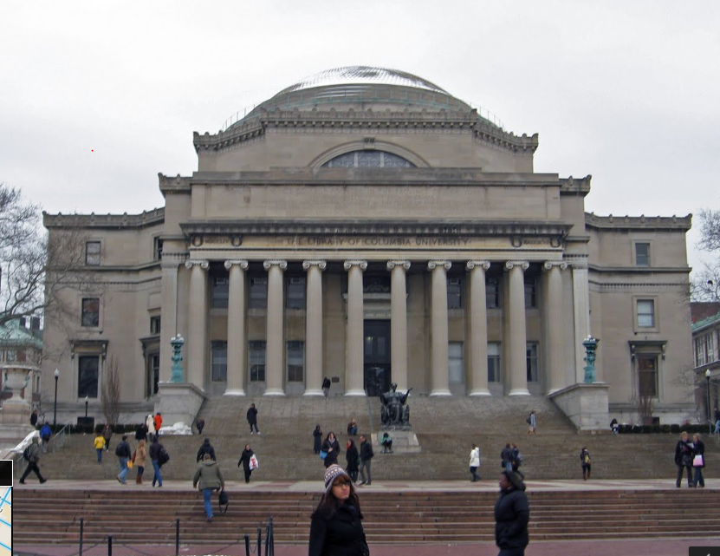  Tom's Restaurant is a diner located at 2880 Broadway (on the corner of 112th Street) in the Morningside Heights neighborhood of Manhattan in New York City.^{[1]} Frequented by students and faculty of nearby Columbia University, it has been owned and operated by the Greek-American family of Minas Zoulis since the 1940s.^{[2]}  Tom's Restaurant was the locale that inspired Suzanne Vega's 1987 song "Tom's Diner."^{[2]} Later, its exterior was used as a stand-in for the fictional Monk's Café in the television sitcom Seinfeld, where comedian Jerry Seinfeld's eponymous character and his friends regularly gathered to eat.^{[1][2]} The interior, however, looked very little like the real "Tom's", as indoor scenes were filmed on a set in California.^{[ (Wikipedia)}  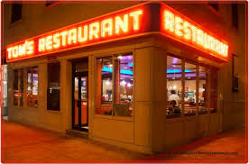  Walk down Broadway from our hotel:    he Upper West Side is one of Manhattan's most prosperous neighborhoods, but it lacks the stuffiness and sterility of the Upper East Side, that enclave of the super-rich just across the park. Instead, this is home to bankers, lawyers, media types, rumpled intellectuals, yuppies pushing strollers and out-of-work actors walking their dogs. It's a livable, convenient neighborhood, with a tiny dash of hip and a decidedly liberal bent (hence its nickname, the People's Republic of the Upper West Side).  Once upon a time, when most of Manhattan was concentrated way downtown, this was considered the country-rural farmland that was much too remote for development. Obviously, development did come, originally led by grand apartment buildings, many of which stand to this day. The neighborhood declined in the mid-20th century, as thousands of poor Hispanic immigrants settled here; these were the gang-ridden mean streets depicted in West Side Story. But gentrification began in the late 1960's, spurred by the construction of Lincoln Center. Patches of the neighborhood remained mired in poverty and crime well into the 1980's, but after a couple of stock-market booms, the entire West Side has now been thoroughly gentrified, with skyrocketing apartment prices. Residents bemoan the ever-widening presence of big-chain mega-stores (you can't throw a rock without hitting a Starbucks these days), but a few mom-and-pop stalwarts remain. This is a good walk if you'd like to see how New Yorkers really live outside the bustle of Midtown.  […]Continuing south down Broadway, you'll pass a few of the retail landmarks that define the neighborhood. Between 83rd and 82nd Streets is a Barnes & Noble superstore. West Siders railed against its presence (as West Siders are wont to do) when it arrived in the early 1990's, eventually crushing the independent Shakespeare & Co. a block south, but it has won over locals with its massive selection and frequent appearances by high-profile authors. At 80th Street stands a West Side icon, Zabar's. This is one of the city's top gourmet stores, with a dizzying selection of cheeses, breads, prepared foods, salads and much more. You may want to pick up a few items now, for a picnic in Central Park later on the tour. Farther south, the massive Apthorp apartment building dominates an entire city block between 79th and 78th Streets. Take a peek inside the iron gates to envy the residents' private courtyard.  At 74th Street, you'll see Fairway, another West Side institution, and the best place in town to buy fabulous produce at bargain prices. This is another good place to assemble your picnic.  A block farther south stands the grand Ansonia Hotel, a wedding-cake confection taking up an entire block between 74th and 73rd Streets. Originally opened in 1904 as a luxury residential hotel, the Ansonia offered its tenants a grand ballroom, a swimming pool, a theater and a system that sent messages swooshing in pneumatic tubes from room to room. Live seals splashed in the fountain, and W. E. D. Stokes, the architect, kept a pet bear and chickens in the roof garden. Celebrities from Enrico Caruso to Babe Ruth have lived here, and the Chicago White Sox conspired here to throw the 1919 World Series.  Cross over to the east side of Broadway. Between 74th and 73rd Streets is the monumental Apple Bank for Savings, with a heavy limestone facade and intricate ironwork doors. Continue down to 72nd Street, where you might want to stop in at Gray's Papaya for the "recession special" (a hot dog and a papaya drink for $1.95). Take 72nd Street east, where you'll spot a branch of Krispy Kreme on the north side of the street (double-dare you to resist if the "Hot Doughnuts Now" sign is lit).  Now turn left on Columbus and wander uptown for several blocks, stopping at any boutique that catches your fancy. As you approach 77th Street, you'll see the grounds of the American Museum of Natural History. This is one of New York's top attractions, with a world-class collection of dinosaurs. Stop in if you have time, or continue up the Columbus Avenue side, and take the path through the museum lawn, passing the New York Times time capsule (established at the turn of the millenium and designed by Santiago Calatrava) at 79th Street. The path curves around the building at 81st Street.  Up ahead you'll see the glorious Rose Center for Earth and Space. Even if you don't have time for the riveting Harrison Ford-narrated Space Show, you can admire the building, a stunning glass cube enclosing a glowing white globe.  At the corner of 81st Street and Central Park West rise the three cupola-topped towers of the Beresford, another grand apartment building. Jerry Seinfeld has a multimillion-dollar duplex here, and is currently building a private garage on 83rd Street with space for his collection of 20 Porsches - so he need not ever have a George Costanza-style meltdown over finding a parking spot.  Turn right down Central Park West, heading past the equestrian statue of Teddy Roosevelt outside the Natural History Museum. Below 77th Street, you'll pass the New-York Historical Society, a manageably sized museum with fascinating exhibits of the world's most unmanageable city.  Between 75th and 74th Streets stands the San Remo, another landmark apartment building designed by Emery Roth, architect of the Beresford. In the depths of the Depression, the projects fared poorly, and the two buildings were sold together for the total sum of $25,000 (a fee that would not buy you a broom closet in the San Remo today).  At Central Park West and 72nd Street stands the brooding fortress-like hulk of the Dakota (so named because the developer's friends told him the site was so far north that it might as well be in Dakota territory). Though it's been home to an illustrious group of tenants over the years-Lauren Bacall, Boris Karloff, Judy Garland, Leonard Bernstein, William Inge and many more-the Dakota will forever be associated with John Lennon, who was tragically gunned down outside its gates on 72nd Street. John's widow, Yoko Ono, still lives here.  It's only appropriate, after visiting the Dakota, to make a pilgrimage into Central Park across the way. Just inside the 72nd Street entrance is Strawberry Fields, a beautifully landscaped area dedicated to Lennon's memory. It's one of the loveliest, most tranquil spots in the park, and a perfect place to spread out your picnic and end your tour.  http://www.nytimes.com/ref/travel/TOUR-WS.html  9.3.2014 | Suzanne Vega: Tom’s Diner  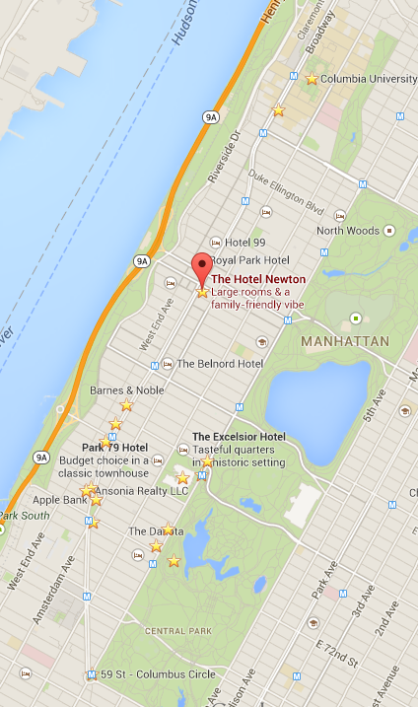  Explore Columbia University  Tom’s Diner  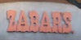  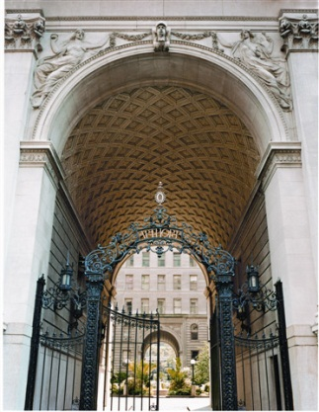  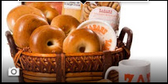  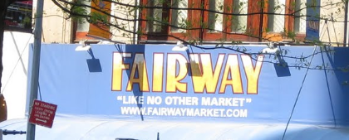  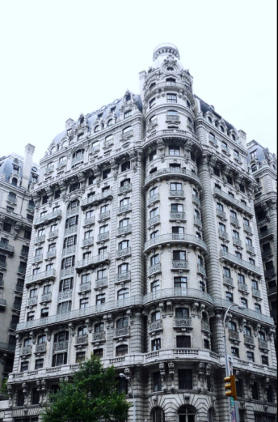  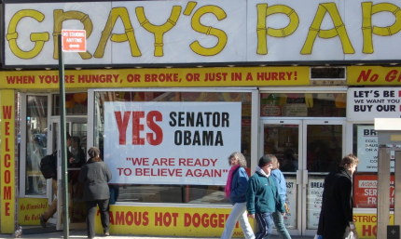  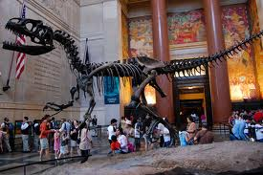  The American Museum of Natural History is one of the largest and most innovative natural history museums in the world. Journey through the universe in the spectacular Rose Center for Earth and Space. Walk through a re-creation of an African rain forest in the Hall of Biodiversity. See the world’s largest collection of dinosaur and other vertebrate fossils, with more than 600 specimens on display.  New York Pass grants you free admission to the American Museum of Natural History,  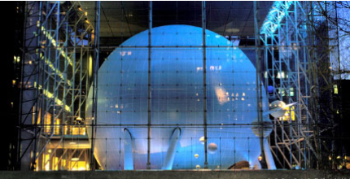  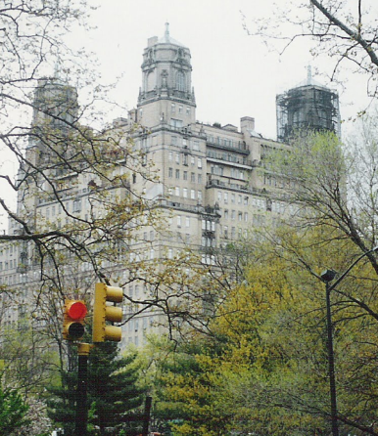  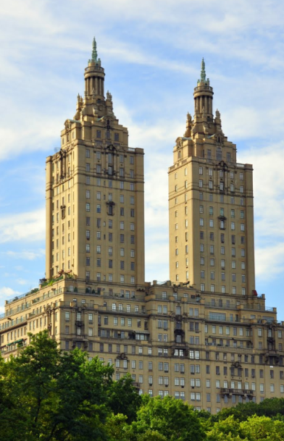  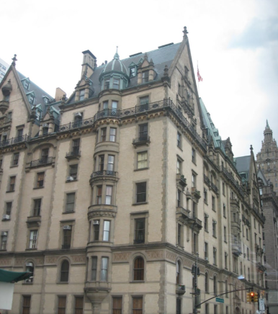  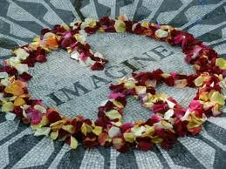
  I am sitting  In the morning  At the diner  On the corner  I am waiting  At the counter  For the man  To pour the coffee  And he fills it  Only halfway  And before  I even argue  He is looking  Out the window  At somebody  Coming in  It is always  Nice to see you  Says the man  Behind the counter  To the woman  Who has come in  She is shaking  Her umbrella  And I look  The other way  As they are kissing  Their hellos  And I'm pretending  Not to see them  And Instead  I pour the milk  I open  Up the paper  There's a story  Of an actor  Who had died  While he was drinking  He was no one  I had heard of | And I'm turning  To the horoscope  And looking  For the funnies  When I'm feeling  Someone watching me  And so  I raise my head  There's a woman  On the outside  Looking inside  Does she see me?  No she does not  Really see me  'Cause she sees  Her own reflection  And I'm trying  Not to notice  That she's hitching  Up her skirt  And while she's  Straightening her stockings  Her hair  Is getting wet  Oh, this rain  It will continue  Through the morning  As I'm listening  To the bells  Of the cathedral  I am thinking  Of your voice  And of the midnight picnic  Once upon a time  Before the rain began  And I finish up my coffee  And it's time to catch the train  Songwriters  VEGA, SUZANNE Published by  Lyrics © Warner/ Chappell Music, Inc.

