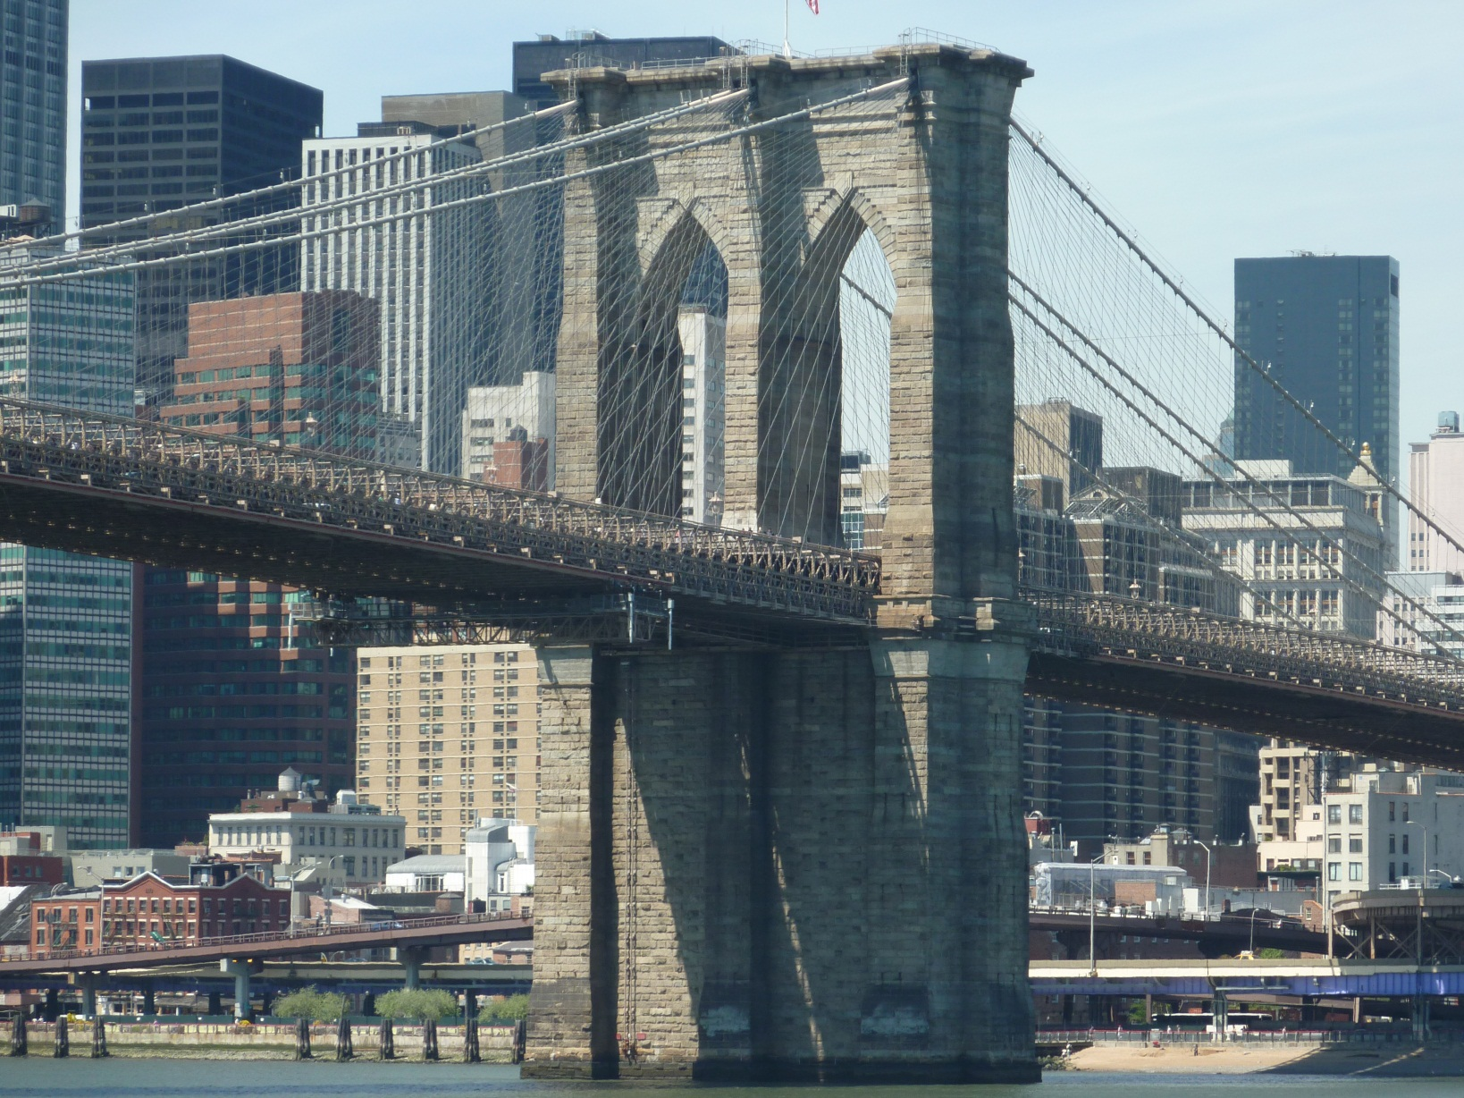
GIBS 6c classtrip 2017 | New York City Here we come

by Elisabeth Pölzleitner, for classroom use only

Schedule for NYC Trip
 | MORNING | AFTERNOON | EVENING
Friday,  April 21st |  | Arrival in Newark 15.45  Trip to hotel  Go Airlink NYC | Stroll along 5th Avenue to Empire State Building  See Manhattan by night from the top.
Saturday, April 22nd | 10.00 – 12.30  Boat trip: Circle Line :  Best of NYC Cruise  at  Pier 83, 42nd Street | The Bohemian Experience:  Walk through Chelsea:  Chelsea Hotel, Algonquin Hotel - Round Table  Midtown Manhattan: Glitz and Glamour Broadway, 5th Ave, Plaza Hotel,  Chrysler Building,  Grand Central Station, Macy’s | Theater: 6 p.m.  Apollo Amateur Night  Urban Word NYC Teen Poetry Grand Slam Finals
Sunday,  April 23rd | Walking up Broadway  Columbia University  Tom’s Diner  The Black Experience  11h Gospel service at Convent Avenue Baptist Church  420 W 145th St, New York, NY 10031, USA  Phone: +1 212-234-6767  and walk through Harlem | Central Park  Guggenheim Museum (just a short stop)  Then choose one of these options (together with 6b):  Option A: MOMA: Museum of Modern Art (closes at 5.30) and  Ground Zero Memorial (open till 8 p.m.)  Option B: Street Art in Williamsburg and Bushwick  Option C: Bike-rides in Central Park  Option D: Museum of Natural History | 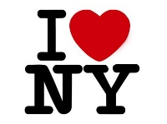  Times Square by night
Monday,  April 24th | Jewish New York  Lower East Side: Tenement Museum Walking Tour  Lunch at Katz’ Deli | Lower Manhattan  East Village  Greenwich Village  Soho | Dinner in Chinatown
Tuesday  April 25th | Trip to Airport:  pickup time 7.15  Flight departure 11.29 | Arrive in KC at 13.47 | with KC families

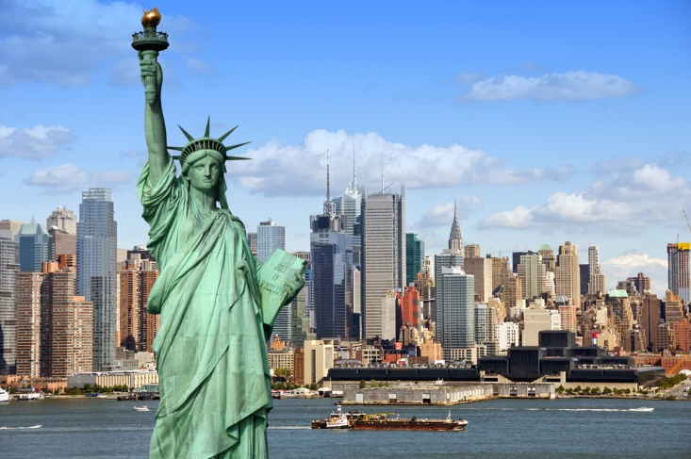

Table of Contents

New York City Here we come 0
Schedule for NYC Trip 2
Map of Manhattan 5
Mannahatta by Walt Whitman 7
Everyone Knows This Is Somewhere by CHUCK KLOSTERMAN 8
Glitz & Glamour 10
Breakfast at Tiffany’s by Truman Capote 12
“My Lost City” by F. Scott Fitzgerald 13
The Heart of the World… Broadway by Nik Cohn 17
Poems by Dorothy Parker (1893 – 1967) 21
“From the Diary of a New York Lady” by Dorothy Parker 22
Untitled Poem by Donald A. Bullard 25
Grand Central Winter by Lee Stringer 26
The Bohemian Experience 29
Every room at the Chelsea tells its own story. 30
Chelsea Hotel No.2 (song) by Leonhard Cohen 31
“Tom’s Diner” (song) by Suzanne Vega 34
Harlem – The Black Experience 35
“Harlem” aka “A Dream Deferred” (poem) by Langston Hughes 37
No Longer Majority Black, Harlem Is in Transition by SAM ROBERTS 38
Map of Central Park 41
Go Tell It on the Mountain by James Baldwin 42
A Self-Guided Brooklyn Graffiti Tour 45
Throw-ups and Pieces 46
Murals 46
Poster-work 47
Jewish New York 48
The Jews of New York (Commentary by Dr. Gerhard Falk) 51
The Streit’s family dynasty: Passing on the matzo on the Lower East Side by Bonnie Rosenstock 53
Manhattan (film) by Woody Allen 55
East Village – Greenwich Village - SoHo 56
“The Last Leaf“ by O. Henry 58
Gentrification 62
The Beat Generation in the East Village: Allen Ginsberg (1926-1997) 63
“Howl” by Allan Ginsberg 65
The Heart of the World... Chinatown by Nik Cohn 66
Exploring the Upper West Side 70

Overview of Text Samples

- “Mannahatta” (poem) by Walt Whitman Manhattan
- Everyone Knows This Is Somewhere (New York Times article) by Chuck Klosterman Manhattan
- Breakfast at Tiffany’s (novella) by Truman Capote 5th Avenue, Tiffany’s, Glitz & Glamour…
- “My Lost City” (essay) by F. Scott Fitzgerald Glitz & Glamour lost, Great Depression
- The Heart of the World… Broadway by Nik Cohn Theater District, Broadway
- Poems by Dorothy Parker (1893 – 1967) Glitz & Glamour
- “From the Diary of a New York Lady” by Dorothy Parker Glitz & Glamour
- Untitled Poem by Donald A. Bullard Grand Central Station, “other side” of NYC
- Grand Central Winter (novel) by Lee Stringer Grand Central Station, “other side” of NYC
- “The Jews of New York” (commentary by Dr. Gerhard Falk) East Village
- The Streit’s family dynasty: Passing on the matzo on the Lower East Side by Bonnie Rosenstock (article) Jewish New York, Lower East Side
- Manhattan (film) by Woody Allen Jewish New York
- “The Last Leaf“ by O. Henry Greenwich Village
- The Beat Generation in the East Village: Allen Ginsberg (1926-1997) East Village, “Beat” culture
- “Howl” by Allan Ginsberg Lower Manhattan
- The Heart of the World... Chinatown by Nik Cohn Chinatown
- “Tom’s Diner” (song) by Suzanne Vega Morningside Heights, Columbia University
- “Harlem” aka “A Dream Deferred” (poem) by Langston Hughes Harlem
- No Longer Majority Black, Harlem Is in Transition (New York Times article) by Sam Roberts Harlem
- Go Tell It on the Mountain (novel) by James Baldwin Central Park, Broadway, Harlem
- Every room at the Chelsea tells its own story. (article) Chelsea (Bohemian Experience)
- Chelsea Hotel No.2 (song) by Leonhard Cohen Chelsea

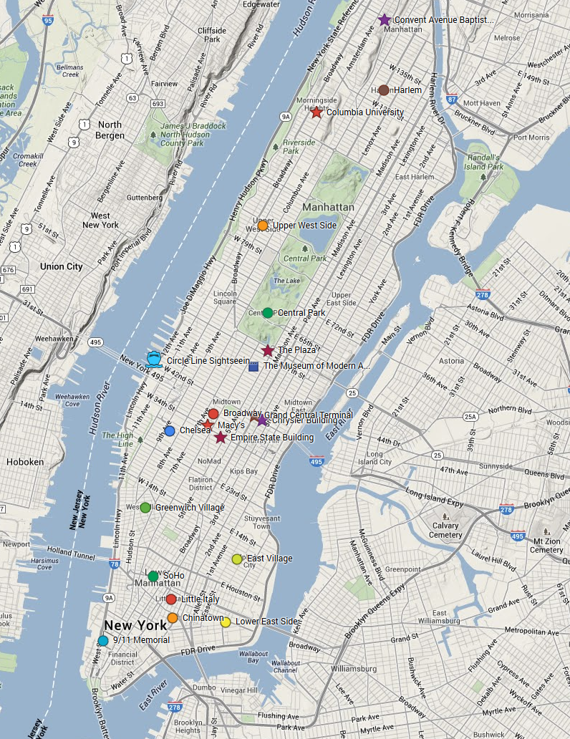
Map of Manhattan

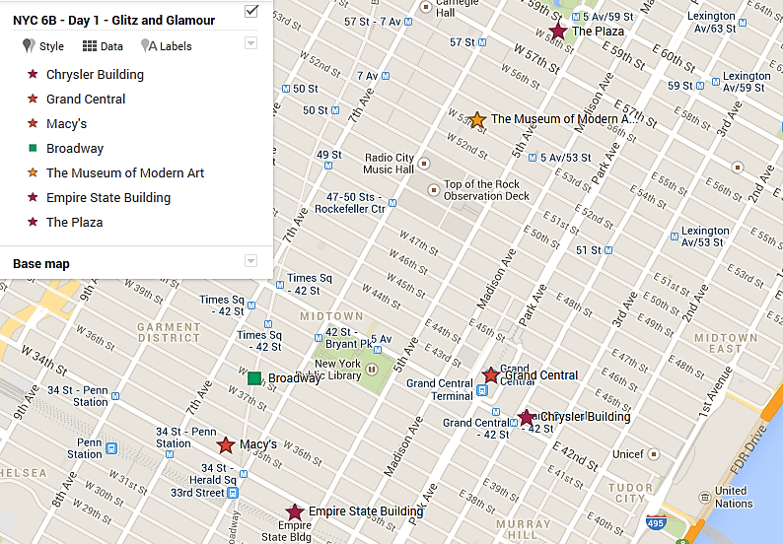
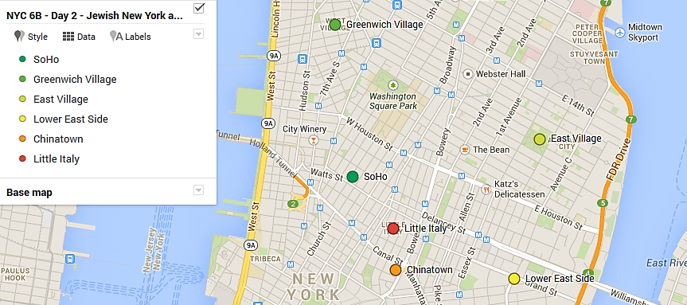
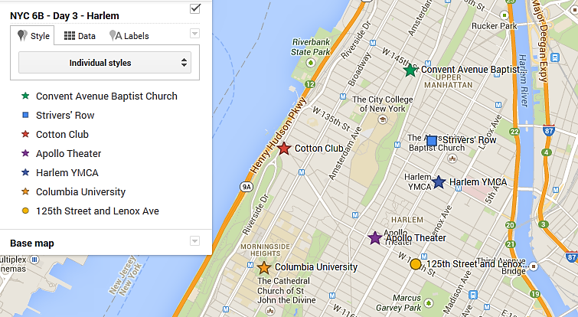

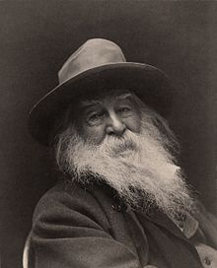

Mannahatta
by Walt Whitman

I was asking for something specific and perfect for my city,
Whereupon lo! upsprang the aboriginal name.

Now I see what there is in a name, a word, liquid, sane,
unruly, musical, self-sufficient,
I see that the word of my city is that word from of old,
Because I see that word nested in nests of water-bays,
superb,
Rich, hemm'd thick all around with sailships and
steamships, an island sixteen miles long, solid-founded,
Numberless crowded streets, high growths of iron, slender,
strong, light, splendidly uprising toward clear skies,
Tides swift and ample, well-loved by me, toward sundown,
The flowing sea-currents, the little islands, larger adjoining
islands, the heights, the villas,
The countless masts, the white shore-steamers, the lighters,
the ferry-boats, the black sea-steamers well-model'd,
The down-town streets, the jobbers' houses of business, the
houses of business of the ship-merchants and money-
brokers, the river-streets,
Immigrants arriving, fifteen or twenty thousand in a week,
The carts hauling goods, the manly race of drivers of horses,
the brown-faced sailors,
The summer air, the bright sun shining, and the sailing
clouds aloft,
The winter snows, the sleigh-bells, the broken ice in the
river, passing along up or down with the flood-tide or
ebb-tide,
The mechanics of the city, the masters, well-form'd,
beautiful-faced, looking you straight in the eyes,
Trottoirs throng'd, vehicles, Broadway, the women, the
shops and shows,
A million people--manners free and superb--open voices--
hospitality--the most courageous and friendly young
men,
City of hurried and sparkling waters! city of spires and masts!
City nested in bays! my city!

http://www.poets.org/viewmedia.php/prmMID/16081

This copy is for your personal, noncommercial use only. You can order presentation-ready copies for distribution to your colleagues, clients or customers, please click here or use the "Reprints" tool that appears next to any article.
Visit www.nytreprints.com for samples and additional information. Order a reprint of this article now. »

April 27, 2003

Everyone Knows This Is Somewhere
by CHUCK KLOSTERMAN

THERE is nothing inherently remarkable about how I ended up in New York. Like most people who live here, I just got out of a cab one afternoon and there I was. That's pretty much the whole story. And it all seemed completely normal to me -- until I started talking to people and telling them where I was from. Only then did I realize that I am an absolute alien here, akin to the likes of Yao Ming, Tony Blair and/or Chewbacca.
I came to New York from Akron, Ohio (pop. 217,000), which is where I lived after relocating from Fargo, N.D. (pop. 91,000), which is the only metro area within an hour of my hometown of Wyndmere, N.D. (pop. 533), which was five miles from my parents' farm (pop. 9). This (apparently) qualifies me to write about my ''personal journey,'' the assumption being that I must have myriad insights and askew observations about New York.
This is what people assume about you when you come from a place where it's totally acceptable to leave your car running -- with the keys in the ignition and the doors unlocked -- in the middle of the night.
People in North Dakota do this because it falls to 40 below zero in January and the wind regularly blows in excess of 40 miles an hour, and those climatic conditions cause the fluid in a car battery to freeze into a brick. This makes it impossible to drive home from the bar. Consequently, everyone leaves their automobiles running when they're in public, sometimes for up to five or six hours. People in rural North Dakota don't steal cars, and people in New York find that strange.
In fact, people in New York seem to find everything about rural North Dakota strange, almost to the point of not believing such a place exists. But that's good, because if they did believe North Dakota was a real place, I'm sure they'd tell me it was over.
In the 10 months I've been here, I have learned only one thing: Absolutely everything is no longer relevant. Every rock band, every film, every book, every restaurant, every street, every emotion, every newborn baby, every religion, every species of antelope, every over-the-counter cough medication, every style of affordable trousers and every future moment is completely over. Moreover, I fully realize that pointing out how ''everything is over'' is also over, so this essay is completely tired and clichéd. It was over before I started.
Like many young American idiots, I moved to New York because I wanted to be cool. New York rewards coolness; in fact, I have met at least 17 people in this city who apparently make a living by being cool full time, a vocation that requires its adherents to (a) never actually work, yet still (b) wear stylish neckties. Unfortunately, I can't seem to make this lifestyle work, and my problem is semantic. In North Dakota, the words ''cool'' and ''trendy'' are interchangeable; if you're cool, you're also trendy (and vice versa). This is not the case on the coasts.
In New York and Los Angeles, these two terms are antonyms: ''trendy'' means doing what everyone else is doing, while ''cool'' means doing what no one else is doing. People in L.A. put a premium on being trendy, so no one there is cool; meanwhile, New York is more focused on coolness than on trendiness. Granted, there are trendy people here, too, but they're uncool (usually, they're just inexplicably rich).
Now, these people would have been cool if they had done what is now trendy before it was widely recognized as popular, but because they didn't, they are completely over. Of course, even the cool people are kind of over, because they inevitably congregate with other cool people, and their coolness becomes a localized trend. That's trendy, which is not cool. It's a wicked game.
As far as I can tell, being cool in New York requires you to do something totally and wholly random. These actions include (but are not limited to) walking around your neighborhood with a toucan on your shoulder; wearing an eye patch and a Dekalb Seed cap; drinking hemlock recreationally; and/or smashing a banjo on the L train in the hope of getting spare change.
I'm not necessarily claiming that any of these schemes will work, but you may as well try (it's always 50/50). And being cool is certainly worth the gamble. This is the best place in the universe to be socially desirable, since we all know that New York is supersaturated with beautiful people. (Please note that I am using supersaturated literally: the air around Manhattan actually contains more attractive people than it has the potential to hold under normal atmospheric conditions.) While walking home from work one afternoon, I decided to count how many people whom I would classify as physically desirable; over 18 blocks, the number was 204, and that included one homeless woman who wore tin foil on her forearms and was talking to an invisible minotaur. New York has got to be the only city on earth with foxy homeless people.
The main thing I've noticed most about New York is that people who live here have no idea how anyone else in America lives, thinks or manages to survive. They seem to assume rural Americans mostly sit in barren 12x12 aluminum rooms and stare at mounted elk carcasses. However, it's worth noting that the rest of the country has the same confusion about New Yorkers, particularly in regard to their level of general rudeness (and cast members from the 1979 film ''The Warriors''). It has been my experience that strangers in New York are exceedingly friendly, almost to the point of being weirdly insecure.
I've noticed that if you stand at the top of a subway platform and appear even mildly baffled, someone will immediately ask you if you need directions (and they seem almost disappointed if you don't). I suspect this is because just about everyone here is ultimately from somewhere else, and they all adore recalling the bygone days when that disconcerting displacement was still new and electrifying and vaguely dangerous.
New Yorkers love reliving the New York experience. For example, my apartment in Midtown recently had a mouse; what I did not realize is that at one time or another every apartment in New York has been plagued by vermin. So whenever I mentioned this mouse problem at a social function, every other person in the room would insist on telling me his or her own personal mouse story. ''The glue traps don't work,'' they would say, ''so I bought a cat to eat the mouse, and then I had to get a dog to take care of the cat problem, and then I had to buy a wolf to eat the dog, and then I had to sue my landlord for not allowing my wolf to install an air-conditioner. It was a nightmare.''
That's how all New York anecdotes seem to end: ''It was a nightmare.''
Clearly, living here is not easy. Everything costs too much; getting anywhere is a hassle; most people are profoundly lazy and nobody is willing to admit to being wrong about anything. I constantly find myself fighting my Midwestern impulse to stop conversations in mid-flow to tell people: ''You're lying! And we all know you're lying!''
It's maddening to live here. But it's also amazing to live here. It's impossible to deny that this city is where all the good stuff is, and all that stuff can still be purchased at 3:50 a.m. That only happens here, and I will never live anywhere else. And I always make sure I tell people that whenever they ask, ''So what do you think of New York?'' -- a question I get at least five times a week. I always say I will stay here forever, because I know what that question really means: ''I'm going broke and I'm feeling alienated and I'm trying to make it and I'm failing horribly, but I desperately need you to tell me that living here is still worth the effort.''
And I always tell them it is, because it's probably true. New York may be terrible, but it's as good as it gets. Besides -- the rest of America is so over.
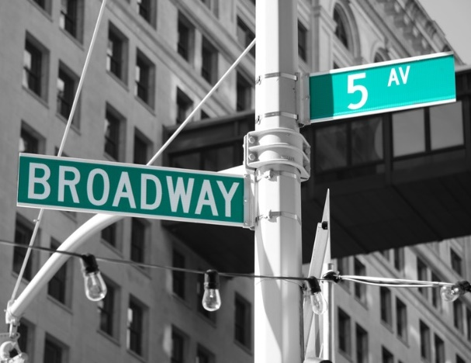



Glitz & Glamour

Stops / Sights | Info | Text Sample
General Intro | - Multicultural NYC, patchwork of races, origins, religions started as a small Dutch community (New Amsterdam), mass immigration in the 1850s,…  - Overview of map: Manhattan, ethnic neighborhoods: Little Italy, Chinatown, Harlem, Williamsburg, East Village,…
Overview of our Walk | Find all of today’s stops on your map and trace our walk in color.  Please stay together as a group, walk quickly, and don’t stop for food or little shopping needs during our tour. There will be times for individual shopping too. If you fall behind, use your map to catch up with the group immediately.  If you recognize one of the settings of your New York novel, please tell the class about the passage you have in mind. Take pictures for your literature project.
The Plaza Hotel  Meeting point at:  ________ p.m. | 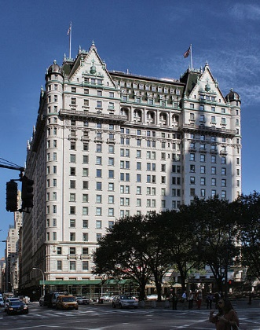  We’ll share our impressions of 5th Avenue and take a few minutes to take down our thoughts.  The Plaza Hotel  - château-style building  - opened in 1907  - most luxurious building in town  - located at 5th Avenue and Central Park South  Read extracts from  Truman Capote’s Breakfast at Tiffany’s  infamous party 1966, 16000$, invited Frank Sinatra, Thornton Wilder, Andy Warhol, Rose Kennedy,…  Outside: anti-Vietnam Demos  Later T.C. saw that this religion of money wasn’t right – published true stories about his high society friends, only slightly fictionalized – they were angry, turned against him – he slipped into depression, alcohol, drugs…  Andy Warhol had long taken over the job of documenting NY society himself, only with camera and paintbrush  F. Scott Fitzgerald’s The Great Gatsby  glamorous life in NY and Long Island, rich and famous, fun and endless parties,… American dream seems to have come true.  Fitzgerald and his wife Zelda were the dream couple of the Jazz-Age: rich, drunk, dancing at the Plaza. In the novel Gatsby spends a day in N.Y. It’s hot and stuffy – he rents a swell suite to cool off in the bathrooms. Time of prohibition… See The Great Gatsby p. 125ff  F. Scott Fitzgerald’s “My lost city”  When Fitzgerald returned to NY in 1931 everything had changed. Even though the Empire State Building had been finished, the glitz and glamour were gone after the stock exchange had crashed… unemployment, the Great Depression… “The party was over”. See how Fitzgerald sees N.Y. society at this point.  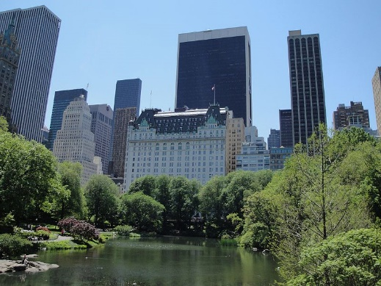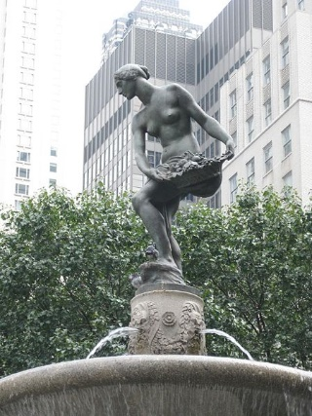  The Plaza and its International Modern style In front of the Plaza Hotel:  neighbors, seen across The Pond in Central Park. Pulitzer Fountain (Pulitzer Prize!) | Text (3) on page 12  Text (4) on page 13
Theatre District / Broadway | - extends from West 40th Street to West 54th Street, from west of Sixth Avenue to east of Eighth Avenue, and includes Times Square  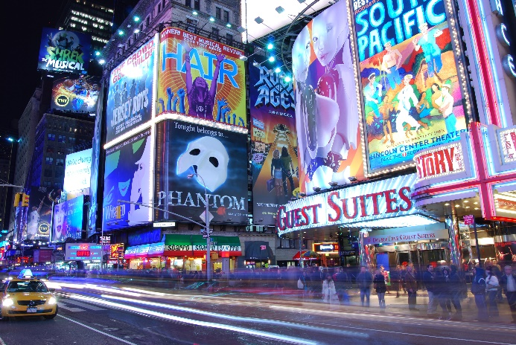  BIT OF HISTORY…  - The Great White Way around 1910, new electric lights  - 1920s and 30s: very glamorous, lots of theaters, dance, musicals… quality live shows  - 1970s and 80s: drugs, sex, prostitution, dirty, (mainly 42nd street west)  - Now: Gentrified, mostly movie houses, mainstream entertainment, Disney productions… remakes of London musicals…  - Good, quality shows have moved off-Broadway or off-off-Broadway  Read Nik Cohn’s account on the beginnings of Broadway entertainment (The heart of the World… Broadway) on page 17 and briefly sum up the development of Broadway. What does the author say about Broadway entertainment? | Text (5) on page 17

Breakfast at Tiffany’s by Truman Capote
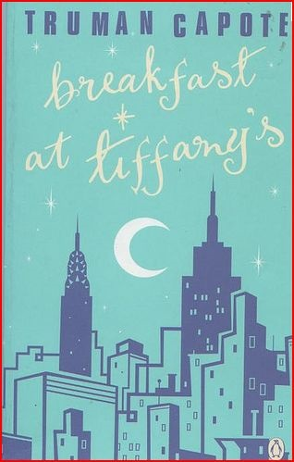
Regarded as one of Capote’s most fresh and enduring works, Breakfast at Tiffany’s is set in Manhattan in 1943. The novella (published 1958) is a portrait of Holly, an impulsive, outspoken, gamine who is in some ways worldly – she has no trouble, for example, accepting fifty dollar bills as “powder room change” from her escorts – but is fundamentally naïve. Drawn to the social whirl of New York City, she lives in an apartment with a nameless cat and no furniture; bringing her gentlemen friends home at all hours, she rings her neighbor’s doorbells, seemingly oblivious to her acts of social indiscretion.
Her story is related in the first person by her devoted friend, Buster, a struggling writer and a neighbor in her apartment building. Both Buster and an elderly bartender become deeply attached to Holly, who avoids all close relationships. What she does live is Tiffany’s, which is where she goes when she’s depressed. It calms her down, and if she “could find a real-life place that made me feel like Tiffany's, then I'd buy some furniture and give the cat a name.” While sharing with him her affection and appealing eccentricity, Holly ultimately draws Buster into trouble when she becomes embroiled with a criminal named Sally Tomato, a dope dealer whose exploits are depicted in a convoluted subplot.
But the secret of Holly’s origins presents a facet of her that is unlike the person we have come to know. Unlike the urban sophisticate she appears to be, she is in truth a hillbilly form Texas, a child bride whose husband comes to fetch her and relates the story of her marriage at thirteen, her escape from a life of domestic banality, and her flight to New York.
Holly is often regarded as one of Capote’s most important creations. Furthermore, critics consider Breakfast at Tiffany’s a well-structured, beautifully paced portrait of 1940s New York that captures the manners and language of the time with an easy charm and grace.
from Characters in 20th-Century Literature by Laurie Lanzen Harries

I knew damn well I'd never be a movie star. It's too hard; and if you're intelligent, it's too embarrassing. My complexes aren't inferior enough: being a movie star and having a big fat ego are supposed to go hand-in-hand; actually, it's essential not to have any ego at all. I don't mean I'd mind being rich and famous. That's very much on my schedule, and someday I'll try to get around to it; but if it happens, I'd like to have my ego tagging along. I want to still be me when I wake up one fine morning and have breakfast at Tiffany's. You need a glass," she said, noticing my empty hands. "Rusty! Will you bring my friend a drink?"
She was still hugging the cat. "Poor slob," she said, tickling his head, "poor slob without a name. It's a little inconvenient, his not having a name. But I haven't any right to give him one: he'll have to wait until he belongs to somebody. We just sort of took up by the river one day, we don't belong to each other: he's an independent, and so am I. I don't want to own anything until I know I've found the place where me and things belong together. I'm not quite sure where that is just yet. But I know what it's like." She smiled, and let the cat drop to the floor. "It's like Tiffany's," she said. "Not that I give a hoot about jewelry. Diamonds, yes. But it's tacky to wear diamonds before you're forty; and even that's risky. They only look right on the really old girls. Maria Ouspenskaya. Wrinkles and bones, white hair and diamonds: I can't wait. But that's not why I'm mad about Tiffany's. Listen. You know those days when you've got the mean reds?"
"Same as the blues?"
"No," she said slowly. "No, the blues are because you're getting fat or maybe it's been raining too long. You're sad, that's all. But the mean reds are horrible. You're afraid and you sweat like hell, but you don't know what you're afraid of. Except something bad is going to happen, only you don't know what it is. You've had that feeling?"
"Quite often. Some people call it angst."
"All right. Angst. But what do you do about it?"
"Well, a drink helps."
"I've tried that. I've tried aspirin, too. Rusty thinks I should smoke marijuana, and I did for a while, but it only makes me giggle. What I've found does the most good is just to get into a taxi and go to Tiffany's. It calms me down right away, the quietness and the proud look of it; nothing very bad could happen to you there, not with those kind men in their nice suits, and that lovely smell of silver and alligator wallets. If I could find a real-life place that made me feel like Tiffany's, then I'd buy some furniture and give the cat a name.

from Breakfast at Tiffany’s (p.39-40)

“My Lost City” by F. Scott Fitzgerald

MY LOST CITY

July, 1923
There was first the ferry boat moving softly from the Jersey shore at dawn – the moment crystallized into my first symbol of New York. Five years later when I was fifteen I went into the city from school to see Ina Claire in The Quaker Girl and Gertrude Bryan in Little Boy Blue. Confused by my hopeless and melancholy love for them both, I was unable to choose between them – so they blurred into one lovely entity, the girl. She was my second symbol of New York. The ferry boat stood for triumph, the girl for romance. In time I was to achieve some of both, but there was a third symbol that I have lost somewhere, and lost for ever.
I found it on a dark April afternoon after five more years.
'Oh, Bunny,' I yelled. 'Bunny!'
He did not hear me – my taxi lost him, picked him up again half a block down the street. There were black spots of rain on the sidewalk and I saw him walking briskly through the crowd wearing a tan raincoat over his inevitable brown get-up; I noted with a shock that he was carrying a light cane.
'Bunny!' I called again, and stopped. I was still an undergraduate at Princeton while he had become a New Yorker. This was his afternoon walk, this hurry along with his stick through the gathering rain, and as I was not to meet him for an hour it seemed an intrusion to happen upon him engrossed in his private life. But the taxi kept pace with him and as I continued to watch I was impressed: he was no longer the shy little scholar of Holder Court - he walked with confidence, wrapped in his thoughts and looking straight ahead, and it was obvious that his new background was entirely sufficient to him. I knew that he had an apartment where he lived with three other men, released now from all undergraduate taboos, but there was something else that was nourishing him and I got my first impression of that new thing - the Metropolitan spirit.
Up to this time I had seen only the New York that offered itself for inspection - I was Dick Whittington up from the country gaping at the trained bears, or a youth of the Midi dazzled by the boulevards of Paris. I had come only to stare at the show, though the designers of the Wool-worth Building and the Chariot Race Sign, the producers of musical comedies and problem plays, could ask for no more appreciative spectator, for I took the style and glitter of New York even above its own valuation. But I had never accepted any of the practically anonymous invitations to debutante balls that turned up in an undergraduate's mail, perhaps because I felt that no actuality could live up to my conception of New York's splendour. Moreover, she to whom I fatuously referred as 'my girl' was a Middle Westerner, a fact which kept the warm centre of the world out there, so I thought of New York as essentially cynical and heartless – save for one night when she made luminous the Ritz Roof on a brief passage through.
Lately, however, I had definitely lost her and I wanted a man's world, and this sight of Bunny made me see New York as just that. A week before, Monsignor Fay had taken me to the Lafayette where there was spread before us a brilliant flag of food, called an hors d'oeuvre, and with it we drank claret that was as brave as Bunny's confident cane – but after all it was a restaurant, and afterwards we would drive back over a bridge into the hinterland. The New York of undergraduate dissipation, of Bustanoby's, Shanley's, Jack's, had become a horror, and though I returned to it, alas, through many an alcoholic mist, I felt each time a betrayal of a persistent idealism. My participance was prurient rather than licentious and scarcely one pleasant memory of it remains from those days; as Ernest Hemingway once remarked, the sole purpose of the cabaret is for unattached men to find complaisant women. All the rest is a wasting of time in bad air.
But that night, in Bunny's apartment, life was mellow and safe, a finer distillation of all that I had come to love at Princeton. The gentle playing of an oboe mingled with city noises from the street outside, which penetrated into the room with difficulty through great barricades of books; only the crisp tearing open of invitations by one man was a discordant note. I had found a third symbol of New York and I began wondering about the rent of such apartments and casting about for the appropriate friends to share one with me.
Fat chance - for the next two years I had as much control over my own destiny as a convict over the cut of his clothes. When I got back to New York in 1919 I was so entangled in life that a period of mellow monasticism in Washington Square was not to be dreamed of. The thing was to make enough money in the advertising business to rent a stuffy apartment for two in the Bronx. The girl concerned had never seen New York but she was wise enough to be rather reluctant. And in a haze of anxiety and unhappiness I passed the four most impressionable months of my life.
New York had all the iridescence of the beginning of the world. The returning troops marched up Fifth Avenue and girls were instinctively drawn east and north towards them - this was the greatest nation and there was gala in the air. As I hovered ghost-like in the Plaza Red Room of a Saturday afternoon, or went to lush and liquid garden parties in the East Sixties or tippled with Princetonians in the Biltmore Bar, I was haunted always by my other life – my drab room in the Bronx, my square foot of the subway, my fixation upon the day's letter from Alabama – would it come and what would it say? – my shabby suits, my poverty, and love. While my friends were launching decently into life I had muscled my inadequate bark into midstream. The gilded youth circling around young Constance Bennett in the Club de Vingt, the classmates in the Yale-Princeton Club whooping up our first after-die-war reunion, the atmosphere of the millionaires' houses that I sometimes frequented – these things were empty for me, though I recognized them as impressive scenery and regretted that I was committed to other romance. The most hilarious luncheon table or the most moony cabaret – it was all the same; from them I returned eagerly to my home on Claremont Avenue - home because there might be a letter waiting outside the door. One by one my great dreams of New York became tainted. The remembered charm of Bunny's apartment faded with the rest when I interviewed a blowsy landlady in Greenwich Village. She told me I could bring girls to the room, and the idea filled me with dismay – why should I want to bring girls to my room? – I had a girl. I wandered through the town of 127th Street, resenting its vibrant life; or else I bought cheap theatre seats at Gray's drugstore and tried to lose myself for a few hours in my old passion for Broadway. I was a failure -mediocre at advertising work and unable to get started as a writer. Hating the city, I got roaring, weeping drunk on my last penny and went home....
. . . Incalculable city. What ensued was only one of a thousand success stories of those gaudy days, but it plays a part in my own movie of New York. When I returned six months later the offices of editors and publishers were open to me, impresarios begged plays, the movies panted for screen material. To my bewilderment, I was adopted, not as a Middle Westerner, not even as a detached observer, but as the archetype of what New York wanted. This statement requires some account of the metropolis in 1920.
There was already the tall white city of today, already the feverish activity of the boom, but there was a general inarticulateness. As much as anyone the columnist F.P.A. guessed the pulse of the individual crowd, but shyly, as one watching from a window. Society and the native arts had not mingled - Ellen Mackay was not yet married to Irving Berlin. Many of Peter Arno's people would have been meaningless to the citizen of 1920, and save for F.P.A.'s column there was no forum for metropolitan urbanity.
Then, for just a moment, the 'younger generation' idea became a fusion of many elements in New York life. People of fifty might pretend there was still a four hundred, or Maxwell Bodenheim might pretend there was a Bohemia worth its paint and pencils - but the blending of the bright, gay, vigorous elements began then, and for the first time there appeared a society a little livelier than the solid mahogany dinner parties of Emily Price Post. If this society produced the cocktail party, it also evolved Park Avenue wit, and for the first time an educated European could envisage a trip to New York as something more amusing than a gold-trek into a formalized Australian Bush.
For just a moment, before it was demonstrated that I was unable to play the role, I, who knew less of New York than any reporter of six months' standing and less of its society than any hall-room boy in a Ritz stag line, was pushed into the position not only of spokesman for the time but of the typical product of that same moment. I, or rather it was 'we' now, did not know exactly what New York expected of us and found it rather confusing. Within a few months after our embarkation on the Metropolitan venture we scarcely knew any more who we were and we hadn't a notion what we were. A dive into a civic fountain, a casual brush with the law, was enough to get us into the gossip columns, and we were quoted on a variety of subjects we knew nothing about. Actually our 'contacts' included half a dozen unmarried college friends and a few new literary acquaintances - I remember a lonesome Christmas when we had not one friend in the city, nor one house we could go to. Finding no nucleus to which we could cling, we became a small nucleus ourselves and gradually we fitted our disruptive personalities into the contemporary scene of New York. Or rather New York forgot us and let us stay.
This is not an account of the city's changes but of the changes in this writer's feeling for the city. From the confusion of the year 1920 I remember riding on top of a taxicab along deserted Fifth Avenue on a hot Sunday night, and a luncheon in the cool Japanese gardens at the Ritz with the wistful Kay Laurel and George Jean Nathan, and writing all night again and again, and paying too much for minute apartments, and buying magnificent but broken-down cars. The first speak-easies had arrived, the toddle was passé, the Montmartre was the smart place to dance and Lillian Tashman's fair hair weaved around the floor among the enliquored college boys. The plays were Declassée and Sacred and Profane Love, and at the Midnight Frolic you danced elbow to elbow with Marion Davies and perhaps picked out the vivacious Mary Hay in the pony chorus. We thought we were apart from all that; perhaps everyone thinks they are apart from their milieu. We felt like small children in a great bright unexplored barn. Summoned out to Griffith's studio on Long Island, we trembled in the presence of the familiar face of the Birth of a Nation; later I realized that behind much of the entertainment that the city poured forth into the nation there were only a lot of rather lost and lonely people. The world of the picture actors was like our own in that it was in New York and not of it. It had little sense of itself and no centre: when I first met Dorothy Gish I had the feeling that we were both standing on the North Pole and it was snowing. Since then they have found a home but it was not destined to be New York.
When bored we took our city with a Huysmans-like perversity. An afternoon alone in our 'apartment' eating olive sandwiches and drinking a quart of Bushmill's whisky presented by Zoe Atkins, then out into the freshly bewitched city, through strange doors into strange apartments with intermittent swings along in taxis through the soft nights. At last we were one with New York, pulling it after us through every portal. Even now I go into many flats with the sense that I have been there before or in the one above or below - was it the night I tried to disrobe in the Scandals, or the night when (as I read with astonishment in the paper next morning) 'Fitzgerald Knocks Officer This Side of Paradise'? Successful scrapping not being among my accomplishments, I tried in vain to reconstruct the sequence of events which led up to this denouement in Webster Hall. And lastly from that period I remember riding in a taxi one afternoon between very tall buildings under a mauve and rosy sky; I began to bawl because I had everything I wanted and knew I would never be so happy again.
It was typical of our precarious position in New York that when our child was to be born we played safe and went home to St Paul – it seemed inappropriate to bring a baby into all that glamour and loneliness. But in a year we were back and we began doing the same things over again and not liking them so much. We had run through a lot, though we had retained an almost theatrical innocence by preferring the role of the observed to that of the observer. But innocence is no end in itself and as our minds unwillingly matured we began to see New York whole and try to save some of it for the selves we would inevitably become.
It was too late - or too soon. For us the city was inevitably linked up with Bacchic diversions, mild or fantastic. We could organize ourselves only on our return to Long Island and not always there. We had no incentive to meet the city half way. My first symbol was now a memory, for I knew that triumph is in oneself; my second one had grown commonplace - two of the actresses whom I had worshipped from afar in 1913 had dined in our house. But it filled me with a certain fear that even the third symbol had grown dim – the tranquillity of Bunny's apartment was not to be found in the ever-quickening city. Bunny himself was married, and about to become a father, other friends had gone to Europe, and the bachelors had become cadets of houses larger and more social than ours. By this time we 'knew everybody' - which is to say most of those whom Ralph Barton would draw as in the orchestra on an opening night.
But we were no longer important. The flapper, upon whose activities the popularity of my first books was based, had become passé by 1923 – anyhow in the East. I decided to crash Broadway with a play, but Broadway sent its scouts to Atlantic City and quashed the idea in advance, so I felt that, for the moment, the city and I had little to offer each other. I would take the Long Island atmosphere that I had familiarly breathed and materialize it beneath unfamiliar skies.
It was three years before we saw New York again. As the ship glided up the river, the city burst thunderously upon us in the early dusk – the white glacier of lower New York swooping down like a strand of a bridge to rise into uptown New York, a miracle of foamy light suspended by the stars. A band started to play on deck, but the majesty of the city made the march trivial and tinkling. From that moment I knew that New York, however often I might leave it, was home.
The tempo of the city had changed sharply. The uncertainties of 1920 were drowned in a steady golden roar and many of our friends had grown wealthy. But the restlessness of New York in 1927 approached hysteria. The parties were bigger - those of Conde Nast, for example, rivalled in their way the fabled balls of the nineties; the pace was faster - the catering to dissipation set an example to Paris; the shows were broader, the buildings were higher, the morals were looser and the liquor was cheaper; but all these benefits did not really minister to much delight. Young people wore out early - they were hard and languid at twenty-one, and save for Peter Arno none of them contributed anything new; perhaps Peter Arno and his collaborators said everything there was to say about the boom days in New York that couldn't be said by a jazz band. Many people who were not alcoholics were lit up four days out of seven, and frayed nerves were strewn everywhere; groups were held together by a generic nervousness and the hangover became a part of the day as well allowed-for as the Spanish siesta. Most of my friends drank too much – the more they were in tune to the times the more they drank. And so effort per se had no dignity against the mere bounty of those days in New York, a depreciatory word was found for it: a successful programme became a racket – I was in the literary racket.
We settled a few hours from New York and I found that every time I came to the city I was caught into a complication of events that deposited me a few days later in a somewhat exhausted state on the train for Delaware. Whole sections of the city had grown rather poisonous, but invariably I found a moment of utter peace in riding south through Central Park at dark towards where the facade of 59th Street thrusts its lights through the trees. There again was my lost city, wrapped cool in its mystery and promise. But that detachment never lasted long - as the toiler must live in the city's belly, so I was compelled to live in its disordered mind.
Instead there were the speak-easies – the moving from luxurious bars, which advertised in the campus publications of Yale and Princeton, to the beer gardens where the snarl-ing face of the underworld peered through the German good nature of the entertainment, then on to strange and even more sinister localities where one was eyed by granite-faced boys and there was nothing left of joviality but only a brutishness that corrupted the new day into which one presently went out. Back in 1920 I shocked a rising young business man by suggesting a cocktail before lunch. In 1929 there was liquor in half the downtown offices, and a speakeasy in half the large buildings.
One was increasingly conscious of the speak-easy and of Park Avenue. In the past decade Greenwich Village, Washington Square, Murray Hill, the chateaux of Fifth Avenue had somehow disappeared, or become unexpressive of anything. The city was bloated, gutted, stupid with cake and circuses, and a new expression 'Oh yeah?' summed up all the enthusiasm evoked by the announcement of the last super-skyscrapers. My barber retired on a half million bet in the market and I was conscious that the head waiters who bowed me, or failed to bow me, to my table were far, far wealthier than I. This was no fun – once again I had enough of New York and it was good to be safe on shipboard where the ceaseless revelry remained in the bar in transport to the fleecing rooms of France.
'What news from New York?'
'Stocks go up. A baby murdered a gangster.'
'Nothing more?'
'Nothing. Radios blare in the street.'
I once thought that there were no second acts in American lives, but there was certainly to be a second act to New York's boom days. We were somewhere in North Africa when we heard a dull distant crash which echoed to the farthest wastes of the desert.
'What was that?'
'Did you hear it?'
'It was nothing.'
'Do you think we ought to go home and see?'
'No - it was nothing.'
In the dark autumn of two years later we saw New York again. We passed through curiously polite customs agents, and then with bowed head and hat in hand I walked reverently through the echoing tomb. Among the ruins a few childish wraiths still played to keep up the pretence that they were alive, betraying by their feverish voices and hectic cheeks the thinness of the masquerade. Cocktail parties, a last hollow survival from the days of carnival, echoed to the plaints of the wounded: 'Shoot me, for the love of God, someone shoot me!', and the groans and wails of the dying: 'Did you see that United States Steel is down three more points?' My barber was back at work in his shop; again the head waiters bowed people to their tables, if there were people to be bowed. From the ruins, lonely and inexplicable as the sphinx, rose the Empire State Building and, just as it had been a tradition of mine to climb to the Plaza Roof to take leave of the beautiful city, extending as far as eyes could reach, so now I went to the roof of the last and most magnificent of towers. Then I understood – everything was explained: I had discovered the crowning error of the city, its Pandora's box. Full of vaunting pride the New Yorker had climbed here and seen with dismay what he had never suspected, that the city was not the endless succession of canyons that he had supposed but that it had limits - from the tallest structure he saw for the first time that it faded out into the country on all sides, into an expanse of green and blue that alone was limitless. And with the awful realization that New York was a city after all and not a universe, the whole shining edifice that he had reared in his imagination came crashing to the ground. That was the rash gift of Alfred W. Smith to the citizens of New York.
Thus I take leave of my lost city. Seen from the ferry boat in the early morning, it no longer whispers of fantastic success and eternal youth. The whoopee mamas who prance before its empty parquets do not suggest to me the ineffable beauty of my dream girls of 1914. And Bunny, swinging along confidently with his cane towards his cloister in a carnival, has gone over to Communism and frets about the wrongs of southern mill workers and western farmers whose voices, fifteen years ago, would not have penetrated his study walls.
All is lost save memory, yet sometimes I imagine myself reading, with curious interest, a Daily News of the issue of 1945:

MAN OF FIFTY RUNS AMUCK IN NEW YORK
Fitzgerald Feathered Many Love Nests Cutie Avers Bumped Off By Outraged Gunman

So perhaps I am destined to return some day and find in the city new experiences that so far I have only read about. For the moment I can only cry out that I have lost my splendid mirage. Come back, come back, O glittering and white!

F. Scott Fitzgerald’s iridescent city of 1919
Author, Lost Generation spokesman, and 1920s Jazz Age icon F. Scott Fitzgerald was once just like millions of New Yorkers before and after him: a struggling writer trying to make his mark.
“My Lost City”, completed by July 1932, was published posthumously in The Crack-Up in 1945, a collection of essays, which consists of previously unpublished letters, notes and also three essays originally written for and published first in the Esquire magazine during 1936. It was compiled and published shortly after Fitzgerald's death in 1940. The main essay starts "Of course all life is a process of breaking down ...." which gives something of the tone of the overall piece.
“My Lost City” chronicles Fitzgerald’s move to New York City in 1919 – renting a room, working at an ad agency, and waiting for Zelda Sayre to leave Alabama and marry him.

ABOUT THE AUTHOR
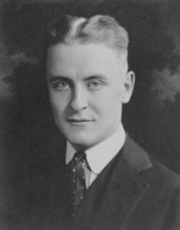
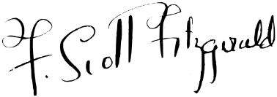
Francis Scott Key Fitzgerald (1896 –1940) was an American author of novels and short stories, whose works are the paradigmatic writings of the Jazz Age, a term he coined. He is widely regarded as one of the greatest American writers of the 20th century. Fitzgerald is considered a member of the "Lost Generation" of the 1920s. He finished four novels: This Side of Paradise, The Beautiful and Damned, The Great Gatsby (his most famous), and Tender Is the Night. Fitzgerald also wrote many short stories that treat themes of youth and promise along with age and despair.
Fitzgerald's work has been adapted into films many times. His short story, "The Curious Case of Benjamin Button", was the basis for a 2008 film. The Great Gatsby has resulted in a number of film adaptations; the 2013 adaption starring Leonardo DiCaprio as Jay Gatsby and Tobey Maguire as Nick Carraway being the latest.

The Heart of the World… Broadway by Nik Cohn
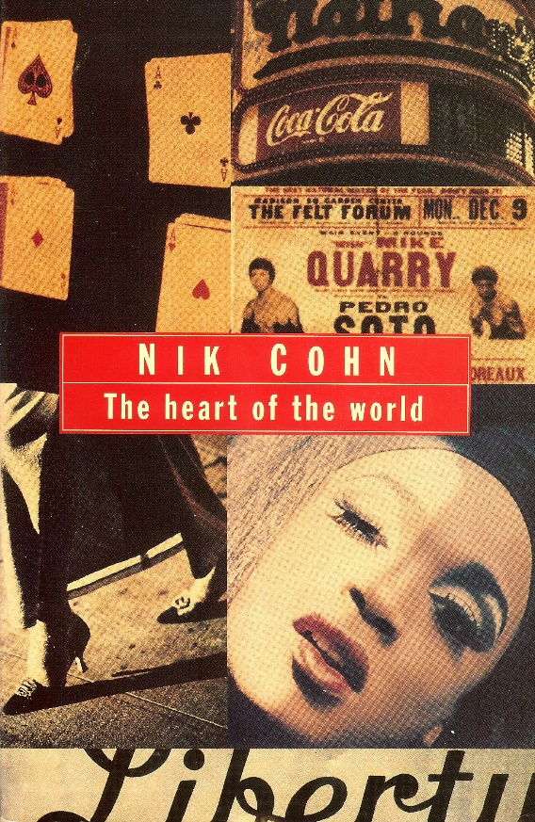 |  |  | 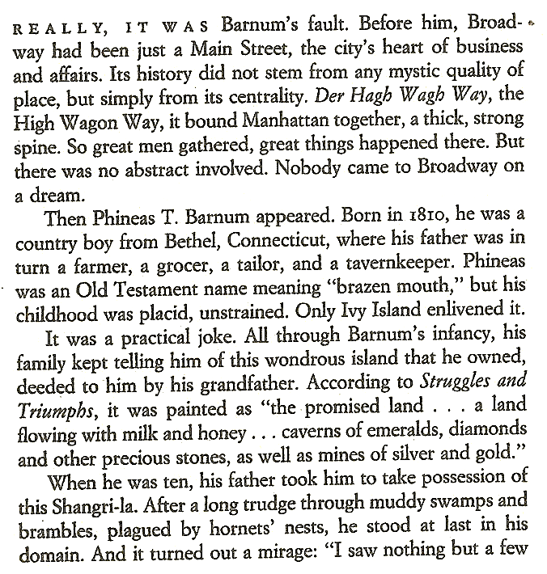
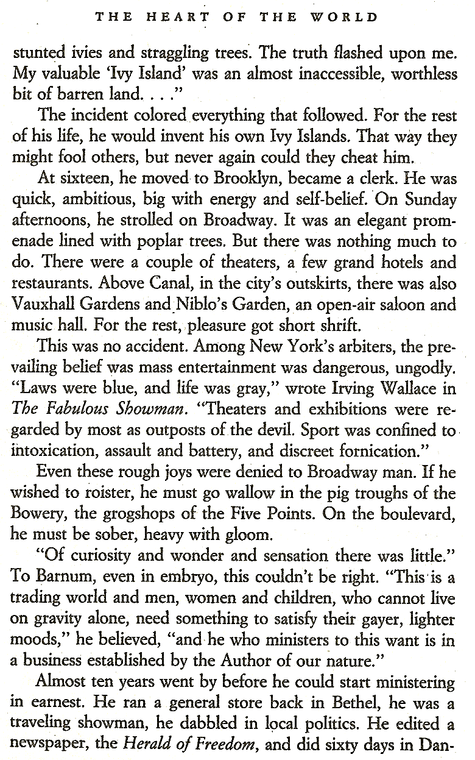 |  |  | 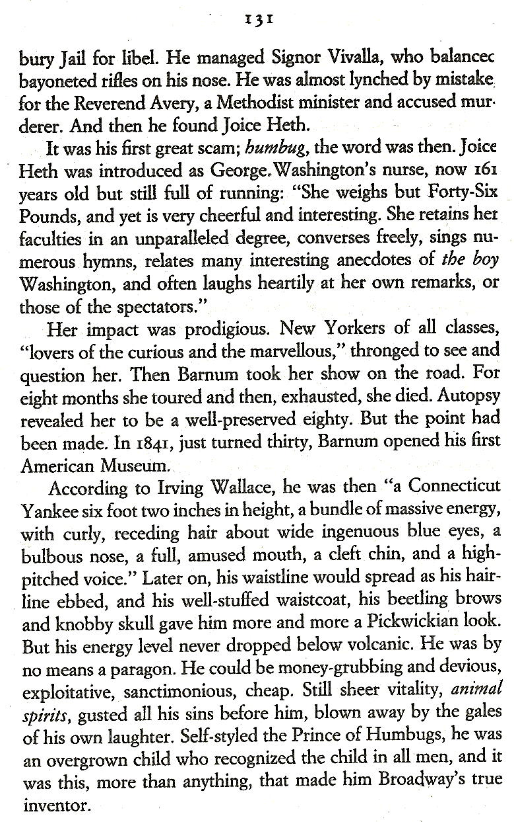
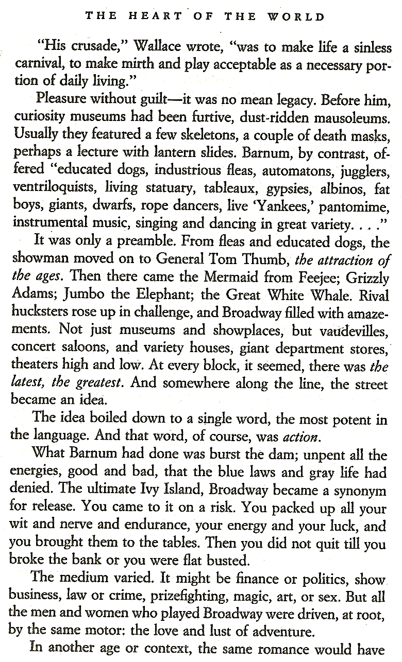 |  |  | 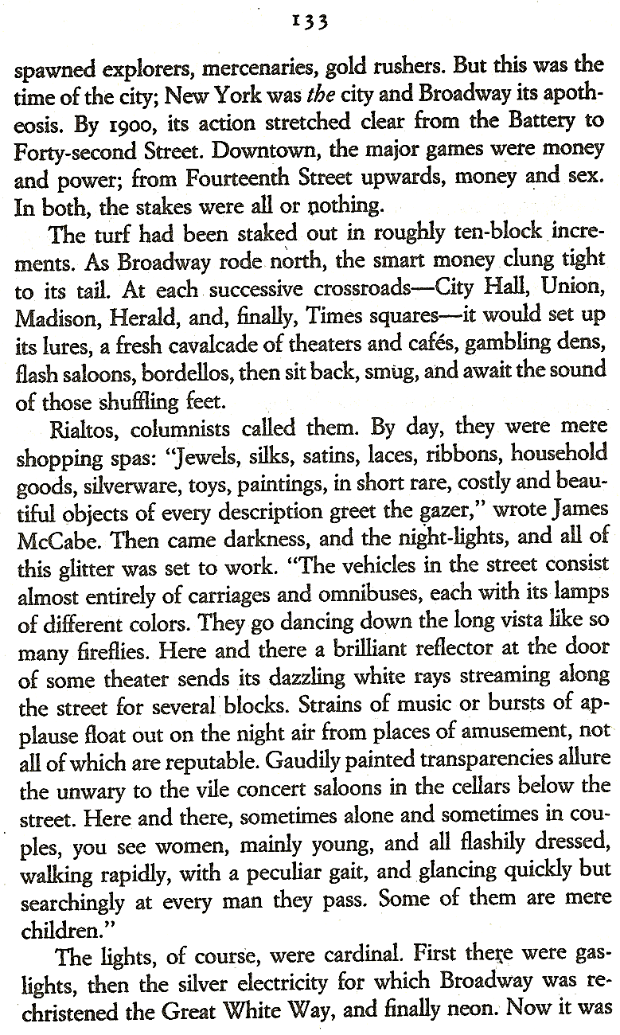
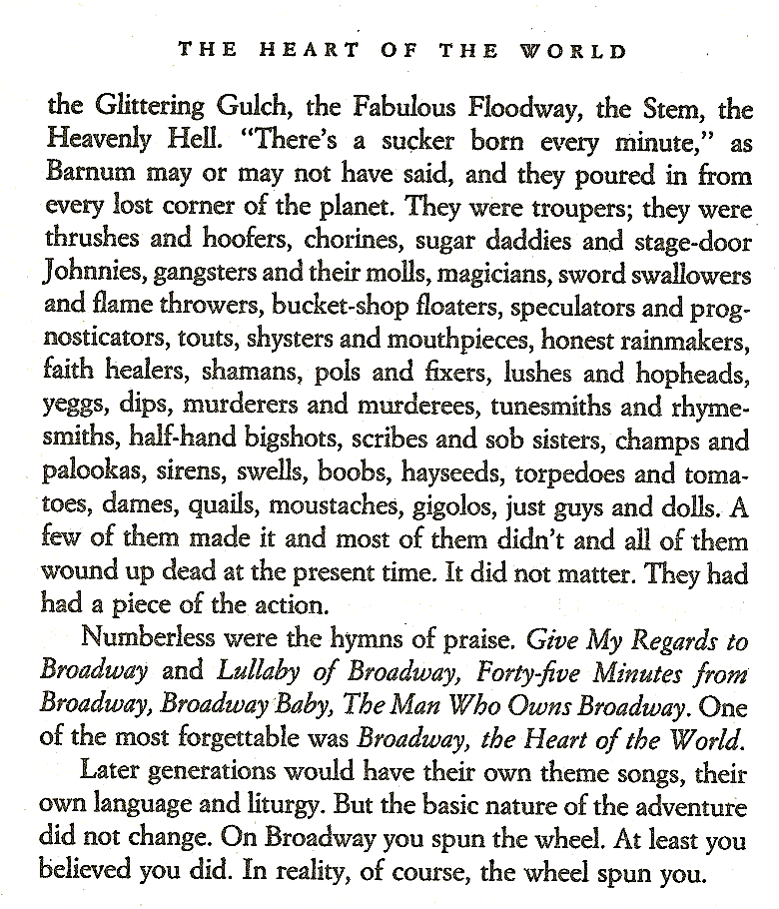
 | 5th Avenue  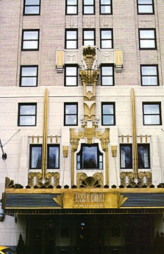  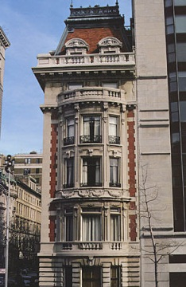  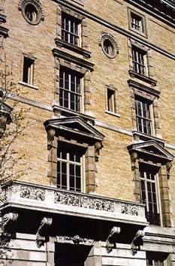  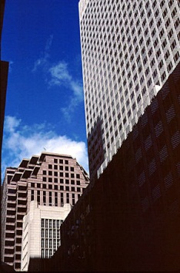 | The world of Glitz & Glamour  Stroll down 5th Avenue between the Plaza Hotel and 42nd Street to get a good impression of the glitz and glamour of this part of town. Here money and shopping has become the new religion.  - Take in the atmosphere: Look at the people closely and take some mental snapshots. Take the time to sit down on the way and take a few notes (keywords) that will remind you of this area.  - As you walk along 5th Ave. stop at some of the more interesting buildings to take a closer look at their architecture. You will notice four main styles of skyscrapers:  - Beaux-Arts  - Art Deco  - Italian Renaissance  - Modern Giants  What are the characteristic features of the four styles? Note a few details next to each type. Make a simple sketch of one example of each style and be ready to share them with the group later (at the Plaza Hotel)  Some of the highlights are:  - Nr. 749: Tiffany’s  - Nr. 745: (57th St) Art Deco, 1931  - Nr. 730: Crown Building, 1921,  - Peninsula Hotel (2W55th) Beaux-Arts, 1905  - St. Regis Hotel (2E55th), Beaux-Arts, 1904  - University Club (54th St): Florentine palazzo, 1899  - Nr. 666: international, 1957  - Nr. 651: Cartier, ital. Renaissance, 1905  - St. Patrick’s Cathedral (53rd St): neo-gothic, 1879  - Nr. 647: Versace, ital. Renaissance, 1905  - Nr. 597: Benetton, Beaux-Arts ,1913  - Nr. 551: Fred H. French Bldg., Art Deco, 1927  - Nr. 452: HSBC, Beaux-Arts, 1902
 | The  Chrysler Building  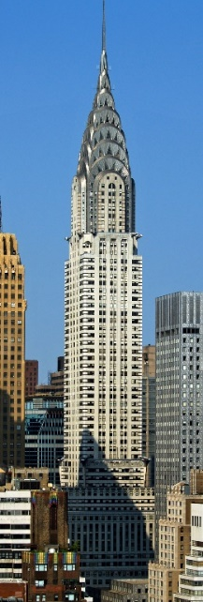 | - Art Deco style skyscraper  - considered by many contemporary architects to be one of the finest buildings in NYC  - located on the east side of Manhattan in the Turtle Bay area at the intersection of 42nd Street and Lexington Avenue  - Competition between the architects of the Chrysler Building and the Bank of Manhattan (Wall Street) building Secret plans: Chrysler Building had a hidden spike that was only raised at the last minute, which made it the taller one!  - At 1,046 feet (319 m), the structure was the world's tallest building for 11 months before it was surpassed by the Empire State Building in 1931  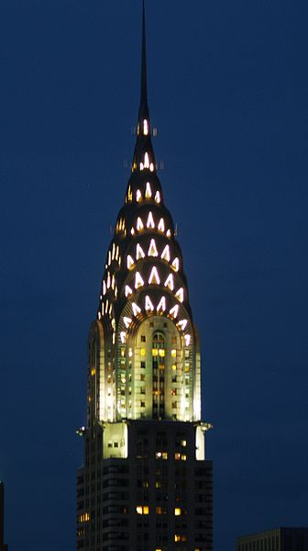  - Height:  - Antenna spire: 1,046 ft (319 m)  - Roof: 925 ft (282 m)  - Floor Count: 77  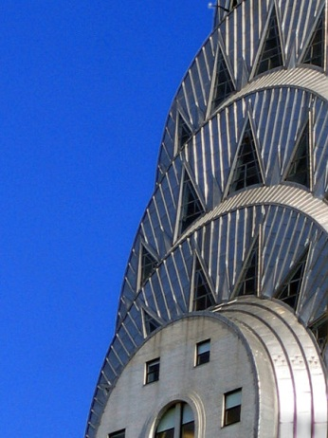  Detail of the Art Deco ornamentation at the crown. The Chrysler Building illuminated at night.
 | The  Algonquin Hotel | 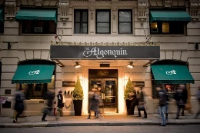  - historic hotel located at  59 West 44th Street  - opened in 1902  - known for hosting literary and theatrical notables, most prominently the members of the Algonquin Round Table, a celebrated group of New York City writers, critics, actors and wits:  - they met here in the Rose Room in the 20s and 30s and held hot discussions and verbal fights  - irony and sarcasm were their main weapons against the shallow bohemian life-style around them  - prominent New York intellectuals: F. Scott Fitzgerald and his wife Zelda, Dorothy Parker, Harpo Marx…  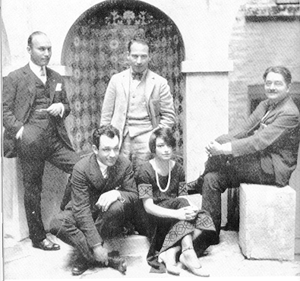  Members and associates of the Algonquin Round Table:  Art Samuels, Charles MacArthur, Harpo Marx,  Dorothy Parker and Alexander Woollcott  Dorothy Parker:  Read “From The Diary Of A New York Lady” on page 22 and the sample poems on page 21. What type of woman was Dorothy Parker? What does she say about society around her? |  | Text (7);  Text (6) on page 21ff.

Poems by Dorothy Parker (1893 – 1967)

Resume
Razors pain you;
Rivers are damp;
Acids stain you;
And drugs cause cramp.
Guns aren't lawful;
Nooses give;
Gas smells awful;
You might as well live.
SYMPTOM RECITAL
I do not like my state of mind;
I'm bitter, querulous, unkind.
I hate my legs, I hate my hands,
I do not yearn for lovelier lands.
I dread the dawn's recurrent light;
I hate to go to bed at night.
I snout at simple, earnest folk.
I cannot take the gentlest joke.
I find no peace in paint or type.
My world is but a lot of tripe.
I'm disillusioned, empty-breasted.
For what I think, I'd be arrested.
I am not sick, I am not well.
My quondam dreams are shot to hell.
My soul is crushed, my spirit sore;
I do not like me any more.
I cavil, quarrel, grumble, grouse.
I ponder on the narrow house.
I shudder at the thought of men .
I'm due to fall in love again.

Men
They hail you as their morning star
Because you are the way you are.
If you return the sentiment,
They'll try to make you different;
And once they have you, safe and sound,
They want to change you all around.
Your moods and ways they put a curse on;
They'd make of you another person.
They cannot let you go your gait;
They influence and educate,
They'd alter all that they admired.
They make me sick, they make me tired.

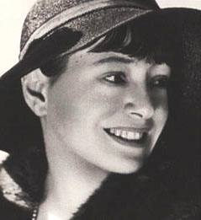

Unfortunate Coincidence
By the time you swear you're his,
Shivering and sighing,
And he vows his passion is
Infinite, undying
Lady, make a note of this:
One of you is lying.
General Review of the Sex Situation
Woman wants monogamy;
Man delights in novelty.
Love is woman's moon and sun; Man has other forms of fun. Woman lives but in her lord; Count to ten, and man is bored. With this the gist and sum of it, What earthly good can come of it?
Social Note
Lady, lady, should you meet
One whose ways are all discreet,
One who murmurs that his wife
Is the lodestar of his life,
One who keeps assuring you
That he never was untrue,
Never loved another one…
Lady, lady, better run!

“From the Diary of a New York Lady” by Dorothy Parker
Dorothy Parker (1893 - 1967) was an American poet, short story writer, critic and satirist, best known for her wit, wisecracks, and eye for 20th-century urban foibles. She was a legendary figure in the New York literary scene.
From a conflicted and unhappy childhood, Parker rose to acclaim, both for her literary output in such venues as The New Yorker and as a founding member of the Algonquin Round Table. Following the breakup of the circle, Parker traveled to Hollywood to pursue screenwriting. Her successes there, including two Academy Award nominations, were curtailed as her involvement in left-wing politics led to a place on the Hollywood blacklist.
Dismissive of her own talents, she deplored her reputation as a "wisecracker". Nevertheless, her literary output and reputation for her sharp wit have endured.

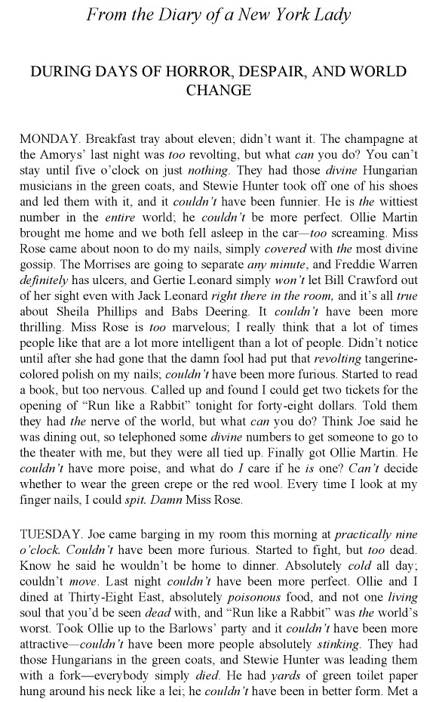

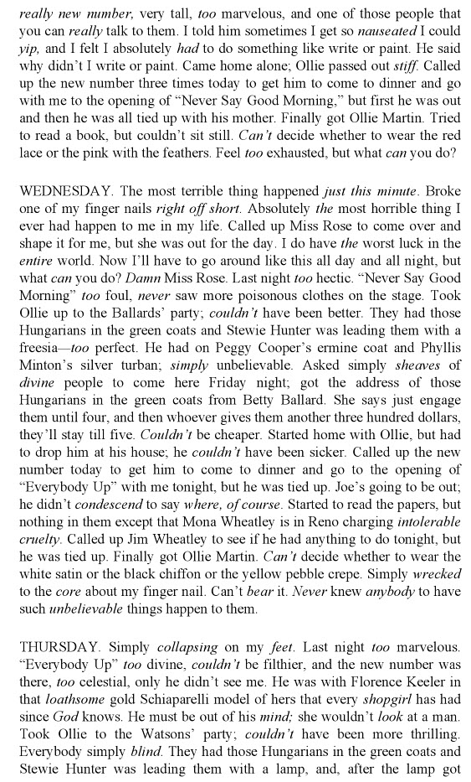

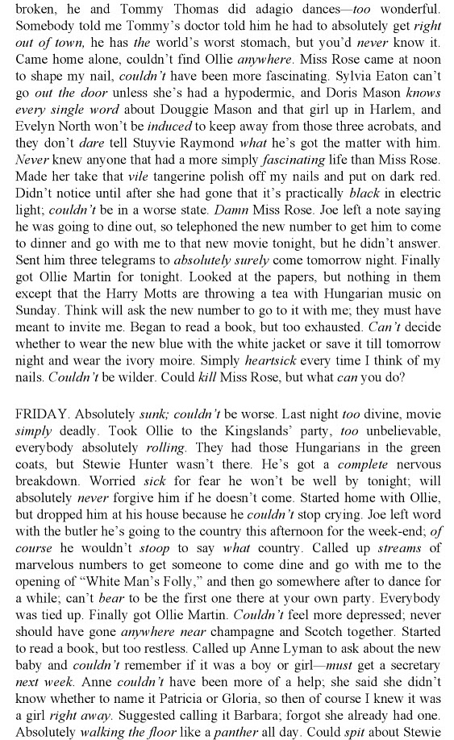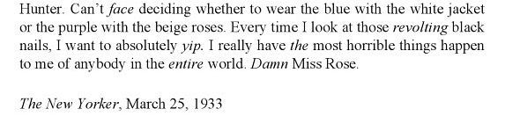

Grand Central Terminal | 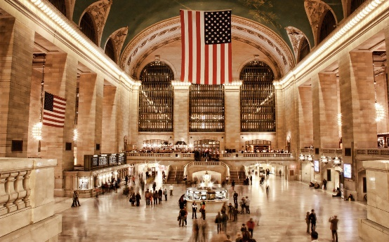  - at 42nd Street and Park Avenue in Midtown Manhattan  - busy commuter station  - Beaux-Arts style  - huge clock  - ceiling painting  Read the following poem by Donald A. Bullard, then discuss the extracts from Grand Central Winter (by Lee Stringer) on page 26. | Text (8); Text (9) on page 26

Untitled Poem by Donald A. Bullard
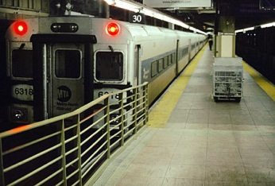
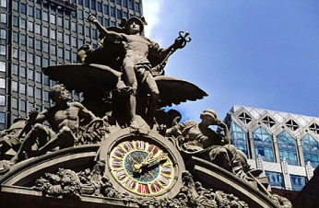
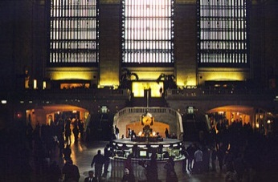
“Grand Central, let’em out please, watch the doors!”
In His own image did He make all men.
“One ham on rye, I’ll have a Coke, what’s yours?”
From Adam’s side our mother moves again.

“Canarsie Harlem, Yorktown and the Narrows”
Sing, messenger, above the IRT.
Who gets the breaks, the outrageous slings and arrows?
Is there a voice that calls for her and me?

“Out please, getting out please, getting out!”
All lines are running late – to Heaven and Hell.
Warm smells and lights and bodies gird about;
Redeem, illumine and transfigure all.

Oh! Ever young and ageless Mother Eve
Be with us till we take our final leave.

Grand Central Winter by Lee Stringer
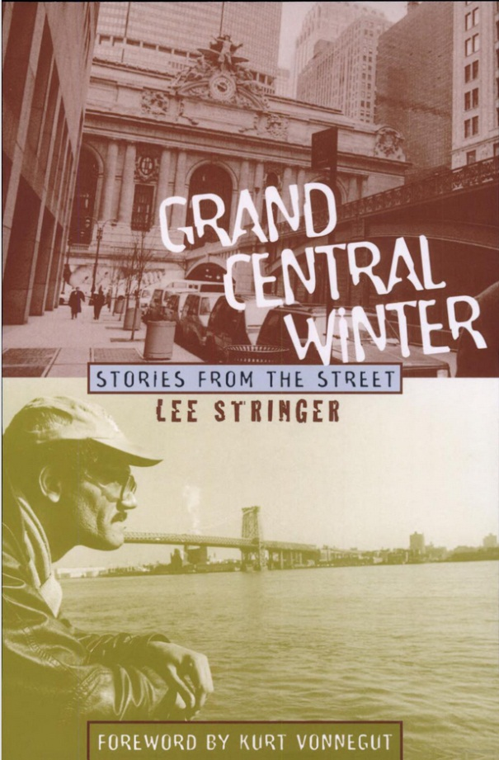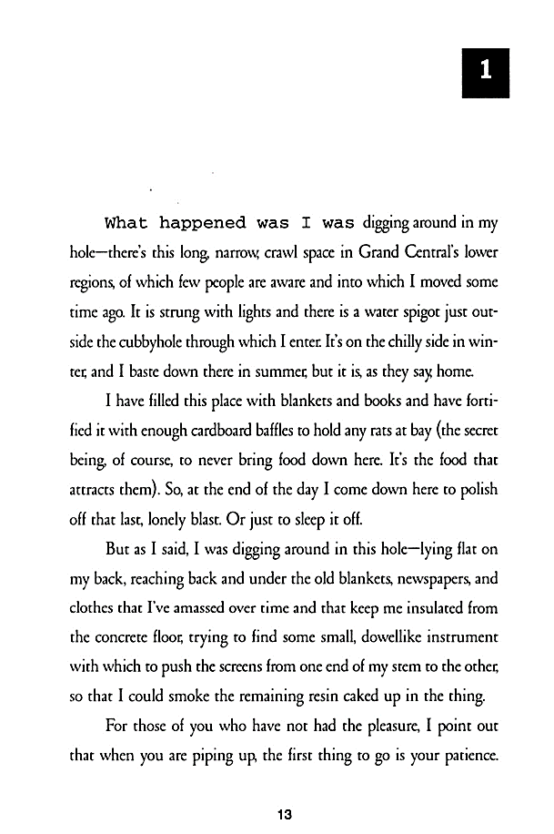
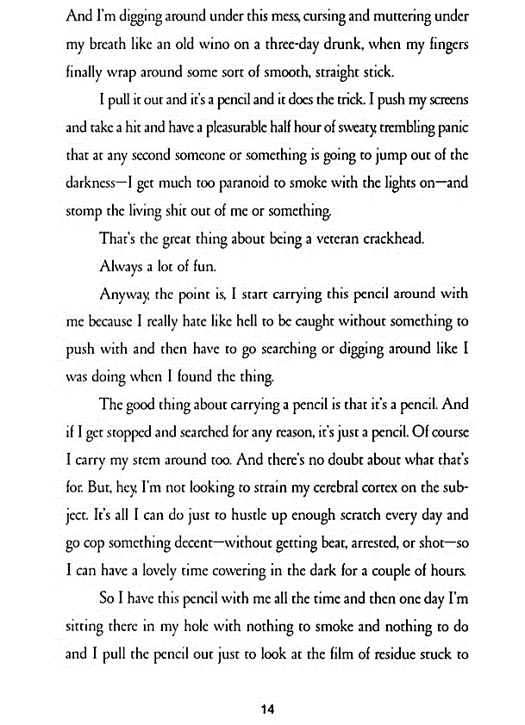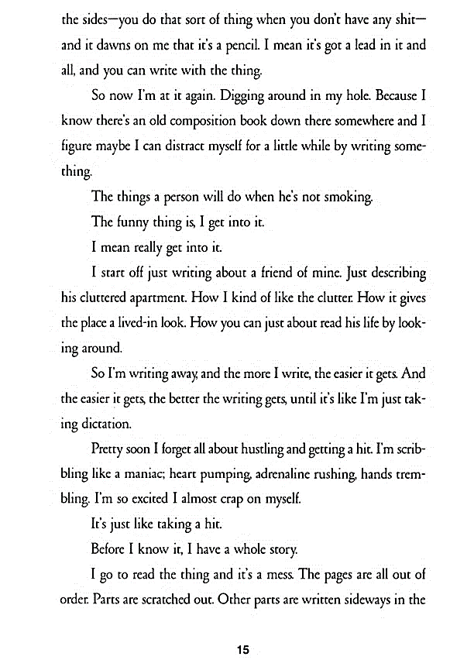
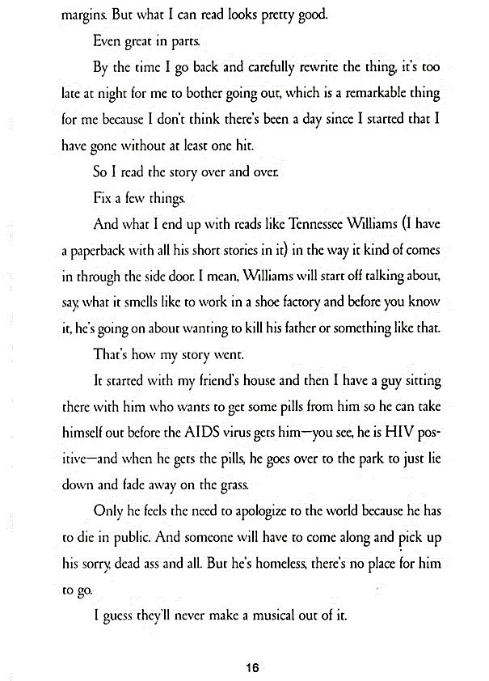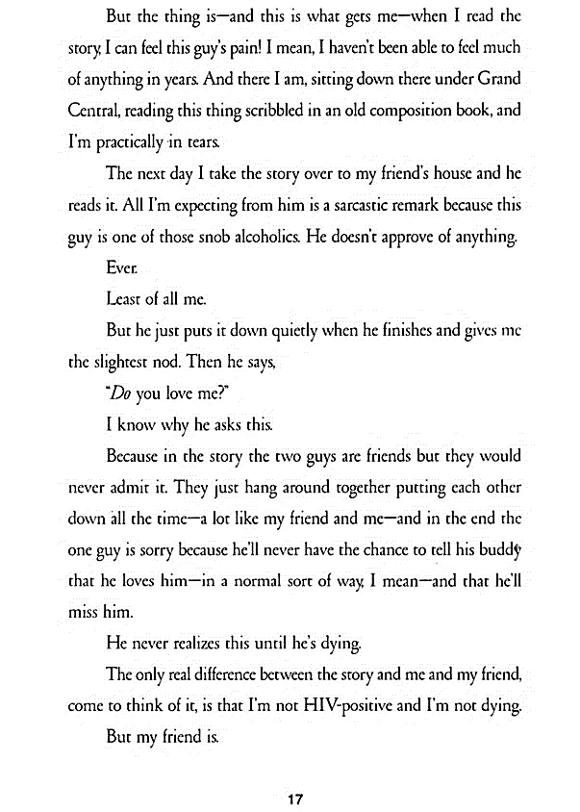
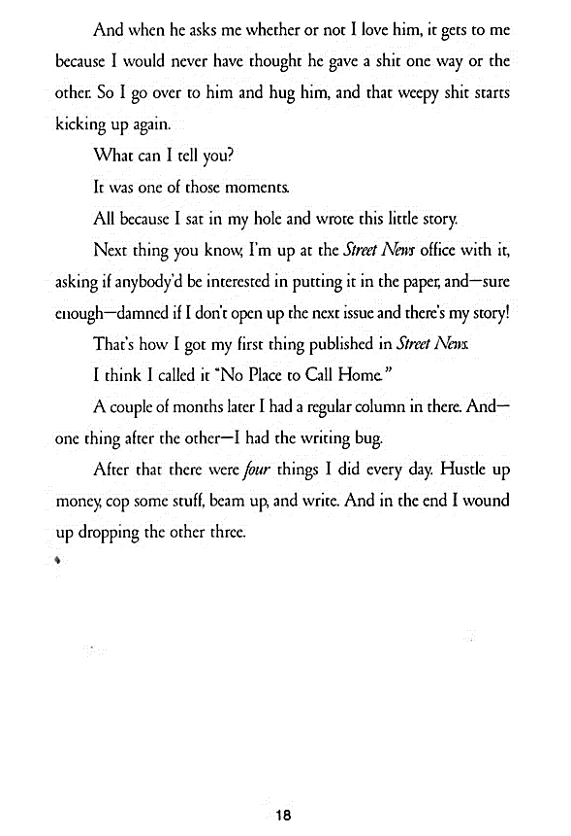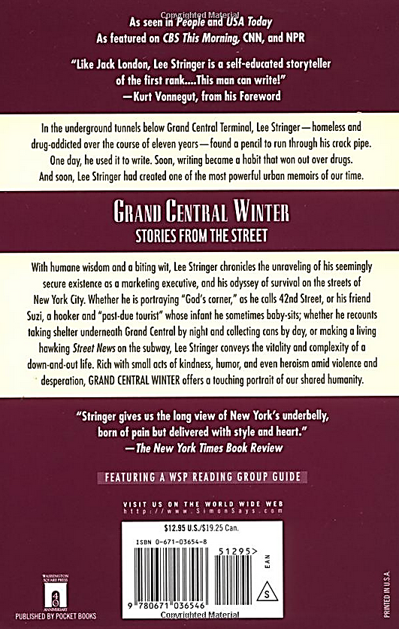
Macy’s   | 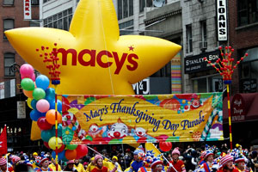  - Shopping window  - Macy's Thanksgiving Day Parade (annual parade - started in 1924)  - 151 West 34th Street  If we have time, stroll through this famous department store.  You might also want to look at Daffy’s, a big designer outlet nearby (1311 Broadway at 34th street)
The Museum of Modern Art   | 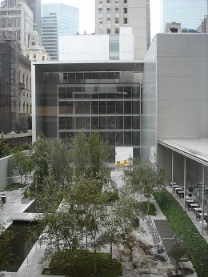  - 5th Ave, 33rd/34th street  - often identified as the most influential museum of modern art in the world  - museum's collection offers an overview of modern and contemporary art  After the MoMA we are going to get a good view of the city at night.
The Empire State Building | - 350 5th Avenue between 33rd and 34th St. (entrance on 5th Avenue)  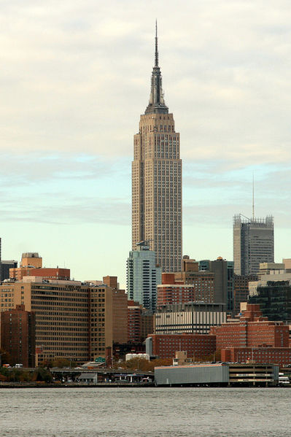  - 103-story skyscraper  - built in 1930 – Great Depression had started – the opening ceremony was meant to be a symbol of progress (lights would go on) – not only in the new tallest building (was tallest until 1973 when WTC was finished) but for the whole city and country – but this didn’t work out… many offices stayed empty, no tenants who could pay the rent were found nickname: Empty State Building  - Art Deco style  - currently the fourth-tallest completed skyscraper in the United States and the 23rd-tallest in the world  - impressive 360-degree views of the city from the 86th floor observation deck or 102nd terrace  - open until 2AM daily, with last elevators going up at 1:15 AM  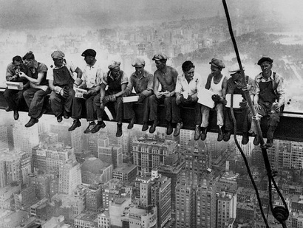  This well-known photograph was taken during the  construction of the Empire State Building in 1930.

The Bohemian Experience
Stops / Sights | Info | Text Sample
Flatiron Building  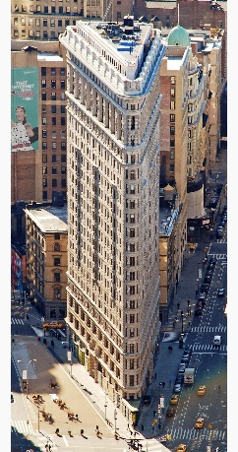 | - 175 Fifth Avenue  - built in 1902 – tallest building at the time  - steel construction  - fun shape – space was expensive taller and taller  - people thought it wouldn’t hold up against winter storms  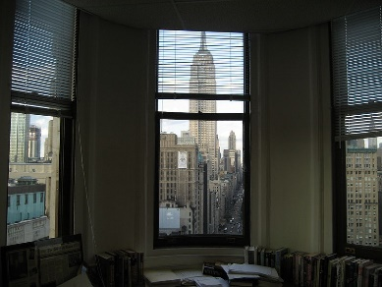  The Flatiron’s interior is known for having its strangely-shaped offices with walls that cut through at an angle on their way to the skyscraper’s famous point. These “point” offices are the most coveted and feature amazing northern views that look directly upon another famous Manhattan landmark, the Empire State Building.  View from the inside of a "point" office
Chelsea | 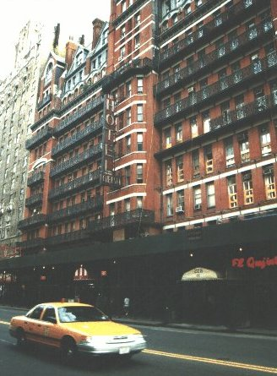  See the pretty, green Chelsea area - trendy with artists who left SoHo and Greenwich Village. Also see the infamous Chelsea Hotel at 222 West 23rd street, between Seventh and Eighth Avenue.  "The Chelsea Hotel has always been a sort of Tower of Babel of creativity and bad behavior. Some of the world's most gifted and most destructive minds have called 222 West 23rd Street home."  --The International Herald Tribune  "The Chelsea Hotel may be one of the few civilized places in New York, if we mean by civilized freedom of the spirit, tolerance of differences, creativity, and art. "  --Richard R. Lingeman, The New York Times Book Review  If you want to check out the trails of the Beat Generation in nowadays New York City, you can't avoid to visit Greenwich Village and Chelsea. The ones who are looking for Rock'n'Roll history, searching for the spirits of Bob Dylan, Janis Joplin, Leonard Cohen, Jim Morrison, Nico or Patti Smith are likely to find some of it within the red brick walls of the Chelsea Hotel.  The Chelsea was famous even back at a time when Mark Twain was living in one of its rooms. Thomas Wolfe and Arthur Miller have been living and writing there. Miller, who stayed six years at the Chelsea described the famous artist's hotel like this: This hotel does not belong to America. There are no vacuum cleaners, no rules and shame...it's the high spot of the surreal. Cautiously, I lifted my feet to move across bloodstained winos passing out on the sidewalks--and I was happy. I witnessed how a new time, the sixties, stumbled into the Chelsea with young, bloodshot eyes.  CHELSEA HOTEL:  - 222 West 23rd Street (between 7th and 8th Ave)  - historic NYC hotel and landmark built between 1883 and 1885  - Highest building in NYC until 1884 – today burried somewhere in the suburbia of Manhattan  - known primarily for the notability of its residents over the years has been the home of many  - writers: Mark Twain, O. Henry, Allen Ginsberg, Jack Kerouac, Arthur Miller, Simone de Beauvoir, Jean-Paul Sartre, Thomas Wolfe, Charles Bukowski…  - musicians: Bob Dylan, Janis Joplin, Jimmy Hendrix, Madonny, Falco…  - and numerous artists and actors  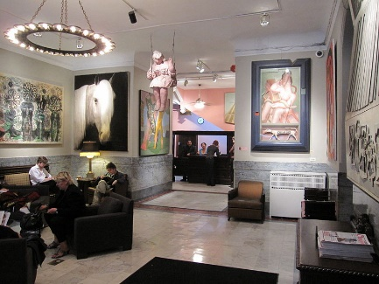  The glamor of ancient time has been nagged away by the destruction done by the years. Only the main entrance with its memorial plates is reminding us of the great past of the hotel. The lobby (picture on the left side) is resembling an art gallery consisting of objects that sometimes were kept by the hotel management in lieu of payment for a rent long overdue.  The reception desk looks like straight out of an old black & white Hollywood movie.  Both lifts seem to move in slow motion up and down the ten-story building.  Sometimes, the inside of the hotel looks like a barrack. But holes in the floors, squeaking water pipes or breathing heat pipes only add to the ambient of the hotel. Nonchalance is being cultivated in this place. Luxury is unwanted. Usefulness, atmosphere and non-conformism are dominating.  Read the info page below (“Every room at the Chelsea tells its own story”) about the infamous hotel and explore the lobby. | Text (21)

Every room at the Chelsea tells its own story.
In room #205, Welsh poet Dylan Thomas, who reputedly inspired young Zimmerman to change his name to Bob Dylan, fell into a fatal coma after having 18 whiskies in a row. #100 was once occupied by Sid Vicious, bass player with The Sex Pistols, and his girlfriend Nancy Spungeon. On the morning of October 11, 1978 Spungeon was found in the bathroom, stabbed to death. Viscious, arrested under suspicion of murder, died shortly thereafter of a heroin overdose.
Jimi Hendrix lived, loved and experimented here, with drugs and other things. Janis Joplin did not only have a love affair with Southern Comfort but also had a short liaison with Leonard Cohen. The Canadian rock poet, too, loved the hotel: It's one of those hotels that have everything that I love so well about hotels. I love hotels to which, at four a.m., you can bring along a midget, a bear and four ladies, drag them to your room and no one cares about it at all.
His song “Chelsea Hotel” is not only a remembrance of past loves with the likes of Janis Joplin or Nico, it's also a declaration of love towards the hotel: I remember you well in the Chelsea Hotel/ You were taking so brave and so free/ Giving me head on the unmade bed/ While the limousines wait in the street/ Those were the reasons and that was New York/ I was running for the money and the flesh/ That was called love for the workers in song/ Probably still is for those of us left.
The list of big names of literature, music or the arts scene who stayed at the Chelsea is seemingly bottomless: Jane Fonda, Jackson Pollock, Brendan Behan, Sarah Bernhardt to name but a few. They all encountered tragedies and comedies. They wrote short stories, movie scripts and novels and painted their pictures. They completed their movies within their heads, long before the actual shooting took place. Some of them had fatal endings...
For many, the Chelsea was a hideout or regular address for many years, remembers Stanley Bard, who's been the hotel manager for almost 40 years now. Some of them lived here over decades. It was only recently that punk-icon Patti Smith moved out.
Stanley Bard appears to be friendly but keeps distance, on the other hand he's happy about reminiscing every once in a while and he points out the bookcase in his office. I'm collecting every book that has been written in my hotel, he says taking out Thomas Wolfe's novel You Can't Go Home. Many things have happened here, he continues. Jim Morrison, Hendrix and Janis Joplin were having their drug parties here. Today, there's a 'No Smoking' sign in the hotel lobby.
For many years, Bob Dylan used to live in suite #2011, #411 was Janis Joplin's suite. Over the years, Leonard Cohen has lived in many rooms. I like to think of him, back then. He was one of the very few calm ones in these tumultuous times. But perhaps his restlessness was better hidden than that of the others. Most of his time in New York in the sixties he was living at #424. Long after this, Jon Bon Jovi wrote the song and shot his video for “Midnight At Chelsea” in suite #515.
But Bard refuses to talk about the mysterious Viscious/Spungeon murder case. That's a different story, he says but he's proud of Andy Warhol's love for the hotel. In the 60s, Warhol and Nico have done a movie, Chelsea Girl, at the hotel. All in all it has been a turbulent time back then, Stanley Bard resumes and wistfully finishes, I don't want to have missed any moment in the life of the Chelsea Hotel.
There's hardly been an artist who has lived in the Chelsea that was not in some way captured by its flair, says Patti Smith. Of course, Leonard Cohen is amongst them and with his song Chelsea Hotel No.2 he not only remembers his former lover Janis Joplin but also puts up a monument to his former hunting trails.

Chelsea Hotel No.2 (song) by Leonhard Cohen

I remember you well in the Chelsea Hotel,
you were talking so brave and so sweet,
giving me head on the unmade bed,
while the limousines wait in the street.
Those were the reasons and that was New York,
we were running for the money and the flesh.
And that was called love for the workers in song
probably still is for those of them left.
Ah but you got away, didn't you babe,
you just turned your back on the crowd,
you got away, I never once heard you say,
I need you, I don't need you,
I need you, I don't need you
and all of that jiving around.
I remember you well in the Chelsea Hotel
you were famous, your heart was a legend.
You told me again you preferred handsome men
but for me you would make an exception.
And clenching your fist for the ones like us
who are oppressed by the figures of beauty,
you fixed yourself, you said, "Well never mind,
we are ugly but we have the music."
Ah but you got away, didn't you babe,
you just turned your back on the crowd,
you got away, I never once heard you say,
I need you, I don't need you,
I need you, I don't need you
and all of that jiving around.
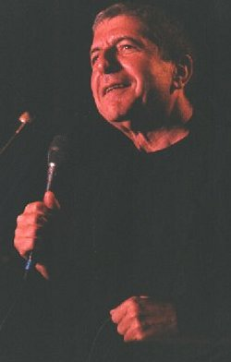
I don't mean to suggest that I loved you the best,
I can't keep track of each fallen robin.
I remember you well in the Chelsea Hotel,
that's all, I don't even think of you that often.
© by Leonard Cohen

The High Line | 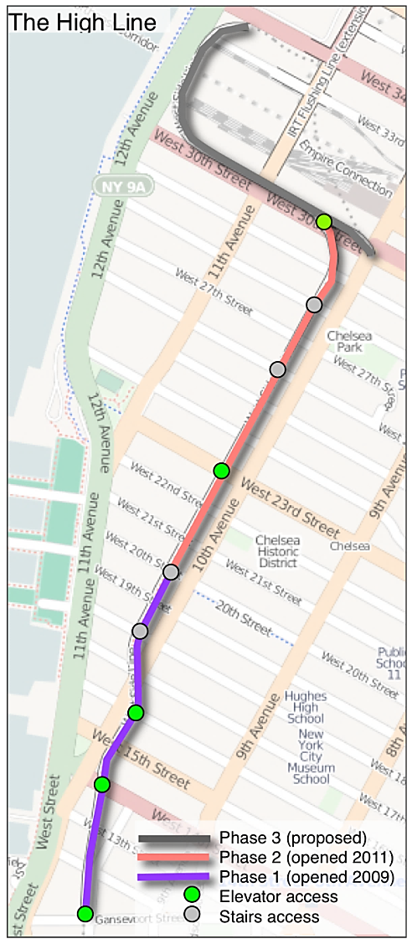  - public park built on an historic freight rail line elevated above the streets on Manhattan’s West Side  - 1.45-miles long, with one mile currently open to visitors  - last train chugged along the High Line in 1980  - park’s first section opened in 2009, followed by the second section in 2011  - there are more than 300 species of perennials, grasses, shrubs, and trees on the High Line  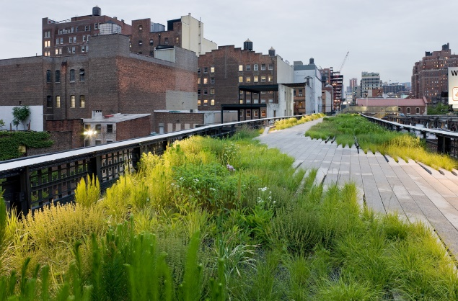
Boat Trip: The Circle Line | A Circle Line cruise is a relaxing and fun way to see the world's most famous skyline: experience the grandeur of midtown and lower Manhattan, witness magnificent views of the world’s premier skyline and a “close encounter” of the best kind with the Statue of Liberty.  By the way, the Circle Line passes every sight two times, making this cruise ideal for getting just the “right” photo of your favorite landmarks, including:  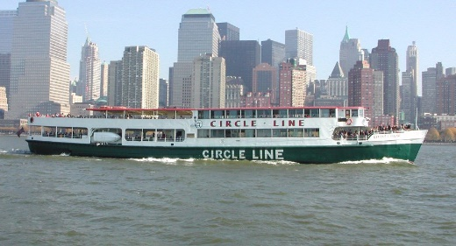  - Statue of Liberty  - Ellis Island  - Wall Street  - Brooklyn Bridge  - Chrysler Building  - Empire State Building  - United Nations  - …
Ground Zero Memorial | - The memorial is located at the World Trade Center site, on the former location of the Twin Towers, which were destroyed during the terrorist attacks on September 11, 2001.  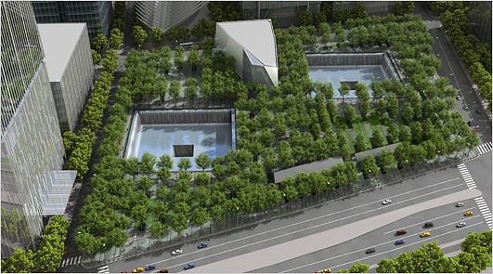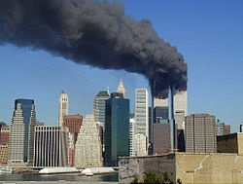

Sunday in Harlem
Stops / Sights | Info | Text Sample
Columbia University | Let’s explore the area around Columbia University, north of our hotel.  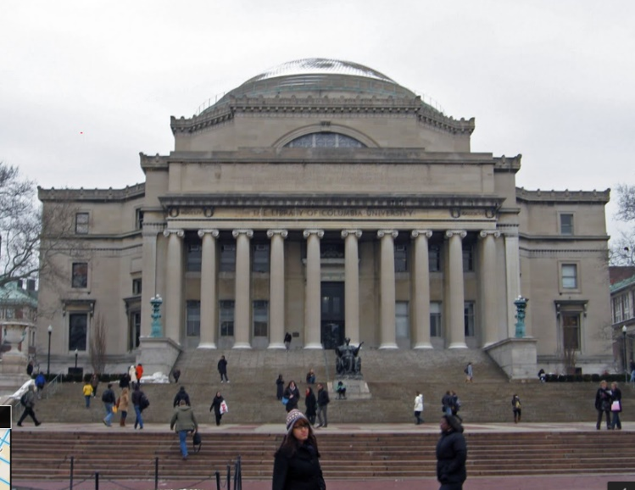  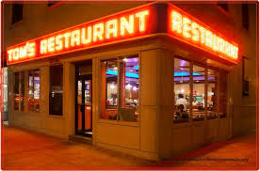  Tom's Restaurant is a diner located at 2880 Broadway (on the corner of 112th Street) in the Morningside Heights neighborhood of Manhattan in New York City. Frequented by students and faculty of nearby Columbia University, it has been owned and operated by the Greek-American family of Minas Zoulis since the 1940s.  Tom's Restaurant was the locale that inspired Suzanne Vega's 1987 song "Tom's Diner." Later, its exterior was used as a stand-in for the fictional Monk's Café in the television sitcom Seinfeld, where comedian Jerry Seinfeld's eponymous character and his friends regularly gathered to eat. The interior, however, looked very little like the real "Tom's", as indoor scenes were filmed on a set in California. _{(Wikipedia)}

“Tom’s Diner” (song) by Suzanne Vega
I am sitting  In the morning  At the diner  On the corner  I am waiting  At the counter  For the man  To pour the coffee  And he fills it  Only halfway  And before  I even argue  He is looking  Out the window  At somebody  Coming in  It is always  Nice to see you  Says the man  Behind the counter  To the woman  Who has come in  She is shaking  Her umbrella  And I look  The other way  As they are kissing  Their hellos  And I'm pretending  Not to see them  And Instead  I pour the milk  I open  Up the paper  There's a story  Of an actor  Who had died  While he was drinking  He was no one  I had heard of | And I'm turning  To the horoscope  And looking  For the funnies  When I'm feeling  Someone watching me  And so  I raise my head  There's a woman  On the outside  Looking inside  Does she see me?  No she does not  Really see me  'Cause she sees  Her own reflection  And I'm trying  Not to notice  That she's hitching  Up her skirt  And while she's  Straightening her stockings  Her hair  Is getting wet  Oh, this rain  It will continue  Through the morning  As I'm listening  To the bells  Of the cathedral  I am thinking  Of your voice  And of the midnight picnic  Once upon a time  Before the rain began  And I finish up my coffee  And it's time to catch the train  Songwriters  VEGA, SUZANNE Published by  Lyrics © Warner/ Chappell Music, Inc.

Harlem – The Black Experience
Striver’s Row: 138th and 139th street between 7th and 8th Ave - beautiful residential area, popular with the rich and famous during the 20s and 30s Harlem Renaissance - fun, music, glamour, taxis, parties…
Tip: striver = striving upwards (Streberstraße)

Convent Avenue Baptist Church (Gospel Service!!)

Cotton Club: operated from 1923 to 1940, most notably during America's Prohibition Era - was a whites-only establishment even though it featured many of the best black entertainers and jazz musicians of the era (e.g. Duke Ellington, Count Basie, Bessie Smith, Ella Fitzgerald, Louis Armstrong…)

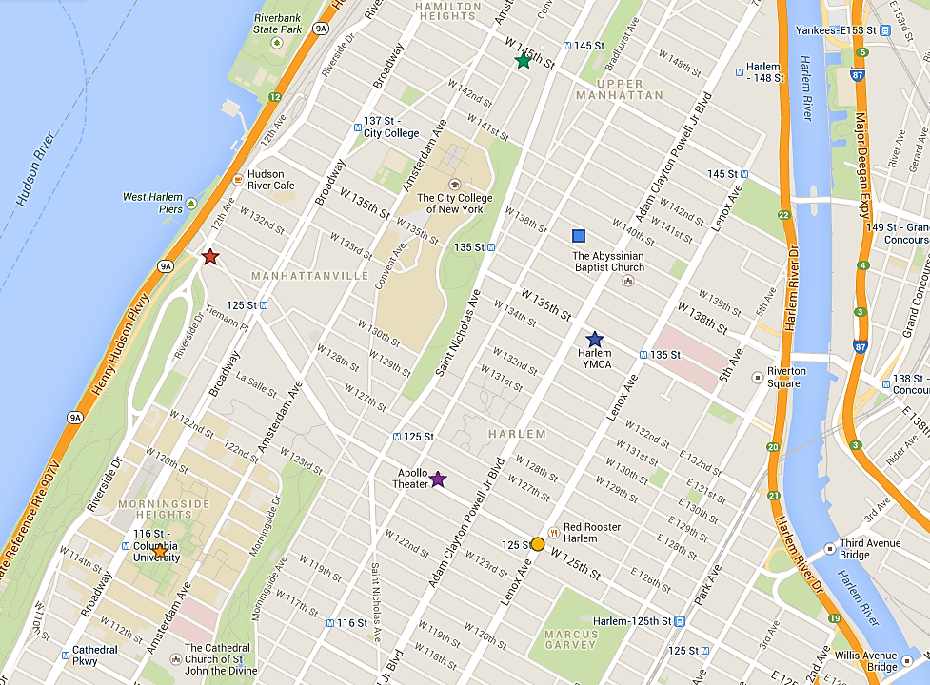
YMCA (180 West 135th Street) = significant landmark of Black Culture in NYC
Langston Hughes lived here – Bill Clinton is a current member
Apollo Theater
(253 West 125th Street)

125th Street (co-named “Martin Luther King Blvd) and Lenox Avenue: Street University in the 60s
Columbia University

Stops / Sights | Info | Text Sample
Harlem | Join us on a Sunday morning walk in the Black capital of the world and learn about Harlem and  - its start as a rural Dutch community in 1658  - its transformation into a green summer retreat for New York’s most prominent families,  - how real estate agents failed to sell new apartments to the rich and  - how the newly arrived Blacks from the southern states moved in at the turn of the century  - how it then became a Mecca for African American writers and artists during the 20s and 30s… During this period, called the Harlem Renaissance, Jazz, Ballet, Theater, Literature… flourished. Famous artists of the time were  - the musicians Louis Armstrong, Count Basie, Duke Ellington, Billie Holiday, Ella Fitzgerald, Sarah Vaughan  - the poets and writers Langston Hughes, W.E.B. DuBois, Countee Cullen, Zora Neale Hurston  - to its troubled past during the 1960’s and 70’s when poverty, drugs and crime made Harlem a taboo zone for whites.  - Malcolm X grew up here and lectured to the Blacks in 125th street (street university). After a white policeman shot a Black youth in 1964 there were riots all over Harlem.  - and its upward trend during the 90s, often lead by the church.  - The Abyssinian Development Corporation has bought hundreds of town houses and renovated them. They want to prevent the negative effects of gentrification. Harlem must not become the new yuppie-land where Blacks cannot afford the skyrocketing rents. They are helping to start a second Harlem Renaissance by fostering Black cultural activities and local business rather than selling the place to Disney, Starbuck’s and huge, white-owned malls.  - that Harlem's black population peaked in the 1950s – in 2008, the Census found that for the first time Harlem's population was no longer a majority black, with their share being 4 in 10 residents.  Read the article “No Longer Majority Black, Harlem Is in Transition” by Sam Roberts on page Error! Bookmark not defined..  Along the way you will see famous sights and landmarks such as the Columbia University, Morning Side Heights, Strivers Row and the Convent Avenue Baptist Church, and the famed 125th street (street university and Franco the Great’s store), the Cotton Club, and the Apollo Theater…  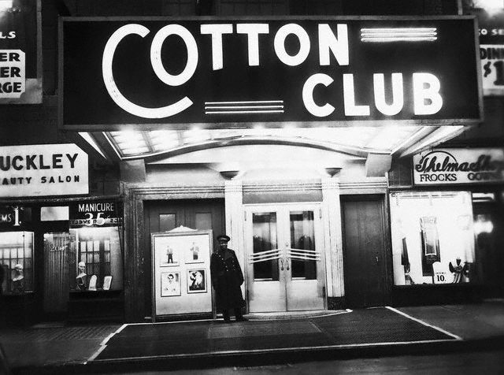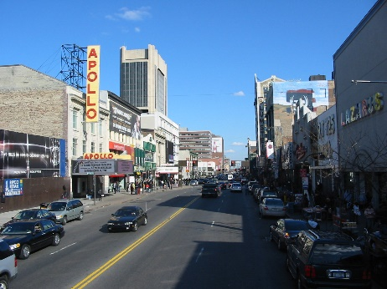  The Cotton Club The Apollo Theater on 125th Street | Text (19) on p. Error! Bookmark not defined.
9 a.m.  Gospel Service at the  Convent Avenue Baptist Church | 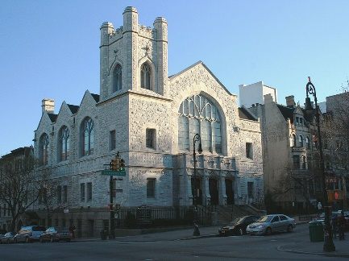  - Convent Avenue Baptist Church: 145th Street and Convent Ave.  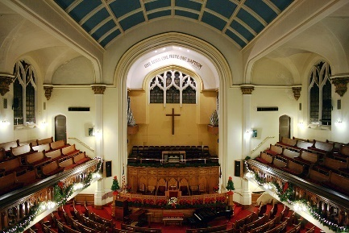  DRESS YOUR BEST! The regular churchgoers will be wearing their best Sunday suits – let’s show our respect!!! You will be expected to give a small donation (American Churches depend on these donations, there is no Kirchensteuer like in Austria).  A whole branch of Gospel tourism has developed recently. Churches have gone so far as to shorten the sermon and other parts of the service to a minimum in order to leave a lot of time for the Gospel choir. This is seen as a dangerous development by the regular congregation.

“Harlem” aka “A Dream Deferred” (poem) by Langston Hughes

Harlem
BY LANGSTON HUGHES

What happens to a dream deferred?

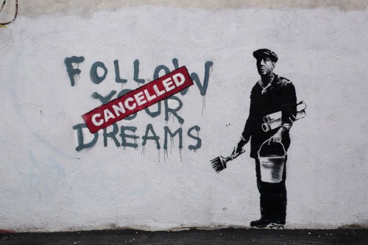
Does it dry up
like a raisin in the sun?
Or fester like a sore—
And then run?
Does it stink like rotten meat?
Or crust and sugar over—
like a syrupy sweet?

Maybe it just sags
like a heavy load.

Or does it explode?

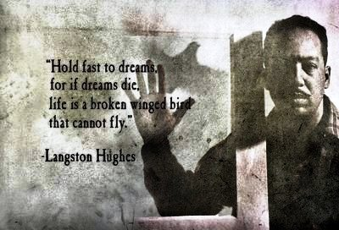

This copy is for your personal, noncommercial use only. You can order presentation-ready copies for distribution to your colleagues, clients or customers, please click here or use the "Reprints" tool that appears next to any article.
Visit www.nytreprints.com for samples and additional information. Order a reprint of this article now. »

January 6, 2010

No Longer Majority Black, Harlem Is in Transition
by SAM ROBERTS

For nearly a century, Harlem has been synonymous with black urban America. Given its magnetic and growing appeal to younger black professionals and its historic residential enclaves and cultural institutions, the neighborhood’s reputation as the capital of black America seems unlikely to change soon.
But the neighborhood is in the midst of a profound and accelerating shift. In greater Harlem, which runs river to river, and from East 96th Street and West 106th Street to West 155th Street, blacks are no longer a majority of the population — a shift that actually occurred a decade ago, but was largely overlooked.
By 2008, their share had declined to 4 in 10 residents. Since 2000, central Harlem’s population has grown more than in any other decade since the 1940s, to 126,000 from 109,000, but its black population — about 77,000 in central Harlem and about twice that in greater Harlem — is smaller than at any time since the 1920s.
In 2008, 22 percent of the white households in Harlem had moved to their present homes within the previous year. By comparison, only 7 percent of the black households had.
“It was a combination of location and affordability,” said Laura Murray, a 31-year-old graduate student in medical anthropology at Columbia, who moved to Sugar Hill near City College about a year ago. “I feel a community here that I don’t feel in other parts of the city.”
Change has been even more pronounced in the narrow north-south corridor defined as central Harlem, which planners roughly define as north of 110th Street between Fifth and St. Nicholas Avenues.
There, blacks account for 6 in 10 residents, but those born in the United States make up barely half of all residents. Since 2000, the proportion of whites living there has more than doubled, to more than one in 10 residents — the highest since the 1940s. The Hispanic population, which was concentrated in East Harlem, is now at an all-time high in central Harlem, up 27 percent since 2000.
Harlem, said Michael Henry Adams, a historian of the neighborhood and a resident, “is poised again at a point of pivotal transition.”
Harlem is hardly the only ethnic neighborhood to have metamorphosed because of inroads by housing pioneers seeking bargains and more space — Little Italy, for instance, has been largely gobbled up by immigrants expanding the boundaries of Chinatown and by creeping gentrification from SoHo. But Harlem has evolved uniquely.
Because so much of the community was devastated by demolition for urban renewal, arson and abandonment beginning in the 1960s, many newcomers have not so much dislodged existing residents as succeeded them. In the 1970s alone, the black population of central Harlem declined by more than 30 percent.
“This place was vacated,” said Howard Dodson, director of Harlem’s Schomburg Center for Research in Black Culture. “Gentrification is about displacement.”
Meanwhile, the influx of non-Hispanic whites has escalated. The 1990 census counted only 672 whites in central Harlem. By 2000, there were 2,200. The latest count, in 2008, recorded nearly 13,800.
“There’s a lot of new housing to allow people to come into the area without displacing people there,” said Joshua S. Bauchner, who moved to a Harlem town house in 2007 and is the only white member of Community Board 10 in central Harlem. “In Manhattan, there are only so many directions you can go. North to Harlem is one of the last options.”
In 1910, blacks constituted about 10 percent of central Harlem’s population. By 1930, the beginnings of the great migration from the South and the influx from downtown Manhattan neighborhoods where blacks were feeling less welcome transformed them into a 70 percent majority. Their share of the population (98 percent) and total numbers (233,000) peaked in 1950.
In 2008, according to the census, the 77,000 blacks in central Harlem amounted to 62 percent of the population.
The number of blacks living in greater Harlem hit a high of 341,000 in 1950, but their share of the population didn’t peak until 1970, when they made up 64 percent of the residents. In 2008, there were 153,000 blacks in greater Harlem, and they made up 41 percent of the population.
About 15 percent of Harlem’s black population is foreign-born, mostly from the Caribbean, with a growing number from Africa.
Some experts say the decline in the black population may be overstated because poorer people are typically undercounted by the census, and Harlem has a disproportionate number of poor people. Others warn that proposed development and higher property values may force poor people out, and they say that when the city was the neighborhood’s leading landlord it should have increased ownership opportunities for Harlem residents .
“Gentrification — the buying up and rehabilitation of land and buildings, whether by families or developers, occupied or abandoned — means a rising rent tide for all, leading inevitably to displacement next door, down the block, or two streets away,” said Neil Smith, director of the Center for Place, Culture and Politics at the City University of New York Graduate Center.
Mr. Dodson of the Schomburg Center moved from Riverside Drive to Newark not long ago. He said, “I tell people that I can’t afford to live in Harlem or in New York in the manner I deserve to.”
Other analysts point to the outflow of some blacks and the influx of others as positive evidence that barriers to integration have fallen in other neighborhoods and that Harlem has become a more attractive place to live.
“It’s a mistake to see this only as a story of racial change,” said Scott M. Stringer, the Manhattan borough president. “ What’s interesting is that many African-Americans are living in Harlem by choice, not necessity.”
Andrew A. Beveridge, a sociologist at Queens College, said, “Harlem has become as it was in the early 1930s — a predominantly black neighborhood, but with other groups living there as well.”
Ronald Copney, a former limousine driver, and his two sisters share a brownstone on West 147th Street that his grandmother bought in 1929. He rents two floors to tenants, one of whom is white.
“This was always a very nice neighborhood,” he said. “In a way, it’s better now as far as property values are concerned.”
Geneva Bain, the district manager of Community Board 10, blamed the economy and the lack of jobs for the dwindling number of blacks.
She acknowledged, though, that white newcomers have sometimes been greeted ambivalently. “Integration is very subjective,” Ms. Bain said. “One person’s fellowship is another person’s antagonism. I am one who thinks that central Harlem has become a better place because of integration.”
Mr. Dodson, the Schomburg Center director, said one source of historic resentment remained: that blacks still accounted for a tiny minority of the area’s property owners.
“There are people who would like to maintain Harlem as a ‘black enclave,’ but the only way to do that is to own it,” Mr. Dodson said. “That having been said, you can’t have it both ways: You can’t on the one hand say you oppose being discriminated against by others who prevent you from living where you want to, and say out of the other side of your mouth that nobody but black people can live in Harlem.”
“The question of whether it’s a good thing or not,” he added. “I honestly can’t make that judgment yet.”
Central Park | We’ll then walk down to Central Park. If the weather is nice we’ll buy food for a picnic in the park. Then we’ll explore Central Park Life on a Sunday.  LUNCH PICNIC:  We will go to a supermarket or deli and buy ingredients for a simple picnic. Plan with a few friends what you are going to eat. Only buy as much as you can eat. Otherwise you have to carry the leftovers for the rest of the day. Don’t forget something to drink.  We’ll find a nice spot on the south side of the park and have our picnic. Please clean up the site around you after you are finished. We want to leave the place as nice as we have found it!  WALK THROUGH CENTRAL PARK SOUTH:  We’ll walk through the southern part of the park and see some of the highlights (see map below). We’ll make several stops to rest, watch and listen to a few relevant extracts from literature.  Read the extract from James Baldwin’s Go Tell It on the Mountain on page Error! Bookmark not defined.. | Text (20) on p. Error! Bookmark not defined.

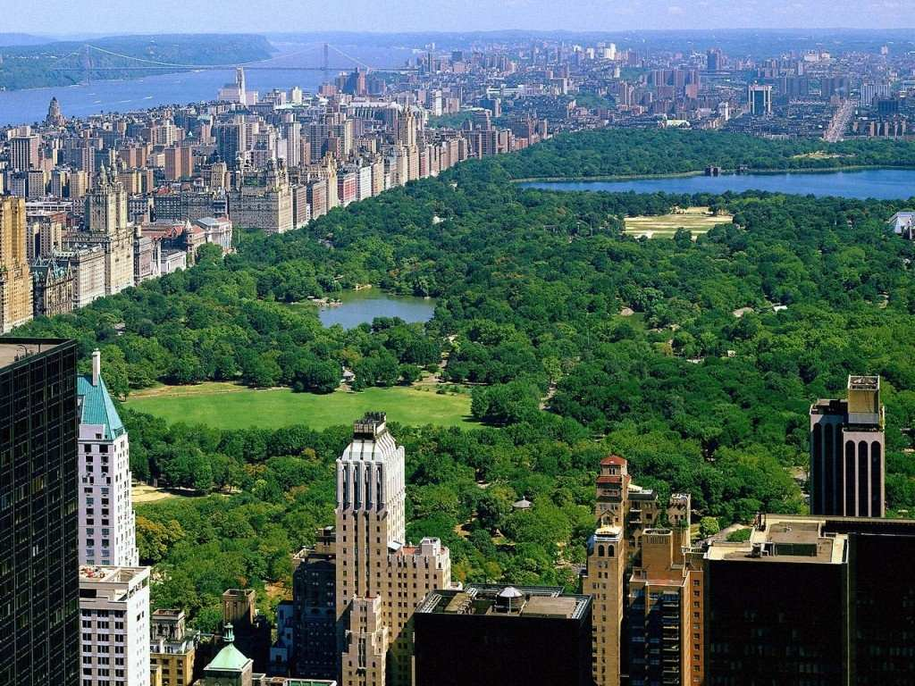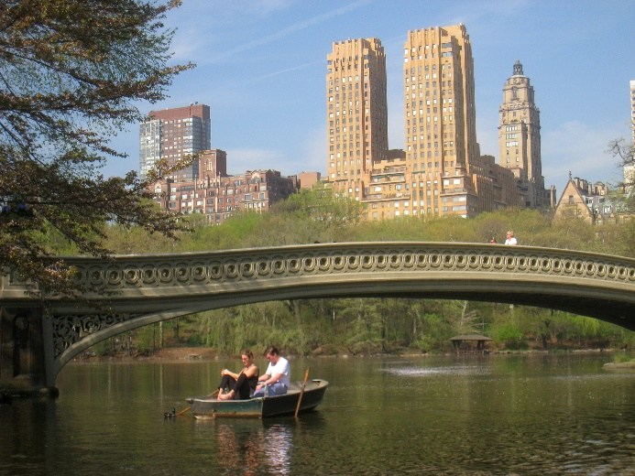
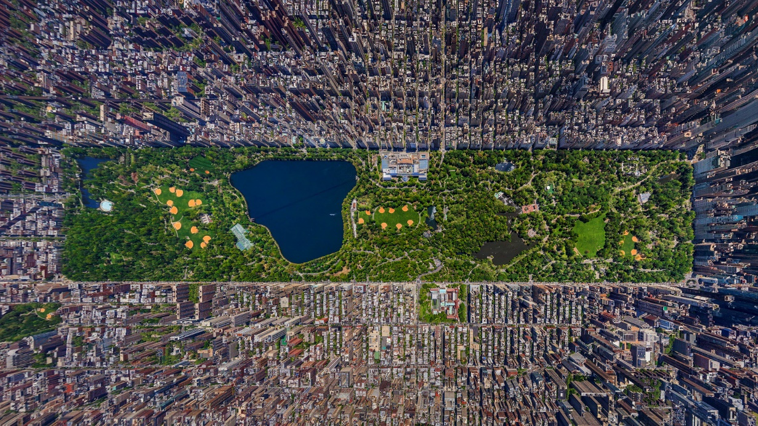

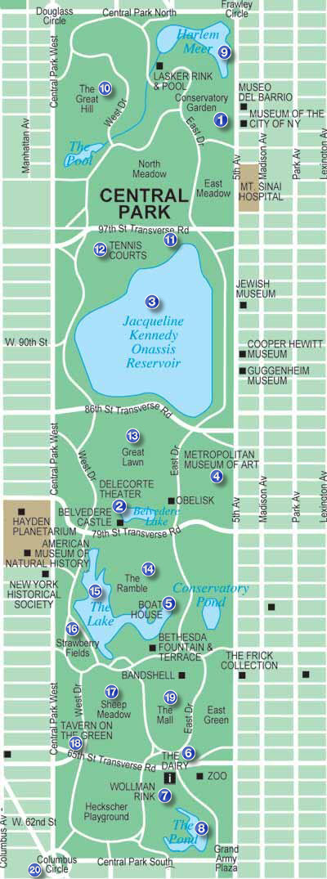
Map of Central Park
Central Park Highlights
- Conservatory Garden: beautiful formal gardens
- Delacorte Theater: Shakespeare in the Park performances
- Reservoir: jogger’s favorite round
- Metropolitan Museum of Art
- Loeb Boathouse: boat rental, bike rental, nice café
- Dairy: used to be the place where the milk of the Central Park cows was sold. Now an information stall
- Woolman Rink: for ice skating and roller-skating
- Pond: Swans, ducks… very nice view from Gapstow Bridge, Holden Caulfield loved this pond too.
The ducks play an important role in the novel The Catcher in the Rye.
- Harlem Meer: popular fishing lake, fish must be thrown back into the water
- The Great Hill: James Baldwin’s favorite hill coming from Harlem in the novel Go Tell it to the Mountain (page Error! Bookmark not defined.)
- Security Center
- Tennis Courts
- The Great Lawn: free open air concerts (New York Philharmonic Orchestra, Elton John, Simon&Garfunkel, Pavarotti…)
- The Ramble: bird watcher’s paradise (don’t go in alone, it’s secluded and dangerous)
- The Lake: with wrought iron bridge
- Strawberry Fields: Yoko Ono’s Memorial for John Lennon
- Sheep Meadow: up until 1934 sheep used to graze here
- Tavern on the Green: fancy restaurant, used to be sheep barns
- The Mall: main promenade on Sundays, roller-skaters, performances…
- Columbus Circle

Go Tell It on the Mountain by James Baldwin

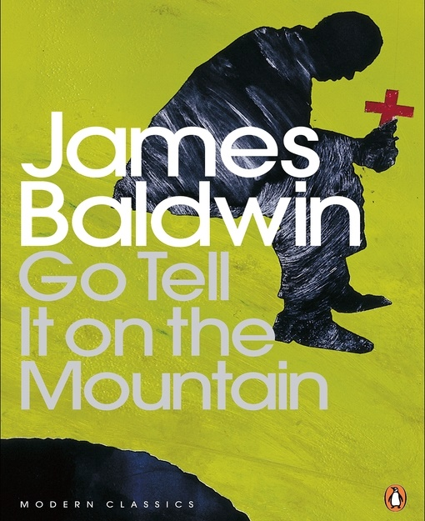 |  | P E N G U I N T W E N T I E T H C E N T U R Y C L A S S I C S  JAMES BALDWIN  Go Tell It on the Mountain  ‘Mountain is the book I had to write if I was ever going to write anything else. I had to deal with what hurt me most. I had to deal with my father’ – James Baldwin  Set against the backdrop of 1930s Harlem, 'Go Tell It on the Mountain' relates the progress of Johnny Grimes along with tortuous road to salvation. The greatest obstacle he has to overcome is the pure, scalding hatred he feels for his father, a lay preacher, whose bigotry, fear and fanaticism make him abuse and repress his own family. At once bluesy and biblical, Baldwin's tale is full of passion and guilt, of sinners brought low and prayers singing on the wind.  ‘Baldwin’s opportunities made him more sensitive to the fate of his brothers … He drew into himself the agony he saw around him and charged it with the force of an electric and passionate personality’ – Arthur Schlesinger  ‘Passionately eloquent’ – The Times
 |  | GO TELL IT ON THE MOUNTAIN 38
In Central Park the snow had not yet melted on his favorite hill. This hill was in the center of the park, after he had left the circle of the reservoir, where he always found, outside the high wall of crossed wire, ladies, white, in fur coats, walking their great dogs, or old, white gentlemen with canes. At a point that he knew by instinct and by the shape of the buildings surrounding the park, he struck out on a steep path overgrown with trees, and climbed a short distance until he reached the clearing that led to the hill. Before him, then, the slope stretched upward, and above it the brilliant sky, and beyond it, cloudy, and far away, he saw the skyline of New |  | York. He did not know why, but there arose in him an exultation and a sense of power, and he ran up the hill like an engine, or a madman, willing to throw himself headlong into the city that glowed before him.  But when he reached the summit he paused; he stood on the crest of the hill, hands clasped beneath his chin, looking down. Then he, John, felt like a giant who might crumble this city with his anger; he felt like a tyrant who might crush this city beneath his heel; he felt like a long-awaited conqueror at whose feet flowers would be strewn, and before whom multitudes cried, Hosanna! He would be, of all, the mightiest, the most beloved, the Lord’s anointed; and he would live in this shining city which his ancestors had seen with longing from far away. For it was his; the inhabitants of the city had told him it was his; he had but to run down, crying, and they would take him to their hearts and shoe him wonders his eyes had never seen.  And still, on the summit of that hill he paused. He remembered the people he had seen in that city, whose eyes held no love for him. And he thought of their feet so swift and brutal, and the dark gray clothes they wore, and how when they passed they did not see him, or, if they saw him, they smirked. And how the lights, unceasing, crashed on and off above him, and how he was a stranger there. Then he remembered his father and his mother, and all the arms stretched out to hold him back, to save him from this city where, they said, his soul would find perdition.  And certainly perdition sucked at the feet of the people who walked there; and cried in the lights, in the gigantic towers; the marks of Satan could be found in the faces of the people who waited at the doors of movie houses; his words were printed on the great movie posters that invited people tosin. It was the roar of the damned that filled Broadway, where
39 THE SEVENTH DAY |  | GO TELL IT ON THE MOUNTAIN 40
motor-cars and buses and the hurrying people disputed every inch with death. Broadway: the way that led to death was broad, and many could be found thereon; but narrow was the way that led to life eternal, and few there were who found it. But he did not long for the narrow way, where all his people walked; where the houses did not rise, piercing, as it seemed, the unchanging clouds, but huddled, flat, ignoble, close to the filthy ground, where the streets and the hallways and the rooms were dark, and where the unconquerable odor was of dust, and sweat, and urine, and home-made gin. In the narrow way, the way of the cross, there awaited him only humiliation for ever; there awaited him, one day, a house like his father’s house, and a church like his father’s, and a job like his father’s, where he would grow old and black with hunger and toil. The way of the cross had given him a belly filled with wind and had bent his mother’s back; they had never worn fine clothes, but here, where the buildings contested God’s power and where the men and women did not fear God, here he might eat and drink to his heart’s content and clothe his body with wondrous fabrics, rich to the eye and pleasing to the touch. And then what of his soul, which would one day come to die and stand naked before the judgment bar? What would his conquest of the city profit him on that day? To hurl away, for a moment of ease, the glories of eternity!  These glories were unimaginable—but the city was real. He stood for a moment on the melting snow, distracted, and then began to run down the hill, feeling himself fly as the descent became more rapid, and thinking: ‘I can climb back up. If it’s wrong, I can always climb back up.’ At the bottom of the hill, where the ground abruptly leveled off on to a gravel path, he nearly knocked down an old white man with a white beard, who was walking very slowly and leaning on his cane. |  | They both stopped, astonished, and looked at one another. John struggled to catch his breath and apologize, but old man smiled. John smiled back. It was as though he and the old man had between them a great secret; and the old man moved on. The snow glittered in patches all over the park. Ice, under the pale, strong sun, melted slowly on the branches and trunks of trees.  He came out of the park at Fifth Avenue where, as always, the old-fashioned horse-carriages were lined along the kerb, their drivers sitting on the high seats with rugs around their knees, or standing in twos and threes near the horses, stamping their feet and smoking pipes and talking. I summer he had seen people riding in these carriages, looking like people out of books, or out of movies in which everyone wore old-fashioned clothes and rushed at nightfall over frozen road, hotly pursued by their enemies who wanted to carry them back to death. ‘Look back, look back,’ had cried a beautiful woman with long blonde curls, ‘and see if we are pursued!—and she had come, as John remembered, to a terrible end. Now he stared at the horses, enormous and brown and patient, stamping every now and again a polished hoof, and he thought of what it would be like to have one day a horse of his own. He would call it Rider, and mount it at morning when the grass was wet, and from the horse’s back look out over great, sun-filled fields, his own. Behind him stood his house, great and rambling and very new, and in the kitchen his wife, a beautiful woman, made breakfast, and the smoke rose out of the chimney, melting into the morning air. They had children, who called him Papa and for whom at Christmas he bought electric trains. And he had turkeys and cows and chickens and geese, and other horses besides Rider. They had a closet full of whisky and wine; they had cars—but what church did they go to and what would he
41 THE SEVENTH DAY |  | GO TELL IT ON THE MOUNTAIN 42
teach his children when they gathered around him in the evening? He looked straight ahead, down Fifth Avenue, where graceful women in fur coats walked, looking into the windows that held silk dresses, and watches, and rings. What church did they go to? And what were their houses like in the evening they took off these coats, and these silk dresses, and put their jewelery in a box, and leaned back in soft beds to think for a moment before they slept of the day gone by? Did they read a verse from the Bible every night and fall on their knees to pray? But no, for their thoughts were not of God, and their way was not God’s way. They were in the world, and of the world, and their feet laid hold on Hell.  Yet in school some of them had been nice to him, and it was hard to think of them burning in Hell for ever, they who were so gracious and beautiful now. Once, one winter when he had been very sick with a heavy cold that would not leave him, one of his teachers had bought him a bottle of cod-liver oil, especially prepared with heavy syrup so that it did not taste so bad: this was surely a Christian act. His mother had said that God would bless that woman; and he had got better. They were kind—he was sire that they were kind—and on the day that he would bring himself to their attention they would surely love and honor him. This was not his father’s opinion. His father said that all white people were wicked, and that God was going to bring them low. He said that white people were never to be trusted, and that they told nothing but lies, and that no one of them had ever loved a nigger. He, John, was a nigger, and he would find out, as soon as he got a little older, how evil white people could be. John had read about the things white people did to colored people; how, in the South, where his parents came from, white people cheated them of their wages, and burned them, and shot them—and did worse |  | things, said his father, which the tongue could not endure to utter. He had read about colored men being burned in the electric chair for things they had not done; how in riots they were beaten with clubs; how they were tortured in prisons; how they were the last to be hired and the first to be fired. Niggers did not live on these streets where John now walked; it was forbidden; and yet he walked here, and no one raised a hand against him. But did he dare to enter this shop out of which a woman now casually walked, carrying a great round box? Or this apartment before which a white man stood, dressed in a brilliant uniform? John knew he did not dare, not to-day, and he heard his father’s laugh: ‘No, nor to-morrow neither!’ For him there was the back door, and the dark stairs, and the kitchen or the basement. This world was not for him. If he refused to believe, and wanted to break his neck trying, then he could try until the sun refused to shine; they would never let him enter. In John’s mind then, the people and the avenue underwent a change, and he feared them and knew that one day he could hate them if God did not change his heart.  He left Fifth Avenue and walked west toward the movie houses. Here on 42nd Street it was less elegant but not less strange. He loved this street, not for the people or the shops but for the stone lions that guarded the great main building of the Public Library, a building filled with book and unimaginably vast, and which he had never yet dared to enter. He might, he knew, for he was a member of the branch in Harlem and was entitled to take books from any library in the city. But he had never gone in because the building was so big that it must be full of corridors and marble steps, in the maze of which he would be lost and never find the book he wanted. And then everyone, all the white people inside, would know that he was not used to great buildings, or to many books, and
43 THE SEVENTH DAY |  | GO TELL IT ON THE MOUNTAIN 44
they would look at him wit pity. He would enter on another day, when he had read all the books uptown, an achievement that would, he felt, lend him the poise to enter any building in the world. People, mostly men, leaned over the stone parapets of the raised park that surrounded the library, or walked up and own and bent to drink water from the public drinking-fountains. Silver pigeons lighted briefly on the heads of the lions or the rims of fountains, and strutted along the walks. John loitered in front of Woolworth’s, staring at the candy display, trying to decide what candy to buy—and buying one, for the store was crowded and he was certain that the salesgirl would never notice him—and before a vendor of artificial flowers, and crossed Sixth Avenue where the Automat was, and the parked taxis, and the shops, which he would not look at to-day, that displayed in their windows dirty postcards and practical jokes. Beyond Sixth Avenue the movie houses began, and now he studied the stills carefully, trying to decide which of all these theaters he should enter. He stopped at last before a gigantic, colored poster that represented a wicked woman, half undressed, leaning in a doorway, apparently quarreling with a blond man who stared wretchedly into the street. The legend above their heads was: ‘There’s a fool like him in every family—and a woman next door to take him over!’ He decided to see this, for he felt identified with the blond young man, the fool of his family, and he wished to know more about his so blatantly unkind fate.  And so he stared at the price above the ticket-seller’s window and, showing her his coins, received the piece of paper that was charged with the power to open doors. having once decided to enter, he did not look back at the street again for fear that one of the saints might be passing and, seeing him, might cry out his name and lay hands on him to drag him back. He walked very quickly across the carpeted lobby, looking |  | at nothing, and pausing only to see his ticket torn, half of it thrown into a silver box and half returned to him. And then the usherette opened the doors of this dark palace and with a flashlight held behind her took him to his seat. Not even then, having pushed past a wilderness of knees and feet to reach his designated seat, did he dare to breathe; nor, out of a last, sick hope for forgiveness, did he look at the screen. He stared at the darkness around him, and at the profiles that gradually emerged from this gloom, was so like the gloom of Hell. He waited for this darkness to be shattered by the light of the second coming, for the ceiling to crack upward, revealing, for every eye to see, the chariots of fire on which descended a wrathful God and all the host of Heaven. He sank far down in his seat, as though his crouching might make him invisible and deny his presence there. But then he thought: ‘Not yet. The day of judgment is not yet,’ and voices reached him, the voices no doubt of the hapless man and the evil woman, and he raised his eyes helplessly and watched the screen.  The woman was most evil. She was blonde and pasty white, and she had lived in London, which was in England, quite some time ago, judging from her clothes, and she coughed. She had a terrible disease, tuberculosis, which he had heard about. Someone in his mother’s family had died of it. She had a great many boy friends, and she smoked cigarettes and drank. When she met the young man, who was a student and who loved her very much, she was very cruel to him. She laughed at him because he was a cripple. She took his money and she went out with other men, and she lied to the student—who was certainly a fool. He limped about, looking soft and sad, and soon all John’s sympathy was given to this violent and unhappy woman. He understood her when she raged and shook her lips and threw back her head in laughter so furious that it seemed the veins of her neck would
45 THE SEVENTH DAY |  | GO TELL IT ON THE MOUNTAIN 46
burst. She walked the cold, foggy streets, a little woman and not pretty, with a lewd, brutal swagger, saying to the whole world: ‘You can kiss my arse.’ Nothing tamed or broke her, nothing touched her, neither kindness, nor scorn, nor hatred, nor love. She had never thought of prayer. It was unimaginable that she would ever bend her knees and come crawling along a dusty floor to anybody’s altar, weeping for forgiveness. Perhaps her pride was so great that she did not need forgiveness. She had fallen from that high estate which God had intended for men and women, and she made her fall glorious because it was so complete. John could not have found in his heart, had he dared to search it, any wish for her redemption. He wanted to be like her, only more powerful, more thorough, and more cruel; to make those around him, all who hurt him, suffer as she made the student suffer, and laugh in their faces when they asked pity for their pain. He would have asked no pity, and his pain was greater than theirs. Go on, girl, he whispered, as the student, facing her implacable ill-will, sighed and wept. Go on, girl. One day he would talk like that, he would face them and tell them how much he hated them, how they had made him suffer, how he would pay them back!  Nevertheless, when she came to die, which she did eventually, looking more grotesque than ever, as she deserved, his thoughts were abruptly arrested, and he was chilled by the expression on her face. She seemed to stare endlessly outward and down, in the face of a wind more piercing than any she had felt on earth, feeling herself propelled with speed into a kingdom where nothing could help her, neither her pride, nor her courage, nor her glorious wickedness. In the place where she was going, it was not these things that mattered but something else, for which she had no name, only a cold |  | intimation, something that she could not alter in any degree, and that she had never thought of. She began to cry, her depraved face breaking into an infant’s grimace; and they moved away from her, leaving her dirty in a dirty room, alone to face her Maker. The scene faded out and she was gone; and though the movie went on, allowing the student to marry another girl, darker, and very sweet, but by no means so arresting, John thought of this woman and her dreadful end. Again, had the thought not been blasphemous, he would have thought that it was the Lord who had led him into this theater to show him an example of the wages of sin. The movie ended and people stirred around him; the newsreel came on, and while girls in bathing suits paraded before him and boxers growled and fought, and baseball players ran home safe and presidents and kings of countries that were only names to him moved briefly across the flickering square of light, John thought of Hell, of his soul’s redemption, and struggled to find a compromise between the way that led to life everlasting and the way that ended in the pit. But there was none, for he had been raised in the truth. He could not claim, as African savages might be able to claim, that no one had brought him the gospel. His father and mother and all the saints had taught him from his earliest childhood what was the will of God. Either he arose from this theater, never to return, putting behind him the world and its pleasures, its honors, and its glories, or he remained here with the wicked and partook of their certain punishment. Yes, it was a narrow way—and John stirred in his seat, not daring to feel it God’s injustice that he must make so cruel a choice.

A Self-Guided Brooklyn Graffiti Tour
http://offmetro.com/ny/470/a-self-guided-brooklyn-graffiti-tour/
Let’s walk across the Williamsburg bridge (great views and photo opportunities!!!) and explore examples of street art in Williamsburg. You might not find all these examples; street art is alive and changes all the time.
by Arturo Conde 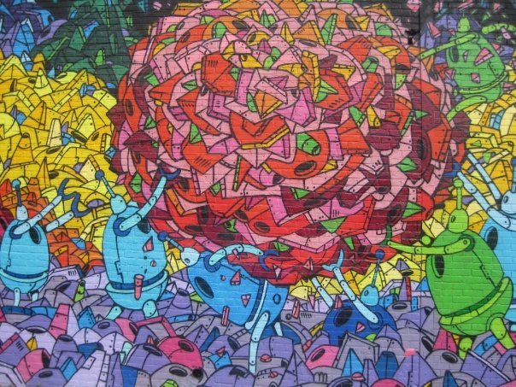
Artist: R.Robots (mural)
Location: North 3rd and Bedford (on North 3rd)
Update July 2015: Please note that the street art in this article is from 2008 and may no longer be there as it is described in the story.
Williamsburg has long been a focal point for established and emerging graffiti artists competing for niche spaces in which to exhibit their artwork. At present, local residents appreciate a wide selection of street art that peers out from walls, billboards and abandoned commercial and industrial lots.
Once deemed as a subversive act by many detractors, graffiti has evolved into a popular art form that’s gained wide recognition in international galleries and influenced marketing campaigns, graphic designers, and the fashion industry. And while London has replaced New York at the forefront of street art, Williamsburg has remained a fertile ground for experimental graffiti.
Accessible rents, a thriving arts community, and the availability of public spaces have attracted a diverse cluster of talented graffiti artists that continue to challenge our perspective through different mediums. In recent years, graffiti in Williamsburg has ranged from highly stylized texts and tags that are commonly associated with American graffiti, to more European-style street art, including poster-work, stencils and stickers.
An improvised tour of the area can offer you a substantial survey of classic and contemporary styles of artwork. On a recent walk through Williamsburg, we found four different types of graffiti:

Throw-ups and Pieces
Considered to be the earliest forms of graffiti, these elaborate representations of the artist’s name vary in size, thickness and outline. The use of multiple colors, and the speed and precision that is required to write them, have elevated these trademark signatures to a universal form of self-expression. Start your tour with a selection from legendary and upcoming writers:
Artist: T.Kid (piece)  Location: Hope and Keap (on Hope) | Artist: Ghost (piece)  Location: Keap and Hope (on Keap) | Artist: Os Gemeos (piece)  Location: North 3rd and Wythe (on Wythe) | Artist: Diva (piece)  Location: North 6th and Metropolitan (Gas Station)
 | 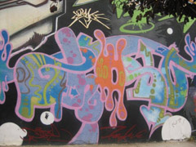 | 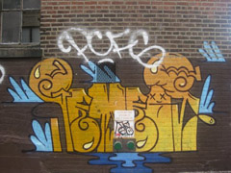 | 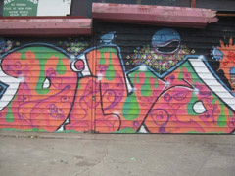

Murals
Painted by individual artists or collectives, murals can sometimes commemorate emblematic musicians, politicians and activists. With the influence of graffiti in advertising, some graffiti artists have also been contracted to paint murals for local businesses and corporations. Featured murals on this tour include:
MÖTUG collective (Monsters of the Unda – Ground)  Artist: Ewok (mural)  Location: Keap and Hope (on Hope | MÖTUG collective (Monsters of the Unda – Ground)  Artist: Ewok (mural)  Location: Keap and Hope (on Hope) | Artist: R.Robots (mural)  Location: North 3rd and Bedford (on North 3rd) | MÖTUG collective (Monsters of the Unda – Ground)  Artists: Obey (mural)  Location: Keap and Hope (on Keap)
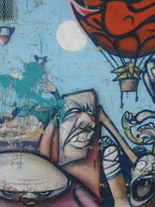 | 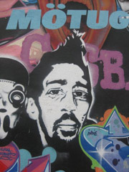 | 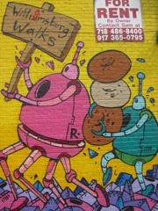 | 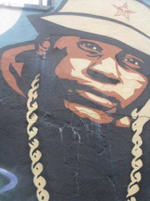

Stencils
Working from a print of one or more colors that are later sprayed-over, stencils allow graffiti artists to focus on cultural icons that can be reproduced with precision. In Williamsburg you will find stencil-work from:
Artist: Nick Walker (paint/stencil)  Location: Roebling and Metropolitan (on Roebling) | Artist: C215 (stencil)  Location: Corner of Roebling and Metropolitan (Fire Box) | Artist: Nick Walker (stencil)  Location: Wythe and North 3rd St. (on Wythe) | Artist: C215 (stencil)  Location: Meeker and Withers (On Withers, fire hydrant)
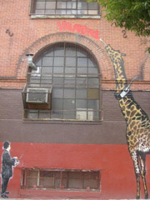 | 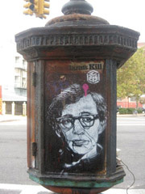 | 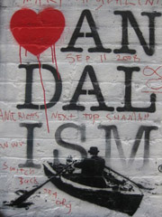 | 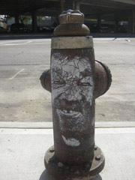

Poster-work
Graffiti artists wheatpaste their poster-work on billboards and walls, sometimes actively incorporating their surroundings into the piece. In Williamsburg you will enjoy a roundup of the most innovative wheatpaste artists:
Artist: Obey (wheatpaste)  Location: North 6th bet. Wythe and Kent | Artist: Judith Supine (wheatpaste)  Location: Meeker Avenue and North 7th (On North 7th) | Artist: OHM (wheatpaste)  Location: Meeker Avenue and North 6th (on Meeker)
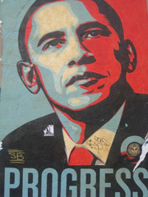 | 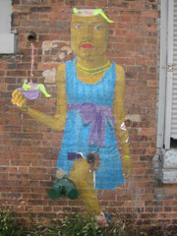 | 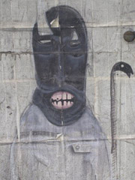

How to get there: Take the L train from Union Square to Lorimer St – Metropolitain Ave Station. Then proceed on foot at your discretion with the self-guided tour of the featured graffiti sites. Print out this article and the map below to help guide you to the locations. Please note that graffiti is usually not permanent, so we cannot guarantee that all our sites are still in tact. On the other hand, new art is constantly being created—let us know in the comments if you discover anything new in the area!
Map of Featured Artwork
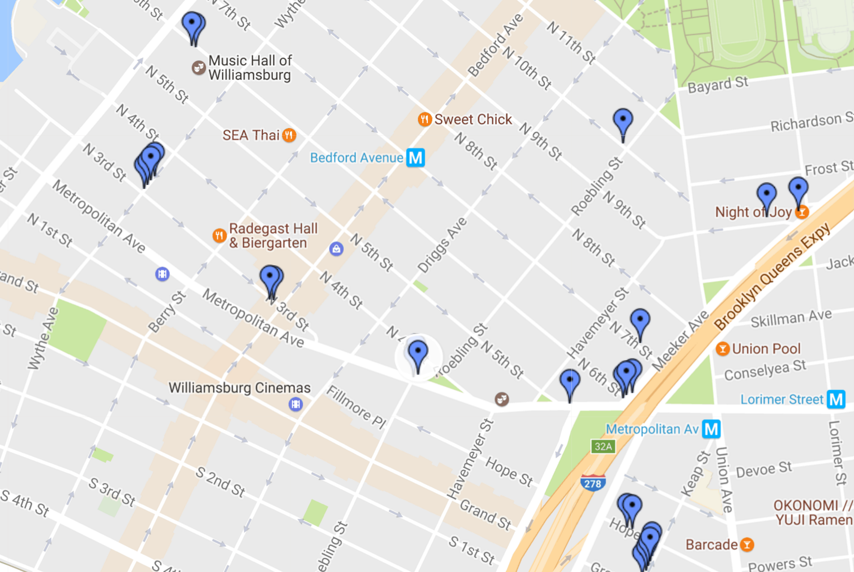
photos: Courtesy Arturo Conde: http://offmetro.com/ny/470/a-self-guided-brooklyn-graffiti-tour/

Jewish New York
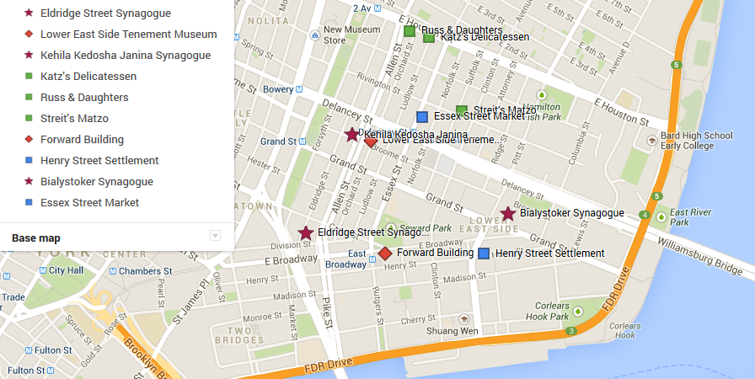
Stops / Sights | Info | Text Sample
General Intro – Jewish Life  in NYC | We’ll take a walking tour of the Lower East Side (LES) with a guide from the Lower East Side Tenement Museum and get to know Jewish life in New York past and present. The walking tour will start at 10 o’clock.  After the walking tour, we’ll explore the LES on our own and have kosher lunch at Katz’s Deli.  - New York has a huge Jewish community. You will learn about Jewish life (kosher food, Sabbath rules, dress code…) and see orthodox Jews working and living there.  - Jews have always belonged to the intellectual, artistic and political elite of America. Some of the well-known names are:  - Entertainment: the Mark Brothers, Woody Allen…  - Writers: Henry Roth, Philip Roth, Norman Mailer, Paul Auster, Max Frisch, Bernard Malamud, Isaak Asimov…  - Music: George Gershwin, Leonard Bernstein, Barbra Streisand, Bob Dylan…  - Politics: Henry Kissinger, Ed Koch…  Read “The Jews of New York" (Commentary by Dr. Gerhard Falk) on page 51 and the info-page about Woody Allen’s Manhattan on page 55. | Text (10);  Text (12) on page 55
A Jewish Tour of New York's Lower East Side | In its turn-of-the-century heyday, the Lower East Side was home to a flourishing Jewish community of Germans, Eastern Europeans, Russians, and Greeks. They lived in cramped tenements and peddled pushcarts or toiled in the garment industry for a living – when they weren’t agitating for social reform or establishing synagogues, community centers, Yiddish theaters, and newspapers. These days, the neighborhood has a different flavor. New waves of Chinese and Latino immigrants have set up their own shops, bodegas, and religious sites, converting defunct synagogues into churches and Buddhist temples. And though still an immigrant hub, the area is also decidedly hip, with pricey boutiques, swanky nightspots, and rising rents. But beneath the L.E.S.'s ever-changing identity, remnants of a gritty, tumultuous, and Jewish past remain.
Eldridge Street Synagogue | 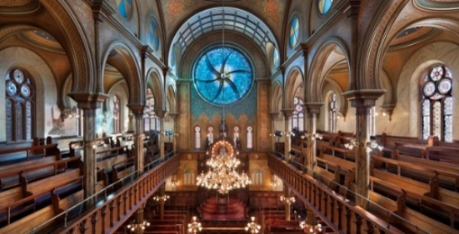  - 12 Eldridge St.  - designed and built more than a century ago by Jewish Eastern European immigrants, opened in 1887  - spiritual home for the first Eastern European Orthodox Jewish congregation in America  - New York City Jews flocked to Eldridge Street after years of makeshift gatherings in tenements, bakeries, and storefronts - crowds were so great that policeman patrolled the area on horseback during the high holy days when as many as 1,000 people might attend services  - Today, the congregation is still active, celebrating the Sabbath and performing religious services in the basement beis midrash.  - façade and interior of the synagogue reflect an eclectic mix of Moorish, Romanesque, and Gothic influences  - the bimah (a platform from which the Torah is read) sits in the center of the sanctuary
Lower East Side Tenement Museum | - 97 Orchard St.  - five-floor landmark built in 1863  - today apartments have been furnished to mimic the lives of former residents - each apartment tour relates the tale of a different family  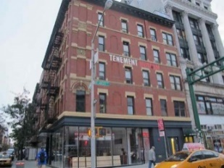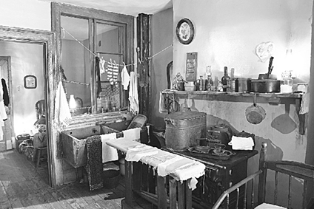
Kehila Kedosha Janina | 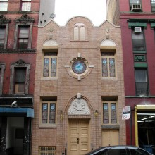  - 280 Broome St. at Allen St.  - only Romaniote (Greek Jewish) synagogue left in the Western Hemisphere  - a band of Jewish immigrants from the Greek village of Janina established the synagogue in 1927  - struggles to keep alive the traditions and liturgy of its dwindling congregation
Katz’s Delicatessen | 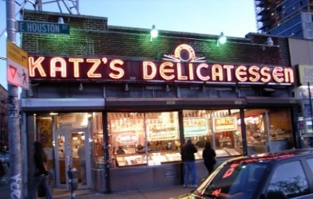  - 205 Houston St. at Ludlow St. : Locals and tourists alike stream into big, bustling Katz’s Delicatessen, the oldest deli in New York (est. 1888) and the only one where the pastrami and corned beef are still hand-cut.  - A sign hangs from the ceiling pointing toward the table where Meg Ryan and Billy Crystal sat during the “I’ll have what she’s having” scene from When Harry Met Sally.  - photos of celebrities and politicians plaster the walls  - Specialties include soft salami, liverwurst, knockwurst, knishes, frankfurters, and matzo-ball soup.  - A word of warning: This may be the bargain district, but the sandwiches aren’t cheap and they aren’t kosher either.
Russ & Daughters | 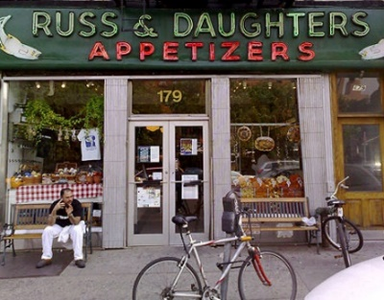  - 179 E. Houston St.  - dried fruits and nuts, chocolates, and cheeses line the shelves of the pristine specialty food shop  - run by the Russes family since 1914  - historic photographs above the counters suggest little inside the shop has changed  - Fish is still the biggest draw – from the classic bagel and lox to nova, homemade pickled herring, and Caspian Sea caviar…
Streit’s Matzo | 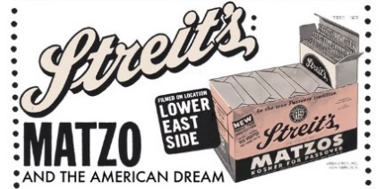  - 148-150 Rivington St.  - family-owned and operated for five generations  - last neighborhood matzo factory left  - kosher shop  Read the article about the Streit’s family dynasty on page 53.
East Broadway Landmarks | 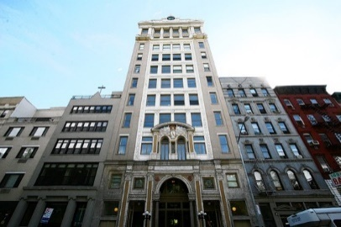  East Broadway is home to a handful of turn-of-the-century Jewish landmarks as well as a small, active Orthodox community:  - the imposing Forward Building: once the headquarters of the Jewish Daily Forward, a Yiddish-language paper that promoted social reform while striving to expose its readers to American culture and customs  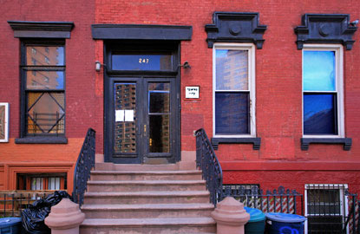  - the Educational Alliance: a community center established in 1889 to provide immigrants with language and art classes, a free library, and help “Americanizing”  - Shteibl Row: a series of former tenements converted into shuls where worshippers still gather  - Henry Street Settlement: founded by social worker Lillian Wald in 1893, offers numerous educational and social services  - Abrons Arts Center: a collection of theaters, art studios, and dance spaces
Bialystoker Synagogue | 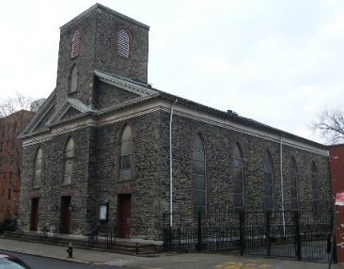  - 7-11 Willett St.  - built in 1826, converted into a synagogue in 1905 by Polish Jews from Bialystok  - Federal-style building  - originally housed a Methodist church and served as a stop on the Underground Railroad (=network of secret routes and safe houses used by 19th-century African-American slaves)  - paintings of zodiac symbols corresponding to Jewish calendar months span the sanctuary ceiling
Gertel’s Bakery | 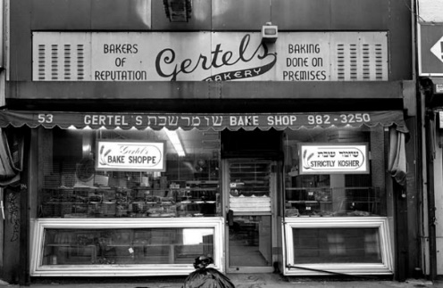  - 53 Hestor St.: trays parked outside the tiny doorway affirm the faded sign overhead: “baking done on premises.”  - while the staff is heavily Hispanic, the goodies remain decidedly Jewish and Eastern European: raspberry, chocolate, apricot and cinnamon raisin rugelach, challah bread, poppy seed cake, bowties and cookies with apricot paste…
Essex Street Market | 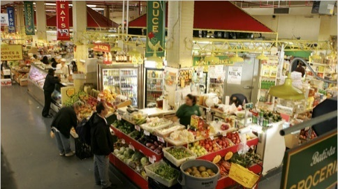  - 120 Essex St. at Delancey St.  - indoor market, set up in 1939  - Batista Grocery, Luis’s Meat Market and the bulk of today’s food, tchotcke and clothing stands…  - Schapiro’s Wines, a LES fixture since 1899, sells kosher wines on weekdays

The Jews of New York (Commentary by Dr. Gerhard Falk)
On January 1, 2004, when we welcome the New Year, we will be marking the 350th anniversary of the establishment of a Jewish community in our country.
It was in 1654 when twenty-three Jews arrived in New Amsterdam from Recife, in the province of Pernambuco, Brazil. That coastal area of Brazil had been in the hands of the Dutch since 1633. Some Jews therefore migrated to that part of the world because they had already lived in the Netherlands, a Protestant country, where they were welcome. You will recall that the great Spinoza was born in the Netherlands whence his ancestors had fled to escape the Inquisition active in Catholic Spain and Portugal.
When the Portuguese conquered Pernambuco in 1654, the Protestant and Jewish citizens traveled to the nearest Dutch colony in the New World, i.e. Nieuw Amsterdaam, which had been established as the capital of the New Netherlands in 1624. Although initially denied residence by the Dutch governor, Peter Stuyvesant, the Jews remained in the city when the Dutch West India Company ordered him to allow Jewish settlement. These Jews formed a congregation which they called Shearith Israel, or The Remnants of Israel.
Ten years after the first Jewish immigrants arrived, the British conquered New Amsterdam and renamed it New York after the Duke of York, later to become king of England and Scotland.
In 1730, Congregation Shearith Israel built its first synagogue on Mill St. just south of Wall Street. Until 1825, Shearith Israel was the only Jewish congregation in New York. Today that congregation continues at Central Park West and 70th Street.
In 1825 the second Jewish synagogue was erected in New York. It was called B’nai Jeshuron and it became the forerunner of all the Ashkenazi “shuls” and “temples” and “synagogues” now serving the 972,000 Jews in the city. That is right. Only 972,000. For the first time in 50 years the Jewish population of New York City has dropped to less than one million. In fact, 50 years ago New York had 2 million Jews, who constituted one fourth of the New York population. Now, when New York City has 8 million people, the Jews are only 12 percent. The reason is both migration and the falling Jewish birth rate. There are in fact 1.4 million Jews in Greater New York, meaning the suburbs.
Now Brooklyn has the greatest concentration of Jews with 456,000, followed by Manhattan, which has 243,000 Jews. In Nassau County, outside the city limits, there are now 221,000 Jews. 129,000 live in Westchester and Suffolk has 90,000 Jews.
The State of New York has 1,657,000 Jews, which makes us about 9.1% of the New York State population of 19 million.
About 25% of New York Jews have no religion. The orthodox, however, are the fastest growing segment of the Jewish population of this state. They grew from 13% in 1991 to 19 percent in 2003. Meanwhile the Conservative and Reform movements in New York City are losing members rapidly as their people move to the suburbs or to other states.
This movement may be seen by looking at the growth of the Jewish population in Southern and Western states. For example, California now has 999,000 Jews and Florida has 625,000, so that Florida and Maryland now both have a Jewish population totaling four percent of each state’s population. Even Arizona now has over 81,000 Jews and Texas has 131,000 Jews.
Nevertheless, New York City is still the mother of American Judaism. There are several reasons for this. First, there are religious aspects to the Jewish experience in New York. Unlike any other American city, New York has numerous synagogues readily within walking distance of anyone living there. This also meant that there was always a Jewish school available to Jewish children of the numerous immigrants who had come over the years. Those who wanted to eat only kosher food had easy access to kosher butchers and to kosher restaurants.
Religious diversity is also a great advantage for those Jews who live in New York. Thus, Reform Judaism first appeared in New York City in 1845 when Temple Emanu-el was established by German immigrants. Although Germans were predominant among Reform Jews until the First World War, the Eastern European Jews who had come from the shtetls of Russia and Poland turned towards Reform by the first world war. At that time 60% of lower east side merchants were open on Saturday. Unfortunately, the Orthodox and the Reform no longer consider each other as members of K’lal Israel, the community of Israel.
New York City is of course the birthplace of the Conservative movement in American Judaism. In 1913 the movement had 22 congregations devoted to maintaining the Jewish tradition while adapting to modern American life. The Conservative movement was invented by the German Jew Zacharias Fraenkel but grew in this country, ie. in New York. The movement in now called the United Synagogue of Conservative Judaism. It is affiliated with the Jewish Theological Seminary.
In addition to religious advantages, New York City has had economic advantages for Jews and everyone else. Located on the Hudson River and featuring an excellent harbor, the city has always attracted business from overseas and from inland. With the building of the Erie Canal commerce grew immensely as New York City became the crossroads between Europe and the interior part of the United States.
New York also has many social advantages for Jews. New immigrants could use Yiddish there until they learned English. Some never learned English and lived with Yiddish until their death. Yiddish newspapers and plays once flourished there and Jewish labor unions developed into great political pressure groups.
These and many other reason kept most Jews in New York City even if New York City can be abrasive and overcrowded and seemingly uncaring.
If you are a native of New York City or if your ancestors came from there you want to go to the library and get that great book World of Our Fathers, which Irving Howe published in in 1976. This is a wonderful history of how we first came to New York, what happened to us there and how New York has left an indelible mark on the Jewish community of this great land.
May you have a wonderful and fruitful New Year and may all of us lose weight in 2004.
Shalom u’vracha.
http://jbuff.com/c010104.htm

Volume 73, Number 38 | January 21 - 27, 2004

The Streit’s family dynasty: Passing on the matzo on the Lower East Side
by Bonnie Rosenstock
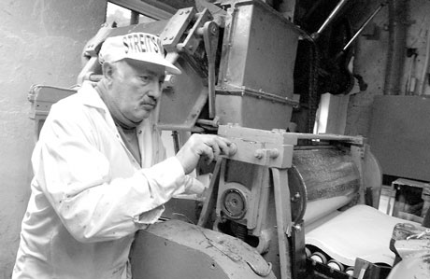
Villager photos by Elisabeth Robert
Stages in the matzo production process at Streit’s Rivington St. factory.
When October rolls around, most people set their sights on the upcoming fall and winter holidays. But not the Streit family. For them, October signals “spring cleaning,” the season to roll out Passover matzos, the traditional unleavened bread that Jews eat during the eight-day holiday, which begins in April this year. The Streit’s factory is shut down for a week for a thorough cleaning, and all daily production of year-round matzo ceases. Non-Passover products (malt, shortening, salt, etc.) are removed from the factory.
All chutes are opened and cleaned with compressed air, towels, a steam machine and a blowtorch under rabbinic supervision. The floors and walls, are scrubbed clean, so that not a particle of non-Passover flour dust remains. Passover baking will continue until just a few weeks before the holiday, but may go on longer depending on supply and demand.
Five generations of Streits have been engaged in this process for almost 80 years. In the 1890s, Aron Streit and his wife, Nettie, immigrated to America. Around 1915, Streit, who had prior matzo-baking experience in his native Austria, opened his first handmade matzo factory on Pitt St. on the Lower East Side.
In 1925, after a brief respite in the Catskills while his oldest son Irving recuperated from a respiratory condition, Streit and son opened a “modern machine” bakery on Rivington St. between Delancey and Suffolk Sts. where the factory still operates.
When Streit’s other son Jack was older, he joined the family concern. (The Streits also had two daughters.) Streit then purchased the three adjoining buildings to accommodate the expanding business.
Aron Streit died in 1937, but his progeny carry on the enterprise, proudly preserving it as the only family-owned and operated matzo company in America. (Bernard Manischewitz, whose grandfather founded the kosher foods, sweet wine and matzo empire in 1888 in Cincinnati, was the last generation to run the family company. He sold it in 1991 to private investors. He died in September 2003.)
Today, four Streit descendants — three great grandsons and one great-great-grandson — work at the factory full time, and three of the granddaughters sit on the policy-making board of directors. Alan M. Adler, 52, whose grandfather was Irving, handles production and legal matters. Adler’s first cousin, Aron Yagoda, 36 (Jack’s grandson), deals with ordering and distribution; like Adler, whose Hebrew name is Aron, Yagoda was named for his great grandfather. Mel Gross (also an Irving grandson) is in charge of sales.
Gross’ son, Aaron (with two “A”’s — he was named after his paternal grandfather of the same name, not to be confused with great-great grandfather, Aron Streit, with one “A”) is the fifth generation and works in the sales office, “learning the business from the ground up,” says Adler. “When the phone rings and somebody says, ‘Is Aron there?’ it sounds like ‘Alan,’ and they don’t know which Aron [or Aaron], so we’re always getting the wrong phone messages,” he says.
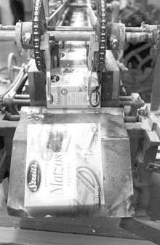
According to Adler, Passover matzo hasn’t changed much in thousands of years because of stringent religious requirements. It must consist of just flour and water and be baked within 18 minutes. “We have many rabbis supervising — at the matzo-forming machine, in the mixing room, to inspect the flour when it arrives in the morning,” he explains. “Water for Passover has to sit overnight, so we have three tanks that have to be filled up for the water to sit. The rabbis lock and unlock the water tanks to make sure the matzo meets the strictest rabbinical standards.”
After 18 minutes, the mixing bowls, the arms of the mixers and the rollers on the matzo-forming machine are completely cleaned. The rabbis carry stopwatches to insure accuracy. “If there’s ever a mechanical breakdown that lasts for more than a few minutes,” Adler says, “the dough is thrown out, the entire line is shut down and the machines — the mixers, chutes and matzo-cutting machines — are thoroughly cleaned from top to bottom with towels, compressed air and scrapers.”
Some of the equipment — the ovens and some packing machines — date back to the 1930s. “Actually, we find that some of the older machines do a better job than the modern machines, although it’s hard to get parts. If anything breaks, we basically have to custom make them,” says Adler.
Streit’s manufactures about 150 products, including noodles, pickles, applesauce, cake and soup mixes, canned soups, borscht and ketchup. Only the matzo products are made on Rivington St.; the others are packed in outlying plants in New York and Canada. (Their other line, Ethnic Delights, is imported from various countries.) Streit’s has a factory workforce of about 80.
Adler characterizes the company as “small-to-medium sized,” adding they sell “millions of pounds of matzo and matzo products.” He admits that it’s hard to compete with Procter & Gamble, for example. “There’s no doubt we could benefit from a multi-million-dollar advertising budget,” he notes. “But there’s a certain pride in walking through the same halls that my father walked through, that my grandfather walked through, that my great-grandfather walked through. There’s a family history here that means more to us than making some money by selling to a large corporation.”
His cousin Aron concurs. “We all hung out here as kids. We played in the retail store. My daughter is only 18 months. When she says the word, I’ll bring her into the business,” he says.
Adler’s son, Hillel, just turned 9, has already gotten his hands into the mix. “He puts on his hat, coat and gloves and pushes the dough down the chute into the matzo-forming machine. He loves coming down,” Adler says with fatherly pride.
The company’s number-one seller is still the blue-label, unsalted matzo for daily use. However, other flavorings have been added over the years to keep up with the times, including salt-and-pepper matzo (last year) and Mediterranean matzo with sun-dried tomatoes, garlic, olive oil and basil.
Naturally, their customer base is primarily Jewish. But judging from e-mails and letters that Adler receives, other ethnic groups are also munching on matzos, and some churches in the South and Southwest use them as communion wafers. “It’s not just a Jewish food product anymore,” Adler declares. He explains that according to industry information, kosher products are a growing industry, not necessarily the ethnic kosher (matzo) products, but for general food.
“Consumers view ‘kosher’ as higher quality and a better product, so mainstream companies are now making sure their ingredients are kosher,” Adler notes. “Nabisco and Campbell’s soup are going kosher. Hydrox cookies are kosher, and you can now get Oreos, too.”
Arguably, the office space is cramped and cluttered, and the factory space appears small by today’s standards. The solid-gray cement stairs leading up to the second-floor production area are worn smooth and concave in the center from the generations of footsteps that have trod on them.
“Sure we’ve thought about moving,” admits Adler. “But we’re committed to the neighborhood. We’ve been putting in some new equipment, refacing the brick. Obviously a single-story building in New Jersey would be much more efficient for production. But this is our history, and this is where we intend to stay.”
Aron Streit, Inc., 148-154 Rivington St. Retail store hours: Mon. to Thurs., 9 a.m. to 4:30 p.m., and Sundays before Passover. Phone: 212-475-7000 E-mail: AronStreit@StreitsMatzos.com.
http://thevillager.com/villager_38/thestreitsfamily.html

Manhattan (film) by Woody Allen
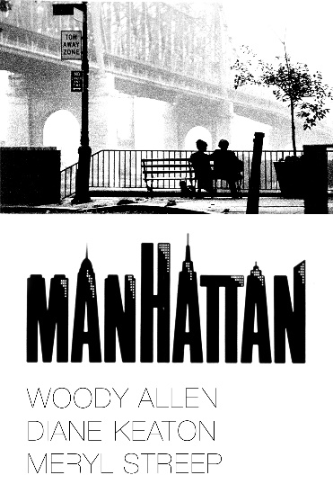
Manhattan
(USA 1979)
Directed by Woody Allen Comedy, Drama, Romance Starring Woody Allen, Diane Keaton, Mariel Hemingway, Meryl Streep…
This is the masterpiece of one of the greatest filmmakers of the 20th century. An ode to Woody Allen’s hometown, it is breathtakingly photographed in black-and-white by Gordon Willis and makes splendid use of George Gershwin’s music on the soundtrack.

QUOTES
(Opening sequence. Voiceover)
Isaac: Chapter One. He adored New York City. He idolized it all out of proportion. Eh uh, no, make that he, he romanticized it all out of proportion. Better. To him, no matter what the season was, this was still a town that existed in black and white and pulsated to the great tunes of George Gershwin. Uh, no, let me start this over.
Isaac: Chapter One: He was too romantic about Manhattan, as he was about everything else. He thrived on the hustle bustle of the crowds and the traffic. To him, New York meant beautiful women and street smart guys who seemed to know all the angles. Ah, corny, too corny for, you know, my taste. Let me, let me try and make it more profound.
Isaac: Chapter One: He adored New York City. To him it was a metaphor for the decay of contemporary culture. The same lack of individual integrity that caused so many people to take the easy way out was rapidly turning the town of his dreams in - no, it's gonna be too preachy, I mean, you know, let's face it, I wanna sell some books here.
Isaac: Chapter One: He adored New York City. Although to him it was a metaphor for the decay of contemporary culture. How hard it was to exist in a society desensitized by drugs, loud music, television, crime, garbage - too angry. I don't want to be angry.
Isaac: Chapter One. He was as tough and romantic as the city he loved. Behind his black-rimmed glasses was the coiled sexual power of a jungle cat. Oh, I love this. New York was his town, and it always would be.
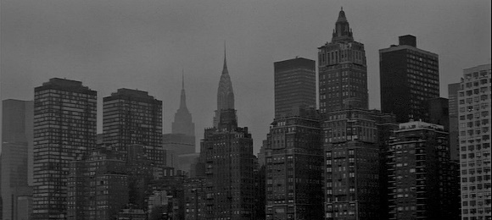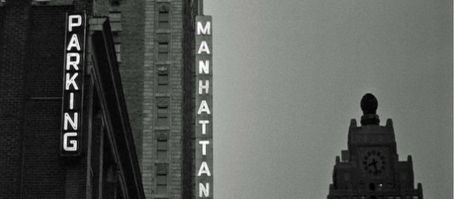
(at the MoMA. Isaac and Tracy running into Yale and Mary)
Isaac: We were downstairs at the Castelli galleries and saw the photography exhibition. Incredible, absolutely incredible.
Tracy: Yes.
Mary: Really, you liked it?
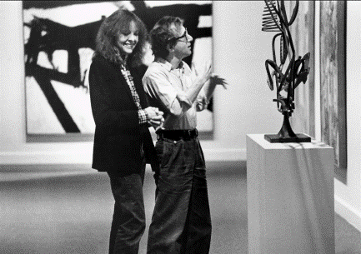
Isaac: Er, yes, the photographs downstairs – great, absolutely great. Did you…
Mary: No, I really felt it was very derivative. To me it looked like it was straight out of Diane Arbus, but it had none of the wit…
Isaac: Really? Well, you know, we didn’t like them as much as the Plexiglas sculpture. That’s what I meant…
Mary: …Really, you like the Plexiglas, huh?
Isaac: You didn’t like the Plexiglas sculpture either?
Mary: Uh, that’s interesting. No, er,…
Isaac: It was a hell of a lot better than that steel cube. Did you see the steel cube?
Tracy: Oh, yeah. That was the weirdest.
Mary: Now that was brilliant to me, absolutely brilliant.
Isaac: The steel cube was brilliant?
Mary: Yes. To me, it was very textural. You know what I mean? It was perfectly integrated, and it had a marvelous kind of negative capability. The rest of the stuff downstairs was bullshit!
(Isaac lying on the couch, speaking into the tape recorder)
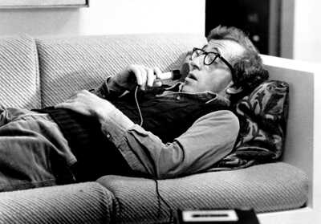
Isaac: An idea for a short story about … um … people in Manhattan who … er … are constantly creating these real unnecessary neurotic problems for themselves – because it keeps them from dealing with more unsolvable terrifying problems about … er … the universe – Um, tsch – it’s, uh … well, it has to be optimistic. Well, all right, why is life worth living? That’s a very good question. Um. Well, there are certain things I – I guess that make it worthwhile. Uh, like what? Okay. Um, for me … oh, I would say … what, Groucho Marx, to name one thing … uh ummmmm and Willie Mays, and um, uh, the second movement of the Jupiter Symphony, and ummm … Louie Armstrong’s recording of “Potatohead Blues”… umm, Swedish movies, naturally… “Sentimental Education” by Flaubert … um, Marlon Brando, Frank Sinatra … ummm, those incredible apples and pears by Cézanne … uh, the crabs at Sam Who’s … tsch, uh, Tracey’s face…

East Village – Greenwich Village - SoHo
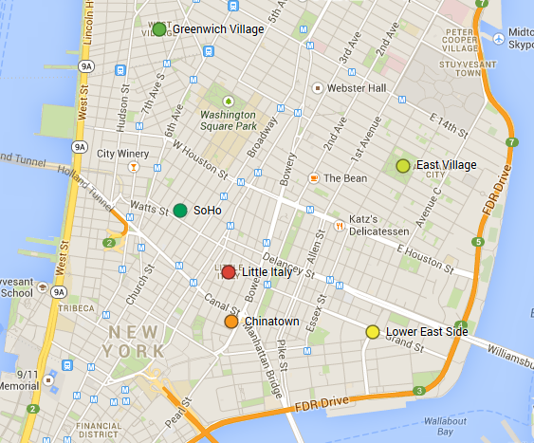
Stops / Sights | Info | Text Sample
Greenwich Village | - between 14th St and Houston St, the Hudson River and 4thAve/Bowery  - old, European style “Village” with curved streets and lots of trees (had already been built before the 1811 decision to build streets in a regular grid system)  - green front yards, nice old buildings…  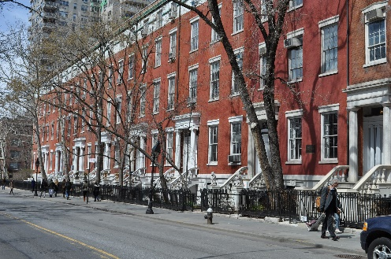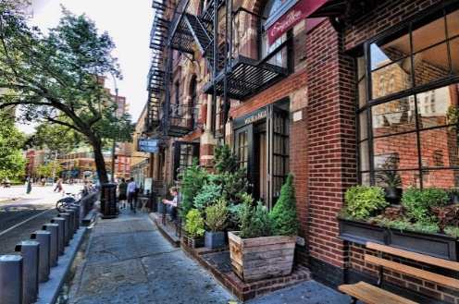  Washington Square used to be farmland for growing tobacco, later a graveyard for the poor, the large tree in the northwest corner was used as a gallows up to 1820. First buildings around the square around 1820…  Now place full of roller-skaters doing fancy tricks, circus artists, esoteric healers and students from the nearby New York University.  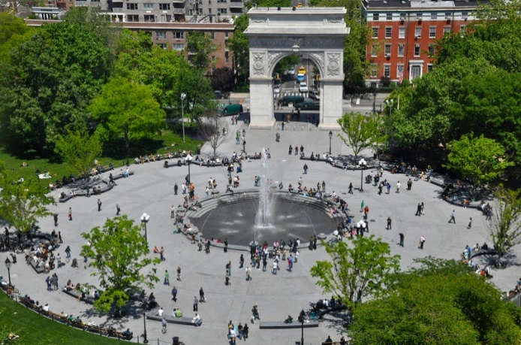  On Sunday mornings you’ll meet “Jesus” in Washington Square shouting “Sister, Jesus loves you and will save you…” He wants to save the inhabitants of the Village from all the evil around (such as homosexuality, drugs, bad morals…)  BIT OF HISTORY…  1820s: many people moved to the Village during the big epidemics of yellow-fever in 1822  1830s: University of New York, attracted intellectuals like Walt Whitman, Edgar Allan Poe…  1880s and 90s: later the village deteriorated and almost became a slum at the end of the 19th century  1920s and 30s: at the turn of the 20th century the Village was discovered by the artists and critical thinkers was the center of avant-garde culture  1950s: the Beatniks and anti-Vietnam activists came here, the Village became gentrified and the real artists then moved to the East Village to start again  Examples of such gentrified streets are Bleecker St. and MacDougal St. they are full of restaurants, cafés, gift- and souvenir-shops…  Now: The Village is still a vibrant place, you’ll find lots of Jazz-clubs, Off-Off Broadway theaters and restaurants. Many of the waiters work in both; they serve you coffee during the day and act in the theaters at night.  The Village is also a center of the gay-scene of N.Y. (esp. the western part around Christopher Street).  NICE PLACES AND STREETS TO VISIT…  - St. Luke’s Place (ital. style of 1850s)  - Grove Street and Grove Court (nr. 10-12) Read the short story “The Last Leaf” (set in Greenwich Village) by O. Henry.  - Bedford Street (Chumley’s nr. 86: a “speakeasy” from the times of prohibition. Writers used to meet and discuss their works and drink illegal alcohol in such speakeasies.)  - Shopsin’s (63 Bedford St./Morton St.) eccentric café with pancakes, sandwiches, soups…  - Cornelia St. Café (29 Cornelia St, near Bleecker St) was Suzanne Vega’s favorite café, also has poetry readings  - Waverly Place, Bleecker Street  - Washington Square  - Christopher Park (George Segal’s sculpture “Gay Liberation) | Text (13) on page 58

“The Last Leaf“ by O. Henry
In a little district west of Washington Square the streets have run crazy and broken themselves into small strips called "places." These "places" make strange angles and curves. One Street crosses itself a time or two. An artist once discovered a valuable possibility in this street. Suppose a collector with a bill for paints, paper and canvas should, in traversing this route, suddenly meet himself coming back, without a cent having been paid on account!
So, to quaint old Greenwich Village the art people soon came prowling, hunting for north windows and eighteenth-century gables and Dutch attics and low rents. Then they imported some pewter mugs and a chafing dish or two from Sixth Avenue, and became a "colony."
At the top of a squatty, three-story brick Sue and Johnsy had their studio. "Johnsy" was familiar for Joanna. One was from Maine; the other from California. They had met at the table d'hôte of an Eighth Street "Delmonico's," and found their tastes in art, chicory salad and bishop sleeves so congenial that the joint studio resulted.
That was in May. In November a cold, unseen stranger, whom the doctors called Pneumonia, stalked about the colony, touching one here and there with his icy fingers. Over on the east side this ravager strode boldly, smiting his victims by scores, but his feet trod slowly through the maze of the narrow and moss-grown "places."
Mr. Pneumonia was not what you would call a chivalric old gentleman. A mite of a little woman with blood thinned by California zephyrs was hardly fair game for the red-fisted, short-breathed old duffer. But Johnsy he smote; and she lay, scarcely moving, on her painted iron bedstead, looking through the small Dutch window-panes at the blank side of the next brick house.
One morning the busy doctor invited Sue into the hallway with a shaggy, gray eyebrow.
"She has one chance in - let us say, ten," he said, as he shook down the mercury in his clinical thermometer. " And that chance is for her to want to live. This way people have of lining-u on the side of the undertaker makes the entire pharmacopoeia look silly. Your little lady has made up her mind that she's not going to get well. Has she anything on her mind?"
"She - she wanted to paint the Bay of Naples some day." said Sue.
"Paint? - bosh! Has she anything on her mind worth thinking twice - a man for instance?"
"A man?" said Sue, with a jew's-harp twang in her voice. "Is a man worth - but, no, doctor; there is nothing of the kind."
"Well, it is the weakness, then," said the doctor. "I will do all that science, so far as it may filter through my efforts, can accomplish. But whenever my patient begins to count the carriages in her funeral procession I subtract 50 per cent from the curative power of medicines. If you will get her to ask one question about the new winter styles in cloak sleeves I will promise you a one-in-five chance for her, instead of one in ten."
After the doctor had gone Sue went into the workroom and cried a Japanese napkin to a pulp. Then she swaggered into Johnsy's room with her drawing board, whistling ragtime.
Johnsy lay, scarcely making a ripple under the bedclothes, with her face toward the window. Sue stopped whistling, thinking she was asleep.
She arranged her board and began a pen-and-ink drawing to illustrate a magazine story. Young artists must pave their way to Art by drawing pictures for magazine stories that young authors write to pave their way to Literature.
As Sue was sketching a pair of elegant horseshow riding trousers and a monocle of the figure of the hero, an Idaho cowboy, she heard a low sound, several times repeated. She went quickly to the bedside.
Johnsy's eyes were open wide. She was looking out the window and counting - counting backward.
"Twelve," she said, and little later "eleven"; and then "ten," and "nine"; and then "eight" and "seven", almost together.
Sue look solicitously out of the window. What was there to count? There was only a bare, dreary yard to be seen, and the blank side of the brick house twenty feet away. An old, old ivy vine, gnarled and decayed at the roots, climbed half way up the brick wall. The cold breath of autumn had stricken its leaves from the vine until its skeleton branches clung, almost bare, to the crumbling bricks.
"What is it, dear?" asked Sue.
"Six," said Johnsy, in almost a whisper. "They're falling faster now. Three days ago there were almost a hundred. It made my head ache to count them. But now it's easy. There goes another one. There are only five left now."
"Five what, dear? Tell your Sudie."
"Leaves. On the ivy vine. When the last one falls I must go, too. I've known that for three days. Didn't the doctor tell you?"
"Oh, I never heard of such nonsense," complained Sue, with magnificent scorn. "What have old ivy leaves to do with your getting well? And you used to love that vine so, you naughty girl. Don't be a goosey. Why, the doctor told me this morning that your chances for getting well real soon were - let's see exactly what he said - he said the chances were ten to one! Why, that's almost as good a chance as we have in New York when we ride on the street cars or walk past a new building. Try to take some broth now, and let Sudie go back to her drawing, so she can sell the editor man with it, and buy port wine for her sick child, and pork chops for her greedy self."
"You needn't get any more wine," said Johnsy, keeping her eyes fixed out the window. "There goes another. No, I don't want any broth. That leaves just four. I want to see the last one fall before it gets dark. Then I'll go, too."
"Johnsy, dear," said Sue, bending over her, "will you promise me to keep your eyes closed, and not look out the window until I am done working? I must hand those drawings in by to-morrow. I need the light, or I would draw the shade down."
"Couldn't you draw in the other room?" asked Johnsy, coldly.
"I'd rather be here by you," said Sue. "Beside, I don't want you to keep looking at those silly ivy leaves."
"Tell me as soon as you have finished," said Johnsy, closing her eyes, and lying white and still as fallen statue, "because I want to see the last one fall. I'm tired of waiting. I'm tired of thinking. I want to turn loose my hold on everything, and go sailing down, down, just like one of those poor, tired leaves."
"Try to sleep," said Sue. "I must call Behrman up to be my model for the old hermit miner. I'll not be gone a minute. Don't try to move 'til I come back."
Old Behrman was a painter who lived on the ground floor beneath them. He was past sixty and had a Michael Angelo's Moses beard curling down from the head of a satyr along with the body of an imp. Behrman was a failure in art. Forty years he had wielded the brush without getting near enough to touch the hem of his Mistress's robe. He had been always about to paint a masterpiece, but had never yet begun it. For several years he had painted nothing except now and then a daub in the line of commerce or advertising. He earned a little by serving as a model to those young artists in the colony who could not pay the price of a professional. He drank gin to excess, and still talked of his coming masterpiece. For the rest he was a fierce little old man, who scoffed terribly at softness in any one, and who regarded himself as especial mastiff-in-waiting to protect the two young artists in the studio above.
Sue found Behrman smelling strongly of juniper berries in his dimly lighted den below. In one corner was a blank canvas on an easel that had been waiting there for twenty-five years to receive the first line of the masterpiece. She told him of Johnsy's fancy, and how she feared she would, indeed, light and fragile as a leaf herself, float away, when her slight hold upon the world grew weaker.
Old Behrman, with his red eyes plainly streaming, shouted his contempt and derision for such idiotic imaginings.
"Vass!" he cried. "Is dere people in de world mit der foolishness to die because leafs dey drop off from a confounded vine? I haf not heard of such a thing. No, I will not bose as a model for your fool hermit-dunderhead. Vy do you allow dot silly pusiness to come in der brain of her? Ach, dot poor leetle Miss Yohnsy."
"She is very ill and weak," said Sue, "and the fever has left her mind morbid and full of strange fancies. Very well, Mr. Behrman, if you do not care to pose for me, you needn't. But I think you are a horrid old - old flibbertigibbet."
"You are just like a woman!" yelled Behrman. "Who said I will not bose? Go on. I come mit you. For half an hour I haf peen trying to say dot I am ready to bose. Gott! dis is not any blace in which one so goot as Miss Yohnsy shall lie sick. Some day I vill baint a masterpiece, and ve shall all go away. Gott! yes."
Johnsy was sleeping when they went upstairs. Sue pulled the shade down to the window-sill, and motioned Behrman into the other room. In there they peered out the window fearfully at the ivy vine. Then they looked at each other for a moment without speaking. A persistent, cold rain was falling, mingled with snow. Behrman, in his old blue shirt, took his seat as the hermit miner on an upturned kettle for a rock.
When Sue awoke from an hour's sleep the next morning she found Johnsy with dull, wide-open eyes staring at the drawn green shade.
"Pull it up; I want to see," she ordered, in a whisper.
Wearily Sue obeyed.
But, lo! after the beating rain and fierce gusts of wind that had endured through the livelong night, there yet stood out against the brick wall one ivy leaf. It was the last one on the vine. Still dark green near its stem, with its serrated edges tinted with the yellow of dissolution and decay, it hung bravely from the branch some twenty feet above the ground.
"It is the last one," said Johnsy. "I thought it would surely fall during the night. I heard the wind. It will fall to-day, and I shall die at the same time."
"Dear, dear!" said Sue, leaning her worn face down to the pillow, "think of me, if you won't think of yourself. What would I do?"
But Johnsy did not answer. The lonesomest thing in all the world is a soul when it is making ready to go on its mysterious, far journey. The fancy seemed to possess her more strongly as one by one the ties that bound her to friendship and to earth were loosed.
The day wore away, and even through the twilight they could see the lone ivy leaf clinging to its stem against the wall. And then, with the coming of the night the north wind was again loosed, while the rain still beat against the windows and pattered down from the low Dutch eaves.
When it was light enough Johnsy, the merciless, commanded that the shade be raised.
The ivy leaf was still there.
Johnsy lay for a long time looking at it. And then she called to Sue, who was stirring her chicken broth over the gas stove.
"I've been a bad girl, Sudie," said Johnsy. "Something has made that last leaf stay there to show me how wicked I was. It is a sin to want to die. You may bring a me a little broth now, and some milk with a little port in it, and - no; bring me a hand-mirror first, and then pack some pillows about me, and I will sit up and watch you cook."
And hour later she said:
"Sudie, some day I hope to paint the Bay of Naples."
The doctor came in the afternoon, and Sue had an excuse to go into the hallway as he left.
"Even chances," said the doctor, taking Sue's thin, shaking hand in his. "With good nursing you'll win." And now I must see another case I have downstairs. Behrman, his name is - some kind of an artist, I believe. Pneumonia, too. He is an old, weak man, and the attack is acute. There is no hope for him; but he goes to the hospital to-day to be made more comfortable."
The next day the doctor said to Sue: "She's out of danger. You won. Nutrition and care now - that's all."
And that afternoon Sue came to the bed where Johnsy lay, contentedly knitting a very blue and very useless woollen shoulder scarf, and put one arm around her, pillows and all.
"I have something to tell you, white mouse," she said. "Mr. Behrman died of pneumonia to-day in the hospital. He was ill only two days. The janitor found him the morning of the first day in his room downstairs helpless with pain. His shoes and clothing were wet through and icy cold. They couldn't imagine where he had been on such a dreadful night. And then they found a lantern, still lighted, and a ladder that had been dragged from its place, and some scattered brushes, and a palette with green and yellow colors mixed on it, and - look out the window, dear, at the last ivy leaf on the wall. Didn't you wonder why it never fluttered or moved when the wind blew? Ah, darling, it's Behrman's masterpiece - he painted it there the night that the last leaf fell."
East  Village | - once generally considered to be part of the Lower East Side, but began to develop its own identity and culture in the late 1960s, when many artists, musicians, students and hippies began to move into the area, attracted by cheap rents and the base of Beatniks who had lived there since the 1950s  - has become a center of the counterculture in New York  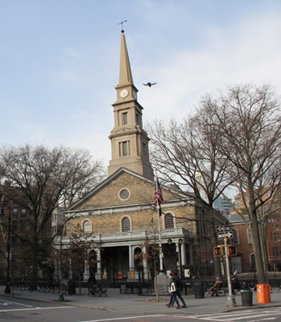  - still known for its diverse community, vibrant nightlife and artistic sensibility, although in recent decades it has been argued that gentrification has changed the character of the neighborhood  - St. Mark’s in the Bowery: The church opened its doors to all the critical thinkers of the time: Anti-Vietnam movement, communists during McCarthy area, lesbian and gay people, Black Panthers…  BIT OF HISTORY…  1950s, 60s: artists moved to the East Village Beat Generation: Jack Kerouac, Allen Ginsberg, William Burroughs.... pop-artists: Andy Warhol, Jazz: John Coltrane…  1970s: Drug dealers moved in, the East Village became an infamous, dangerous place  1980s: Artists moved in again starting from the west, very international community (Whites, Blacks, Hispanics…), colorful neighborhoods, little mosaics on lampposts and walls symbolize the multicultural patchwork community, nice yards, flowers, artwork…  Walk through the ABCs (the streets that connect avenues A, B and C and get an impression of the area.  Present Day: Rents have risen again, become unaffordable for many residents, Yuppies moving in…  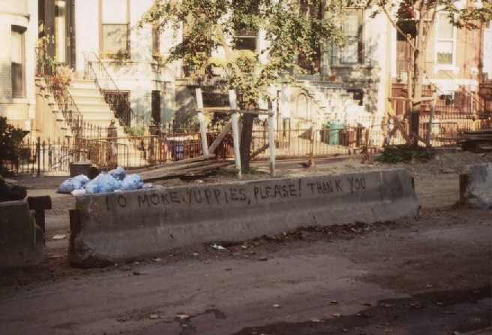  No more Yuppies, please!  INTERESTING PLACES AND STREETS TO VISIT…  - The Nuyorican Poets Café (3rd St. between Ave. B and C)  - Appartment of Allen Ginsberg, Jack Kerouac and William Burroughs  (206 East 7th St.)  - Les Deux Megots Coffeehouse (7th St.)  - Café Le Metro (2nd Ave)  - Tenth Street coffeehouse  - St. Mark’s in the Bowery: church that supported the artists and dissidents, opened its doors to all the critical thinkers of the time: Anti-Vietnam movement, communists during McCarthy area, lesbian and gay people, Black Panthers… (2nd Ave and 10th Street)  - The Fillmore East: concert hall where Elton John, Janice Joplin, The Doors… performed in the 70s (2nd Ave)  - McSorley's Old Ale House, generally known as McSorley's: oldest "Irish" tavern in NYC, dusty bar – hasn’t been dusted since the 1800s… just for a quick look! (15 East 7th Street)  - 2nd and 3rd street, Jewish Delis  Read “The Beat Generation in the East Village” by Allen Ginsberg on page 63 and the opening of Ginsberg’s poem “Howl” (page 65). | Text (14)  Text (15)

Gentrification
We are going to see the different stages of gentrification in these areas. Gentrification is a shift in an urban community toward wealthier residents and/or businesses and increasing property values. This means, a cheap, run-down area is turned into a posh neighborhood.
As you walk through the area note the different stages. We will discuss your impressions later.
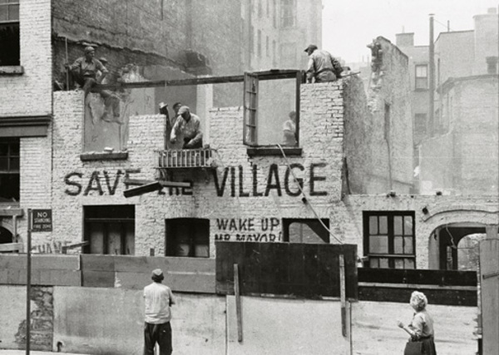
- Artists find a cheap area where they can afford the rents for studios and apartments. They move in and start a lively, vibrant community.
- Galleries, shops, bars and restaurants follow
- Real estate agents start to sell the area as an arty area. They attract people who want to take part in the new, vibrant, bohemian life-style: Wall Street yuppies, advertising people, dentists, lawyers…
- Rents rise and the artists move away because they can no longer afford to live there. They move to another cheap, run-down area and start again.
SoHo | We’ll then walk through SoHo (Wonster Street, Broome Street) to Little Italy and have dinner in Chinatown.  Read the chapter on “Chinatown” from The Heart of the World.  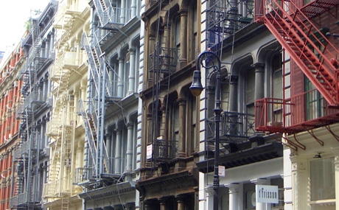 | Text (16) on page 66

The Beat Generation in the East Village: Allen Ginsberg (1926-1997)
Allen Ginsberg was an American poet and diarist, highly visible with Jack Kerouac and William Burroughs in the beat generation literary movement that burst into prominence in the 1950s.
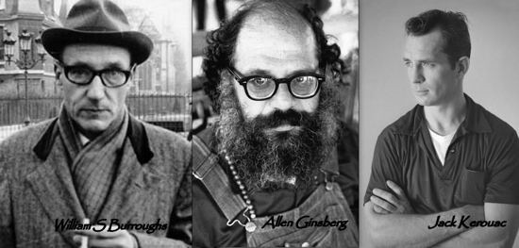
Ginsberg's poem HOWL (1956) is considered to be one of the most significant products of that movement. However, before the radical work he underwent a long apprenticeship in traditional rhymed and metered lyrics.
I saw the the best minds of my generation
destroyed by madness, starving hysterical
naked,
dragging themselves through the negro
streets at dawn looking for an angry fix
angelheaded hipsters burning for the ancient
heavenly connection to the starry dynamo
in the machinery of night.
(from Howl!)
Allen Ginsberg was born in Newark, New Jersey. His parents were second-generation Russian-Jewish immigrants, left-wing radicals interested in Marxism, nudism, feminism, all modern ideas. Louis Ginsberg (1895-1976), his father, was a teacher and poet, whose work appeared susch publications as the New York Times Magazine. During Ginsberg's childhood his mother, Naomi (Levy) Ginsberg, started to suffer from paranoia. She was institutionalized, and eventually lobotomised. Naomi Ginsberg died in an asylum in 1956. Her life is the subject of Ginsberg's poem 'Kaddish', which is considered among his greatest achievements. The poem was written in one 40-hour session as a compensation of her funeral service, where weren't enough male mourners present for the rabbi to read the funeral elegy, the kaddish. It begins with Ginsberg's sense of loss and moves on to document his mother's life and death. "O mother / what have I left out / O mother / what have I forgotten / O mother / farewell".
During Depression era the family lived in Paterson, where Ginsberg found the poems of Walt Whitman. "Where are we going, Walt Whitman? The doors close in an hour. / Which way does your beard point tonight?" (from 'A Supermarket in California') He graduated from a public high school and decided to study law. Ginsberg won a scholarship from the Young Men's Hebrew Association of Paterson to Columbia University, where he changed his major to English. His studies started well: he became a star student and gained fame in the off-campus underground, making friends with Jack Kerouac and William Burroughs. Another important person was Neal Cassady, whose enormous sexual appetite helped Ginsberg to accept his own homosexuality. In 1943 he met and fell in love with his fellow student Lucien Carr.
In the aftermath of a murder investigation, in which Lucien Carr was convicted, Ginsberg was ordered to undergo psychiatric counseling. He was suspended from the university for a year. Before receiving his B.A. from Columbia University in 1949, Ginsberg worked as a welder in the Brooklyn naval yards, as a dishwasher, night porter, and a copy boy.
Ginsberg's troubles with the law continued. His flatmate, the writer and and hustler Herbert Huncke, used the house as a repository for stolen goods. They were arrested after a car chase; Ginsberg's name was found on papers left in the car, which was stolen. Ginsberg pleaded insanity - he had heard in his East Harlem apartment a disembodied voice reciting Blake's Songs of Innocence And Experience. Ginsberg then spent eight months at the Columbia Psychiatric Institute. There was also Carl Solomon, a disciple of Artaud, whom he dedicated later the Howl!. Ginsberg returned to Paterson, where he met the writer William Carlos Williams and the young poet Gregory Corso. He also experimented with peyote. Later he campaigned for the liberation of American anti-drug laws. Along with Timothy Leary and Ken Kesey he was a central figure of the psychedelic movement. Ginsberg also wrote such drug poems as 'Mescaline,' Lysergic Acid' and 'Laughing Gas'.
Before devoting himself entirely to poetry, Ginsberg worked for a short time for Newsweek and as a market research consultant in New York and San Francisco (1951-53). In San Francisco Ginsberg took a room near Lawrence Ferlinghetti's bookstore and started to compose Howl!. William Carlos Williams, his mentor, claimed that Ginsberg had finally found his voice. Howl! gained immediate fame in 1955 at a poetry reading at the Six Gallery in San Francisco. The poem was published by Lawrence Ferlinghetti's City Light Press, with a foreword by Williams: "Hold back the edges of your gowns, Ladies, we are going through hell." The police seized the entirely printing on the grounds of obscenity: Ginsberg's loudly declared homosexuality was explicitly expressed in the book. The matter went to trial and Ginsberg used his fame in the publication of Kerouac's On the Road (1957) and Burroughs's Naked Lunch (1959).
Howl! is a long, free-verse poem, reminiscent of Walt Whitman and influenced by the American Trancendentalists. It exemplifies Ginsberg's poetics of spontaneous composition with attention paid to the natural wanderings of the mind and the rhythms of breathing. "All you have to do," Ginsberg once said, "is think of anything that comes into your head, then arrange in lines of two, three or four words each, don't bother about sentences, in sections of two, three or four lines each." From the beginning, the work was designated to be read aloud. Howl! became one of the symbols of the liberation of American culture in the 1950s from an academic formalism and political conservatism. Influenced by the mysticism and poetics of Blake, Howl! celebrated and lamented with Old Testament rhythms the casualties of capitalism and consumer society, and in particular the lives of bohemians, his friends. The final part, 'Footnote to Howl' is a hymn of praise: because of human love, the world is holy, despite the nightmare.
After the death of his mother, Ginsberg signed onto a ship sailing to the Arctic Circle. It marked the beginning of his travels both at home and abroad. Trips to the far East and India with his lover Peter Orlovsky inspired the collection THE CHANGE (1963). From the position of Beat Generation spokesman, Ginsberg continued as one of the central characters of the counter-culture in the 1960s . He lectured at universities, opposed the Vietnam War, marched against the C.I.A. and the Shah of Iran, and was arrested in the riots during the 1968 Democratic Convention in Chicago. Cuba deported him after he protested at the regiment's treatment of homosexuals and called Che Guevara ''cute''. The students of Prague elected him 'The King of May' - he was soon deported by the Czech authorities.
Ginsberg's turning to Buddhism and a follower of guru Chögyam Trungpa affected deeply his poetry and world view. After Kerouac's death he helped to found the Jack Kerouac School of Disembodied Poetics of the Naropa Institute, a Buddhist university, and also taught there. Among Ginsberg's major collections in the 1960s are KADDISH AND OTHER POEMS (1961), REALITY SANDWICHES (1963), which includes 'The Green Automobile', a fantasy about Neal Cassidy, and PLANET NEWS (1968), echoing the anti-war demonstrations and 1960s radicalism. In the 1970s appeared FIRST BLUES (1975), POEMS ALL OVER THE PLACE (1978). In 1972 Ginsberg won the National Book Award for THE FALL OF AMERICA. Some of his talks on poetry and politics were published in ALLEN VERBATIM (1974).
In the 1970s Ginsberg was jailed for his part in an anti-Nixon protest, he toured with Bob Dylan and campaigned on ecological issues. He wrote 'Plutonium Ode' to be read aloud at a public demonstration in Colorado and was arrested again. In the 1980s he opposed Reagan's covert policies in Nicaragua, and worked as a visiting professor at Columbia (1986-87) and taught at Brooklyn College. His 800-page COLLECTED POEMS 1947-1980 was published in 1984.
JOURNALS, EARLY FIFTIES EARLY SIXTIES appeared in 1977 - throughout his life Ginsberg kept scrapbooks, cuttings files, journals, notebooks, and other records of his life and activities. This journal was an account of Ginsberg's trip to South America in the footsteps of Burroughs to find the hallucinogen yagé. SELECTED GAY POEMS AND CORRESPONDENCE (1978) was a collection of poems and letters, exchanged between Ginsberg and Peter Orlovsky. In PLUTONIAN ODE (1982) Ginsberg returned to the peaceful protest outside a plutonium bomb trigger factory, in which he succeeded with his friends to stop a train carrying nuclear waste. Ginsberg died in 1997 of liver cancer at the age of 70. The plans for a MTV Unplugged performance with such musician as Bob Dylan and Paul McCartney were never realized. Ginsberg's personal archives are collected at Stanford University.
http://www.kirjasto.sci.fi/ginsberg.htm

“Howl” by Allan Ginsberg
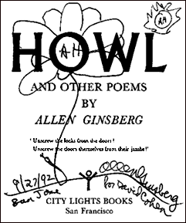
I saw the best minds of my generation destroyed by madness, starving hysterical naked,
dragging themselves through the negro streets at dawn looking for an angry fix,
angelheaded hipsters burning for the ancient heavenly connection to the starry dynamo in the machinery of night,
who poverty and tatters and hollow-eyed and high sat up smoking in the supernatural darkness of cold-water flats
floating across the tops of cities contemplating jazz,
who bared their brains to Heaven under the El and saw Mohammedan angels staggering on tenement roofs
illuminated,
who passed through universities with radiant cool eyes hallucinating Arkansas and Blake-light tragedy among the
scholars of war,
who were expelled from the academies for crazy & publishing obscene odes on the windows of the skull,
who cowered in unshaven rooms in underwear, burning their money in wastebaskets and listening to the Terror
through the wall,
who got busted in their pubic beards returning through Laredo with a belt of marijuana for New York,
who ate fire in paint hotels or drank turpentine in Paradise Alley, death, or purgatoried their torsos night after night
with dreams, with drugs, with waking nightmares, alcohol and cock and endless balls,
incomparable blind; streets of shuddering cloud and lightning in the mind leaping toward poles of Canada &
Paterson, illuminating all the motionless world of Time between,
Peyote solidities of halls, backyard green tree cemetery dawns, wine drunkenness over the rooftops, storefront
boroughs of teahead joyride neon blinking traffic light, sun and moon and tree vibrations in the roaring winter dusks
of Brooklyn, ashcan rantings and kind king light of mind,
who chained themselves to subways for the endless ride from Battery to holy Bronx on benzedrine until the noise of
wheels and children brought them down shuddering mouth-wracked and battered bleak of brain all drained of
brilliance in the drear light of Zoo,
who sank all night in submarine light of Bickford's floated out and sat through the stale beer after noon in desolate
Fugazzi's, listening to the crack of doom on the hydrogen jukebox,
who talked continuously seventy hours from park to pad to bar to Bellevue to museum to the Brooklyn Bridge,
lost battalion of platonic conversationalists jumping down the stoops off fire escapes off windowsills off Empire State
out of the moon,
yacketayakking screaming vomiting whispering facts and memories and anecdotes and eyeball kicks and shocks of hospitals and jails and wars,
… If you want to read the whole poem, you’ll easily find it on the internet.

The Heart of the World... Chinatown by Nik Cohn
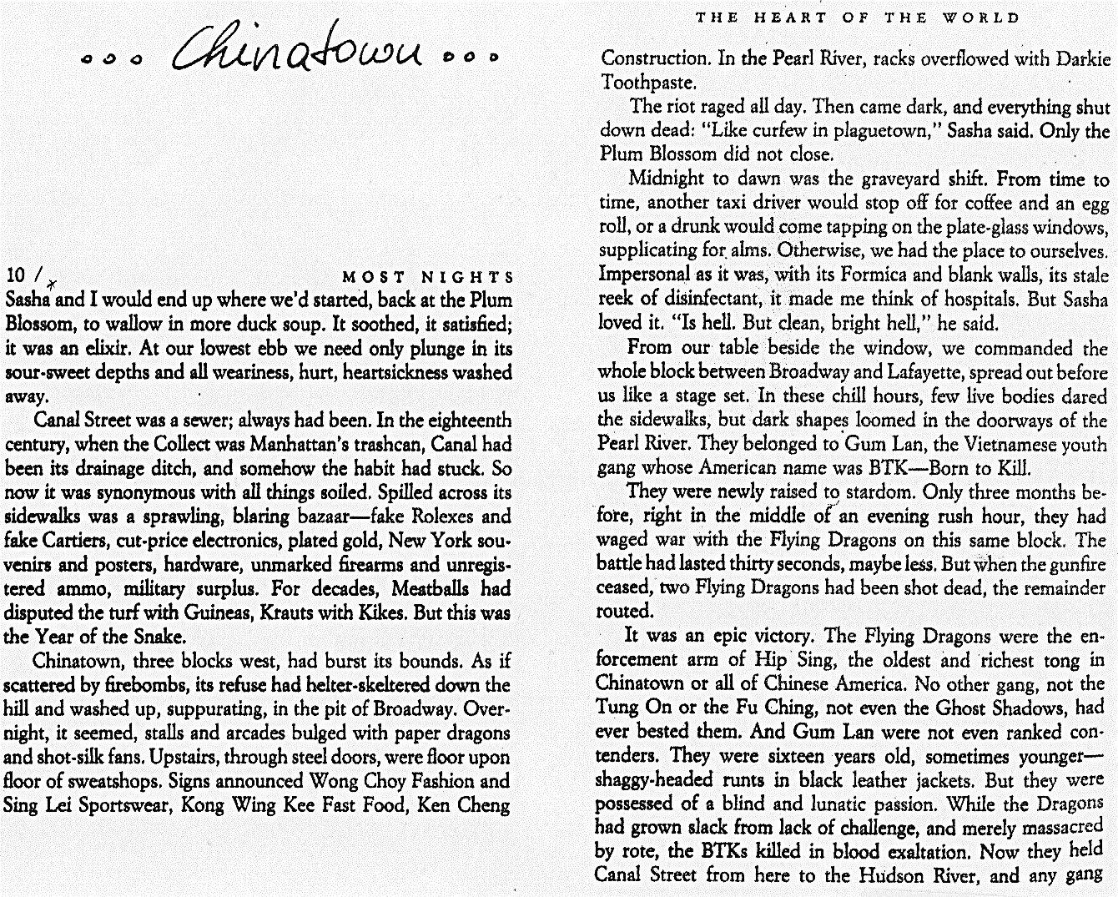
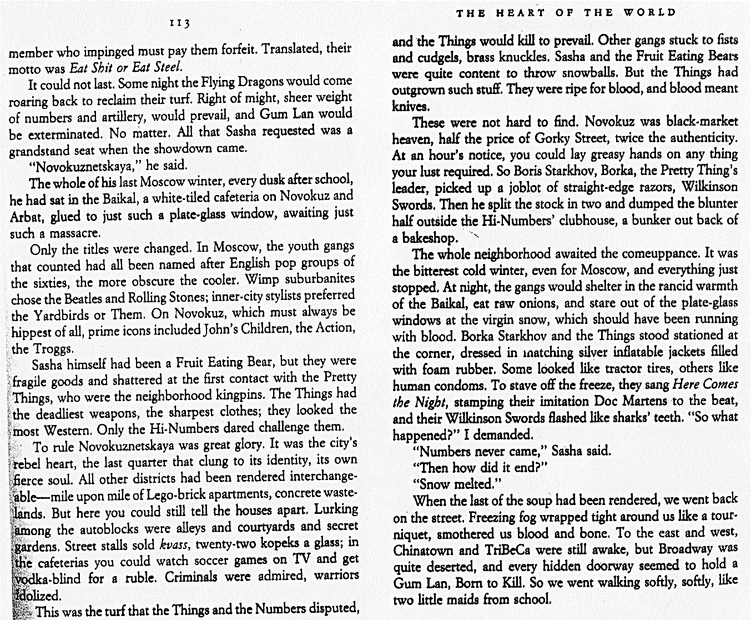
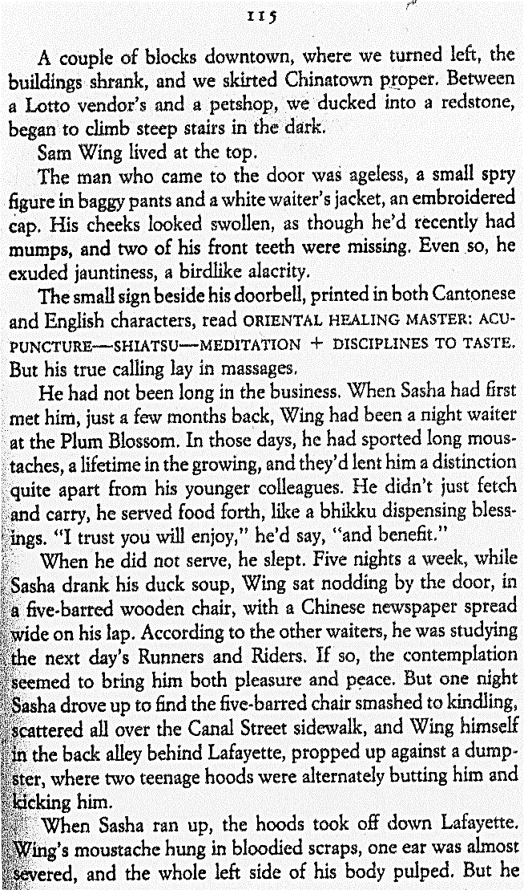 | 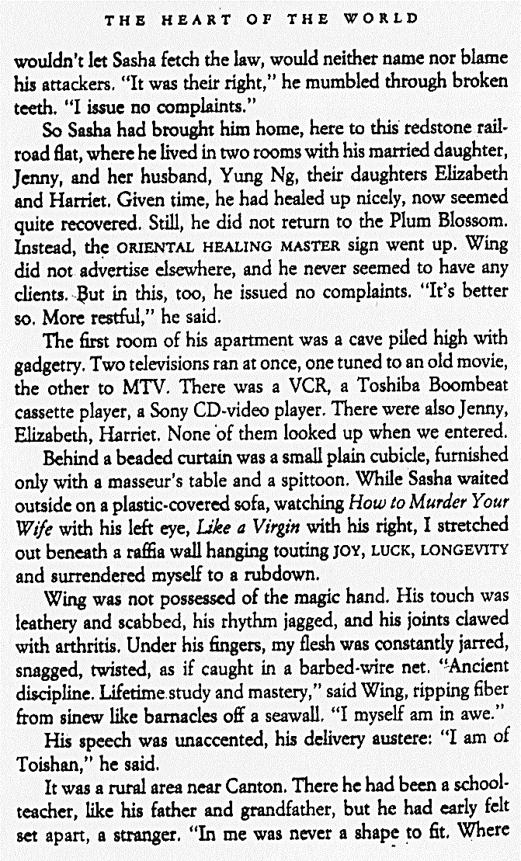
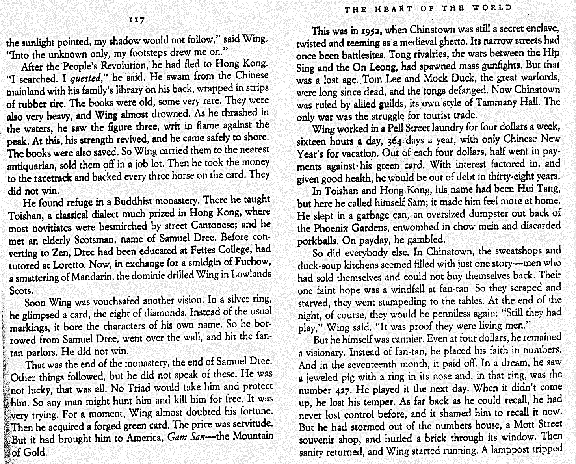
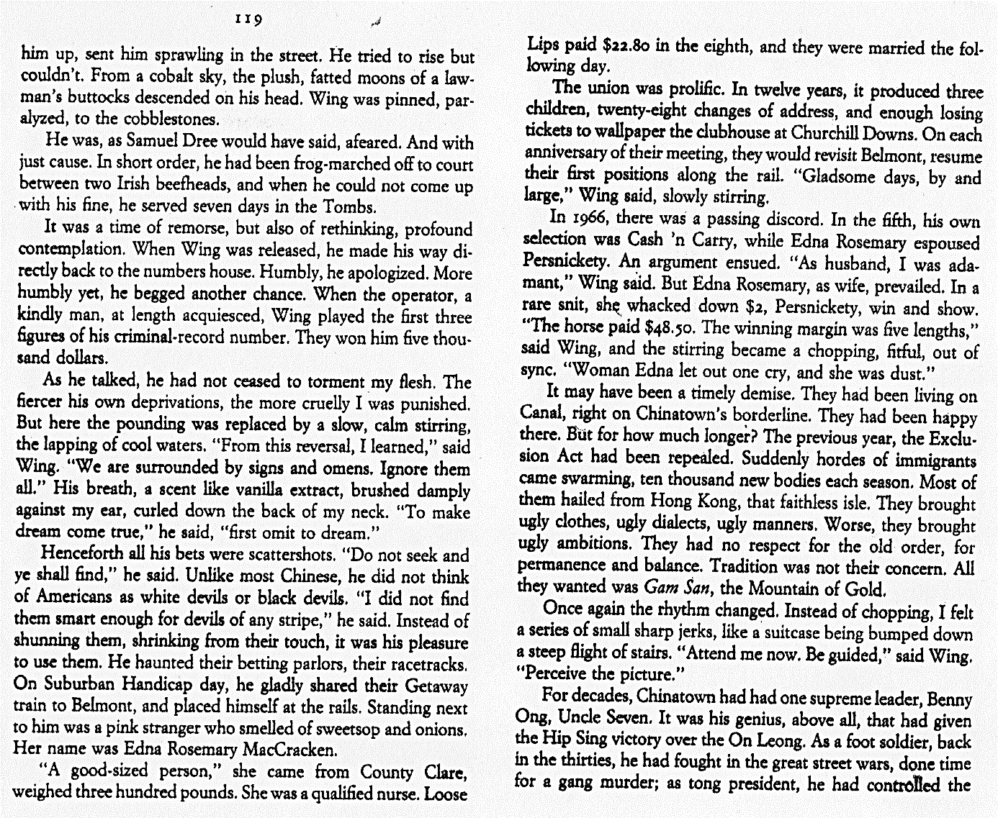
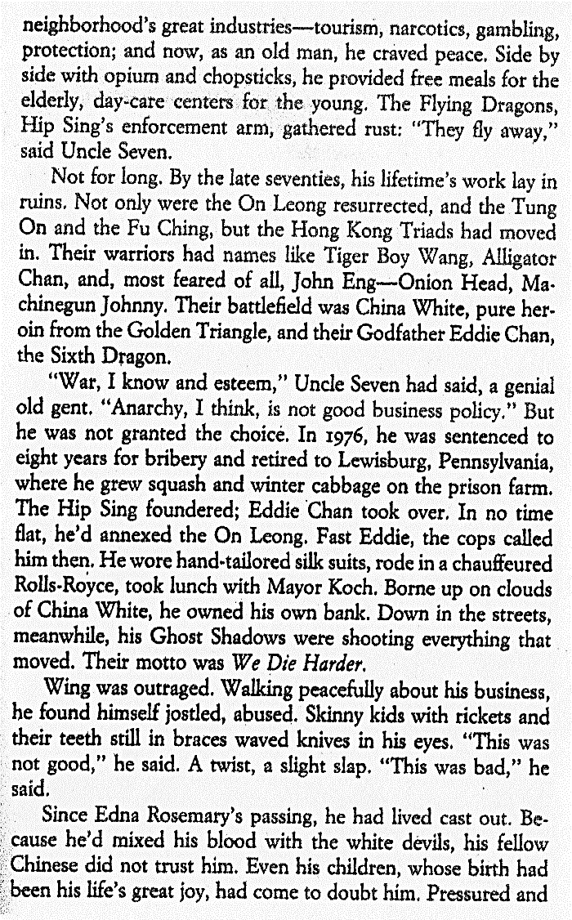 | 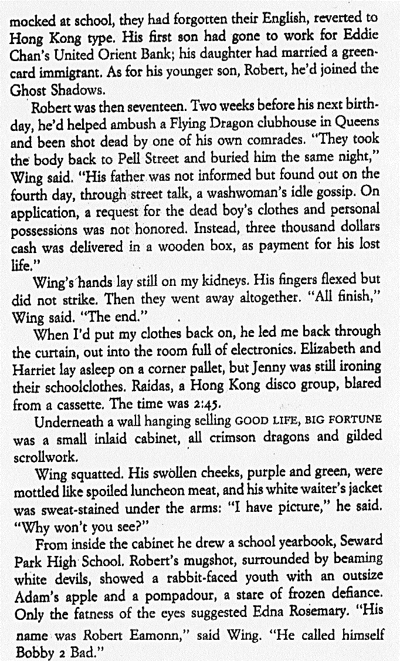
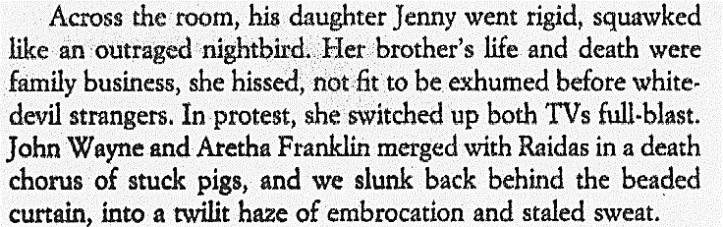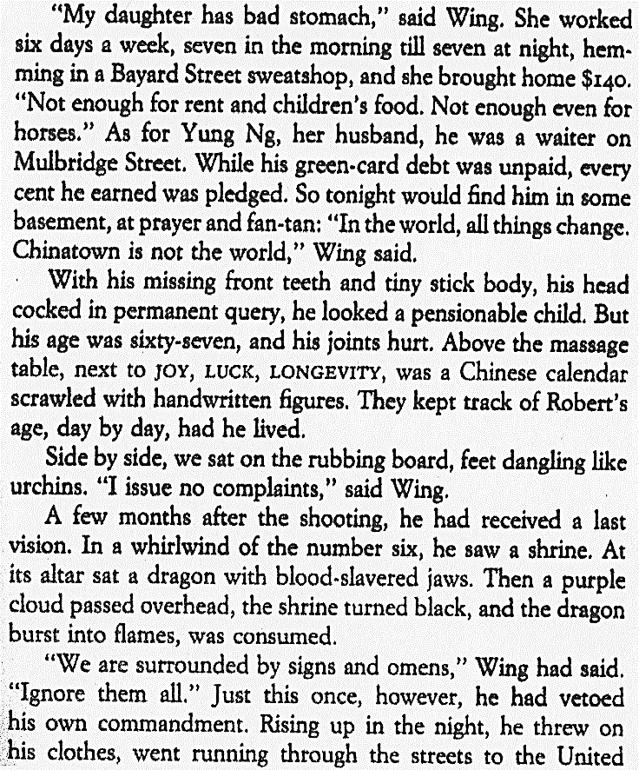 | 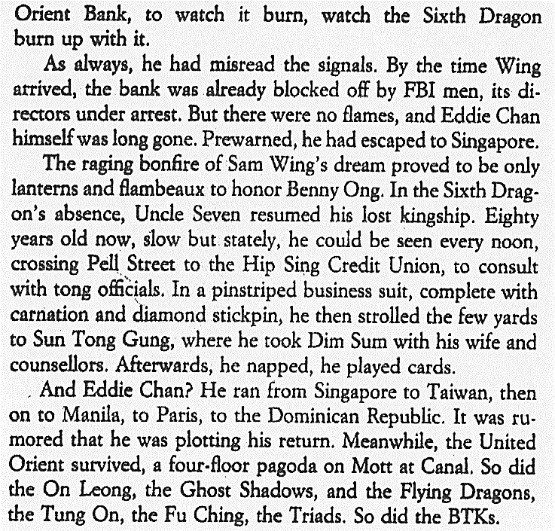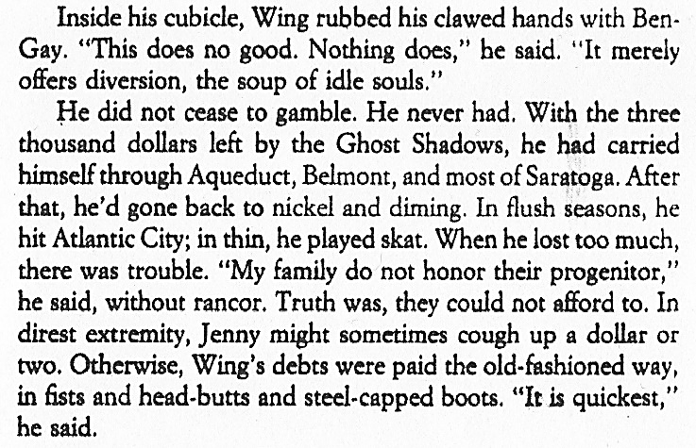
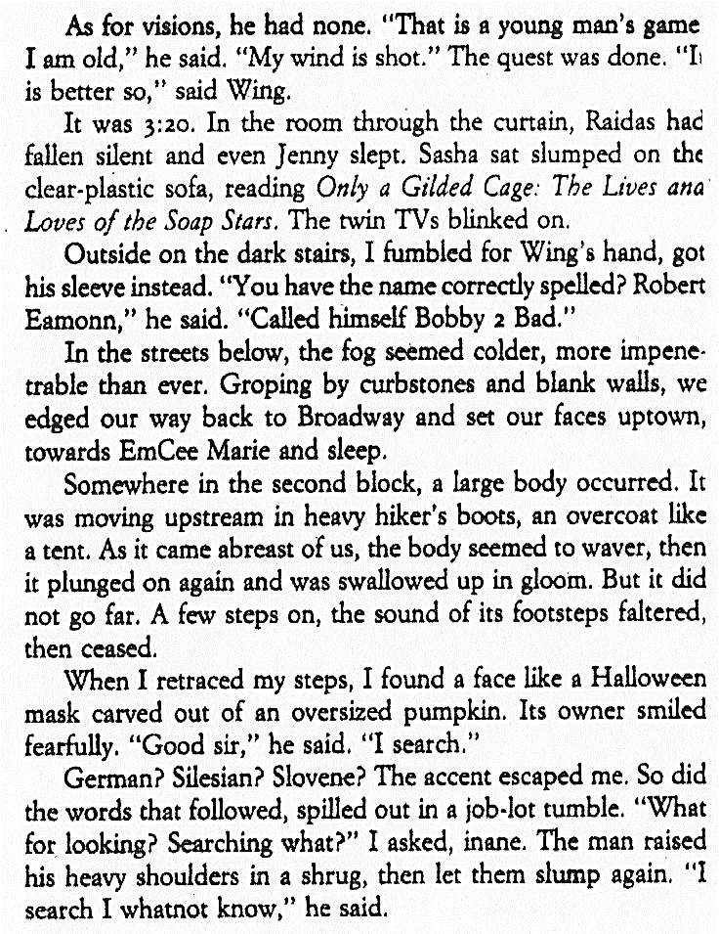

Exploring the Upper West Side
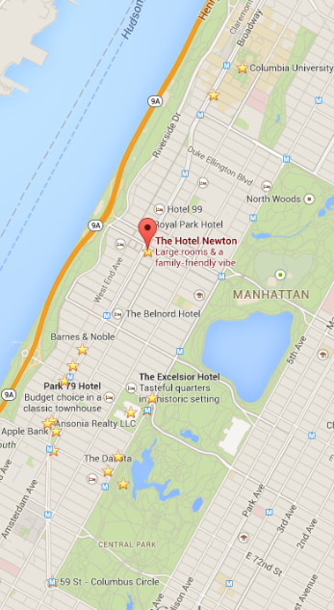
Walking down Broadway from our hotel:

he Upper West Side is one of Manhattan's most prosperous neighborhoods, but it lacks the stuffiness and sterility of the Upper East Side, that enclave of the super-rich just across the park. Instead, this is home to bankers, lawyers, media types, rumpled intellectuals, yuppies pushing strollers and out-of-work actors walking their dogs. It's a livable, convenient neighborhood, with a tiny dash of hip and a decidedly liberal bent (hence its nickname, the People's Republic of the Upper West Side).
Once upon a time, when most of Manhattan was concentrated way downtown, this was considered the country-rural farmland that was much too remote for development. Obviously, development did come, originally led by grand apartment buildings, many of which stand to this day. The neighborhood declined in the mid-20th century, as thousands of poor Hispanic immigrants settled here; these were the gang-ridden mean streets depicted in West Side Story. But gentrification began in the late 1960's, spurred by the construction of Lincoln Center. Patches of the neighborhood remained mired in poverty and crime well into the 1980's, but after a couple of stock-market booms, the entire West Side has now been thoroughly gentrified, with skyrocketing apartment prices. Residents bemoan the ever-widening presence of big-chain mega-stores (you can't throw a rock without hitting a Starbucks these days), but a few mom-and-pop stalwarts remain. This is a good walk if you'd like to see how New Yorkers really live outside the bustle of Midtown.
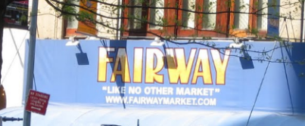


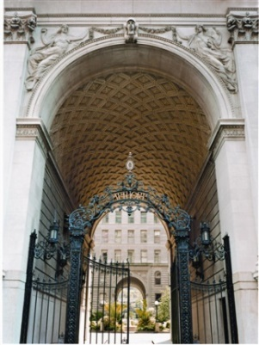
[…]Continuing south down Broadway, you'll pass a few of the retail landmarks that define the neighborhood. Between 83rd and 82nd Streets is a Barnes & Noble superstore. West Siders railed against its presence (as West Siders are wont to do) when it arrived in the early 1990's, eventually crushing the independent Shakespeare & Co. a block south, but it has won over locals with its massive selection and frequent appearances by high- profile authors. At 80th Street stands a West Side icon, Zabar's. This is one of the city's top gourmet stores, with a dizzying selection of cheeses, breads, prepared foods, salads and much more. You may want to pick up a few items now, for a picnic in Central Park later on the tour. Farther south, the massive Apthorp apartment building dominates an entire city block between 79th and 78th Streets. Take a peek inside the iron gates to envy the residents' private courtyard.
At 74th Street, you'll see Fairway, another West Side institution, and the best place in town to buy fabulous produce at bargain prices. This is another good place to assemble your picnic.
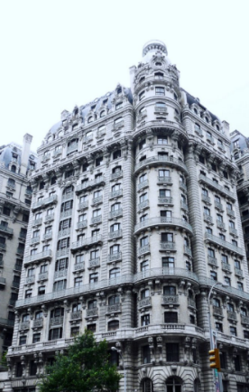
A block farther south stands the grand Ansonia Hotel, a wedding-cake confection taking up an entire block between 74th and 73rd Streets. Originally opened in 1904 as a luxury residential hotel, the Ansonia offered its tenants a grand ballroom, a swimming pool, a theater and a system that sent messages swooshing in pneumatic tubes from room to room. Live seals splashed in the fountain, and W. E. D. Stokes, the architect, kept a pet bear and chickens in the roof garden. Celebrities from Enrico Caruso to Babe Ruth have lived here, and the Chicago White Sox conspired here to throw the 1919 World Series.
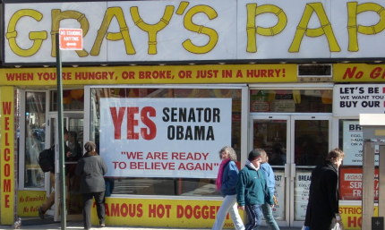
Cross over to the east side of Broadway. Between 74th and 73rd Streets is the monumental Apple Bank for Savings, with a heavy limestone facade and intricate ironwork doors. Continue down to 72nd Street, where you might want to stop in at Gray's Papaya for the "recession special" (a hot dog and a papaya drink for $1.95). Take 72nd Street east, where you'll spot a branch of Krispy Kreme on the north side of the street (double-dare you to resist if the "Hot Doughnuts Now" sign is lit).
Now turn left on Columbus and wander uptown for several blocks, stopping at any boutique that catches your fancy. As you approach 77th Street, you'll see the grounds of the American Museum of Natural History. This is one of New York's top attractions, with a world-class collection of dinosaurs. Stop in if you have time, or continue up the Columbus Avenue side, and take the path through the museum lawn, passing the New York Times time capsule (established at the turn of the millenium and designed by Santiago Calatrava) at 79th Street. The path curves around the building at 81st Street.
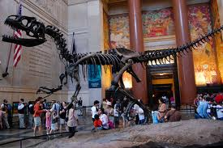
The American Museum of Natural History is one of the largest and most innovative natural history museums in the world. Journey through the universe in the spectacular Rose Center for Earth and Space. Walk through a re-creation of an African rain forest in the Hall of Biodiversity. See the world’s largest collection of dinosaur and other vertebrate fossils, with more than 600 specimens on display.
New York Pass grants you free admission to the American Museum of Natural History.
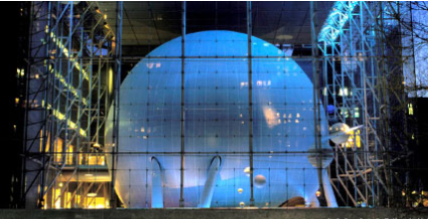
Up ahead you'll see the glorious Rose Center for Earth and Space. Even if you don't have time for the riveting Harrison Ford-narrated Space Show, you can admire the building, a stunning glass cube enclosing a glowing white globe.

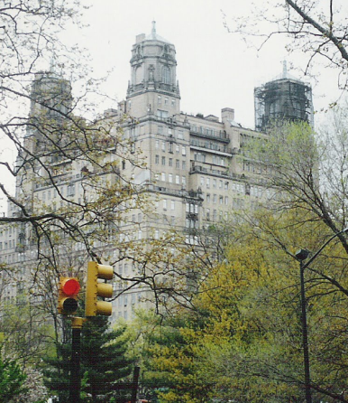
At the corner of 81st Street and Central Park West rise the three cupola-topped towers of the Beresford, another grand apartment building. Jerry Seinfeld has a multimillion-dollar duplex here, and is currently building a private garage on 83rd Street with space for his collection of 20 Porsches - so he need not ever have a George Costanza-style meltdown over finding a parking spot.
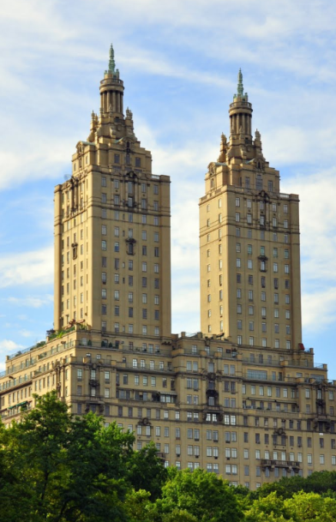
Turn right down Central Park West, heading past the equestrian statue of Teddy Roosevelt outside the Natural History Museum. Below 77th Street, you'll pass the New-York Historical Society, a manageably sized museum with fascinating exhibits of the world's most unmanageable city.
Between 75th and 74th Streets stands the San Remo, another landmark apartment building designed by Emery Roth, architect of the Beresford. In the depths of the Depression, the projects fared poorly, and the two buildings were sold together for the total sum of $25,000 (a fee that would not buy you a broom closet in the San Remo today).
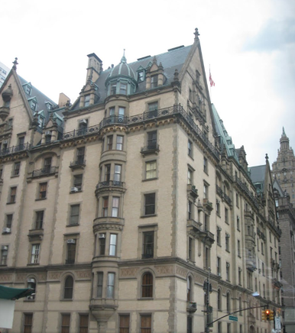
At Central Park West and 72nd Street stands the brooding fortress-like hulk of the Dakota (so named because the developer's friends told him the site was so far north that it might as well be in Dakota territory). Though it's been home to an illustrious group of tenants over the years-Lauren Bacall, Boris Karloff, Judy Garland, Leonard Bernstein, William Inge and many more-the Dakota will forever be associated with John Lennon, who was tragically gunned down outside its gates on 72nd Street. John's widow, Yoko Ono, still lives here.
It's only appropriate, after visiting the Dakota, to make a pilgrimage into Central Park across the way. Just inside the 72nd Street entrance is Strawberry Fields, a beautifully landscaped area dedicated to Lennon's memory. It's one of the loveliest, most tranquil spots in the park, and a perfect place to spread out your picnic and end your tour.

http://www.nytimes.com/ref/travel/TOUR-WS.html (9 March 2014)
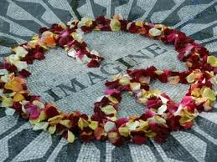
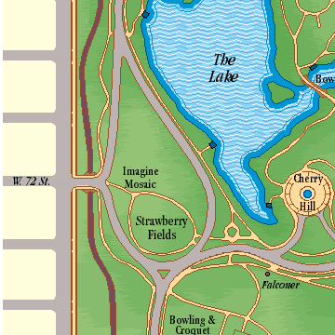

The subway (Interborough Rapid Transit)
yuppie = a young, ambitious, and well-educated city-dweller who has a professional career and an affluent lifestyle

