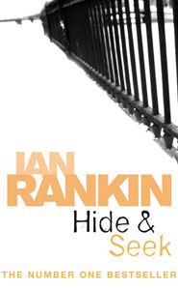

Plot summary
Detective Inspector John Rebus finds the body of an overdosed drug addict in an Edinburgh squat, laid out cross-like on the floor, between two burned-down candles, with a five-pointed star painted on the wall above. Some of his colleagues are inclined to categorise it as the routine death of a "junkie", but Rebus is perturbed by some unusual facts of the case: a full package of heroin in the dead man's room, and some mysterious bruises on his face and body. Rebus takes seriously a death which looks more like a murder every day, and he begins to investigate the true circumstances of the death. As part of his investigation, Rebus finds the young woman named Tracy who knew the dead man and heard his terrifying last words: "Hide! Hide!"
It emerges that the dead man was a photographer who took and hid some sensitive photos in a specialist private members' club - Hyde's - where highly-connected people in society watch illegal boxing. Rebus is able to arrest Hyde's owner and several high profile members, but to his outrage and disgust all the prisoners die suspicious deaths: the powers-that-be are covering it up to prevent scandal.

[edit] Real-life scandal
Shortly after Rankin moved to London, there was a real-life case of male prostitutes bribing lawyers and judges, similar to some parts of the book: "questions were asked in parliament" and two lawyers began to investigate the police investigation. "To everyone's surprise, this inquiry found that the allegations were false. Police officers involved in the case found themselves demoted..." ^{[1]}

