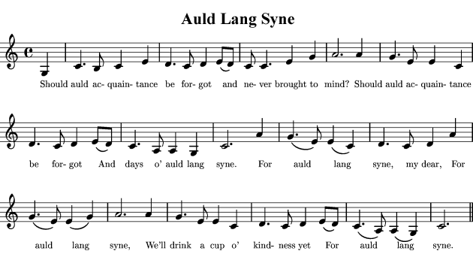AULD LANG SYNE

Throughout the English-speaking world, Auld Lang Syne is traditionally sung on New Year’s Eve (known as Hogmanay in Scotland). That tradition does not hearken back to Burns but rather only to Canadian band leader Guy Lombardo who sang at midnight January 1, 1929 in the Roosevelt Hotel in New York City. Guy Lombardo's orchestra played the song every New Years Eve, in live broadcast from New York, until 1976. Since then, their recording has been played each year as part of the Times Square "ball drop."

Robert Burns sent a copy of the original song to the British Museum with this comment: "The following song, an old song, of the olden times, and which has never been in print, nor even in manuscript until I took it down from an old man's singing , is enough to recommend any air."

♪ Listen to two rather different examples of this song:
- First verse and chorus performed by Ronnie Browne (of The Corries) on the CD called "Robert Burns, The Complete Songs: Volume 3. Published by Linn Records, 1997
- Third and fourth verses, performed by 3 Pints Gone, from their album, Auld Lang Syne
Find, underline and number the equivalents to the words in the box in Robert Burns’ lyrics.
- two  - from  - to  - broad  - have | - since  Auld Lang Syne (Original)  Should auld acquaintance be forqot,  Tho' they return with scars?  These are a noble hero's lot,  Obtain'd in glorious wars;  Welcome, my Varo, to my breast,  Thy arms about me twine,  And make me once again as blest,  As I was lang syne.  O'er moor and dale with your gay friend  You may pursue the chase,  And after a blythe bottle end  AII cares in my embrace.  And in a vacant rainy day  You shall be wholly mine:  We'll make the hours run smooth away  And laugh at lang syne.  Shall Monarchy be quite forgot,  And of it no more heard?  Antiquity be razed about  And slav'ry put in stead?  Is Scotsman's blood now grown so cold,  The valor of their mind,  That they can never once reflect  On old lang syne?  - of  - take  - old  - long

Auld Lang Syne (by Robert Burns, 1788)  Should auld acquaintance be forgot,  And never brought to mind?  Should auld acquaintance be forgot,  And auld lang syne?  Chorus:  For auld lang syne, my dear,  For auld lang syne.  We'll take a cup o' kindness yet,  For auld lang syne.  And surely ye'll be your pint-stowp!  And surely I'll be mine!  And we'll take a cup o' kindness yet,  for auld lang syne.  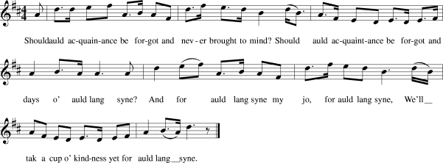We twa hae run about the braes  And pou'd the gowans fine.  We've wandered mony a weary foot,  Sin' auld lang syne.  We twa hae sported i' the burn,  Frae morning sun till dine,  But seas between us braid hae roared  Sin' auld lang syne.  And ther's a hand, my trusty friend,  And gie's a hand o' thine;  We'll tak' a right good willie-waught,  For auld lang syne. | note: Burns based his song on this.

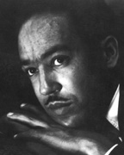Harlem
by Langston Hughes
What happens to a dream deferred?
Does it dry up
like a raisin in the sun?
Or fester like a sore—
And then run?
Does it stink like rotten meat?
Or crust and sugar over—
like a syrupy sweet?
Maybe it just sags
like a heavy load.
Or does it explode?

Answer the following questions:
- What does the speaker believe about dreams being postponed?

- What imageries can you find in the poem?

- Why is the poem called “Harlem”?

Langston Hughes (1902-1967) was part of the Harlem Renaissance and was known during his lifetime as “the poet laureate of Harlem“. He also worked as a journalist, dramatist, and children’s author. His poems, which tell of the joys and miseries of the ordinary black man in America, have been widely translated.
Harlem Renaissance, an African American cultural movement of the 1920s and early 1930s that was centered in the Harlem neighborhood of New York City. The Harlem Renaissance marked the first time that mainstream publishers and critics took African American literature seriously and that African American literature and arts attracted significant attention from the nation at large. Although it was primarily a literary movement, it was closely related to developments in African American music, theater, art, and politics.
- Write your own poem, answering the questions raised in “Harlem”.

The Flower of Scotland
Flower of Scotland was composed at 69 Northumberland Street, Edinburgh. It is the unofficial national anthem of Scotland (written in the 1960's by The Corries) translated into Scottish Gaelic. This song was adopted as the official football anthem by the SFA in 1997. It was already the official rugby anthem.

The Flower of Scotland  by Roy Williamson. The Corries http://www.corries.com/  1.  O flower of Scotland  When will we see  Your like again  That fought and died for  Your wee bit hill and glen  And stood against him  Proud Edward's army  And sent him homeward  Tae think again  2.  The hills are bare now  And autumn leaves lie thick and still  O'er land that is lost now  Which those so dearly held  And stood against him  Proud Edward's army  And sent him homeward  Tae think again  3.  Those days are passed now  And in the past they must remain  But we can still rise now  And be the nation again  And stood against him  Proud Edward's army  And sent him homeward  Tae think again | The Flower of Scotland (Gaelic translation)  (translation by John Angus Macleod)  O Fhlu\ir na h-Albann,  cuin a chi\ sinn  an seo\rsa laoich  a sheas gu ba\s 'son  am bileag feo\ir is fraoich,  a sheas an aghaidh  feachd uailleil Iomhair  's a ruaig e dhachaidh  air chaochladh smaoin?  Na cnuic tha lomnochd  's tha duilleach Foghair  mar bhrat air la\r,  am fearann caillte  dan tug na seo\id ud gra\dh,  a sheas an aghaidh  feachd uailleil Iomhair  's a ruaig e dhachaigh  air chaochladh smaoin.  Tha 'n eachdraidh du\inte  ach air di\ochuimhne  chan fheum i bhith,  is faodaidh sinn e\irigh  gu bhith nar Ri\oghachd a-ri\s  a sheas an aghaidh  feachd uailleil Iomhair  's a ruaig e dhachaidh  air chaochladh smaoin.

Scotland the Brave
A patriotic song, favoured by many as a contender for Scotland's national anthem - usually running second after Flower of Scotland although unlike Flower of Scotland considers Scotland on its own merits rather than dwelling on wars with England.
Scotland the Brave is used at the Commonwealth Games (incidentally, to be hosted in Glasgow in 2014)
It started as a pipe tune around the start of the 20th century and lyrics were added in about 1950 by Cliff Hanley (1922-1999).
Scotland the Brave  by Cliff Hanley  Hark when the night is falling  Hear! hear the pipes are calling,  Loudly and proudly calling,  Down thro' the glen.  There where the hills are sleeping,  Now feel the blood a-leaping,  High as the spirits  of the old Highland men.  Chorus  Towering in gallant fame,  Scotland my mountain hame,  High may your proud  standard gloriously wave,  Land of my high endeavour,  Land of the shining rivers,  Land of my heart for ever,  Scotland the brave.  High in the misty Highlands,  Out by the purple islands,  Brave are the hearts that beat  Beneath Scottish skies.  Wild are the winds to meet you,  Staunch are the friends that greet you,  Kind as the love that shines  from fair maidens' eyes.  Chorus  Far off in sunlit places,  Sad are the Scottish faces,  Yearning to feel the kiss  Of sweet Scottish rain.  Where tropic skies are beaming,  Love sets the heart a-dreaming,  Longing and dreaming for the homeland again. | Scotland the Brave 2007 (alternative version)  by Alan Smart http://www.youtube.com/watch?v=KK6jHFezO_8
  Land of the purple heather  Land of some shocking weather  Land of Elvis Presley's mother  Scotland the brave  Land of some high endeavours  Harry Potter, Ewan McGregor  Land of Sir Sean forever  Scotland the brave  Land o' tech computer dolls  Royal bank and Shopping Malls  Burger Kings but nae Polaris  Moscow, Houston, Texas, Paris  Hip hop, bhangla, Gaelic classes  River city, free bus passes  Rabbie Burns and bonnie lassies  Scotland the brave  Land of Mary and Prince Charlie  Adam Smith and Mick McGahey  Referendums, oor ain Parly  Scotland the brave  Land where the Poll Tax ended  Land where Dennis wis suspended  Land where Bairns they were offended  Scotland the brave  Land where the fox runs safe  Folk look forward tae old age  Our students get cash tae get clever  Warrant sales are gone forever | Liz McColgan, Henrik Larsson,  Andy Murray, Highland Dancin'  Murrayfield, the roar of Hampden  Scotland the brave  Land of all creeds and colours  Polish, English, Moslem brothers  Land where we live together  Scotland the brave  Where gay folks are defended  noo that the Clause has ended  John Knox was fair offended  Scotland the brave  James Connolly and John McLean  Still standing up for hungry weans  Annie Lennox, William Wallace  Joining in the freedom chorus  Land of the purple heather  Land of the shining rivers  Land of my heart forever  Scotland the brave  Land of the purple heather  Land of the shining rivers  Land of my heart forever  Scotland - the brave

Write your own version of “Scotland the Brave”.

