Graz City Ralley
Here is your Graz city map to help you find all the places. The numbers of the places correspond to the numbers on your map. There are 11 places to visit; plus one extra place of your choice. (Check question 12 before you start.) Decide which is the best order to do them. At each stop you will have to answer one or two questions. If you get all the answers right, you can win a prize. Stay together in your group and answer all the questions in note-form. Keep an eye on the time -- do not be late at the meeting point.
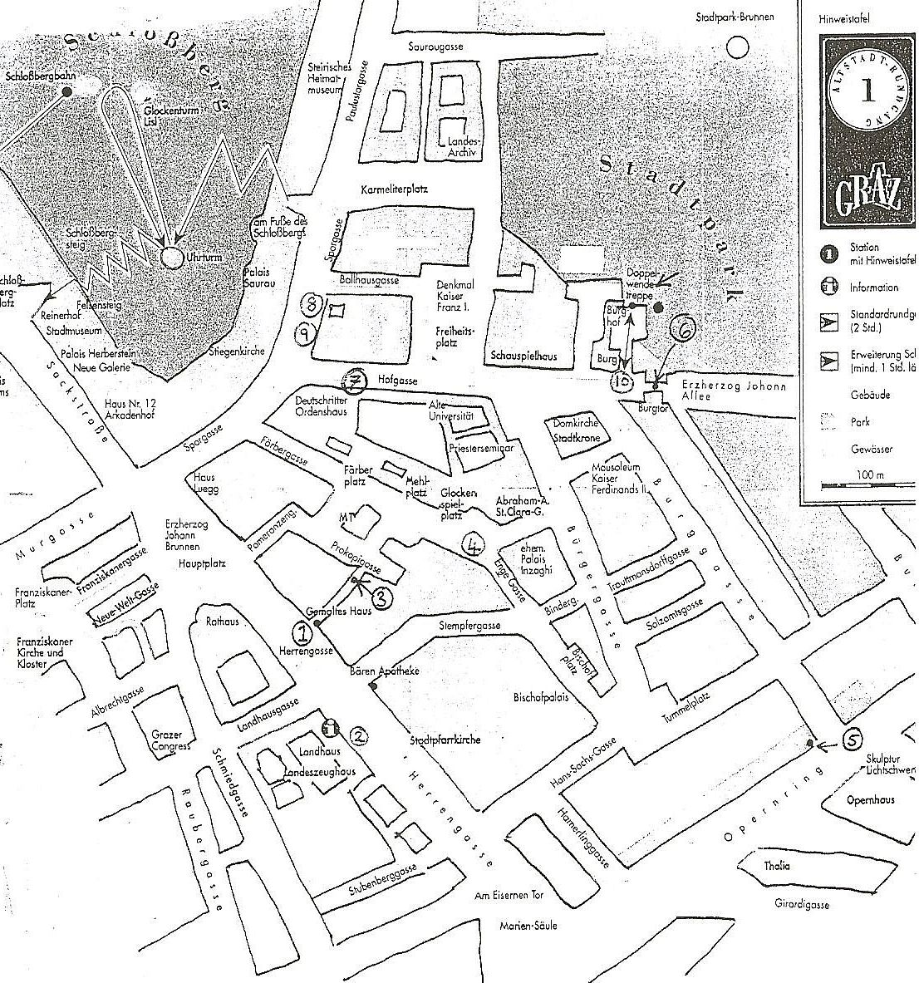
1 Hauptplatz: Fountain
At the center of the main square (Hauptplatz) there is a big fountain. The statue shows a man who has done a lot for Styria and for Graz. He is remembered as a great modernizer. He founded the University of Technology, he introduced the cultivation of potatoes in our area and he is responsible for building the bridges and train-tracks from Triest to Vienna.
What is this man's name?

2. Hauptplatz: Fountain
The four courners of the base of the fountain are facing to the NORTH- EAST - SOUTH and WEST. Figure out these directions. Which direction is the Rathaus (Town Hall)?

“Gemaltes Haus” (Herrengasse 3)
Look at the pictures which have been painted on the outside of this house. What is the main theme of the paintings? What do they show?

Take a picture.
2 “Landhaus” (Herrengasse 16)
Who built the “Landhaus” and when was it built? (To find out you may also go to the tourist office and ask – They speak English!)
Walk into the courtyard of the Landhaus. Look at the beautiful architecture which is very much like the style of buildings you would see in Venice. Look at the gargoyles (they are high up on the gutters).
What are they for?
What sort of animals do they look like?
Take a picture of the courtyard.
3. Altstadt Passage:
Now for a tricky piece of map reading! Walk through the Altstadt Passage (it is on Herrengasse - you have to cross the street from the Lnadhaus and walk a little backin the direction of the Ratghaus) into Prokopigasse. As you enter the open space turn around and look at the archway between houses 8 and 10. What do you see? Make a little sketch or take a picture?

4 “Glockenspielplatz”
This is a pleasant area where lots of tourists come to see and hear the “Glockenspiel”. If you arrive at 11 am or 3 pm the “Glockenspiel” will be in action.
Look at the green building at the corner. What symbols do you find on the façade? Draw them in the space below and take a picture.

5 “Opernhaus” (Opera House)
View the Opernhaus from the junction of Burggasse and Opernring. Look at the modern steel grid statue beside the Opernhaus.
What famous statue does it remind you of?
Do you think it fits into this environment?

6 “Burgtor”
Look at the arch and take a picture

7 “Hofgasse 10”: Renaissance House
How is this building different from the surrounding ones?

Take a picture.

8 “Sporgasse 25”
Look up. Who is looking out of the window on the top floor?
What might he be doing? What might be the story?
Take a picture.

9 Sporgasse 13
Look up at the gutters and the gargoyles. Where have you seen these before?

10 “Burg and Burghof” Hofgasse 15
This is a very important location because it contains a real treasure. Walk through the courtyard and climb the Glockenturm (bell-tower). The Doppelwendeltreppe (staircase) is an amazing feat of craft and design. Try to work out how many steps it has.

11 “Schlossberg”
Walk up the Schlossberg and explore the area.
From the Schlossberg, identify the River Mur and the Old City. What direction does the river Mur flow?
What is unusual about the clock (Uhrturm)

Take a picture.

12. Extra Question:
Make up one extra question about an interesting detail you have found on the way. Your question will be given to the group later. Let's see who can answer it.

