MYSTY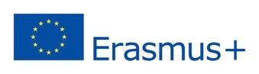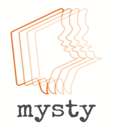

My Story Digital Storytelling Project FEEDBACK FORM

TELL US ABOUT YOUR EXPERIENCE OF BEING INVOLVED ON MYSTY
- Are you a 1) pupil or 2) parent or 3) staff member (delete as applicable)

WHAT HAVE YOU LEARNT on this project?

HAS BEING INVOLVED IN THIS PROJEcT HAD ANY IMPACT ON YOU?
- I.e.: Have you thought about your family (or other families) in a different way than before the project?
- Is there anything that you have learnt about other people either by being involved in the project or by seeing the digital stories at the St Edwards’ Mysty Oscars Event?
- Is there anything else you would like to say about the project?
.

Please email your answers to Dr. Abigail Gardner at agardner@glos.ac.uk by end of January 2018.
You can use this form by return or a answer via a simple email.
All answers will be anonymized and will be used as data in the report on Mysty that will be delivered in October 2018 and in an academic paper that will be published tbc.

