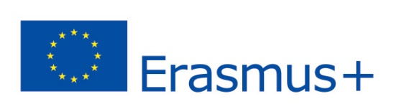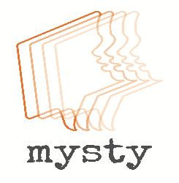
MYSTY - MyStory: Digital Storytelling Project

Tales about The Wörthersee Snake, Christmas cookies, pumpkins and a “real birthday”. Stories about special gifts, brave Eritrean aunts and great grandfathers from the Ukraine . Teenagers’ lives in their own words. After two years The MYSTY project – MyStory: Digital Storytelling Toolbox for Diversity Training in Schools is finally coming to an ending. For two years, two GIBS classes (this year’s 5a and this year’s 6b) have been part of this Erasmus+ project together with schools and universities from England, Italy and Hungary. Its aims have been to create innovative tools for pupils and teachers – specifically, digital storytelling – to share and introduce such teaching practice to enhance awareness on diversity within the school environment. GIBS teachers carrying out the project have been Ms Elizabeth Pölzleitner and Mr Robert Kozak.
Our students have produced more than 40 digital stories on topics like Food, Family or Festival, many of which will become part of the themed digital story collection on the MYSTY homepage (http://mysty.eu/stories/). 2017/18 has seen the finalization of the stories, the presentation of our stories at the partner meeting in Budapest in April and a public project presentation at GIBS on 24 May.

