Digital Storytelling in School
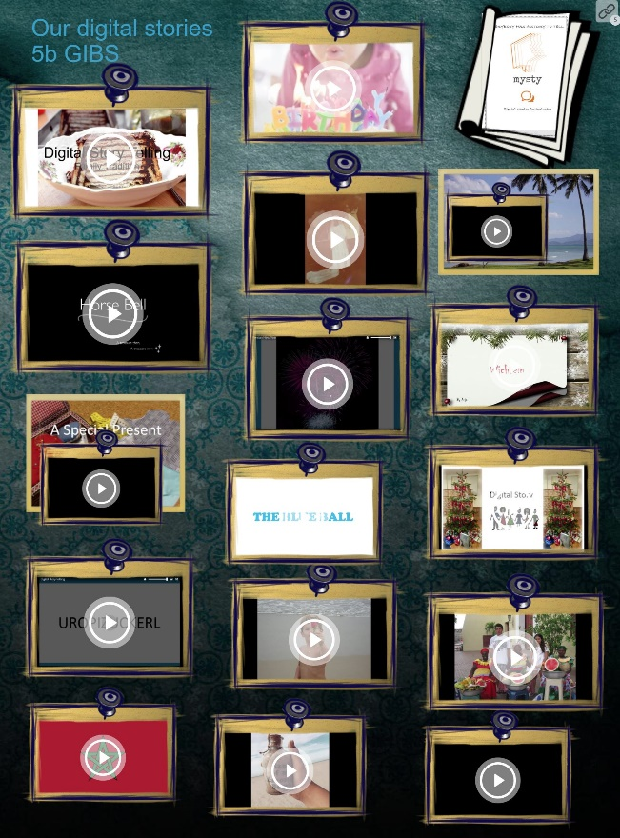
On Thursday, May 24th, Elisabeth Pölzleitner and Robert Kozak will present an interesting project on DIGITAL STORYTELLING at GIBS. The presentation starts at 6p.m. and includes
- a short introduction to the concept and goals of digital storytelling
- practical steps for teachers.
- screenings of a selection of short digital stories produced by the learners
- buffet
Digital storytelling is a really interesting method that allows learners to bring their personal stories or stories of their family culture into the classroom or even into the world wide web.
- The main goals of the project were:
- to raise the learners’ awareness of cultural aspects of their everyday lives and the people around them
- to improve the learners’ interpersonal and social skills
- to develop the learners’ sense of ownership and engagement with their work
- to increase the learners’ confidence as active participants in society (in the real and virtual world)
- to improve the learners’ story-writing skills and speaking skills in English (L2)
- to further develop the learners’ digital skills
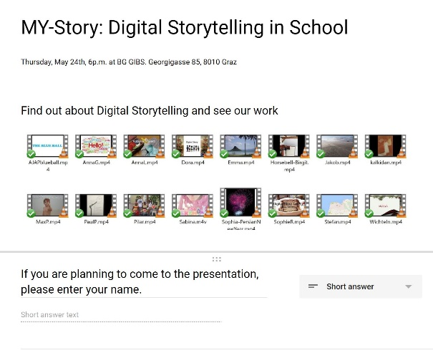
If you are interested in getting a first glimpse of digital storytelling, come to GIBS on Thursday, May 24th.
In order to plan approximately how many people to expect, it would help us if you let us know whether you are planning to come. Last minute guests are also welcome, but we'll have more good food for you if we know you're coming.
Please follow the link to the registration form: https://docs.google.com/forms/d/e/1FAIpQLScELFmLvX-1VVgKZuWyuSfU_vyxuKnfG-fIA3A4DMQA-KoQXw/viewform?usp=sf_link

