Digital Storytelling in School
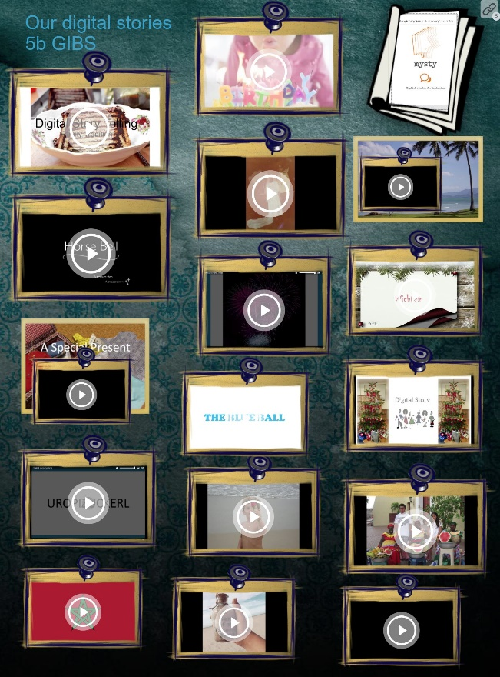
On Thursday, May 24th, Elisabeth Pölzleitner and Robert Kozak presented the results of the MYSTY DIGITAL STORYTELLING project at GIBS. The presentation covered
- a short introduction to the concept and goals of digital storytelling
- practical steps for teachers.
- screenings of a selection of short digital stories produced by the learners
- and was followed by a little reception with food and drink for all participants and visitors.
Mrs. Pölzleitner explained that Digital storytelling is a really interesting method that allows learners to bring their personal stories or stories of their family culture into the classroom or even into the world wide web.
- The main goals of the project were:
- to raise the learners’ awareness of cultural aspects of their everyday lives and the people around them
- to improve the learners’ interpersonal and social skills
- to develop the learners’ sense of ownership and engagement with their work
- to increase the learners’ confidence as active participants in society (in the real and virtual world)
- to improve the learners’ story-writing skills and speaking skills in English (L2)
- to further develop the learners’ digital skills
The culminating point of the evening was the screening of the GIBS stories. Among the 40 digital stories produced by GIBS students were tales about the Wörthersee Snake, Christmas cookies, pumpkins and a “real birthday”, stories about special gifts, brave Eritrean aunts and great grandfathers from the Ukraine. All the stories gave a glimpse of special moments in teenagers’ lives in their own words.
The high interest of the audience showed us that this was not the end of the MYSTA project. It seems that several follow-up projects in our area are going to follow next year.

