
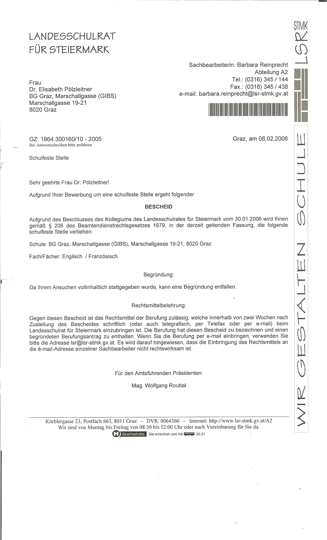
my application has been accepted
Marschallgasse was the old location of GIBS
= permanent contract at this specific school (GIBS)

