Everybody has a story to tell


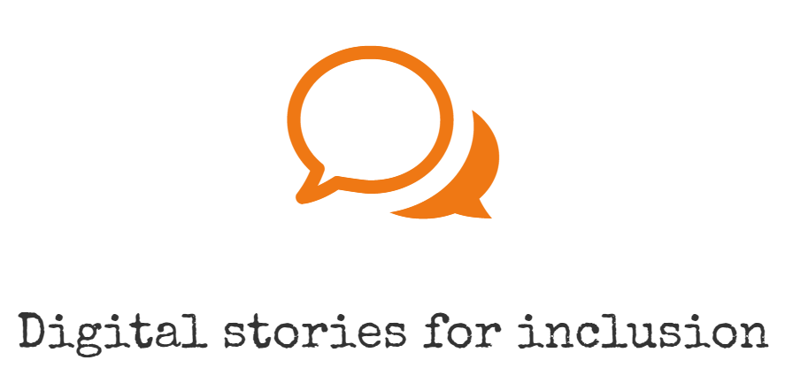

Handout for 5b, by E. Pölzleitner

My Story
Good stories do not need drama and exaggeration. Really good stories are often based on a small moment of understanding some little things in life. In this project, we will explore some important moments in our lives and narrate them in the form of digital stories. We will start by brainstorming and collecting ideas, then we will select the most interesting moments and plan how to organize and present them. ®
A few general concerns: Our stories will be part of the Erasmus + project “mysty” (My Story) and will be shared on the mysty website. (www.mysty.eu) Your identity will not be disclosed, but the fact that your stories will be published might influence your choice of stories and pictures that you want to share. Choose something that you are comfortable with and ask your parents if they agree as well.
We will present our first round of stories to our international mysty partners on May 23rd, 2017 and share our experiences during this pilot phase.
After producing our digital stories, we will write a short USER GUIDE, explaining how we have produced our stories. -In these user guides, we will review the production process and the software that we have used and share any other tips for other students who might want to produce digital stories. Your user guides will also be published on the mysty website. If the project works well, we will also present our digital stories in Budapest next year.

Technical issues:
We will produce our stories with some free video software such as Microsoft Moviemaker, Powerpoint Mix, Adobe Spark or I-movie (for those of you who own a Mac). If you would like to use any other software, please discuss this with your teacher(s).
To get a first idea of digital storytelling, watch a few sample stories on Moodle and read the story “The Ship” on the following page.
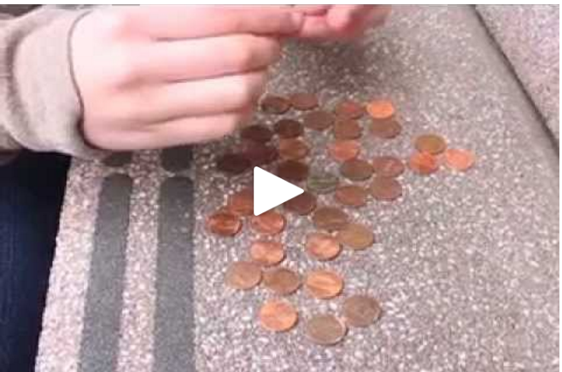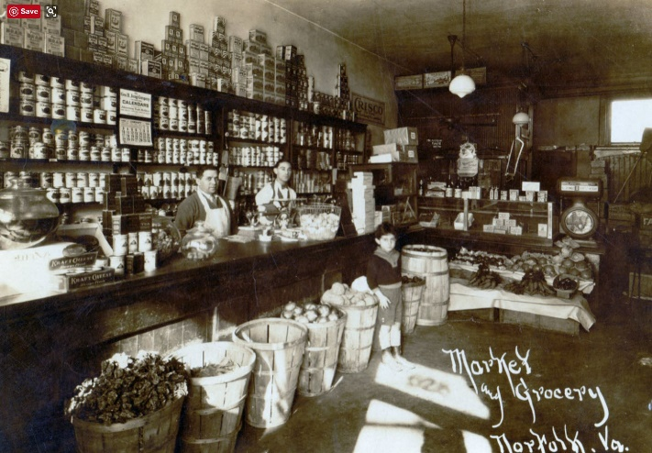

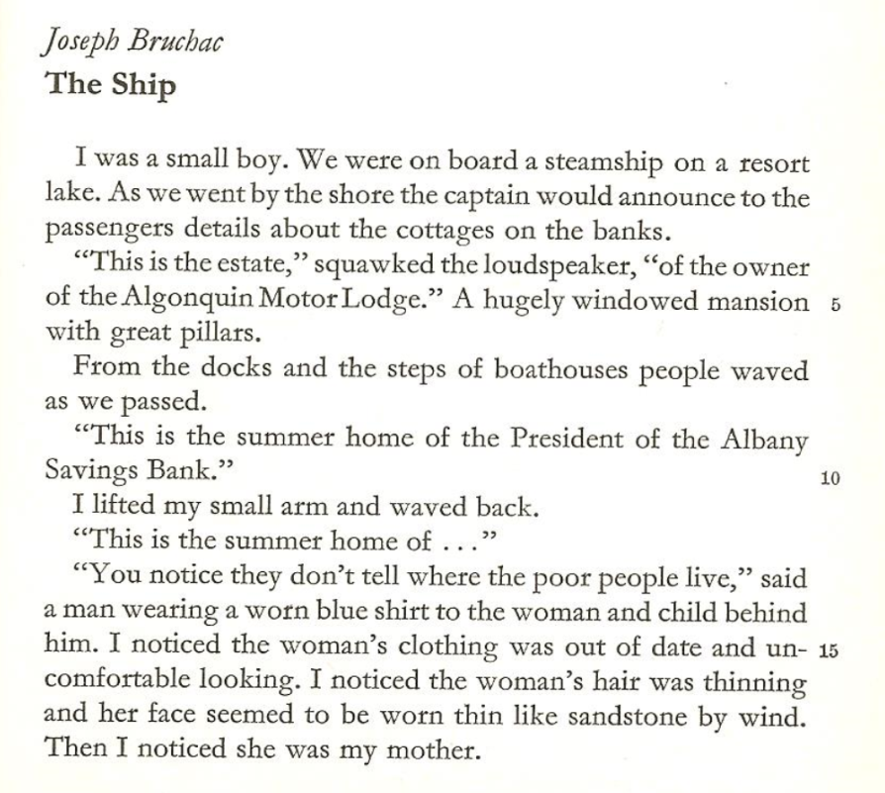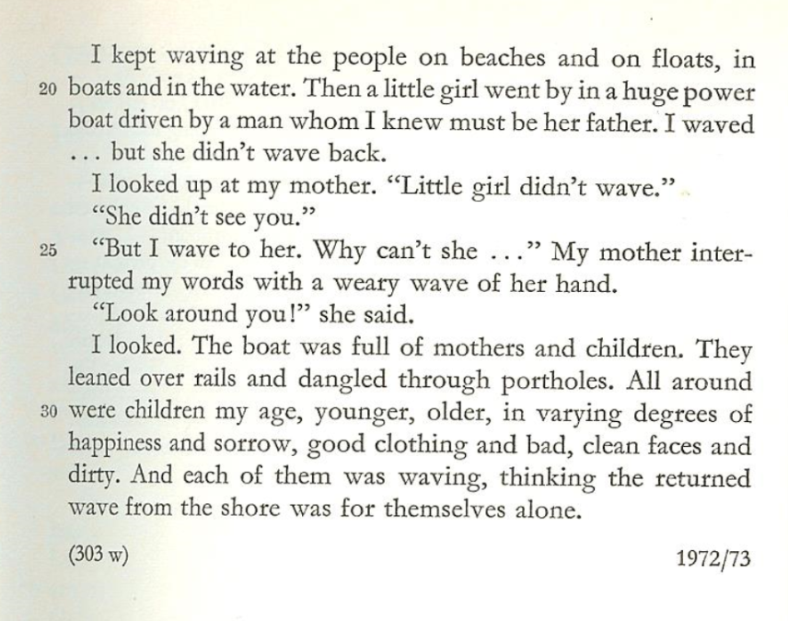
In: Reingard M. Nischik Ed. Short Short Stories, Schöninghbuch 4317, Paderborn, 1983
- What is this story about?
- What has the boy realized?
- What emotions are involved?

Step 1: Brainstorming
Use this page to brainstorm and jot down any ideas that come to your mind. Do not filter, you will choose your favorite story later.

Special objects in my life
Special family moments
Adventures and Accomplishments
Special people I have met
Special places in my life
Celebrations in my life

Homework: Find some memory props:
Look through your photo albums and look around your home to find any interesting pictures or objects that might trigger a good story. Bring them to class (or bring snapshots of the objects)

Mental snapshots and images in my head
How I discovered that….

Step 2: Finding your stories
Look at your ideas and find two or three possible stories that you might use in this project. Take two (or three) of the index cards from the teacher’s desk and write down your stories as if you were telling them to a friend. Write quickly, without too much filtering. Remember, these are rough first drafts. For each of your stories fill the front and back of one index card.

Step 3: Choosing the best story
Now you have two or three possible stories. Which one are you going to use? Think about each of the stories and answer the following questions. Use a separate sheet for each of the possible stories. After answering these questions decide which story is most interesting and share it with your teacher.
What do you think the story means? What is it really about?

What is the most important moment in the story? What is this moment about? Did anything change? Did you learn or realize anything new? Can you describe the moment in more detail?

What emotions are connected to this story?

Step 4: Writing your story
Now it’s time to write your story down. Imagine you are telling the story to a friend. Use a fairly informal style that sounds like oral storytelling. Avoid long, complex sentences. Your story should not be longer than 1 A4 page – otherwise it will exceed the time-limit of our digital stories.
Re-read your first draft and show it to a friend. Have you managed to get your emotions across? Are you focusing on the right things? Is anything unclear or confusing?
Tip: A really good story does not necessarily follow a chronological order. You might start in the middle and throw your audience in at the deep end and then unfold the story from there. Try this. Find a crucial moment in your story and try to start from there in your second draft.

Step 5: Producing your story
In order to produce a convincing story, you’ll need to structure your presentation. Your story will consist of the following elements:
- one or more pictures (if you are using a single picture you will pan and zoom in on various details during your narration)
- your voice-over
- possibly some music that enhances the meaning and emotions of the story
Storyboarding:
Use an A3 sheet and draw a storyboard like the following example or do this on the computer. Paste in your text and decide what images and effects you are going to use. Photocopy your images so you can move them around in the storyboard. If you feel that some background music might enhance your story, choose a fitting piece. (Must be copy-right free).
Images

Voiceover (Text)

Effects (pan, zoom, fade…)
Transitions

Soundtrack

Recording and Editing:
Decide what kind of software you want to use in order to achieve the best results. For quick and easy digital stories use Knovio, Present.me or PowerpointMix (with soundrecording).
For more advanced, professional stories with more effects use Audacity to record your sound and Shotcut to edit the video. You may also use Moviemaker, I-Movie or any other program that you have used before. If you have some money to spend and want to produce a more professional video, use Camtasia Studio.
Important tip for the sound recording: Find a really quiet place for your recording. Work on your recordings in pairs – this will help you to sound natural as if you were talking to a friend, rather than rattling off your text as fast as possible. Speak slowly, pause at important moments and give your audience a chance to take in your message. Use your voice to show your emotions.
Listen to your recording critically and record it again if you are not 100% satisfied.
Step 6: Writing a user guide
Our user-guides will consist of two parts. The first part will be about your personal experience in this project. We want to share our steps and what has helped or hindered you. You are writing your user guides for students who might want to try this project as well. Include all kinds of tips that might help others produce good digital stories.
The second part will include technical instructions for the different software that we have used. Only a few groups in our class will write this kind of guide. For the tech-guides take lots of screenshots of all the steps. Write clear step by step instructions for producing your story. Use the following format.
Steps | Instructions: including screenshots | Materials you need | Personal comments: tips, warnings…
Step 1
Step 2
…

