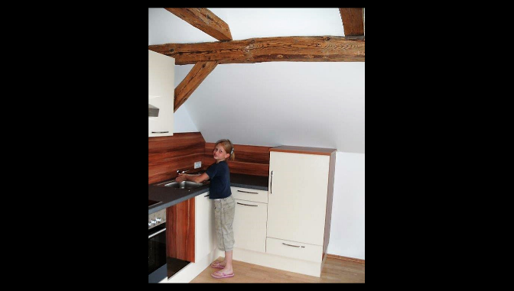
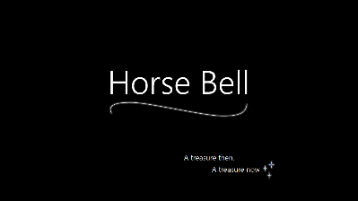
My digital story experience

Working with something that's highly important or very personal to you is just so much more fun. You are very enthusiastic about it and can talk about your own interests. What's more, by wanting to make the final outcome perfect, you put a lot of effort into it and therefore take the chance to include perfect vocabulary and simply take the time to produce something very good and valuable.

I definitely profited from this project. In the process of collecting all the information about my topic, my knowledge expanded. I was also really surprised by the fact that I even got to know a side of my close friends that I didn't knew before.

For me personally, it was really hard to come up with an idea that's supposed to be touching, personal and that has some kind of twist, which makes stories without much suspense also enjoyable to read. What really helped me find a good topic in the given wide range of topics was brainstorming with my friends and my family!

Including visuals in a story always helps. But including your own pictures in your own story, empathizes the personal (valuable) message. The pictures really set the scene for the audience and in my opinion, having self-taken pictures is the best thing you can do. Non-professional, imperfect pictures highlight the individuality of your story. Just go through old family albums or phone your grandparents. Depending on your topic, just grab your phone and take the pictures by yourself.

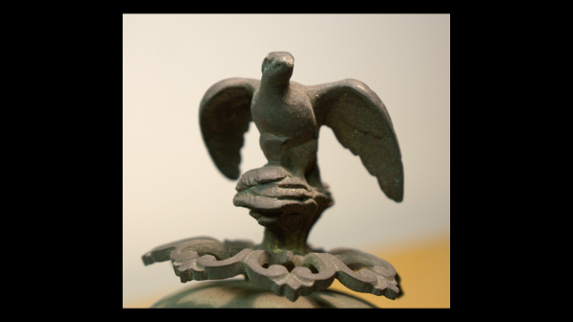
Birgit Schafzahl
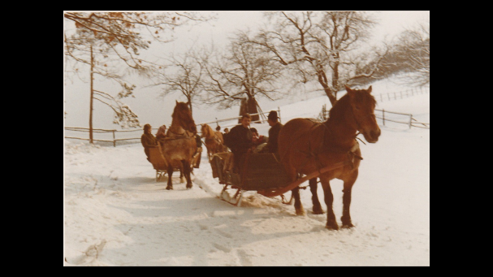
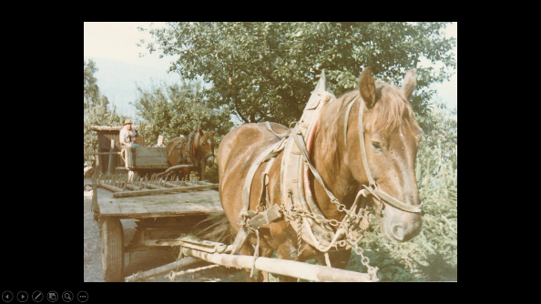
GIBS

