Blogging@GIBS
Reading is Cool
Are you looking for the best, coolest, most riveting page-turners for the summer?
Have a look at 4b’s blog readingiscool.xyz and watch a vast collection of short videos to get a first impression of all the great books.
Have YOU read any great books lately? Do you want to post your recommendations as well?
Contact Mrs. Pölzleitner and join our blog.

For this blog Mrs. Pölzleitner and 4b have won the 2nd prize in this year’s LÖRNIE AWARD

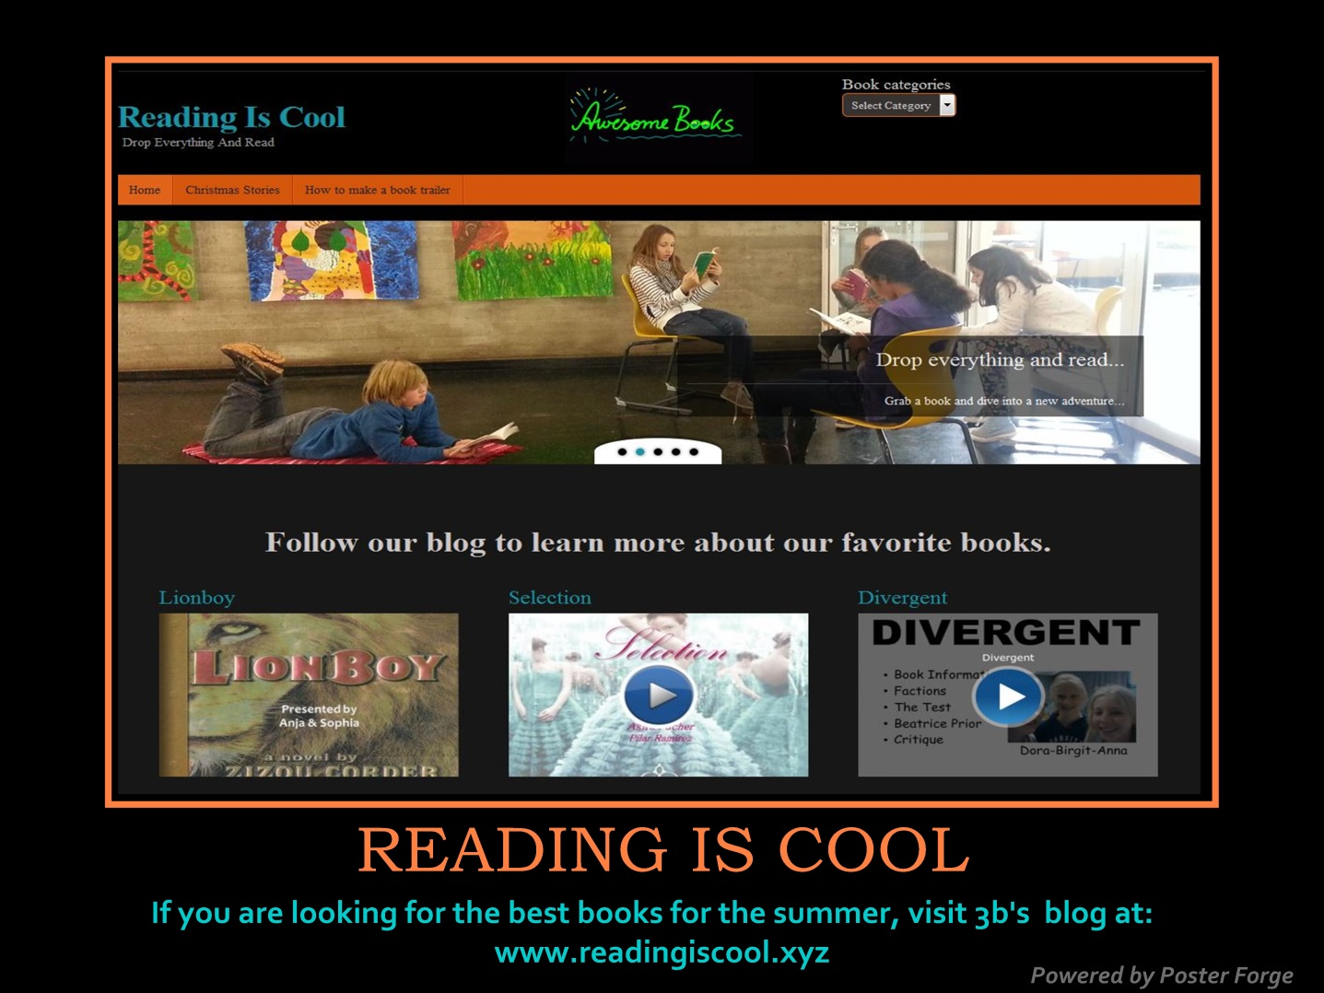

www.gibsters.com
In our new blog www.gibsters.com the students of 5b and 5c have shared their views on lots of interesting topics. Visit our blog and send us your comments.
Elisabeth Pölzleitner

