Blogging@GIBS
Reading is Cool
Are you looking for the best, coolest, most riveting page-turners for the summer?
Have a look at 5bs blog www.readingiscool.xyz and watch a vast collection of short videos to get a first impression of all the great books.
Have YOU read any great books lately? Do you want to post your recommendations as well?
Contact Mrs. Pölzleitner and join our blog.
We’ve added lots of new books! Check out our blog

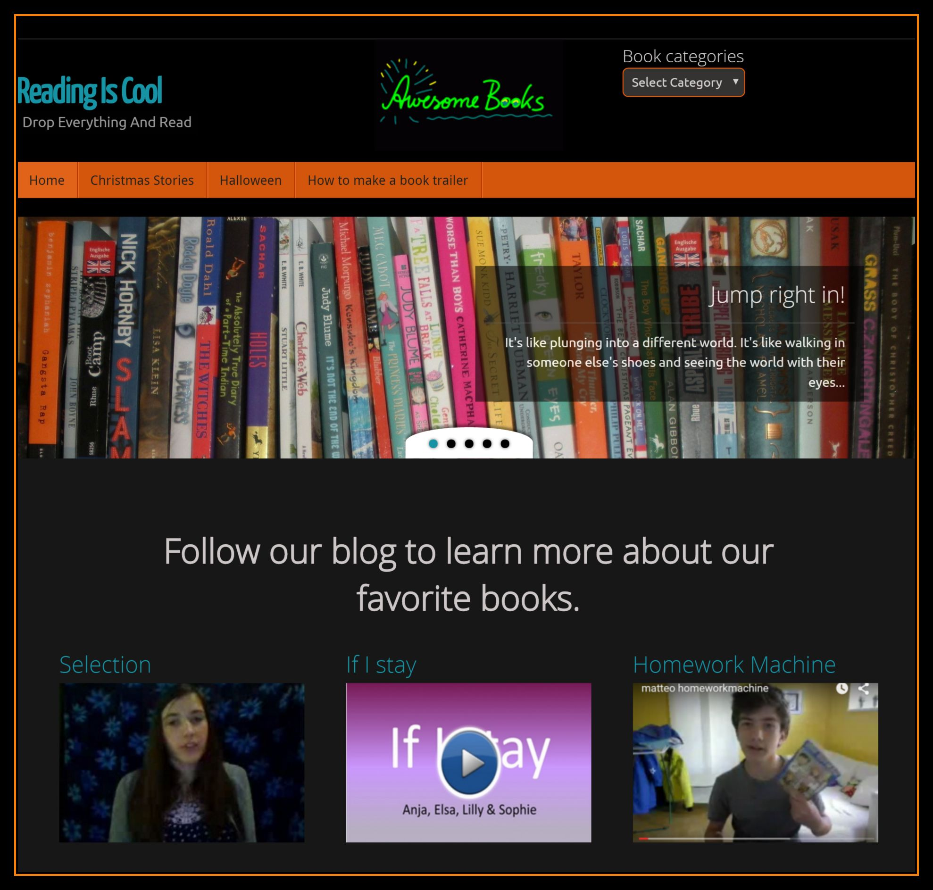
www.gibsters.com
6c has won the Media Literacy Award for this blog.
Visit our blog and read what the students of 6c and 5b have to say about the world around us.
Elisabeth Pölzleitner

