How long have you...?



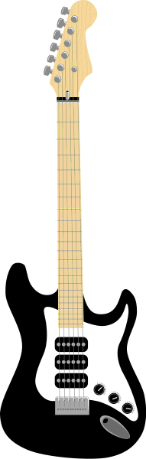

I've had my bike for five years.
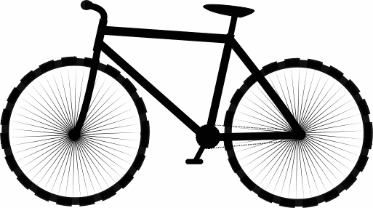I've played the guitar since September.
I've known my friend Sally for 8 years.
I've had this T-shirt for ages.
Now it is your turn: How long have you had ....?
We are going to find the oldest items in this classroom. Check your stuff and choose the 2 oldest items you have with you today. Write five true sentences.
I've had my____________________for
I've had my ____________________since

Old friends and relationships
How long have you all known each other? How long have you known your oldest friends. Think of an old friend and complete the following sentences.
I've known this person for
I've often _____________________________________with___________________
I've never
We've always

Do we have any school couples? How long have they been together? Write 5 more true sentences.

For and Since

Work with a partner. Use the phrases from the box to write true sentences about yourself and the people around.
since 2010… for three years … since September... since 8 o'clock... for more than ten years... since Monday... for three days... for over a year... since Christmas... for almost an hour...
Example: GIBS has been in this building in Eggenberg since 2010.

Find a rule
Look at the above sentences again. When do we use for, when do we use since?
My rule:

More practice
Do the following exercises in your Newby grammar books. Write your answers on a worksheet.
- Yellow Newby: ex. 86 (p. 179)
- Green Newby: ex. 129 (p.66/67)

