How loooooong have you…
Preparation: Cut 5-6 A4 sheets per student into paper strips of about 4cm width. You will need at least 15 strips per student. | 
Hand out about 10 strips to each student. Set a countdown timer to 5 minutes.  Walk around and hand out more paper if needed. | 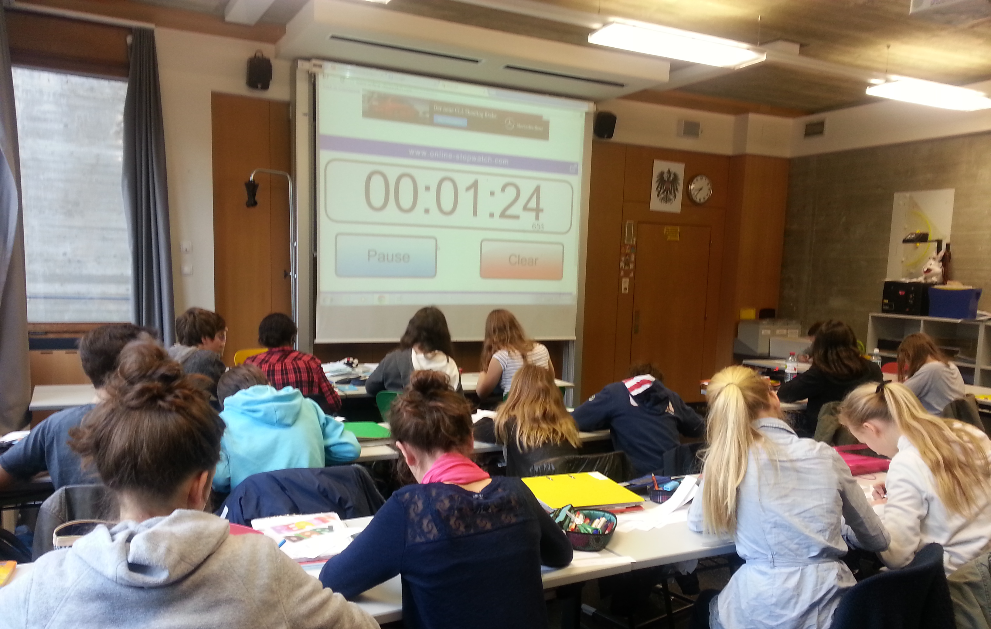
Instructions for the learners  You have five minutes. Write down as many true and correct sentences telling us  - how long you have had /been/ known…  or  - how long you have been doing something  Write each sentence on a separate paper strip. | 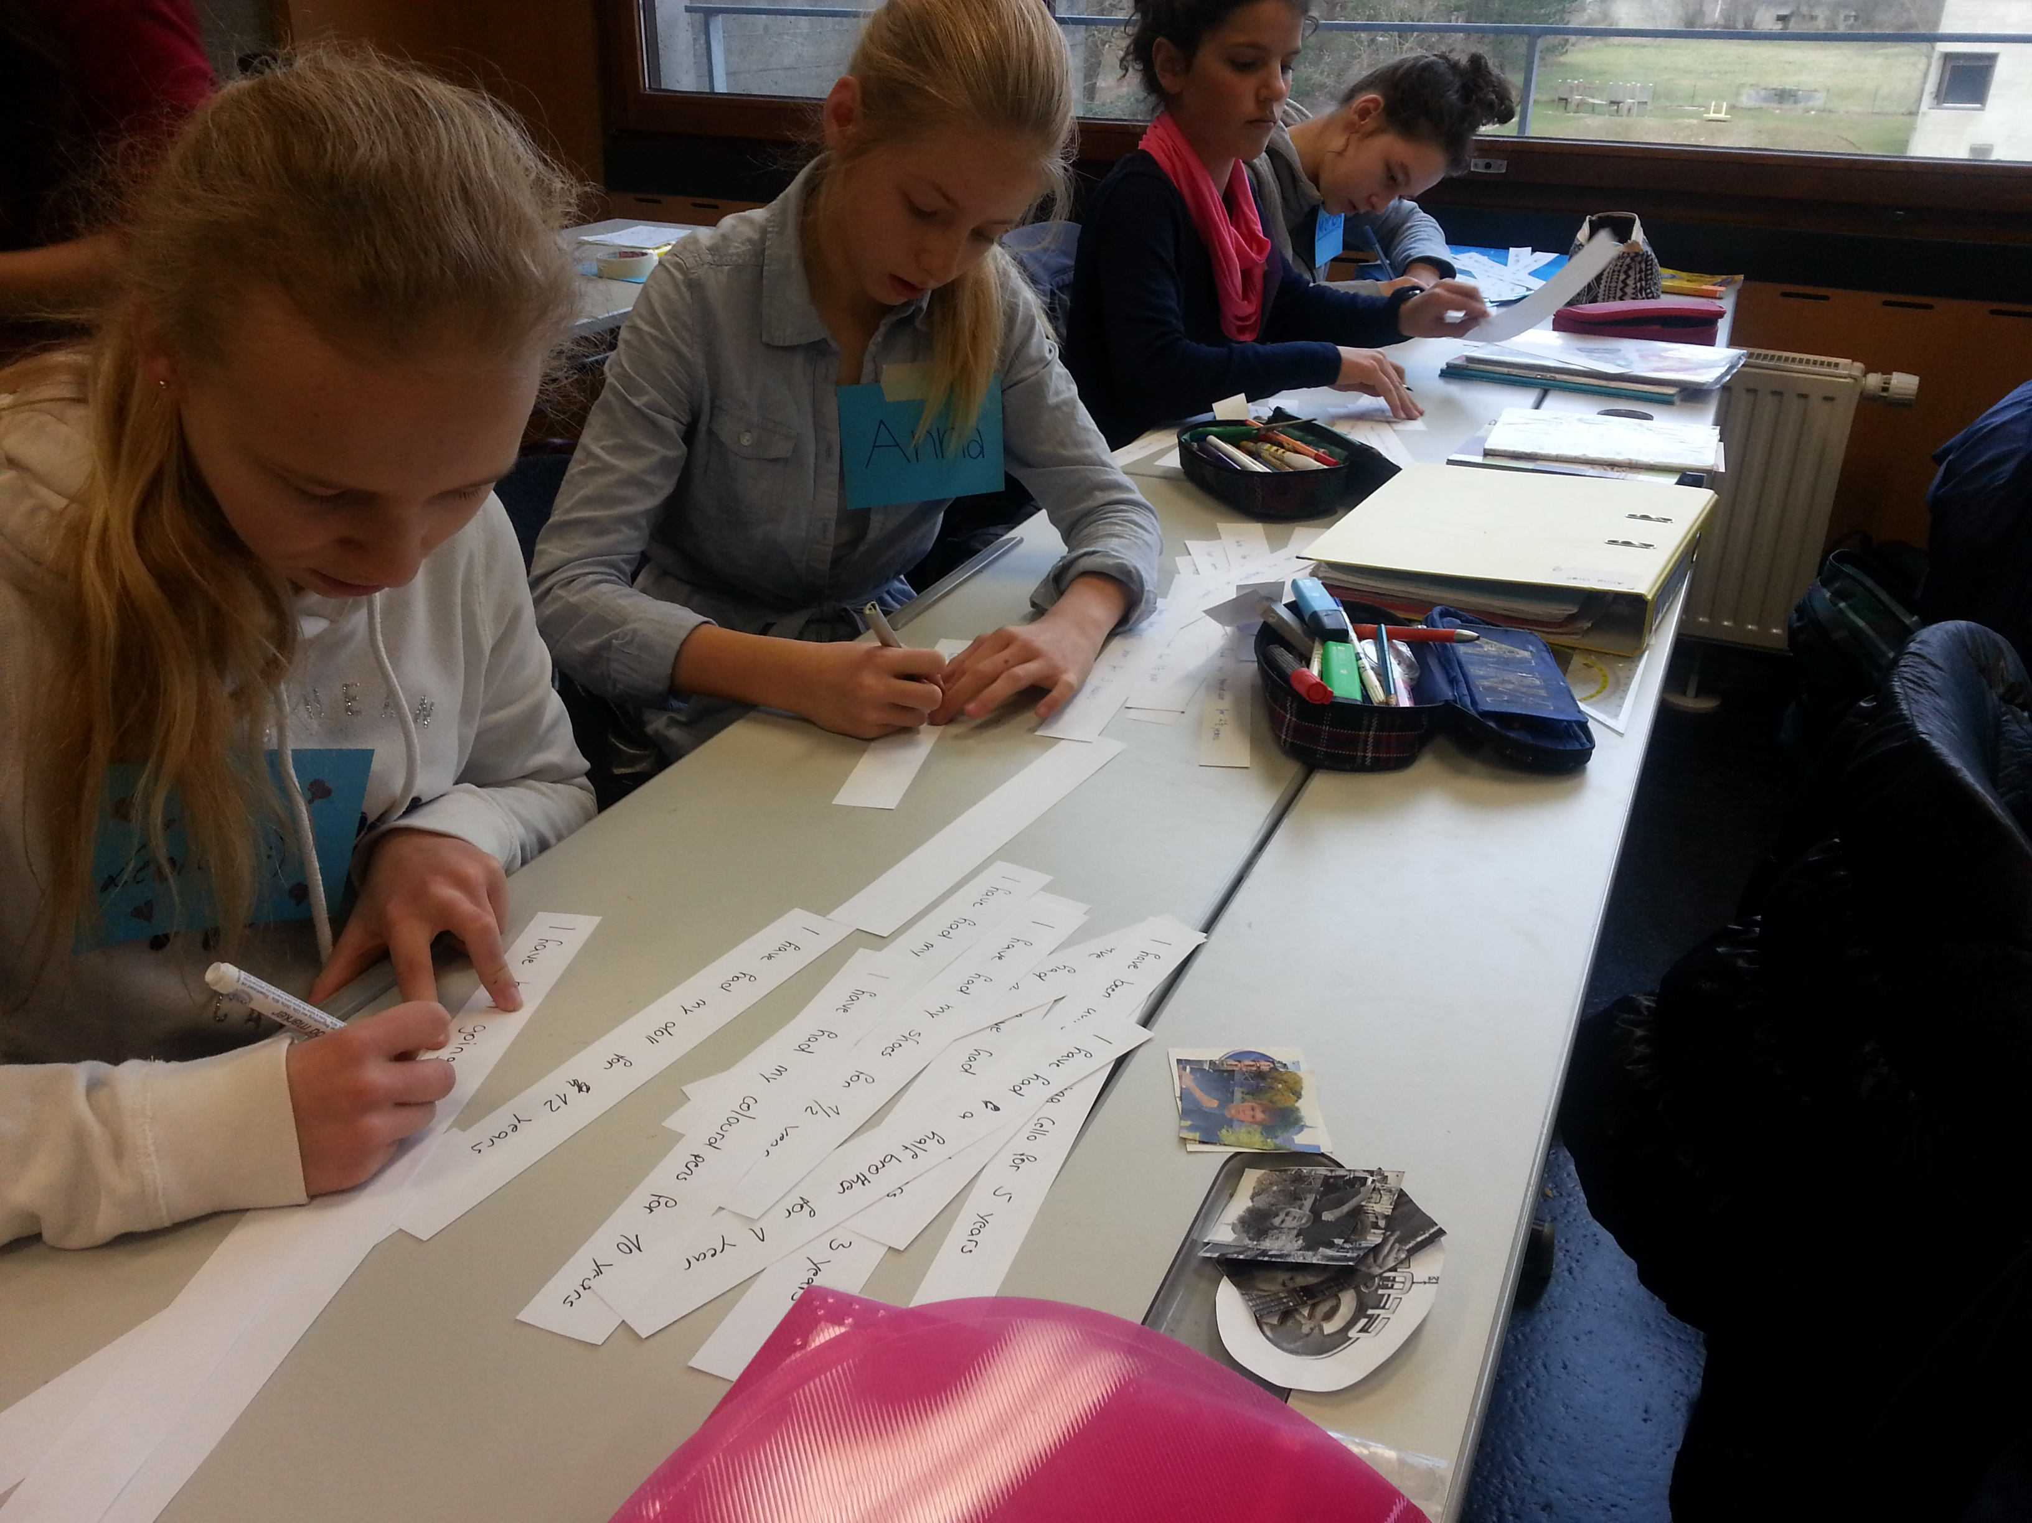
Glue all your strips together and count your pieces. The students with the longest paper-strip (most pieces) will win a prize. | 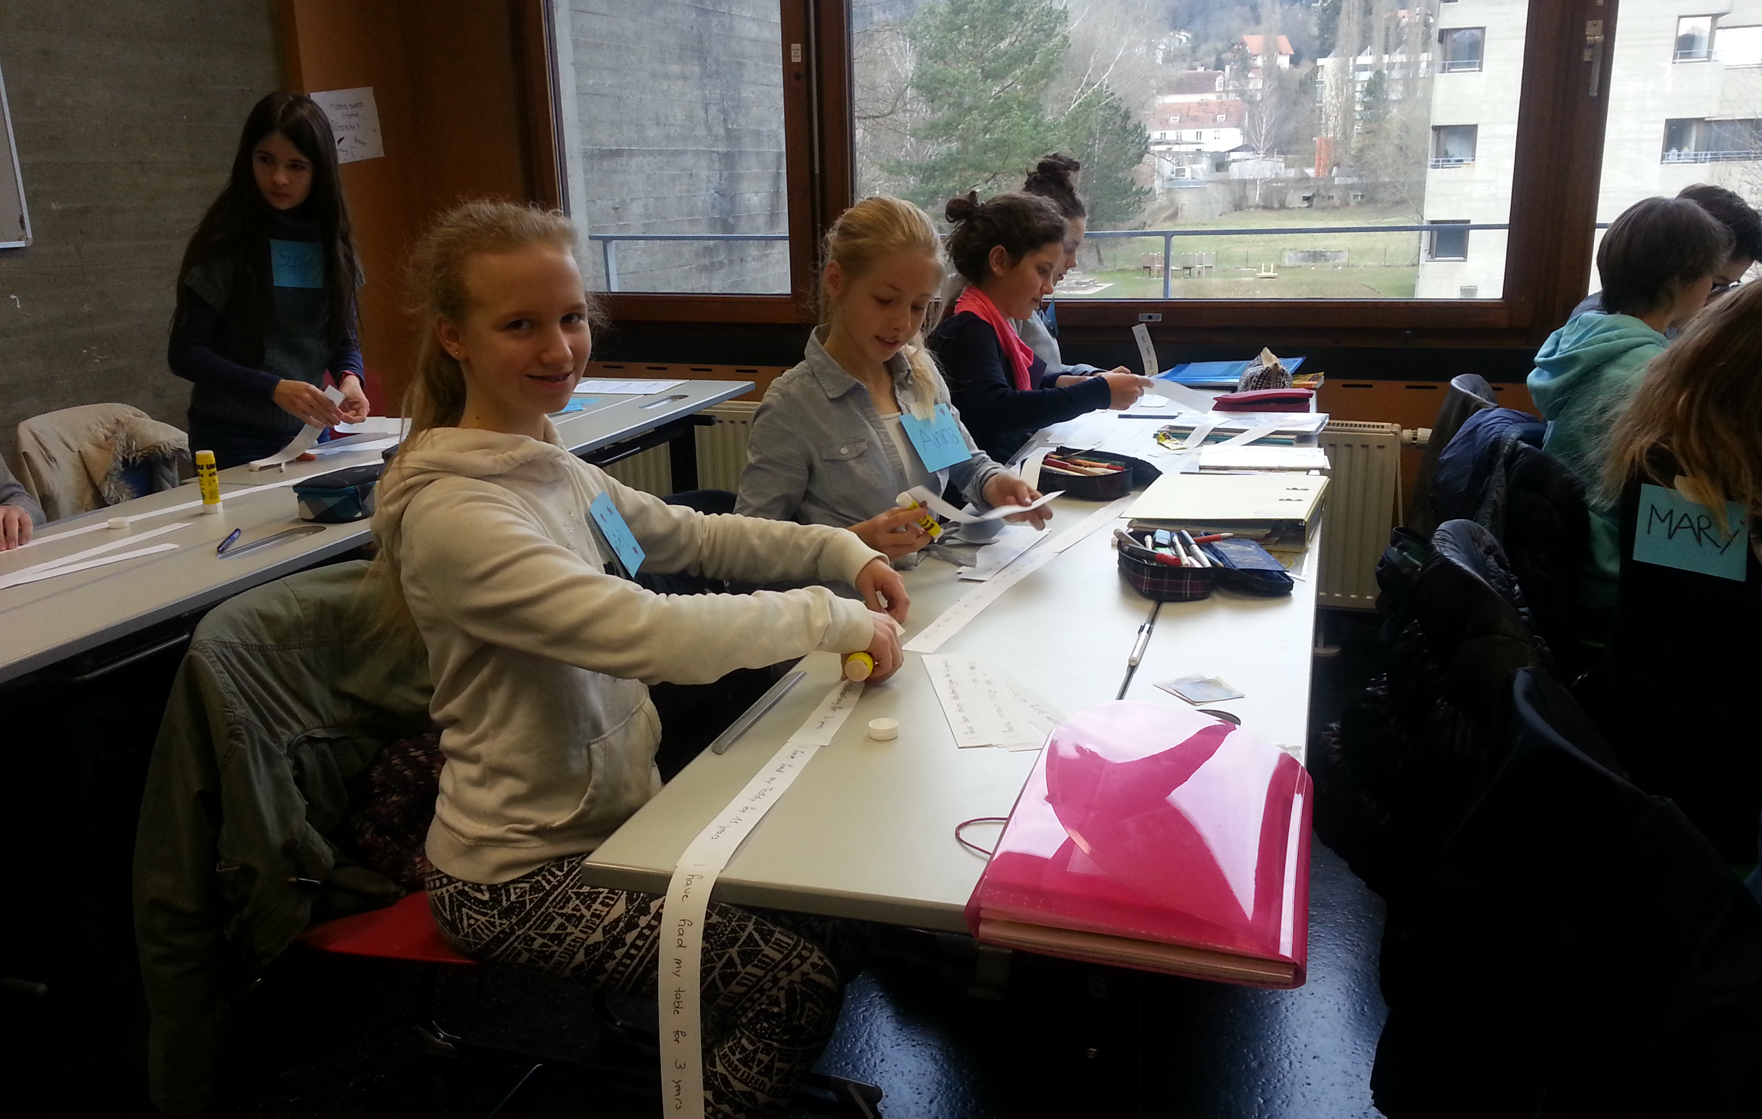
Ask the winners to read out their sentences. | 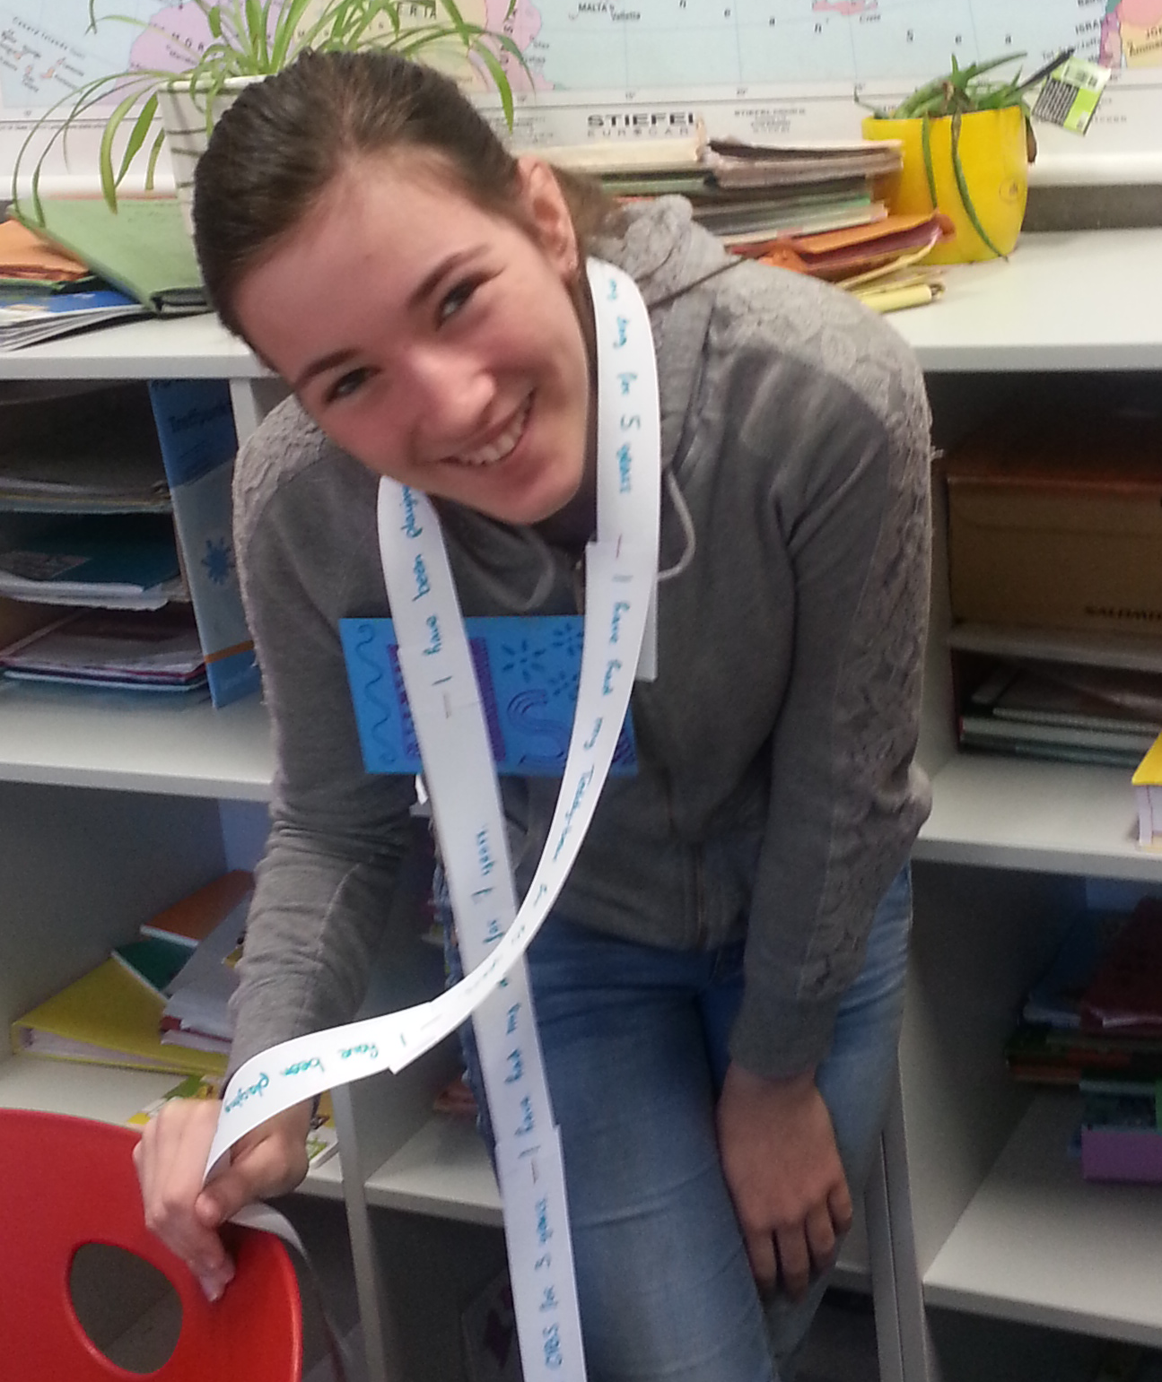
If possible: glue all the strips together and hang them up in the hallway or stick them on the floor. This will remind the students of the concept of DURATION whenever they walk by the loooong line. | 