“How long have you...”
How well do you know your partner?

Work with a partner.
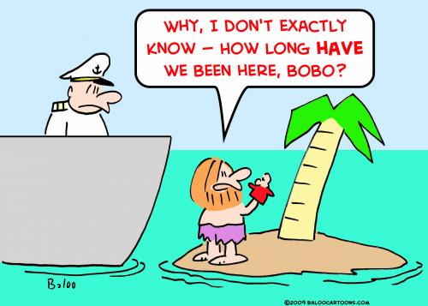
Step 1: Answer the questions below truthfully and guess your partner’s answers.
Step 2: Then talk to your partner to find out whether your guesses are correct.
Example:
Student A “I think you have played the violin for three years, is that correct?”
Student B “Yes, that’s right.” OR “No, I have only played it for one year.” OR “No, I have never played the violin.”
Now it’s your turn:
Question “How long have you…” | You | Your partner (guess!)
known your best friend?
lived in your house?
owned your pet?
practiced your favorite sport?
been at this school?
your grandparents been married?
played the guitar/piano/drums/…or any other instrument
have you had your favourite lucky charm?
have you had your computer?
known your neighbour?
Add your own questions below:
Use the back of this sheet for the following activity:

Write 10 true statements about yourself in the PRESENT tense. After each sentence, write for how long or since when this has been true.
Example: I live in a blue house. I have lived in this house for 20 years.

