Young grammar detectives

Lis Pölzleitner and Laura Bergmann have developed a new way to get beginners at lower secondary to engage with the question what grammar is for, making them more successful in using language correctly.

The problem
Teaching grammar to young beginners (age 10-12) is an ongoing challenge for English teachers. Understanding that forms convey meanings is a difficult concept to grasp and often pre-teens do not have any concept of how language works, not even in their mother tongue. This is a pitfall for teachers who try to explain grammar to learners who do not see the necessity of grammar at all and therefore often fail to apply what they learn in spontaneous production.

What’s the alternative? Some teachers avoid teaching grammar explicitly, hoping that their students will pick up the concepts if they get enough input. While this might work in an English speaking environment, it is seldom successful if the input is limited to a few hours per week and often leads to fossilization of incorrect forms.

Our solution: Students become language detectives

To solve our problem we have developed active awareness raising and conceptualization tasks that are based on the notional grammar teaching model suggested by David Newby (Newby, 2015). In Newby’s model grammar is acquired in typical stages, starting with awareness raising, forming hypotheses about how and when certain grammar is used, practicing the new grammar in scaffolded activities, and finally using grammar independently to communicate one's own ideas. In this communicative model, learning grammar means making meaning-form connections. Consequently, learners need to figure out that rules are simply regularities -- or typical relationships between the meanings they want to express and the forms that English speakers use to convey them, rather than reciting structural rules provided by the teacher or the textbook.

In order to find such regularities the learners need adequate input showing the new forms in typical contexts and communicative situations. Based on the provided input, the learners are then invited to find the rules (i.e. meaning-form connections) themselves. Evidence suggests that this inductive approach will lead to deeper processing, more engagement and thus lead to more permanent learning. (Brown 2006)

Language detectives at work
In our “Personal Grammar Book” students become ‘language detectives’, trying to form their own theories about why a certain form is used or what it means. We decided that the best time to start with these challenging tasks would be right at the beginning, so the learners become aware of grammatical features as early as possible.

Our students do their first discovery task, or "grammar challenge" in the first unit. We start with a very simple problem - the use of ‘a’ and ‘an’. While the rule is obvious to us, it is surprisingly hard to find for students, as they have never thought about language that way. They come up with lots of interesting solutions, which made us change our list of words again and again to disprove their theories and point them towards the correct solution. Some of their theories were: “We use ‘an’ for things that we can eat.” or “We use ‘an’ for animals and a for people” or “We use a if there is one thing and an if there are more.” In their first theories, students usually look at the meanings of the words, not the forms. This is only natural. When they come to discuss their ideas, we tell them that the marked letters are a hint. When the students have figured out the solution, they are usually very proud of themselves. Sometimes they secretly help other students in class, revealing the big secret. So grammar also becomes more exciting and we have actually heard our students reacting with “Wow, cool!” when they learned that their theory was correct. Can we ask for more?
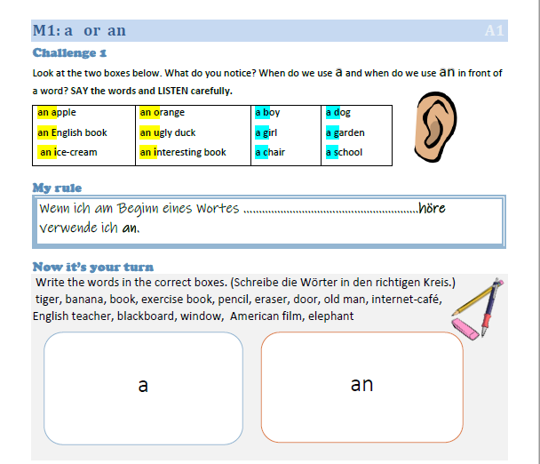

The students have some help with formulating their rule and they are allowed to write the rule in their mother tongue. It is interesting to see that hardly any students use the partly formulated rule for help but they keep looking at the words and try to puzzle it out for themselves.

In the second part of the challenge they have to understand that the rule only applies to the pronunciation of the words, not the spelling. Once they have mastered this challenge, they really understand the rule and are unlikely to forget it again.

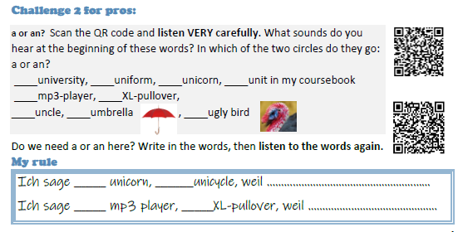

Progression
As the students become more experienced in puzzling out the WHY of grammar, they move into more difficult terrain. In year two they are confronted with different tenses and completely new concepts (tense notions) that often have no equivalent in their mother tongues, such as different notions of the future or the present perfect tense. With these more complex challenges students often work in pairs to figure out why the new forms are used and what meanings they express.

In the following example the learners find out that the English language has more than one concept and form to talk about the future. By analyzing the sample texts the learners can figure out that the going-to form is used to talk about plans or intentions of the speaker, while the will-future is used to talk about vague predictions. Since neither of these concepts are clearly defined in the learner's minds, they usually paraphrase their hypotheses in relatively vague terms. They will say things like: When I know that you will do it I say "I am going to…", when I don't know what I will do on the weekend I say "I will..." Many children unconsciously use lots of hand gestures to explain their ideas and show the concepts of "vagueness" or "fixed plans" with their hands rather than with words.
We encourage this and help the children to become aware of their gestures and to put the concepts into words.

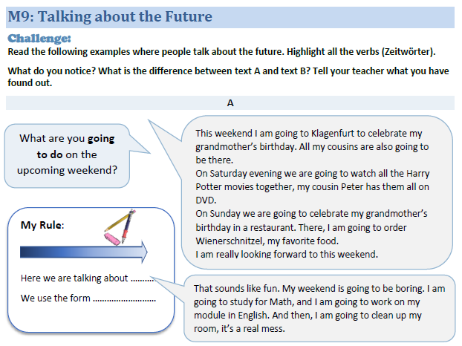
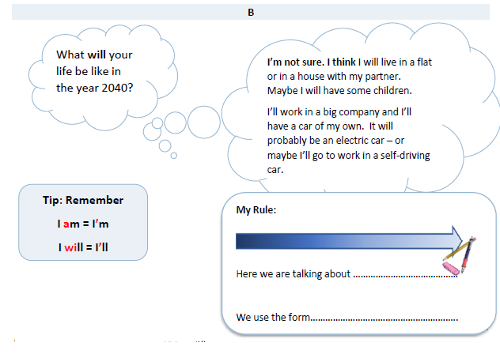

Why do we call it “Personal Grammar Book”?
Personalization plays an important role in learning new things. Since learning always means “making new connections to our existing neural networks” (Braun & Meier, 2006), any task that invites the learners to apply new language to situations in their personal lives will lead to more efficient learning. Moreover, personalized exercises that refer to the learners’ previous experiences and life - stories will seem more interesting and more motivating and thus lead to higher engagement and deeper processing. Using the new language patterns in personal contexts will also make it easier and less abstract for the learners to understand the underlying concepts. Therefore, after the stages of awareness raising and finding the rule (conceptualization), the learners are always asked to produce true examples themselves. These true examples link the new grammar to the learners’ personal experiences and are the first step towards proceduralization and automatic use of the language in typical contexts.

In the following example the learners first see the teacher’s plans (going to) and vague predictions (will-future) for the upcoming weekend. The students then write about their own plans and vague ideas by following the teacher’s examples. This way of dealing with the two notions of the future also shows the learners that grammar is not black and white and one learner’s correct examples might be wrong for another student. For many students this is an eye-opening experience that really convinces them that grammar is actually important.

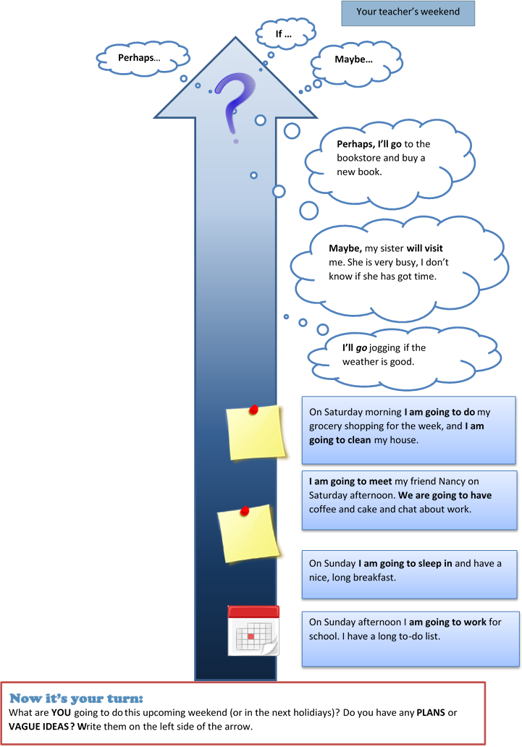

Another pitfall that we are trying to avoid in our Personal Grammar Book is the use of grammatical meta-language. We avoid meta-language whenever possible. We have noticed that students often try to use grammar terms that they have learned in their first language class randomly without any true understanding of what they mean. For this reason, we use everyday words and age-appropriate labels for the grammar concepts in our "Personal Grammar Book".

We have designed such activities for all the grammar topics that are generally taught at A1-B1 level. Each topic follows the steps: awareness raising -- forming a rule -- scaffolded, personalized practice. In addition to these pages, the learners are provided with more communicative practice on our Moodle platform. In order to keep our grammar book short and well-organized, these additional materials and tasks are not included in the paper version of the book. This way our Personal Grammar Book can also serve as a short reference grammar for the learners, where they will find their own short rules as well as their personal examples that immediately ring a bell when they see them.

In the last few years our grammar book has grown step by step and all the tasks have been revised again and again to avoid all the pitfalls that our students have fallen into. We see that our approach works very well and that -- if students make mistakes -- they can quickly recall the rules and concepts by looking at the respective pages in their own grammar book.

We are thinking of publishing our materials, but as a first step, some of the ideas and activities can be downloaded from https://epep.at/grammar

References:
Braun, Anna Katharina and Meier Michaela, “Wie Gehirne laufen lernen oder: Früh übt sich, wer ein Meister werden will!”, in Herrmann Ulrich (Ed.) Neurodidaktik, Beltz, 2006, pp. 97-109
Brown, H. (2006). Principles of Second Language Learning and Teaching. Pearson Longman. pp. 99-100
Newby, D. (2015). The role of theory in pedagogical grammar: A Cognitive + Communicative approach. Eurasian Journal of Applied Linguistics 1/ 2, pp. 13-34, Online: Retrieved 22.02.2021, https://pdfs.semanticscholar.org/b781/61c5ac1fdafba56cb45fcadd2ea45f49f964.pdf

Short Bio of Authors:

Laura Bergmann is a schoolbook author and teaches English at secondary school in Austria as well as methodology classes at the University College of Teacher Education, Styria. She is fascinated by school development and is currently head of a project that promotes a highly differentiated classroom in mixed-aged groups, supported by a high degree of digital support.
Lis Pölzleitner teaches English at secondary school in Austria as well as methodology classes and in-service seminars at the University of Graz and the University College of Teacher Education, Styria. Her main areas of interest are extensive reading, brain-friendly language teaching, creative approaches to teaching writing, cognitive-communicative grammar and the use of technology in language teaching.

