What are you going to do in the upcoming holidays?

Do you have any plans?
- Write down 10 things that you are going to do next week.
- Interview your classmates about their plans and note them in your grid.
- Who is your perfect match? Who do you share most plans with?
What are you going to do in the holidays?
Write your friends’ names or initials into the first line.
Then tick off which of your plans they share with you.
I am going to…

What is going to happen next?
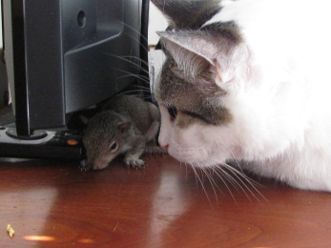 |  |  | 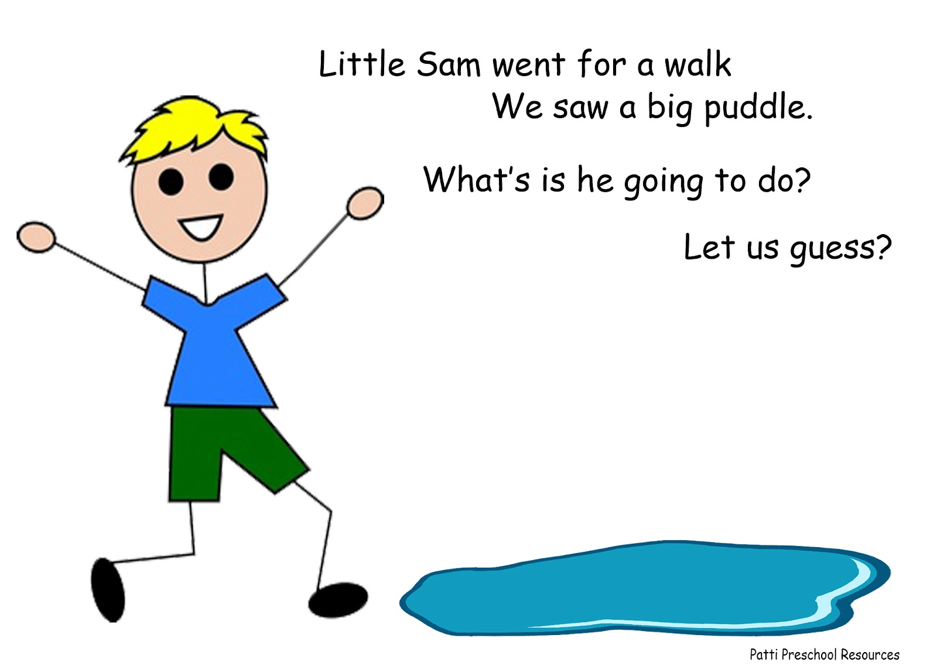
 |  | 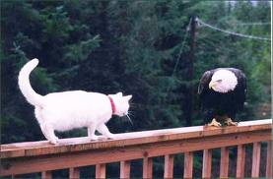 | 

Make predictions like this:
The cat is going to play with the rat. Then it is going to kill the rat and eat it.
The airplane
The pilot
The boy
The balloon
The bubble
The hawk
The cook
We use going to …
to talk about… | to talk about…
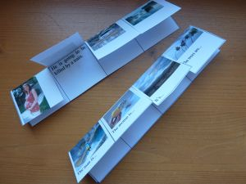
Grammar page: Now design an A4 grammar page for your folder. Write down your own rule, some good examples and design a logo for each of the two ideas.
Homework: Produce a flipflap with four pictures showing some dramatic things that are going to happen. Have a look at the examples on the teacher’s desk. Find some good pictures or draw them yourself. Bring your flipflap to class and show it to your friends.

