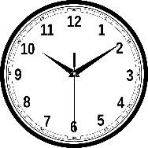
Conditional III: How would things have been different?

Regrets: Have you ever wanted to turn back time?
Have you ever done anything that you regret?
Let’s look at some examples:
I did not study enough for the math test.
If I had studied more for the last maths test, I would not have failed it.

If I had not left my phone on my desk, it would not have been stolen.
I left my phone on my desk in school.

If I had not played computer games all night,
I could have concentrated better during the English test
and I would have done a lot better.
I played computer games all night.

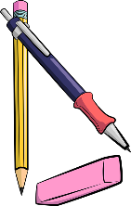
My rule:
Look at the words in bold letters. If you talk about how things in the past
could have been different (but you cannot change them any more) you use:
If I _had + __________________, I would + _________+___________

Your turn:


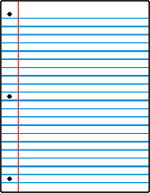
Think of some things that you regret. How would things have turned out if you had acted differently?
Write 5 sentences. Write meaningful and true sentences, not just anything.

What if…

If they had given up, you would never have heard of them

Who are these famous people who all failed miserably, but did not give up?
Match the life stories with the names.
Steve Jobs, Steven Spielberg, Henry Ford, Thomas Edison, The Beatles, Walt Disney, Bill Gates, Michael Jordan, J K Rowling, Albert Einstein, Charly Chaplin

Then watch the video and check your answers. Be careful. Not all examples in the video have been used.
If he had given up after being fired from his basketball team, he would not have become the most famous basketball player of all times.
If they had stopped playing music with their band after several record labels told them that guitar music was not cool, they would not have become the most famous band of all times.
If he had given up drawing cartoons because nobody wanted to hire him as an artist, he would not have created the most famous cartoon figure in the world.
If he had given up his dream of building computers after dropping out of university, he would not have become one of the richest men on Earth.
If she had stopped writing because several publishers rejected (=did not want) her first book, she would not have become one of the most famous authors of children’s books and the second-richest female entertainer.
If he had listened to his teachers who told him that he “would never amount to much”, he would not have won the Nobel prize in physics.
If he had given up after being fired from three computer companies, he would not have become one of the richest men and the owner of one of the most famous industrial designers in the world.
If he had given up his dream after going bankrupt five times, he would not have become one of the most successful car producers of the USA.
If he had given up when his teachers told him that he was “too stupid to learn anything”, he would not have invented the light bulb.
If he had listened to the Hollywood studio chiefs, who said that his acts were too stupid and nonsensical, he would not have become one of the most famous English comic actors of all times.
If he had given up after being rejected from film-school, he would not have become one of the most famous film directors of our times.
https://www.youtube.com/watch?v=5cZh6tYVM2w

