Admonishing and Reprimanding
Jemanden rügen/ tadeln

If you hadn’t….
Work in groups of 3-4. Put the cards face down on a pile. The first player picks up a card, reads it out and expands the idea a bit:
e.g.: “I’ve spent all my pocket money. It’s awful, I am completely broke. I cannot even go to the cinema with you.”
Then, each of the other players responds by admonishing the player using the following format: Oh, not again! If you hadn’t…
Example:
Oh, not again! If you hadn’t bought all those CDs you wouldn’t be broke now.
Oh, not again! If you hadn’t spent so much money at the school-buffet, you’d still have enough to go to the movie with us.

Admonishing and Reprimanding
Jemanden rügen/ tadeln

If you hadn’t….
Work in groups of 3-4. Put the cards face down on a pile. The first player picks up a card, reads it out and expands the idea a bit:
e.g.: “I’ve spent all my pocket money. It’s awful, I am completely broke. I cannot even go to the cinema with you.”
Then, each of the other players responds by admonishing the player using the following format: Oh, not again! If you hadn’t…
Example:
Oh, not again! If you hadn’t bought all those CDs you wouldn’t be broke now.
Oh, not again! If you hadn’t spent so much money at the school-buffet, you’d still have enough to go to the movie with us.
  I’ve spent all my pocket money. |   I’ve got a terrible hangover.
  I lost my temper (got angry). |   I was late for school.
  I am freezing. |   I forgot to do my homework.
  I have failed the Biology test. |   I have broken my leg.
  I’ve burnt the meal. | 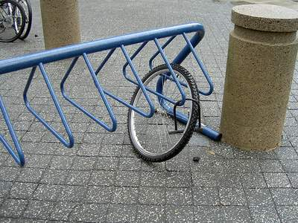  My bike was stolen.

