INTERPRETING SIGNS: GOING TO Attention: Cut off the top row and glue it under the flaps.
...going to hit the ground and get hurt | ... going to bite the man’s finger | ...going to rain | ...going to break


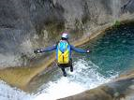  The man is... | 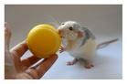  The mouse is... |   It’s... | 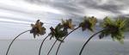  The trees are...

She is going to have a baby. | He is going to be killed by a train. | That car is going to be ruined. | He is going to skid and have an accident.
 | 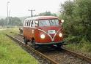 | 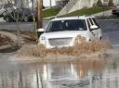 | 