Passive Pairs

Test your knowledge
Work in pairs or groups of three. Put the info-cards on the desk so you can all see them well. Put all the other cards face down on the desk.
One player picks up the first card and reads it out.
For example: Romeo and Juliet was …written by…
You will have to use your own verbs to complete the sentences meaningfully.
Both players try to find the matching info card on the desk and complete the sentence.
Then player 2 reads picks up the next card…
Note: this is not a competitive game. Work as a team and see if you can find all the matching pairs.

Passive Pairs

Test your knowledge
Work in pairs or groups of three. Put the info-cards on the desk so you can all see them well. Put all the other cards face down on the desk.
One player picks up the first card and reads it out.
For example: Romeo and Juliet was …written by…
You will have to use your own verbs to complete the sentences meaningfully.
Both players try to find the matching info card on the desk and complete the sentence.
Then player 2 reads picks up the next card…
Note: this is not a competitive game. Work as a team and see if you can find all the matching pairs.

Passive Pairs

Test your knowledge
Work in pairs or groups of three. Put the info-cards on the desk so you can all see them well. Put all the other cards face down on the desk.
One player picks up the first card and reads it out.
For example: Romeo and Juliet was …written by…
You will have to use your own verbs to complete the sentences meaningfully.
Both players try to find the matching info card on the desk and complete the sentence.
Then player 2 reads picks up the next card…
Note: this is not a competitive game. Work as a team and see if you can find all the matching pairs.

Passive Pairs

Test your knowledge
Work in pairs or groups of three. Put the info-cards on the desk so you can all see them well. Put all the other cards face down on the desk.
One player picks up the first card and reads it out.
For example: Romeo and Juliet was …written by…
You will have to use your own verbs to complete the sentences meaningfully.
Both players try to find the matching info card on the desk and complete the sentence.
Then player 2 reads picks up the next card…
Note: this is not a competitive game. Work as a team and see if you can find all the matching pairs.

Julius Caesar |  | by Brutus | 
Romeo and Juliet |  | by William Shakespeare
America |  | in 1492
The telephone | 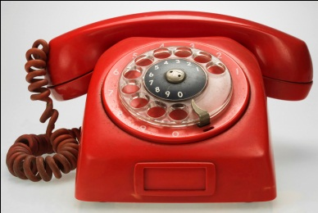 | by Graham Bell
Microsoft |  | by Bill Gates
The Mona Lisa |  | by Leonardo da Vinci
The Eiffel Tower |  | in 1889
The first Apple computer |  | in 1976
The electric lightbulb |  | by Tom Edison
Rome | 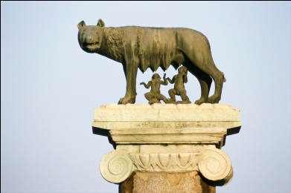 | by Romulus and Remus in 753 BC
Harry Potter | 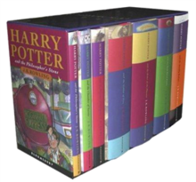 | by J.K. Rowling
First washing machine | 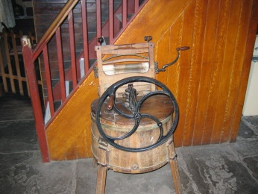 | in the 17th century
The 1st bicycle | 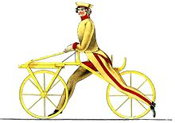 | in 1817 by Karl von Drais in Baden/ Germany
The first Olympic Games |  | in Olympia, Greece in 776 B.C.
The Starry Night | 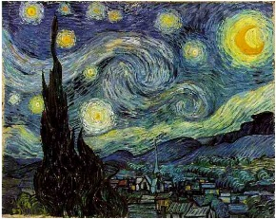 | by Vincent van Gogh
Marilyn Monroe |  | by Andy Warhol | 
The Golden Gate Bridge | 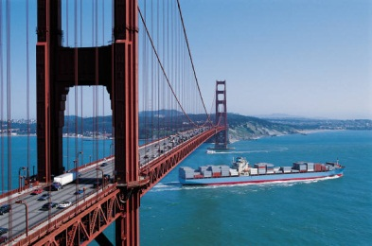 | on May 27, 1937
The Statue of Liberty |  | by Frédéric Auguste Bartholdi in 1886 | 

