Describing the setting and atmosphere

and talking about events that happened in a story.

Challenge:
1- Read the following mini-story. Where does the writer describe the setting and atmosphere?
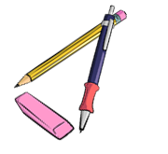
Where does the writer talk about events that happened that night. Use a red and a green color pencil and color the parts that describe events red and the setting and atmosphere passages green.
It was a cold night in October. The moon was shining but dark clouds were moving across the sky.
A storm was howling and the branches of the trees were moving in the wind.
Lots of leaves were flying through the air.
I was walking along the dark street and listened to the rustling of the leaves under my feet. I could hear an owl hooting and a dog was barking nearby.
Suddenly…
a cat rushed out of a side-street and stopped in front of me. It looked at me with burning green eyes and growled.
I screamed in shock and hid behind the nearest car.
My heart was pounding and I was really scared. I heard the cat moving around silently. It was still growling – not like a little housecat, but more like a tiger. The cat’s green eyes were shining in the dark.
The cat crossed the street and came towards me.
With each step it grew bigger and bigger and the growling got louder and louder.
That’s when I remembered the magic coin in my pocket. I took it out, held it up in the air towards the cat and hoped…
Yes, … it worked. The cat saw the shining coin,
froze – and then turned around and ran away.

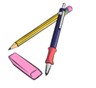
My rule:
When we describe the atmosphere and the background in a story,
we use the …………………………………………

When we talk about events and things that happen in the story,
we use the …………………………………………….

Now it’s your turn:
Write a similar mini story. Write about 5 sentences that describe the setting and atmosphere and about 5 sentences showing what happens in the story.


Ask your teacher to check your sentences. Then use your text to make a flip-flap story and record your story on Flipgrid.
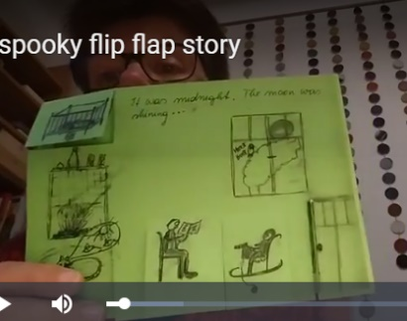

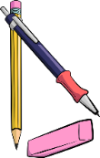
It was a ….

Suddenly…

