Predicting the Future
paper fortune tellers

You will…….
Fold your personal paper fortune teller and write in 8 good fortunes that will happen to your friends.
Then talk to 3-4 of your friends and tell them what’s in store for them in the future.
To fold your paper fortune teller follow these instructions:
Start with a square.   |  |  | Now turn it over.
 |  | 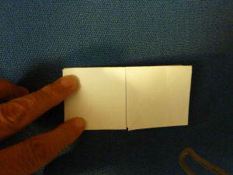 | Push together
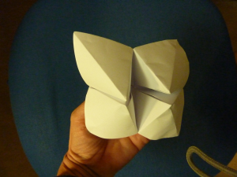 | Open up your fortune teller and write in eight good fortunes.  You will….  You will…  You will… | 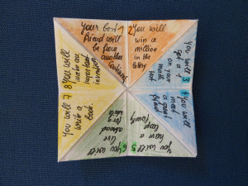 | Add numbers 1-8  and  choose 4 colors to decorate your fortune teller.  Optional: Decorate the outside of your fortune teller.
To play:  Ask your friend to choose a number between 1 and 10.  Open and close your fortune teller counting up to the chosen number. | Ask your friend to choose a color.  Open your fortune teller so you see the chosen color.  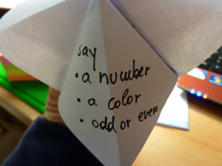 | Ask your friend to choose odd (ungerade) or even (gerade).  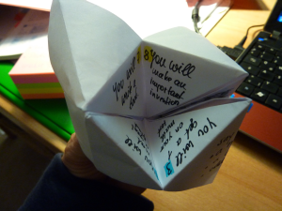 | Read out your friend’s fortune and wish him/her good luck.

