Present Routines: Moebius Strips

My Day … My Week

Learners prepare Moebius strips: Cut flipchart paper lengthwise into strips of about 5-6 cm (2“). Then turn one side over and glue the two ends together. This will give you a never-ending loop of paper.

Learners now write simple sentences describing their daily/weekly routines on the loop, filling it on both sides.
For example:
I usually get up at 6.30. I get dressed and have breakfast. For breakfast I eat …
They go through the whole day.
Then add sentences about their weekly routines: On Mondays school ends at … and I go to my violin lesson at 4.00 …..
Thus the learners fill the whole strip – first on one side, then on the back until they come back to the starting point. More advanced learners can write a whole second round giving lots of details.
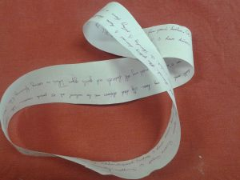 | 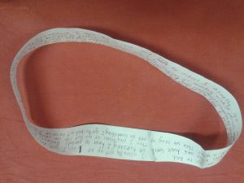

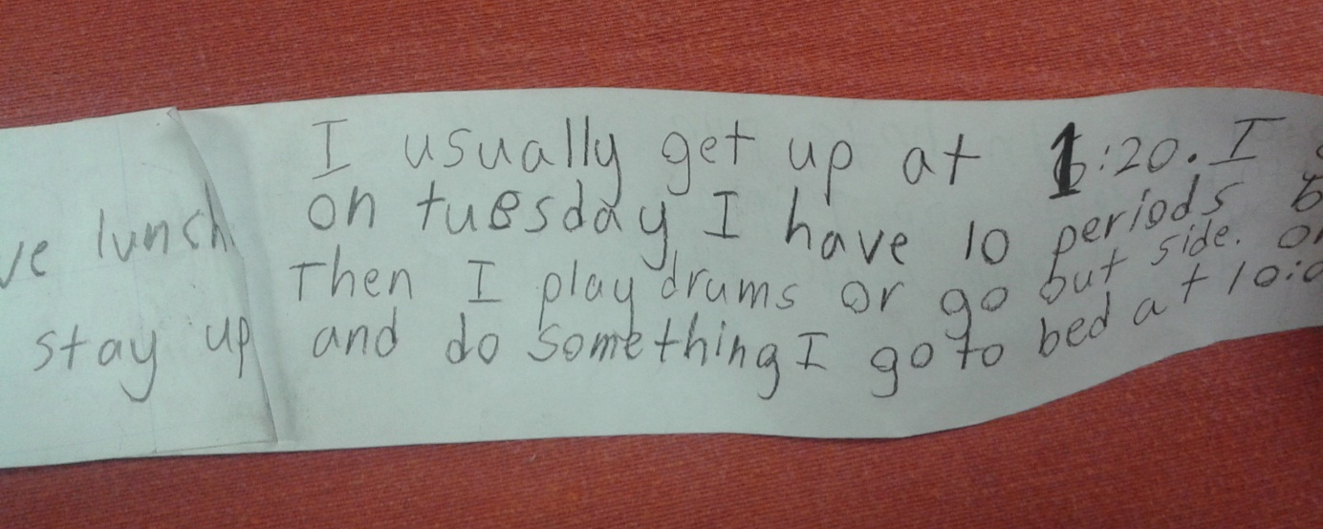

Then learners circulate and read out their routines to each other and/or to the teacher.
The concept of ROUTINES as something that goes round and round and round through the learners’ hands is thus very nicely experienced and encoded in the learners’ brains.

