Group finding activity: Recent activities (pres.perf. tense)
Cut into cards. Each student gets one card. Based on a very similar exercise in: David Newby, Grammar for Communication, ex. 90, p. 180
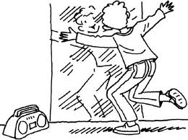
What have you been doing to look so …..?
Walk around in class and keep asking the question on your card.
Keep doing this until you find 3 other students who are asking the same question.

Find creative answers to your classmates’ questions.
What have you been doing to look so…? Think of some activities that have led to your present state.
Why do you look so happy? | Why do you look so happy? | Why do you look so happy? | Why do you look so happy?
Why are you so tired? | Why are you so tired? | Why are you so tired? | Why are you so tired?
Why do you look so bored? | Why do you look so bored? | Why do you look so bored? | Why do you look so bored?
Why are your hands dirty? | Why are your hands dirty? | Why are your hands dirty? | Why are your hands dirty?
Why have you got wet hair? | Why have you got wet hair? | Why have you got wet hair? | Why have you got wet hair?
Why aren’t you wearing any shoes? | Why aren’t you wearing any shoes? | Why aren’t you wearing any shoes? | Why aren’t you wearing any shoes?
Why are you so angry? | Why are you so angry? | Why are you so angry? | Why are you so angry?

