Since 1908:
Objective of the game: Practicing the use of the present perfect tense in order to express DURATION of states and activities.
Instructions: Work in groups of 3-4. Shuffle the cards and deal them out. Look at your cards secretly. Some of the cards have dates (e.g. since 1908…), others just show famous brands or companies. The youngest person in your group starts by asking a question about one of the brands.
E.g: How long has FORD been selling cars? or Since when has FORD been selling cars?
The student who has the matching answer card reads out the correct information, collects the pair and asks the next question.
Aim of the game: Try to collect as many pairs as possible.
At the end of the game, look at all your pairs again in your group and put them in chronological order (start with the oldest one and end with the youngest one). Then write down one sentence about each company or brand.
For example: xxx is the oldest/second oldest/third oldest…/a fairly young/ the youngest company/brand/institution. They have been selling/producing/open to the public… since…
Write your sentences into your language practice book and show them to your teacher or co-teacher before ticking off the game on your task-sheet.

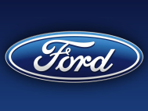  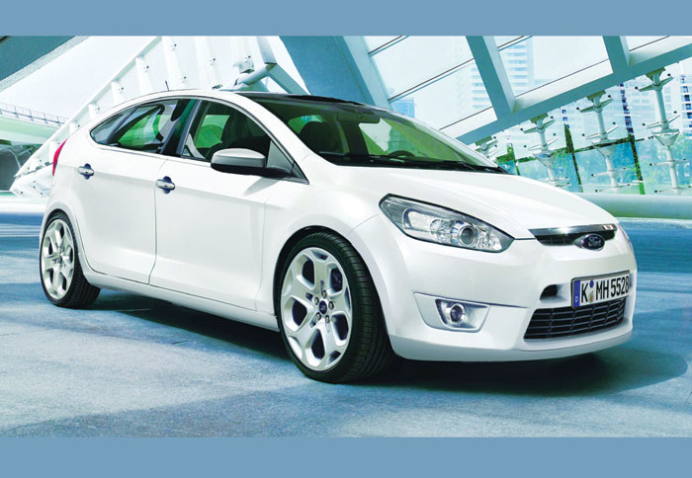 | 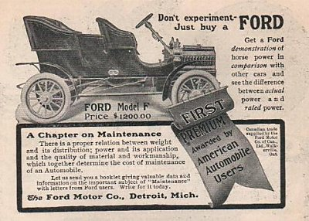  Since 1908
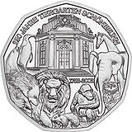  Since 1752 | 
 | 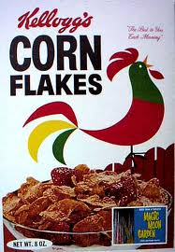
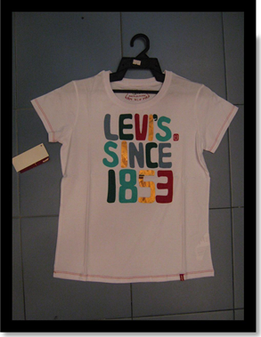 | 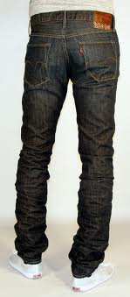
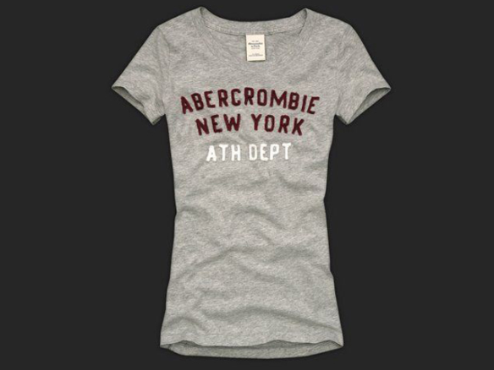 | 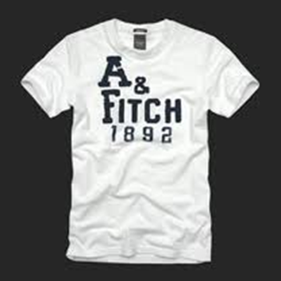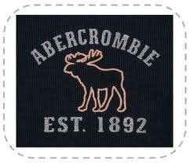
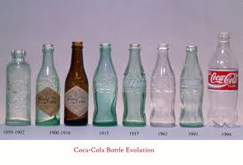  Since 1894 | 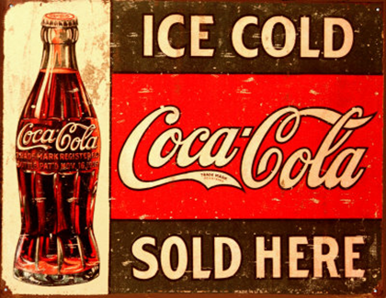
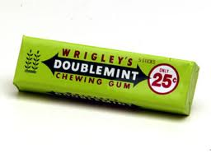 | 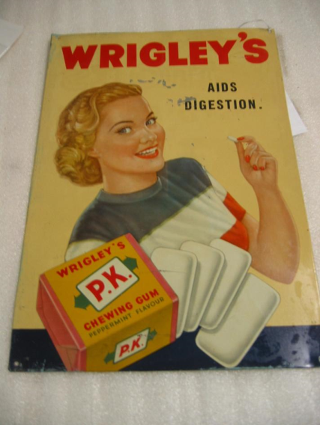  Since 1892
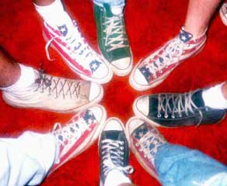  Converse All Star since 1917 | 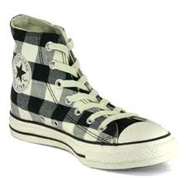  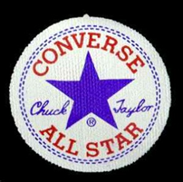
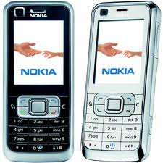  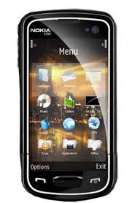 | 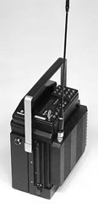  Nokia Mobira Senator (1982)  It may look more like a boombox than a portable phone, but this boxy, bulky device was actually Nokia's first mobile (if you can call it that) phone. Introduced in 1982, the Nokia Mobira Senator was designed for use in cars. After all, you wouldn't want to use this phone while walking: It weighed about 21 pounds
January 17th, 2007  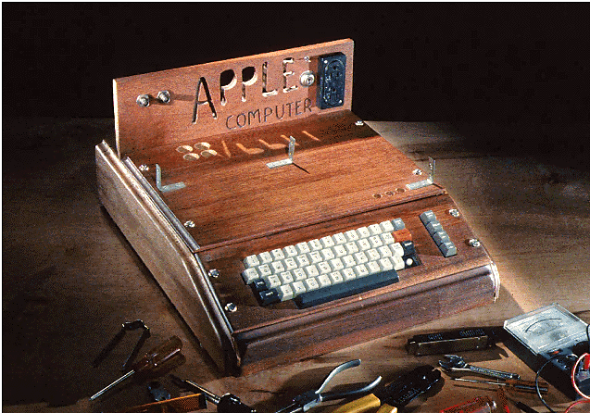  This is Apple I. The first Apple computer. Steve Jobs and Steve Wozniak, the most famous members of the Homebrew Computer Club, designed it over 30 years ago, in 1976. It was mostly a kit computer. Users bought the workings and built their own case. | 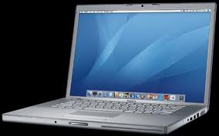  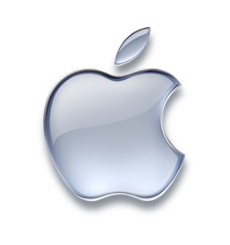
  Since 1991 | 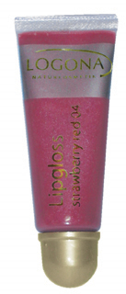
since 1977  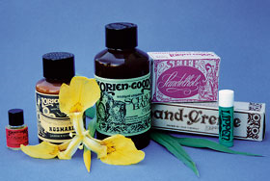 | Logona Lip Gloss Pearl 01  As with all Logona cosmetics, Logona lip glosses are free of synthetic preservatives, colors and fragrances, and, of course, BDIH certified.

 | 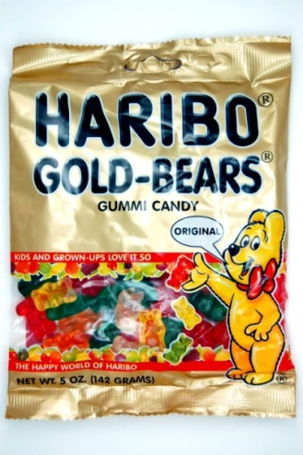  Since 1922
 | 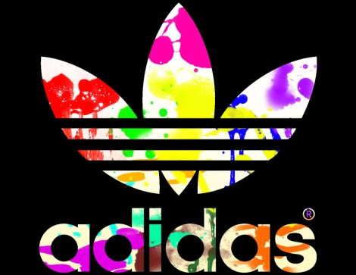  Since 1949
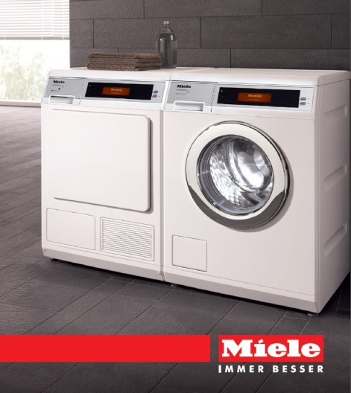 | 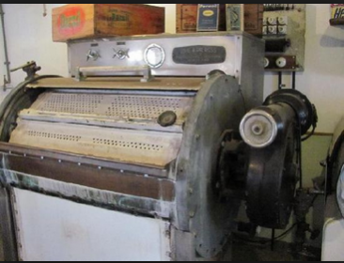  Miele washing machines, since 1956

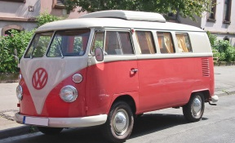  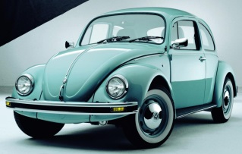  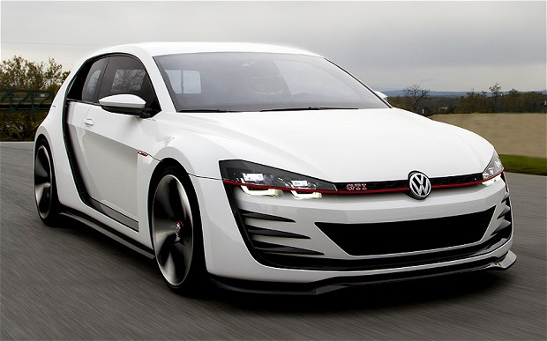 | 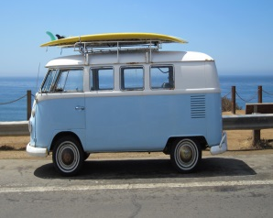  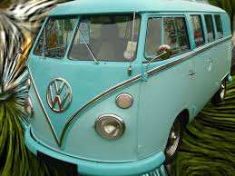  Since 1937
  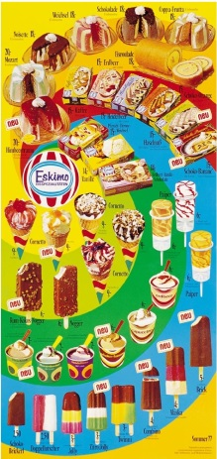 |   Since 1927
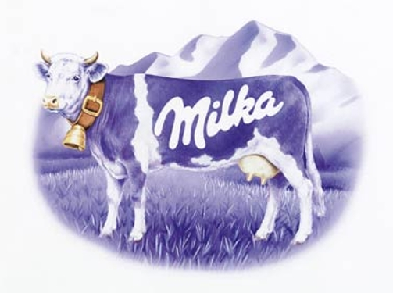 | 