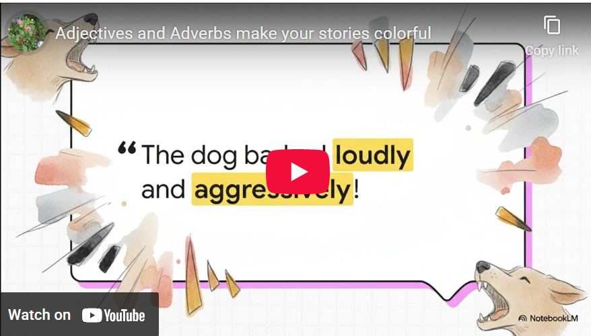
Watch the video.
Then read the story and mark all the adjectives in red and the adverbs in blue.
The Colorful Twins of Wordville
Once upon a time, in the bustling town of Wordville, there lived two curious twins named Jenny and Advy. Jenny loved talking about what things and people were like. She would say, "This dress is so beautiful and colorful! This cake is delicious and sweet! These shoes are old and dirty!” Everyone in Wordville knew Jenny was the queen of adjectives because she was always describing things and people.
Her brother, Advy, was a little different. He didn’t care so much about what things were like; he wanted to know how people were doing things. If his friend walked to school, Advy would ask, "How did you walk?" Did you walk slowly, or did you run quickly?" When he heard his sister singing, he’d say, "Wow, you're singing beautifully!"
Advy would say, "The dog barked loudly and aggressively!" The teacher spoke to the class angrily. His new shoes squeaked loudly!” Advy was the master of adverbs, always describing how people did things.
One sunny morning, Jenny and Advy decided to enter the Great Wordville Race. Jenny wore her bright, shiny sneakers, and Advy put on his fast blue cap. At the starting line, Jenny looked at the other racers and said, "You are all strong and brave!" Advy grinned and shouted, "Let's run quickly and cheer loudly!"
As the race began, Jenny described everything she saw. "The road is long, and I'm tired! The sky is blue, and the sun is hot. The crowd is excited!" Meanwhile, Advy reminded everyone how to race: "Run quickly but carefully around the corners! Breathe deeply! Smile broadly when you reach the finish line!"
At the finish line, the mayor of Wordville handed each of them a medal. "Jenny, you showed us what things are like. Advy, you showed us how to do things. Together, you make our stories colorful and fun!"
From that day on, everyone in Wordville remembered that adjectives describe what things or people are like and adverbs describe how we do things. If you ever forget, just think of the most adventurous twins in town, Jenny and Advy!

You have met Jenny and Advy and you now know how they would describe the following situations.
These words will help you: angry,: angrily, brightly, cute, cold, dark , delicious, heavily, loudly, slowly , strong , sunny, sweet, quickly
Jenny   | Look at the dog. It ...
Advy | Look at the dog. It....
Jenny   | Today our math teacher ...
Advy | Today our math teacher ...
Jenny | It is ....
Advy | The sun is ...
Jenny   | The clouds are ............... and the wind is ............
Advy | It is raining .................... and everyone is running home  .....................
Jenny  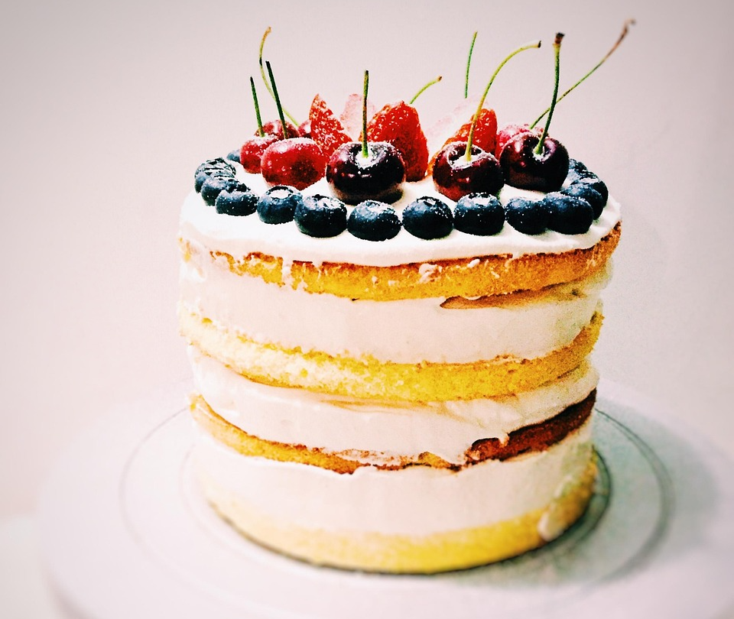 | This cake looks so ............... and ..............
Advy | Let’s eat it ..........................
Now let’s see how Jenny and Advy talk about their school, their teachers and their classmates.

Jenny: What is it like? | Advy: How do they behave?
heavy, difficult, bright, messy, quiet, smart, helpful, nice, friendly, colorful, beautiful, easy, boring, interesting, loud, | quietly, loudly, carefully, patiently, neatly, clearly, aggressively, quickly, slowly, beautifully, angrily, happily, wildly, shyly, sloppily

