How did you …
Think of things you or people around you did during the Christmas holidays and write one true sentence with each of these adverbs.

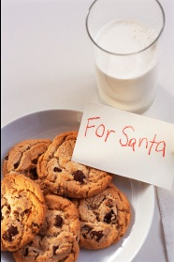

- happily  - quietly  - quickly  - carefully  - nervously  - greedily | - impatiently  - patiently  - calmly  - gently  - slowly  - loudly

