Somebody is watching you…

Sarah and the Fly
Sarah is in 5th grade. She is eleven years old and she is working on a story for a writing contest in school. A fly on the wall is watching Sarah in her room. She is working on her story. Here is what the fly sees:
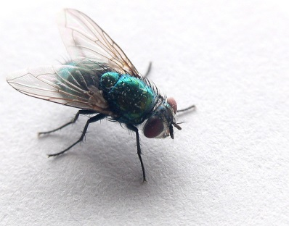
Sarah is sitting at her desk quietly. She is writing slowly.
She stops and looks up. She is chewing her pencil thoughtfully. Then she starts writing again. She angrily erases something. She is frustrated. She gets up and turns off the radio. Suddenly, she hears a bird. She listens carefully. Then she goes back to her desk and starts writing again.
She is writing quickly now. She finishes the story and happily closes her notebook.
Her story is finally finished!

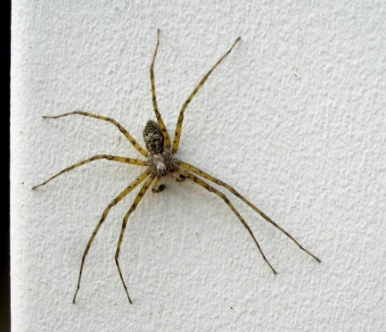
Now it’s your turn: Egon, the spider
An interesting lesson:
Imagine an interesting lesson in your class. Egon, the spider is sitting on the wall near the blackboard. He is watching you. What does he see? What is going on in the classroom? How do you and your classmates behave? Write about 100 words.

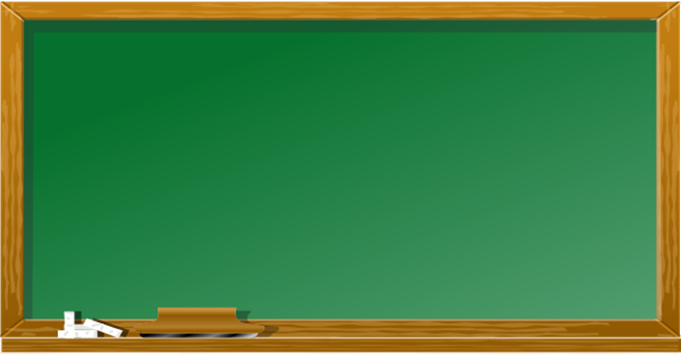
German
Maths test
Egon is watching you..

Physics
Arts
Biology
Today’s lesson…
Maths Test

This exercise is based on Westfall,Weber: English to go 2. Coursebook. p. 61.

