Describing people and things: What are they like?

Read the following text about Willy the Vampire and underline all the adjectives.
ADJECTIVES describe WHAT THINGS and PEOPLE ARE LIKE. The first ones have been done for you:
Willy the Vampire
When I went to elementary school, I had a classmate who was a bit strange. He was very small and thin, and his skin was very pale. He had short, blond hair and very long fingers and toes. Willy always sat in the last row. He seemed very tired and shy.
Willy was a good student. His math grades were always excellent, and he was a talented storyteller. He always got As for his stories in German. Willy liked to draw and paint, and we all liked his pictures. Our teacher often hung his pictures up in the hallways because they were so special.
Willy lived far from the school at the edge of our town. He lived in a large, very old house with his family. They were all as pale as Willy and they were all very shy.
There were lots of wild rumors about Willy and his family. Many people said that they had seen them walking the streets in the middle of the night. Others said that they had heard strange, howling noises in their house at full moon.
We never dared to ask Willy about these rumors, but even if he was a vampire, he was a nice and friendly classmate and he did not do any harm to anybody.

Now it’s your turn

Choose five interesting adjectives and write your own sentences with them. Make sure all your sentences are TRUE and tell us TRUE things about yourself, your family and friends.
Write the adjectives into column 1, then write your sentences into column 2
Adjectives | My TRUE sentences

Describing how people do things

Now read the text about Willy again. Some parts have been changed or added.
Use a new color and highlight all the words and phrases that show us HOW people DO things.
Example: How did Willy speak? He spoke very quietly.

Willy the Vampire
When I went to elementary school, I had a classmate who was a bit strange. He was very small and thin, and his skin was very pale. He had short, light-blond hair and very long fingers and toes. Willy always sat in the last row. He seemed very tired and shy.
When Willy spoke, he did it very quietly. He always looked around shyly and nervously and watched very carefully what his classmates were doing. In the breaks Willy sat quietly in a corner and read a book, while the other students were running around wildly and shouting loudly at each other.
Willy was a good student. He worked very carefully in all subjects and did very well on all tests. In German he loved to write stories and spent a lot of time planning them very carefully. Willy could draw and paint really well.
Willy lived far from the school at the edge of our town. He lived in a large, very old house with his family. They were all as pale as Willy and they were all very shy.
There were lots of wild rumors about Willy and his family. Many people said that they had seen them walking in the streets in the middle of the night. Others said that they had heard the family howl loudly at the full moon, others had heard them whisper silently in the graveyard.
We never dared to ask Willy about these rumors, but even if he was a vampire, he was a nice and friendly classmate and he did not do any harm to anybody.
Now it’s your turn

Choose five interesting adverbs (how they DO things) and write your own sentences. Make sure all your sentences are TRUE and tell us how you, your family and friends do things.
Write the adverbs into column 1, then write your sentences into column 2
Adverbs | My TRUE sentences

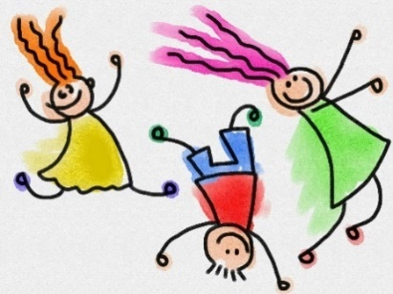
How did they do it?
How did they …

Think of things you or people around you did last week and write one true sentence with each of these adverbs. You can also write about your pets. Highlight the adverbs in your sentences.

happily | Elias smiled happily when Mr. Grasser praised him.
quietly
quickly
carefully
nervously
politely
patiently
slowly
angrily
aggressively
noisily
loudly
sadly

