Match the pictures and the descriptions by putting letters or numbers inside the circles.
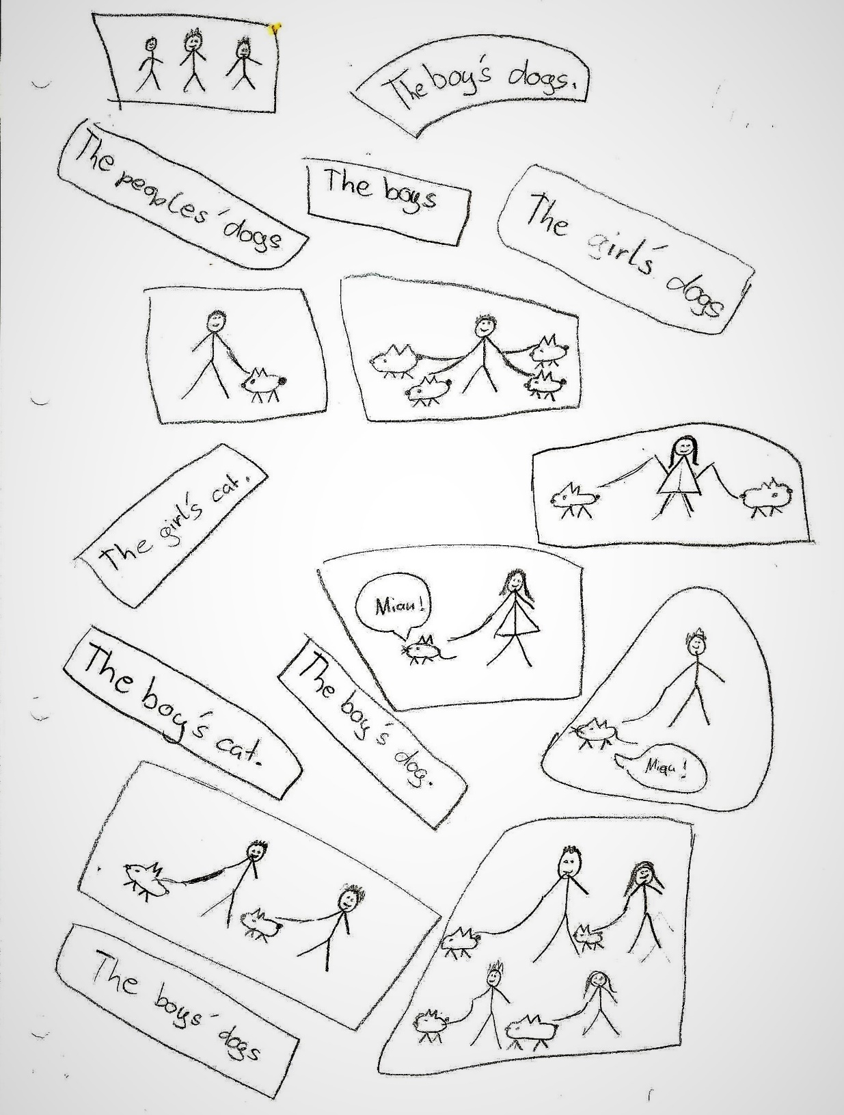
by Maxi
Now draw your own exercise on the back of this sheet. Choose a new topic for your exercise.

