Going to: Plans and intentions

Listening
http://learnenglishteens.britishcouncil.org/skills/listening/intermediate-b1-listening/weekend
https://learnenglishteens.britishcouncil.org/sites/teens/files/the_weekend_-_exercises_0.pdf

Check your understanding:
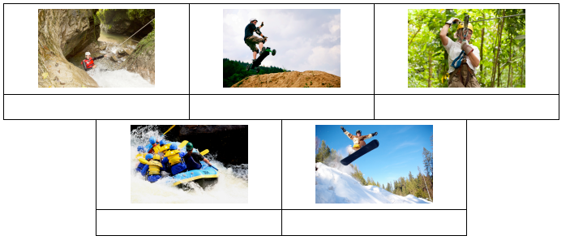

Do this exercise while you listen. Which six activities do the speakers say they are going to do? Write down the correct answers: Speaker 1 is going to …, Speaker 2 is going to…







