Focus on Language and the Learner

ENF.01240UB

SS 2018

Group A

Dr.phil Pölzleitner Elisabeth

Grammar Project about

Past Continuous/Progressive
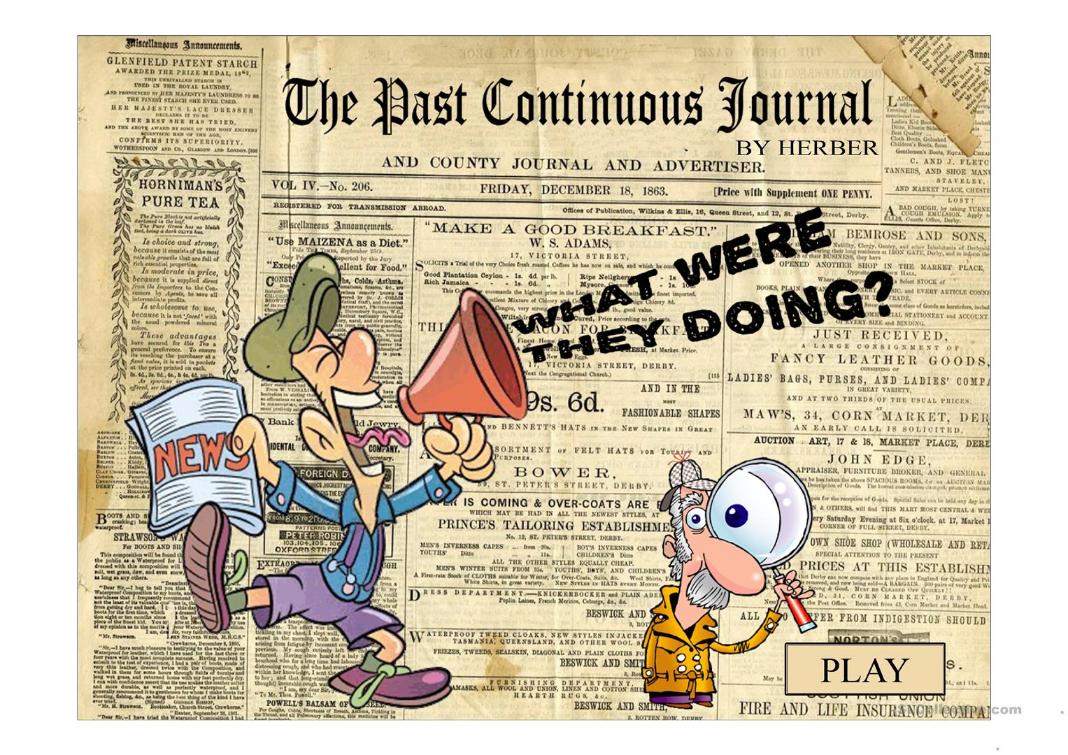

Monschein Lukas (01414905)
Schipflinger Thomas (01512087)

Inhalt
1. Introduction 3
a. Teaching Aims 3
b. Timetable 4
2. Lesson 1 7
a. Activity 1: My dear Spy 7
b. Activity 2: Time Travel 8
c. Activity Three: Don’t break the chain 10
3. Lesson 2 11
a. Activity 1: Witness Game 11
b. Activity 2: Memory Challenge 13
c. Activity 3: Past Simple vs. Past Progressive/Continuous 17
d. Homework: My favorite photo 19
4. Lesson 3 21
a. Activity 1: Detective game 21
b. Activity 2: Flip Flap story 24
c. Testing activity 29
d. Homework: Write an ending 30
5. Sources: 33

Introduction

Teaching Aims
- Age group: 11-12 years
- Grade 2: A1
- Students know how to form the past progressive
- Students understand the difference between the foreground and background of a story
- Students can form the past-progressive correctly in real time context
- Students can distinguish between the past simple and the past progressive tense
- Students know to use the past progressive about specific in the past
- Students know when to use the past progressive in stories.

Timetable

First Lesson
Time | Activity | Learning Stage
20 min | My dear Spy  Students watch a video where the past continuous in real life context is used. The focus is on raising their awareness towards the new grammatical structure. | Awareness Raising:  Students focus on Past Progressive as a new grammatical structure for the first time.
10 min | Time Travel  Students play a game in groups of 4 where one person tells the other what he/she was doing at a specific past event. | Procedualization in scaffolded conditions:  Students practice the form of past continuous in a fun game.
15 min | Don’t break the chain  The Students play a game similar to “Ich packe in meinen Koffer”. The focus is on making students aware of a new grammatical structure. | Awareness Raising and Conceptualization and hypothesis building:  By hearing and saying the past continuous multiple times, the students will be aware of the correct form of the grammatical structure.

Second Lesson
Time | Activity | Learning Stage
10 min | Witness Game  The students practice the past continuous in real life context. The focus lies on understanding when to use the past continuous | Proceduralization in scaffolded conditions:  Through witness statements, the students have to repeatedly form the past continuous
20 min | Memory Challenge  Students will play a very active game where they ask each other questions about they did at a specific past time. Forming the past continuous multiple times is the main goal of this exercise. | Proceduralization under scaffolded conditions:  By asking and answering other students questions they have to form the past continuous multiple times, also as a question.
15 min | Gap Text  Students have to fill in a gap text and later produce their own text. The students have to understand when to use the past simple and past continuous | Conceptualization and hypothesis building:  Through different helpful material, students have to find out, when to use the past simple and past continuous
Homework | Favorite Photo  Students have to write a text about a personal photo. This homework aims at practicing the things which were learned in class. | Performance in real-time context:  Students have to write a personal story with little to no help. Knowledge about the tense is required.

Third Lesson
Time | Activity | Learning Stage
10 min | Detective Game  In this game, students practice the past continuous in a real-life situation where a detective is collecting witness statements from his fellow colleagues. | Proceduralization in scaffolded conditions & Performance in real-time context:  Past continuous is repeatedly practiced, however, prior knowledge and competence is required in order to not seem suspicious.
20 min | Flip Flap Story  Students are able to practice the past continuous with a thrilling story. Creativity and written work is required. | Conceptualization and hypothesis building:  The concept of the past continuous is repeated with the help of task sheets.
15 min | Testing Activity  Students have to write a spooky story. In order to make it spooky, the students have to use the past continuous in the right moments. | Performance in real-time context.  Competence is required. Students have to use the past continuous correctly when writing the story.
Homework | Flip Flap Ending  Based on the work in class, students have to finish a spooky story. Each student will have an individual ending. Speaking is practiced by recording the outcome on FlipGrid | Proceduralization in scaffolded conditions & Performance in real-time context:  The learned grammatical form is used in real-life context which requires competence from the students.

Lesson 1

Activity 1: My dear Spy

Stage: Awareness Raising
Material:
- Youtube Video: https://www.youtube.com/watch?v=zedrT9OHfAg
- excellent video!!!
Procedure:
The teacher shows the video to the students without any particular instructions except that they should watch and listen carefully. After they have seen the video for the first time, the teacher asks the students questions about the content and if there were any words they did not understand. The teacher shows the video for a second time and tells them to pay attention to what the detective and the witness say and how they say it. Following the second viewing, the teacher raises awareness about the past continuous with specific questions and writes one or two examples on the board from the video. While the students are watching the video for a third time, they should write down all grammatical constructions of the past continuous they notice. Once they are done, the teacher visualizes the content by writing all student suggestions on the black board. When a student makes a mistake, the teacher immediately corrects the student with reference to the correct form and writes the correct sentence on the board.
Task:
- Watch the video and listen/watch carefully.
- What is happening in the video? What words are new? Suspect, spy, etc.?
- Watch it again but focus on the language and what and how people in the video say things.
- What were the people saying? (asking questions in past continuous) What were they doing? Teacher writes 1-2 examples of past continuous usage on the board.
- Watch the video again and write down all sentences you hear with this concept/structure.
- What examples did you write down? When do you think this tense is used? (particular event in the past) What do you think is the difference between “was doing” and “were doing”?

Criteria:
Depth of processing and Complex encoding | +  Students will be led into a new grammatical structure step by step. The teacher´s questions ensure that the students have to think about what is happening in the video. In the later stages of the activity new grammatical structures are processed.
Commitment filter | +  I think it is nice to watch a video from time to time, also for the students
Peer and social learning and interaction | ✓  Not in this exercise. (The exercise could be done as a pair work.)
Personalisation | -  Not really, because this task is only for awareness raising.
Contextualisation | +  Yes, because it is a video showing a detective who is interviewing a witness to solve a murder case.
Authenticity of process | ✓  The language in the video is very clear and well structured. The students work together with the teacher on the grammatical structure of the tense. Language in “language-like” ways is used, however the students work a lot with the grammatical context of the tense. The criteria is not fully fulfilled.

Activity 2: Time Travel

Stage: Proceduralization in scaffolded conditions
Material:
- None
Procedure:
The teacher tells the students to think of a place they have been to in the past (e.g. somewhere on holiday, at a festival, at a party or some other event). They should keep their choice to themselves. After this the teacher tells them to imagine the place in detail and travel back in time and observe what was going on there – what people were doing….. They should write down 3 things that they can see people doing, using the past continuous (e.g. at a football game: A lot of people were shouting, a man was blowing a whistle. Someone was kicking a ball.) While they are doing this, the teacher goes around the class monitoring their progress and suggesting alternatives or prompting students who can´t think what to write. Once they are done, the teacher asks them to go together in groups of four. Now one of them has to read out their sentences and the others have to guess at which place this person was. In case 3 sentences are not enough to have a correct guess, additional sentences have to be created. After the first round, either new places can be thought of or the groups can simply get changed up.

Criteria:
Depth of processing and complex encoding | +  The students have to be mentally active because they want to find out where their partner was.
Commitment filter | +  This game mainly thrives through curiosity. It will be fun for the students because they want to find out and guess where their partner was.
Peer and social learning and interaction | +  It is a group work exercise and the students have to collectively guess the right answer. Working together towards a right answer will benefit them. Social interaction is promoted
Personalisation | +  Each student draws specific attention to past experiences. Creativity is also promoted.
Contextualization | ✓  The exercise uses the past continuous as a reference to past experiences in natural context.
Authenticity of process | ✓  Despite the fact that only single sentences have to be read out, the exercise promotes the use of past continuous in natural context.
Task-based | ✓  The students will practice build the past continuous because they have to consciously think about the structure when building the sentences.
Testing versus teaching | I think it is best for teaching. This exercise is a communicative grammar drill and used under scaffolded conditions.

Activity Three: Don’t break the chain

Stage: Awareness Raising and Conceptualization and hypothesis building
Material:
- None
Procedure: excellent activity
The students are arranged in a circle. The teacher chooses a time in the past and tells the students to think about what they were doing at that time. For example, “8 o’clock last night”. One student begins by telling the class what he/she was doing at that time by making a past progressive sentence. For example, “I was watching a movie at 8 o’clock last night”. The next student repeats the previous student’s sentence using “while” and adds what he/she was doing. For example, “While Tom was watching a movie, I was playing a game on my phone”. Then, each student in turn repeats the previous students’ sentences using “while” and adds his/her own sentence. For example, “While Tom was watching a movie and Sarah was playing a game on her phone, I was waiting for the bus”. If a student cannot remember another student’s sentence or makes a grammar mistake, he/she is out of that round. The round finishes when the turn comes back around to the first student. Students score one point if they manage to stay in the game. Several rounds are played using different times in the past. The student with the most points at the end of the game wins. When you have a very big class the students get together in pairs or have a random order.
Task:
- Take your chairs and form a circle.
- I want you to think about what you were doing at 8 o’clock last night.
- [Student #1], what were you doing at 8 o’clock last night?
- While [student #1] was doing … I was watching a movie.
- (Pointing to the next student) Now you repeat what [student #1] and I said and tell your classmates what you were doing last night at 8 o’clock. And so on and so on…

Criteria:
Depth of processing and Complex encoding | +  Due to the fact that the learners have to use their own experiences, their “world knowledge” is definitely processed.
Commitment filter | +  The learners are very enthusiastic to win against classmates.
Peer and social learning and interaction | +  The activity is perfect for social learning. The whole exercise is based on the contribution of each learner.
Personalisation | +  With each round, the learners have the opportunity to incorporate their experiences.
Contextualisation | +  The exercise is based on real-time context.
Authenticity of process | +  Since the students draw on their personal experiences, I believe that the process of grammar learning is very authentic.
Task-based | -  The learners will have an end product after doing this exercise.
Testing versus teaching | The activity fulfils the process of teaching. Additionally, the learners unconsciously practise their use of the Past Progressive.  However, as the students may see it as a challenge, the activity is also part of the process of testing.

Lesson 2

Activity 1: Witness Game

Stage: Proceduralization

Material:
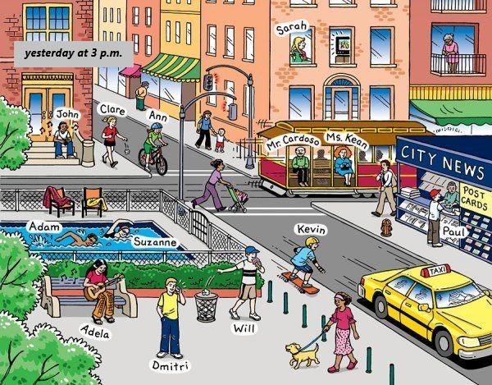
http://englishclassvgp.blogspot.com/2017/02/activities-for-tenth-grade-10th.html
Procedure:
The teacher tells the students that yesterday, around 3 a.m. a burglary happened in the street they live in. The student was looking outside the window when this happened. The teacher tells the student to look at the picture for 90 seconds and remember as much as they can. After 90 seconds, the teacher removes the picture. Then the teacher turns into the role of a policeman and asks the students what they saw. Every detail can help to solve the crime.
After the first part, the students get the picture again and have another 3 minutes to look at the picture. They have to write down three suspects who they think did it. After the three minutes the teacher takes the picture away. The students work with their bench neighbor. They tell each other who they think did it.
Task:
- Look at the picture. You have 90 seconds to remember as many details as possible.
- What do you remember? Tell the policeman as many details as you can remember. Every detail can help solve the case.
- You now have three more minutes to look at the picture again. Come up with three possible suspects and tell your bench neighbour why you think he/she did it.
- Now work with a partner and tell him what you think. Your partner will tell you his thoughts.
Criteria:

Depth of processing and Complex encoding | +  Yes, they have to formulate questions/answer on their own.
Commitment filter | +  Yes, because the exercise starts with a little remembering game which activates their brains and functions as a little challenge for them
Peer and social learning and interaction | +  Pair work and whole class remembering game
Personalisation | ✓  The students are answering questions based on their own ability to remember things and have to formulate own questions. However, the questions/answers are not very personalized.
Contextualisation | +  The exercise is based on real-time actions about what people were doing at a certain point of time.
Authenticity of process | +  Language is authentic. Describing what someone did at a certain point of time.
Task-based | ✓  There is no real product except for the solution of the game.
Testing versus teaching | I think it includes both, testing and teaching. One the one hand, the students are supposed to already know how to form the past progressive, on the other hand, they practice building their own sentences.

Activity 2: Memory Challenge

Stage: Proceduralization
Material:
- Prompt cards with Past Continuous information + helpful ideas.
- If necessary, the prompt card can be combined with the scorecard.
Procedure:
The teacher tells the students that this game requires them to walk around the classroom and ask 10-15 of their fellow students (depending on size of the class) what they were doing at a specific past event. E.g. “What were you doing when you first saw a double-decker bus?” “What were you doing this morning?”. Depending on the level of the class, the teacher can either write the basic structure on the blackboard, e.g. “What were you doing when/last…?” “I was doing/walking/flying/traveling…”, or provide the students with prompt cards. The prompt cards can be seen below.
In order to make the exercise more fun, the game will be a bluff or lying game. The student who gives an answer has the chance to tell a lie. The person who asked the question then has to guess, whether his/her answer was a lie or not. For each right guess, the student receives one point which will be written into his scorecard.

Good idea! I like the bluffing!

Scorecard
Name | Question: | ✓  Right guess | X  Wrong guess
 | Total:

What were you doing…
… yesterday at 7 p.m.? | … when the Royal Wedding took place?
… this morning at 9 p.m.? | … when you first saw a double-decker bus?
… when Madrid won the Champions League? | … when Washington won the Stanley Cup?
… this time last week? | … at 10 p.m. yesterday?

Criteria:
Depth of processing and complex encoding | ✓  Students will be mentally active because they have to pay attention to the answer of their colleagues. However, it might take specific questions from the teacher to raise awareness and make the students think about why and when the past continuous is used.
Commitment filter | +  This exercise will be fun for the students because they will have to guess whether the answers are correct or a lie. Curiosity is the key to this exercise.
Peer and social learning and interaction | +  Since the students have to walk around class and communicate with each other, social interaction is very important. This exercise gets them to speak to each other.
Personalisation | +  The questions and answers will be developed by each student individually. This means each question expresses their own ideas and answers have to be given on personal experience in the past.
Contextualization | +  Students will realize, when the past continuous is useful. Since they want to ask specific questions they will be aware of when to use this grammatical form
Authenticity of process | +  Naturally, the past continuous has always been a difficult grammatical form to teach since books tend to use the typical “one action is interrupted by another” explanation. This exercise, however, uses the past continuous in a way it would naturally occure in communicative English.
Task-based | ✓  In this case the end product is practice and proceduralization.
Testing versus teaching | This exercise supports learning. It does not have any value for testing.

Activity 3: Past Simple vs. Past Progressive/Continuous

Stage: Conceptualization and hypothesis building
Material:
- Gap text
- The Difference Box
Procedure:
Students have to fill in the gap text using either the simple past or the past continuous.
Once they are done, the teacher hands out "The Difference Box” and students read through it independently. Afterwards, the students get together in pairs and correct the other students gap text with the help of the “Difference Box”.
The teacher then corrects the gap text together with the entire class and makes sure that everybody understood the difference between past simple and past continuous.
To end this exercise, students will be asked to come up with their own story of around 100-150 words following a similar structure as the gap text.

say – fly – lie – hear – happen – hold – can – reach – film – see – burn – come – stand – try – drive – run

The accident ………… at six o´clock yesterday. Mr. Lane ……… along the main road away from the town center when he ………….. a helicopter above him. It ………. towards some woods and smoke ………… out of the cockpit. A few seconds later, he ………… an explosion. When Mr. Lane …………. the woods, he ……….. hardly believe his eyes: The wreck of the helicopter …………… and the pilot …………. on the ground near to it. Several people …………. a few meters away, but no one ……….. to help the pilot. One man even ………….. a camera and ………….. the scene. Suddenly one of the man ……….. up to him. “Don´t worry,” he ………… “We´re only making a film!”

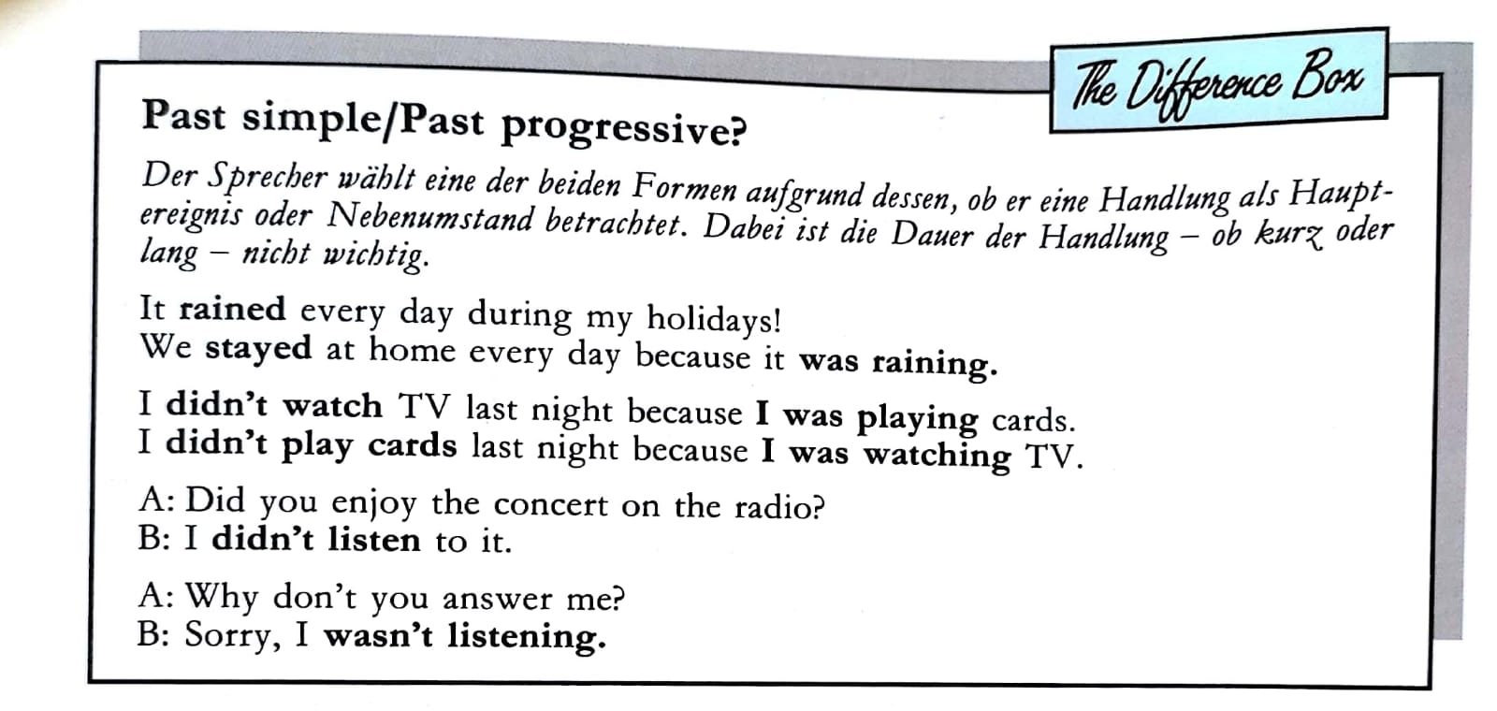

Criteria:
Depth of processing and complex encoding | +  The students have to be mentally active in order to complete the task correctly. They have to pay particular attention to the context to use the right tense.
Commitment filter | ✓  The story of the gap text makes the students curious because they want to find out how the story ends. Additionally the question which tense to use is solved by the students on their own.
Peer and social learning and interaction | ✓  After working individually, the students do peer correction and share their knowledge and understanding of the new grammatical structure.
Personalisation | +  The exercise promotes individual creativity because they have to create their own story at the end.
Contextualization | The exercise in its nature is not communicative but rather a writing exercise. The only communication that exists happens during the peer correction.
Authenticity of process | ✓  Authentic language is used in the gap text.
Task-based | +  Students learn when to use the past continuous in comparison to the past simple. This is done through the gap text and the writing exercise.
Testing versus teaching | The exercise leans more towards testing but also promotes learning because of the new material.

Homework: My favorite photo

Stage: Performance in real-time context
Material:
- See worksheet below.
Procedure:
This activity is meant to be given as homework to the students. The learners choose a photo they like and/or represents an important event of their lives. Based on the photo and its events and people showing, the learners write a short story using the past progressive and past simple correctly.


Get your hands on a photo that shows one special moment from your life you won’t forget. Bring it to life. Describe all the details you can remember. Write about what you were doing when the photo was taken (e.g. I was celebrating my birthday.), what people in the photo were doing at that time (e.g. My cousin was studying at university.), and what was happening outside the frame of the photo (My father was playing the guitar.). Make a copy of the photo and add it beneath the text.
___________________________________________________________________________
___________________________________________________________________________
___________________________________________________________________________
___________________________________________________________________________
___________________________________________________________________________
___________________________________________________________________________
___________________________________________________________________________
___________________________________________________________________________
___________________________________________________________________________
______________________________________________________________________________________________________

___________________________
___________________________
___________________________

___________________________
Glue your photo here

Depth of processing and Complex encoding | +  Due to the fact that the learners have to use their own experiences, their “world knowledge” is definitely processed.
Commitment filter | +  The learners may be very enthusiastic describing their own photos.
Peer and social leaning and interaction | ✓  The activity isn’t very communicative. However, as a next step, the students may present their photos to the class or small groups. This would turn the activity into a social learning one.
Personalisation | +  The learners do not only have the opportunity but the obligation to personalize their product.
Contextualisation | +  The exercise is based on real-time context.
Authenticity of process | +  Since the students draw on their personal experiences, I guess that the process of grammar learning is very authentic.
Task-based | +  The learners will have an end product after doing their homework.
Testing versus teaching | The activity fulfils the process of teaching. Additionally, the learners unconsciously practise their use of the Past Progressive.
Criteria:

Lesson 3

Activity 1: Detective game

Stage: Proceduralization in scaffolded conditions & Performance in real-time context
Material:
- Description cards
Procedure:
One student is asked to be the detective in the following game. He/she has to leave the classroom, while the instructions are given to the class. The setting is explained to the students: the students in the classroom are all suspected of having broken a window at the local school [insert school name] the day before. They are given cards with descriptions about their alibi. One of the students is the perpetrator and is forced to lie about his/her alibi. The detective-student enters the classroom and asks the students questions. He/she must ask questions pertaining to the Past Progressive by only asking questions about the time of the murder. For example, he/she could ask questions like: ‘What were you doing yesterday afternoon when the alarm went off?’. The detective should ask further questions, so the students have to be creative answering the questions.
The game is played, until the detective finds out the real perpetrator, or until the game is drawn-out. Different settings may also be played, for example:
  - [Name of teacher] has got five chicken in his/her garden. Yesterday afternoon someone stole all the eggs.
  - [Name of teacher] went home yesterday at five o’clock. Someone threw a bottle of water out of the window of the classroom.
Task:
- Yesterday afternoon, something terrible happened. Someone broke a window with a big rock and ran away. Although the alarm went off immediately, the police was too late. Now, the school wants to find out who did it and needs a detective. Who wants to be the detective?
- (To detective, outside of classroom): Your task is to find out who of your classmates did it. Ask them questions about what they were doing yesterday afternoon when the alarm went off and try to find out who is lying to you.
- (To students inside): You are all suspected of having broken a window at the school. You now get cards with what you were doing when the window was broken. Read them and be able to answer the detective’s questions. One of you actually broke the window, so the person has to lie and come up with an alibi.

I was shopping in town. | I was having a cup of tea in the hall. | I was watching a film in the cinema.
I was staying at home. | I was eating at a fast food restaurant. | I was doing athletics in the gym class.
I was playing chess at my friend’s house. | I was playing football in the park. | I was visiting the museum.
I was cycling to town. | YOU DID IT.  YOU MUST LIE:  I was doing/having/playing … | I was swimming at the pool.
I was playing with my dog in the garden. | I was visiting my grandmother at the hospital. | I was calling my best friend to make plans for the weekend.
I was lying in the garden. | I was playing video games in my room. | I was having an ice cream with my dad.
I was walking my dog in the park. | I was playing darts with my grandfather. | I was cleaning my room.

Criteria:

Depth of processing and Complex encoding | ✓  The primary goal of the activity is to make the learners speak. In addition to that, the learners hear the grammar notion multiple times during the investigation.
Commitment filter | +  The learners will definitely be very curious about finding out who the real perpetrator may be and, therefore, are probably highly interested in the activity.
Peer and social learning and interaction | +  Since the activity is carried out with the whole class, everyone is forced to be focused. Thus, social learning takes place within the activity.
Personalisation | +  The learners stick to the basic guidelines of their cards, however, they are also able to express additional ideas and come up with new information.
Contextualisation | +  The exercise is based on real-time context; the whole setting is very familiar to the learners.
Authenticity of process | ✓  I think the activity can be considered a neutral way of processing the grammar.
Task-based | ✓  The learners will not have a real end product after the activity, especially because the whole process is merely a speaking exercise.
Testing versus teaching | The activity fulfils the process of teaching. The learners can practise their use of the past progressive in various ways.

Activity 2: Flip Flap story

Stage: Conceptualization and hypothesis building
Material:
- Task sheet
Procedure:
The students get the first part of the flap story (background actions) and have to fill in the gaps. The teacher only reads out the first sentence ‘It was a cold and stormy night in February.’ When the students are finished the teacher reads the story together with the students to check it and ends it with the phrase ‘Suddenly, the door opened’. The teacher asks the students what they think happened next. After some guessing, the students get the second part of the flap story and have to fill the gaps as well (this time in past tense). When the students are done, the teacher reads out loud the story one more time to repeat and check it. Then, the students read the story in pairs and make sounds to the different scenes. After that, the students cut and glue the two parts together, so they create their own flap story.
Task:
- Here is the first part of our spooky story we’re going to work with. Try to fill the gaps in the correct form. The story starts like this: ‘It was a cold and stormy night in February.’
- Now let’s read the story together and see if you have it right.
- Suddenly, the door opened … What do you think happened next?
- Let’s see and find out. Here is the second part of the story. Again, try to fill the gaps in the correct form.
- Now I want you to read the story in pairs and make sounds to the story. For instance, how it sounded when the wind was blowing.
- Now I want you to cut all and only the red lines of the first part of your story like this. When you’re finished let me know. Now, you glue the parts on the second part of the story like this.

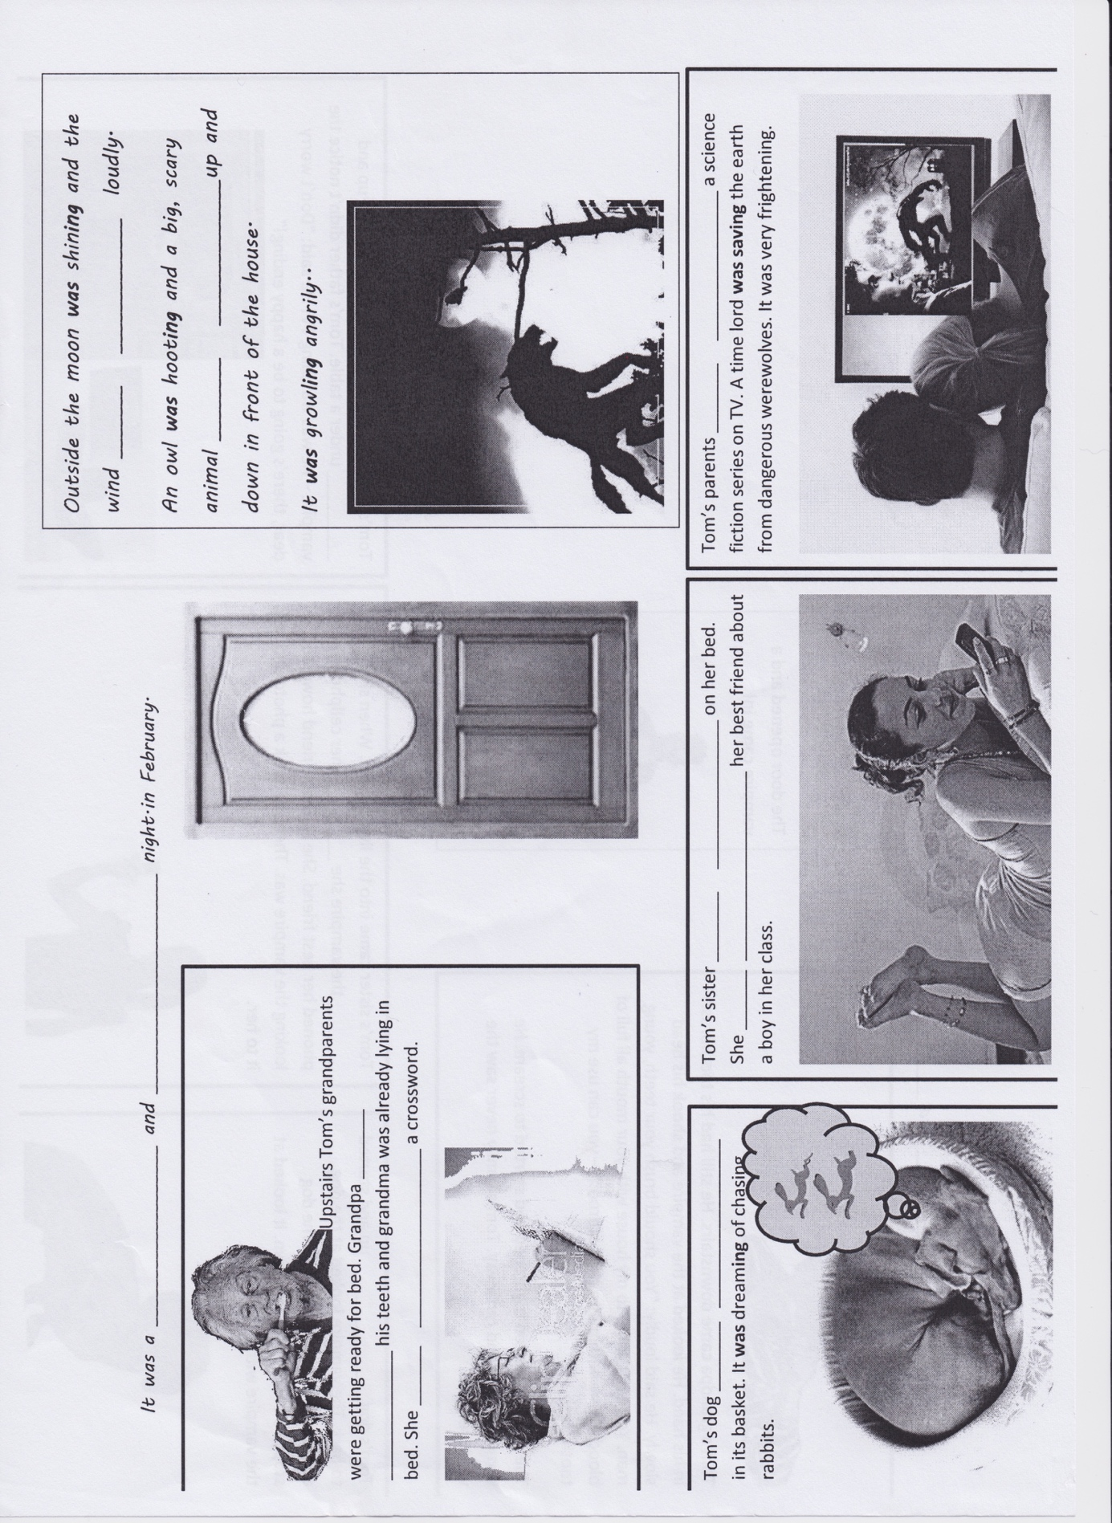
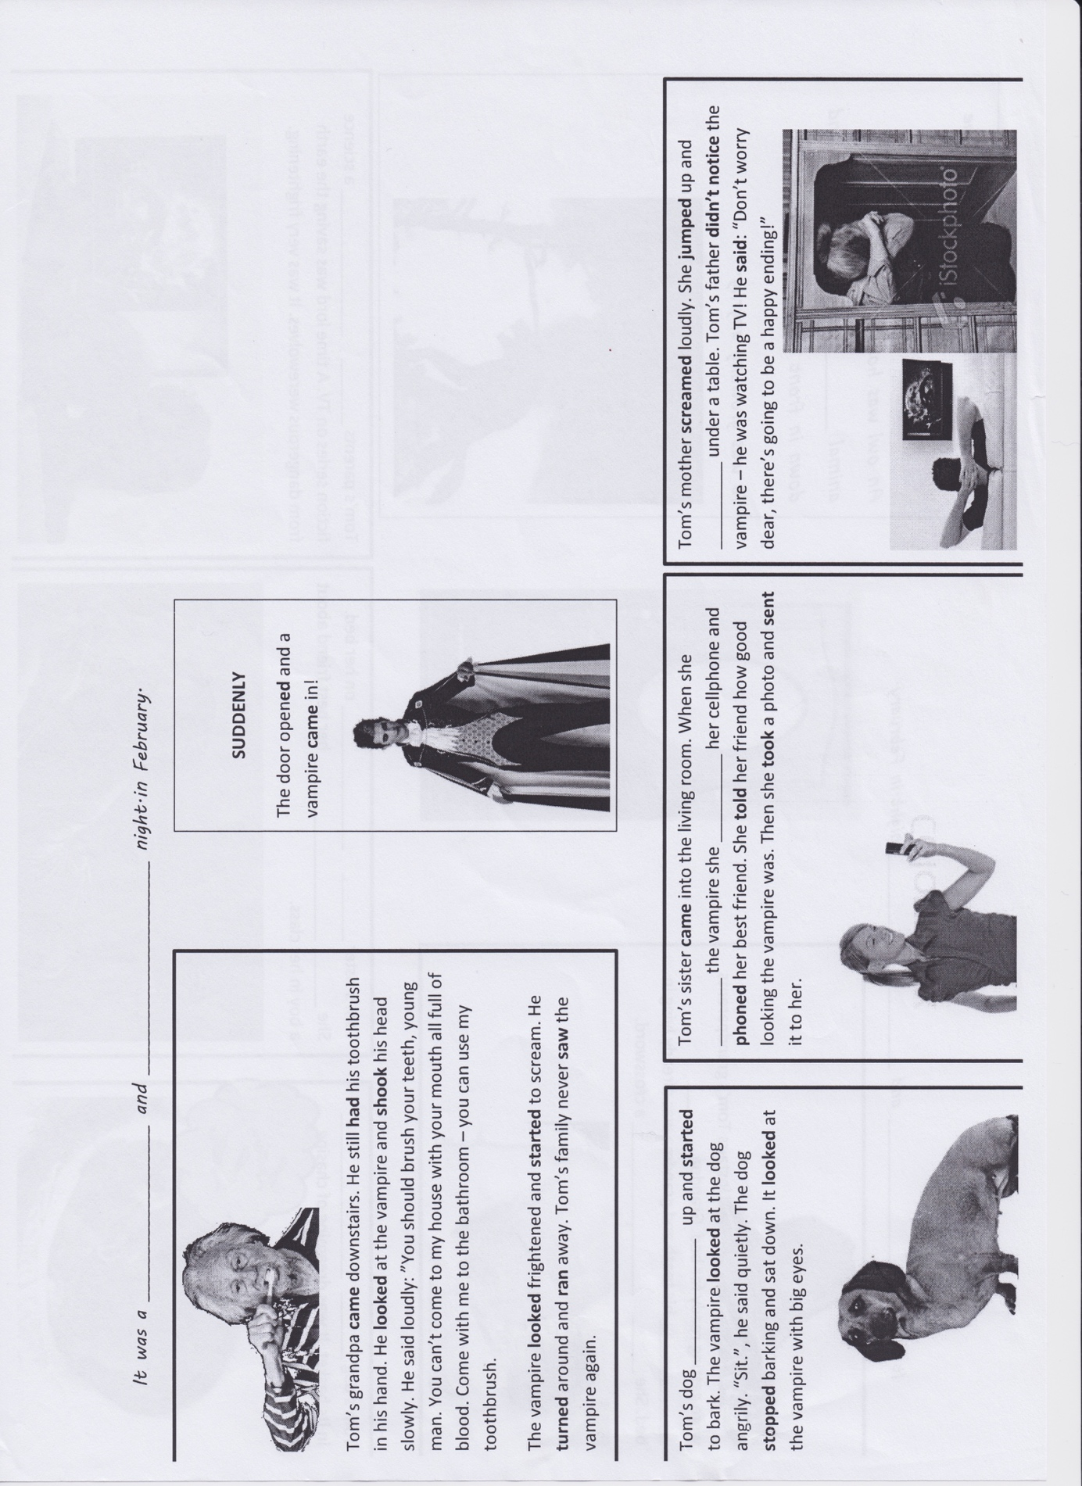
Criteria:
Depth of processing and Complex encoding | ✓  Yes, because although they ‘just’ have to fill in the gap, they have to come up with the correct solutions based on the context.
Commitment filter | +  Yes, because they can work with a picture story and get crafty afterwards, when they cut it and glue it together
Peer and social learning and interaction | +  The students read and act out the story with a partner.
Personalisation | +  The story is quite set, but the students can express their ideas in the middle of the task when the teacher asks how it could continue. Moreover, the students can act out the story the way they want to.
Contextualisation | +  The exercise is embedded in a clear context, describing the background and foreground actions in a story.
Authenticity of process | +  Very authentic, because the language is accurate for the setting.
Task-based | +  The students will have a flap story in the end and can even colour it if they want to.
Testing versus teaching | The activity fulfils the purpose of teaching, because the students should understand the difference between foreground and background actions and what grammatical structure to use.

Testing activity

Stage: Performance in real-life context
Task:
Write a spooky story based on the picture below. Your story should be about 250 to 300 words.
Checkpoints:
- find a title for the story
- describe the setting and the atmosphere of the place. What does it feel like?
- come up with your own ending




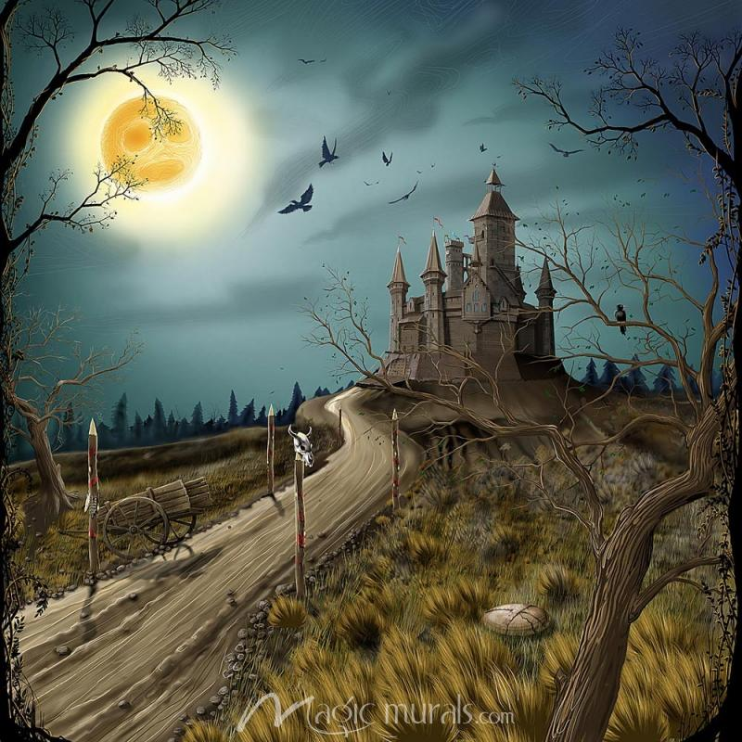
Criteria:
Depth of processing and Complex encoding | +  Yes, the students have to come up with a whole story, fulfil the checkpoints and use accurate language.
Commitment filter | +  Since it will be used in an exam, there is quite some engagement there.
Peer and social learning and interaction | -  Exam: individual work
Personalisation | +  The students are supposed to be creative and use their own ideas.
Contextualisation | +  Yes, the task is to create a spooky story.
Authenticity of process | +  Very authentic, because it’s a spooky story.
Task-based | ✓  The learners will have a finished story, which is graded. However, it will be staying with the teacher.
Testing versus teaching | This exercise is to test the students’ ability of creating a spooky story, including using the Past Progressive to describe background actions.

Homework: Write an ending

Stage: Proceduralization in scaffolded conditions & Performance in real-time context
Procedure:
This activity is meant to be given as homework to the students. Based on the flip flap story (2nd activity/lesson 3), the students write an ending to the story. Additionally, the students record themselves via Flipgrid and present their outcomes to the class.
Task:
Homework
Take your flip flap story.
Write your flip flap story into your homework book.
However, come up with your ending to the story!
Additionally, use Flipgrid to record yourself presenting your flip flap story. Show your classmates how your story ends.



Criteria:

Depth of processing and Complex encoding | +  The learners use the Past Progressive form numerous times orally as well as in written form. As a consequence, they unconsciously process the grammar structure. In addition to that, they recognize the difference between the Simple and Progressive structure.
Commitment filter | +  The students will be enthusiastic coming up with an own ending and present it to the class. The main advantage using Flipgrid is that the students can repeat their recordings until they are happy with the outcome.
Peer and social learning and interaction | +  The activity is given as homework. Therefore, the activity doesn’t provide any social learning.  However, as the students have to record themselves and present their ending to the other classmates online, peer learning definitely takes place within this homework.
Personalisation | +  The learners’ task is to personalise the flip flap story to their ideas. They should come up with own ideas.
Contextualisation | +  The context of the homework is clear; creating an own ending and presenting the story to the classmates.
Authenticity of process | +  The language used in the activity is very authentic. The students create their own ending and present it in their own personal way.

Task-based | +  The learners will even have two end products after doing the homework. Namely, the written homework on the one hand, and, on the other hand, a video presenting their story.
Testing versus teaching | The activity fulfils the process of teaching. Additionally, the learners unconsciously practise their use of the Past Progressive.

Sources:

Witness Game
http://englishclassvgp.blogspot.co.at/2017/02/activities-for-tenth-grade-10th.html

Detective Game
Based on material of the course “Communicative Language Teaching in Practice II” (Winter Term 2017/18, Da Rocha/Weinzettl).

Flip Flap Story
Based on material of the course “Communicative Language Teaching in Practice II” (Winter Term 2017/18, Da Rocha/Weinzettl).

Memory Game
https://www.tefl.net/elt/ideas/grammar/past-continuous-activities/

Time Travel
Harmer, J. (2015). The practice of English language teaching : With DVD. Harlow: Pearson Education.

My dear Spy
https://www.youtube.com/watch?v=zedrT9OHfAg

Past simple vs Past Progressive
Newby, D. (1992). Grammar for communication. Wien: Österreichischer Bundesverlag Schulbuch GmbH & Co. KG

Newby, D. (1992). Grammar for Communication-Exercises and Creative Activities. Wien: Österreichischer Bundesverlag Gesellschaft m.b.H.

Homework: Writing an ending
Based on ideas of the website:
http://epep.at/?page_id=2490

Homework: My favourite photo
Based on the idea “9. Past photos” on the website:
https://www.tefl.net/elt/ideas/grammar/past-continuous-activities/

Testing Activity:
https://en.islcollective.com/resources/printables/worksheets_doc_docx/a_ghost_story/tenses-storytelling-preintermediate/4814

