
“Nancy Mulligan“ by Ed Sheeran
Please provide a link or better a QR code to the song.
The jump from the crossword to understanding the song lyrics is HUGE.
I am not sure this will work in every class. Maybe in a good AHS class if the kids can listen individually and stop as many times as they need to.
As a whole class listening this would not work at A1 level.
1. Write the simple past form of the verbs below!

make (1x):  meet (2x):  propose¹ (1x):  say (1x):  see (1x):  sit (1x):  worry (1x):  1 deut.: einen Heiratsantrag machen, etwas vorschlagen | ask (1x):  be (12x): __________/___________  borrow (1x):  buy (1x):  find (1x):  get (2x):  go (3x):

2. Before you listen to the song read the short text about the history of the song and the explanation of some words, which in the lyrics.

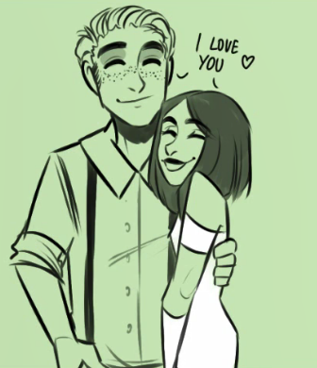
The history of the song:
The song is about the love story of Ed Sheeran’s Irish grandparents Anne and Williams Sheeran. It tells how they fell in love and got married. Both had different religions and their families did not want them to marry. But they ran away and still got married and lived happily ever after.

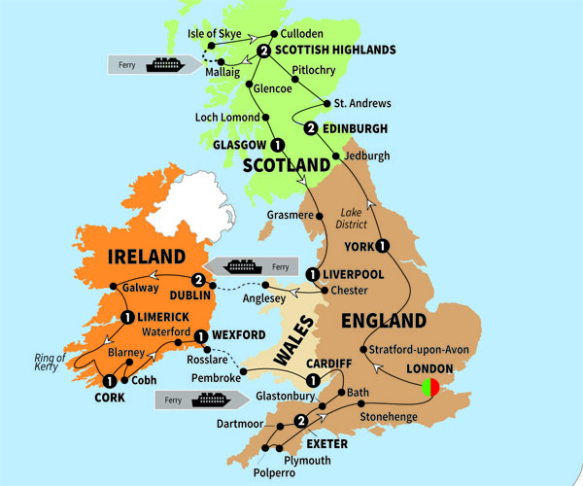
Explanation of vocabulary
Guys: a hospital’s name, in London.
Ward: like a hospital – no_ it’s part of a hospital
Never had I seen: “I never saw before in my life…”
I’ve been loving: “I love…” leave these two out, the kids can guess the meaning
Ya: you



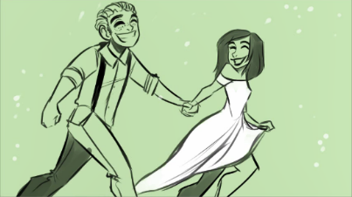
This woman has a white streak in her jet dark hair
Wedding rings

Wexford (a city in Ireland)
Belfast (a city in North Ireland)
Belfast
3. Listen to the song and fill in the missing verbs, from number 1. The numbers in the parenthesis tell you how often you have to use the verbs. You can use each verb more than once.

(Irish music)  I _________ twenty-four years old  When I ___________the woman I would call my own  Twenty-two grandkids now growing old  In the house that your brother ________________ya  (Irish music)  On the summer day when I ________________  I ______________ that wedding ring from dentist gold  And I ____________her father, but her daddy ________________no  You can’t marry my daughter  She and I ___________on the run.  Don’t care about religion.  I’m gonna marry the woman I love.  Down by the Wexford border.  She ______________Nancy Mulligan I______________William Sheeran.  She ________________my name and then we ____________one  Down by the Wexford border.  (Irish music)  Well I __________ her at Guys in the Second World War  She ______________working on a soldier’s ward.  Never had I seen such beauty before  The moment that I ________ her.  Nancy _______ my yellow rose,  And we ________ married wearing ___________ clothes  We ___________ eight children now growing old.  Five sons and three daughters. Please provide a solution sheet. This will facilitate the discussion of the correct forms. | She and I ___________on the run.  Don’t care about religion.  I’m gonna marry the woman I love  Down by the Wexford border.  She ___________Nancy Mulligan and I __________William Sheeran.  She ___________my name and then we __________one  Down by the Wexford border.  (Irish music)  From her snow-white streak in her jet-black hair  Over sixty years I’ve been loving her.  Now we are _____ by the fire in our old armchairs  You know Nancy, I adore you.  From a farm boy born near Belfast town.  I never __________ about the King and Crown.  Cause I _____________my heart upon the southern ground  There’s no difference. I assure you.  She and I ___________on the run.  Don’t care about religion.  I’m gonna marry the woman I love  Down by the Wexford border.  She ___________Nancy Mulligan and I __________William Sheeran.  She ___________my name and then we __________one  Down by the Wexford border.  (Fantastic Irish music)

