Teaching Communicative Grammar

Third Conditional (imagined past)
Level: Year 5

PS Communicative Grammar
Dr. Elisabeth Pötzleitner
SS 2017

Christoph Knoll
1212726
christophknoll1990@gmx.at

Contents
Traditional vs. communicative Grammar- a speech 3
Teaching materials for three lessons 6
Lesson 1 6
Exercise 1 6
Analysis of Exercise 1 8
Exercise 2 10
Analysis of Exercise 2 12
Homework Activity 1 13
Analysis of homework activity 1 13
Lesson 2 13
Exercise 1 14
Analysis of Exercise 1 14
Exercise 2 15
Homework activity 2 18
Analysis of homework activity 2 19
Lesson 3 20
Exercise 1 20
Analysis of Exercise 1 20
Exercise 2 21
Analysis of Exercise 2 22
Homework 3 23
Analysis of homework activity 3 24
Testing task 25
Analysis of the testing task 26
Bibliography 27

Traditional vs. communicative Grammar- a speech

Ladies and gentlemen, colleges and parents!
I am here today to present to you and in case of my colleges to urge you to use a different approach to teaching grammar in our school. The communicative approach.

Traditional grammar teaching, as it is practiced in our classrooms today, has a lot of disadvantages which mainly harm our students. Forcing them to learn rules by heart and to name linguistic concepts which they will not use and need in the future, has turned our English lessons into a source of confusion and many wasted afternoons for the students, spent trying to learn a language as if it consisted of mathematical formulas. And we all know how we LOVED those.

Sorry to all Math teachers who are here today by the way, but I hope you understand that our two subjects should be taught differently.

Language is meant to be used to communicate, not to solve a theoretical problem. Unfortunately, theoretical problems are more often than not everything we offer to the students as exercises and especially testing materials. (he shows the following example on the projector)

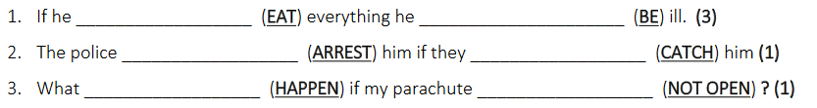

To give an example, nobody cares about the mysterious “he” in the first sentence. Who is “he”? Someone the student knows? No. Is the situation something the student has to deal with? Maybe, if he ate too many cheap snacks in the break, but then he wouldn’t call himself “he”. Let me use this simple exercise to demonstrate to you why a traditional approach hinders language learning.

In traditional teaching, we tend to tell the students the theory of a new grammar topic first. With “theory”, I mean when and how to form a certain type of sentence or phrase. In the case shown here, a traditional teacher would explain to the students how to form a “conditional” sentence first, and that there are three main types of conditional sentence, which all need to be constructed in a certain way. Let me show you a typical explanation offered to students in printed form.
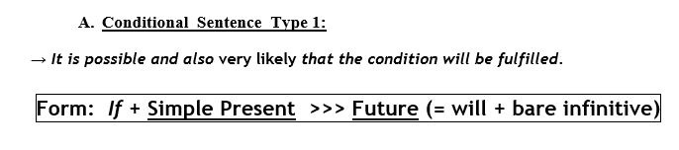

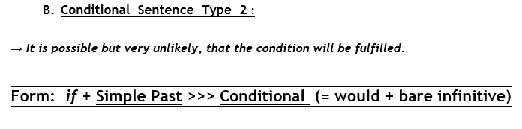

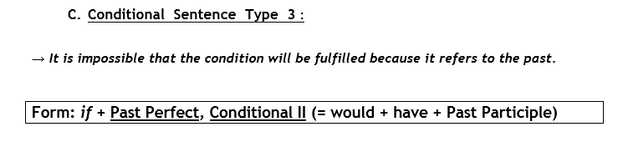

By first showing students this handy guide on how to construct a conditional sentence and then giving them the before shown exercise, they may manage to produce grammatically correct sentences, but they will not be able to use the language taught to express their own thoughts and feelings, something language is actually meant to do. Instead, they will get proficient in filling out empty spaces with the correct words required; it is like a crossword, only without all the fun. As tempting and fast as it may be, language cannot be taught and tested with formulas, which turn sentences into something that needs to be constructed. It needs to be taught with much more connection to the reality of everyday speech production.

But how can this be done, you may ask. Well, first we need to drop the focus on “rules” and “formulas” when teaching. Instead, the reason for producing a certain sentence or, as Newby calls it the “notion” should be the center of attention. Let me give you an example: Instead of telling the students how to construct a Conditional 1 sentence, we tell them that it can be used to warn a friend of theirs about future consequences of their actions. We then offer them an example and a fitting situation. For instance: “Your friend tells you that he wants to cheat on the exam in the next lesson- you want to warn him that your teacher will give him a negative mark if he catches him, so you would say: If you cheat, you will fail the test”.

This simple example raises the students’ awareness much better than any formula ever could. They also start to build a concept in their head, about how to warn someone about future consequences. What comes next is training or proceduralization, which means the students need to repeatedly use the newly acquired form, but not to complete meaningless sentences. Instead, the teacher using the communicative approach may offer them an exercise in which two pictures are shown, showing an action and a negative consequence, without giving the required words. They can now prepare and then tell each other the warnings, using much more of their brainpower than before, because they do not have to fill simple blank spaces, but instead form real, meaningful sentences.
This would then naturally go on with different, more creative exercises, always requiring the students’ to use the language until the notion and the language to use for it are fixed in their brains, and they can perform it in real life situations.

Of course, the communicative approach also brings some problems with it. Many critics legitimately mention that it needs a lot more time than the traditional studying of rules. They are correct. For a teacher, it is faster to just give students the formulas required and then test them with prepackaged exercises. In addition, as you may have found out, notions split the Grammar into much more parts that have to be taught independently from each other to have an effect. However, our job dear colleagues, is not to be as fast as possible, but instead to make it possible for our students to express themselves in the language we teach. More importantly, they also should be able to do it after leaving the classroom and without the carefully prepared exercises we offer them.

To sum up: the communicative approach may be slower and require more work from us, the teachers, but it is also more effective, prepares the students better for real life situations and, perhaps most importantly, is much more fun for them as well as for us. So let us all leave mathematical formulas where they belong: in Math lessons, and instead be more communicative and creative.
Yes, this is a refreshing presentation full of good arguments.
Congratulations, you have digested these ideas really well

Thank you for listening.

Teaching materials for three lessons

Lesson 1

The teacher enters the class, greets the students and begins the lesson by introducing the topic.
He tells the students that they are going to talk about things that could have happened differently in the lesson today and tells a little story about himself and that he had almost overslept on that morning.
He then writes the sentence “If I had heard the alarm, I wouldn’t have gotten up so late.” on the board.

He then tells the students that of course his little story is rather boring and that they will therefore listen to a much more exciting one by Adele now. (He also asks the class if they know Adele already and lets a student explain to the ones who don’t, who she is-or does it himself if nobody wants to);

Exercise 1 (adapted from: http://busyteacher.org/18069-adele-if-it-hadnt-been-for-love-3rd-conditional.html)
- First Task

  - The students listen to the song “If it hadn’t been for love” by Adele and take notes about what the singer never would have done if she had not met her lover. They can compare their results in pairs. The song should only be played once in this phase.

(possible song source: https://www.youtube.com/watch?v=cpN11Df6fSg)

- Task 2

  - Every student gets the Exercise 1 sheet. It contains the lyrics of the song minus the verbs they had to try to note in the first task. They are now given some minutes to work together and to add the missing words.

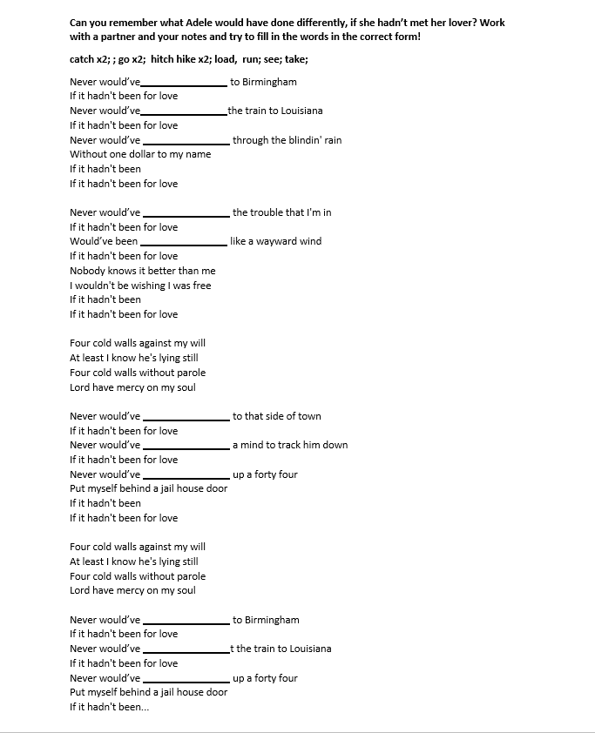
1Exercise 1

- “Debriefing”

  - Students are asked to give their solutions, if there is a lot of confusion the song can also be played again. The teacher can ask questions like “Do you think Adele is happy about what happened?” “Was it good that she met her lover?” etc., to make it clear that in this case, the cond. 3 serves to express regret.

Analysis of Task 1 and Task 2

Learning Stage | The two activities and the introduction of the teacher are awareness raising. They confront the students with the tenses and forms used in the conditional 3 for the first time and also show them why it is used (the notion of regret). The exercises of course also support conceptualization because the forms are repeated often and help students to get a feeling for them.
Depth of processing | By listening and at the same time taking notes, the students need to concentrate attentively on the lyrics of the song. The fill in activity lets them then use their acquired knowledge about the lyrics. In the debriefing they are also asked to analyze the meaning of the lyrics, connecting them to past experiences and to the real world.
Commitment filter | Students will be interested, because they have the opportunity to work with a famous song by a famous artist. Instead of just filling out meaningless sentences they get to actively work on a piece of art and together with their classmates.
Social interaction | Doesn’t play a large role in these first tasks, but the students nevertheless can work together with their neighbors to check and improve their results.
Personalisation | Mostly plays a role in the debriefing-part, because here students have the opportunity to connect personal experiences to the song lyrics.
Testing vs. teaching | This exercise and all its parts should only be used to teach, because they require only a basic knowledge of the third conditional- it should serve as a first contact with the subject matter.

Exercise 2

(first show the students https://www.youtube.com/watch?v=B-khEYhppBs)

“Captain Hindsight”








- Captain Hindsight always knows what should have been done…but never helps anyone. Add his quotes and then compare them with your partner for the best idea!

If they hadn’t _____________________________, the fire wouldn’t have started!

- Now one of you plays the person with the problem and the other one plays the captain. Act out the dialogue. Try to switch roles every turn.
eg: “Help Captain Hindsight, my car is destroyed” “
Well If you had driven a bit slower and not drunken so much your car wouldn’t have crashed into a tree”
“Thank you Captain Hindsight!”

- Now come up with four problems for the captain to solve, write them down. Then your partner’s job as Captain Hindsight is, to tell you what went wrong. Choose the best problem/solution pair and present it to the class!

Problem | The captain’s “solution”

Analysis of Exercise 2
Learning Stage | The first part of the exercise helps the students to proceduralize the conditional 3 under scaffolded conditons. it also, through repetition, helps them again to strengthen the concept in their minds. When acting out the dialogues with their own ideas speech performance becomes the main focus.
Depth of processing | Students need to form their own sentences, by first just using pictures and then just using a given situation as a primer. They therefore need to use a lot of their knowledge.
Commitment filter | Working with funny examples makes it possible that students don’t even realize that they are just learning grammar. Cooperation additionally makes the exercise even more fun.
Social interaction | Students can talk to each other and try to solve each other’s imagined problems.
Personalisation | The exercise is not personalized, but through their own examples students can bring their own experiences into it if they want
Testing vs. teaching | The first part of the exercise could be used to test the conditional 3, but both parts are also valid teaching tools.

Homework Activity 1 (Adapted from Newby – Exercises and Creative Activities p.81)
What could they have done to make it end differently? Give them advice! and write the sentences into your homework-book
- Oh no! I failed the exam!
If you had studied more, you would have passed.
- Damn! I missed the bus and now I have to wait for the next one.
- I thought Daniel’s party started at six! Now I am late!
- I forgot to pick up Christine! Now she will be angry at me!
- This is stupid! I am sick and can’t go to the cinema!
- There is a dance today? Sorry but I didn’t know!
- I thought you had work to do, so I didn’t invite you!
Come up with 4 more situations WITHOUT the advice. (just the thing they did wrong)

Analysis of homework activity 1
Learning Stage | This exercise serves to proceduralize the learned forms of the conditional 3.
Depth of processing | Students are asked to put themselves into the given situation and find their own piece of advice
Commitment filter | Students can be creative with their solutions
Social interaction | The exercise can be completed alone
Personalisation | Not personalized, except the answers that can be given
Testing vs. teaching | Can be used to test, but also as a teaching tool.

Lesson 2
The teacher tells the students at the beginning of the lesson again, that the conditional 3 can be used to show that someone regrets something, but also to show what could have been done better or differently. Difference is the keyword for the following lesson.

Exercise 1

- Students are asked to act out their homework-activities. In turn one of them takes the role of the person with the problem and the other one gives them advice. For the 4 additional situations, the partner has to think about a fitting if sentence by himself- the one they come up with is then added to the homework activity.

Analysis of Exercise 1
Learning Stage | The first part of the exercise helps the students to proceduralize the conditional 3 under scaffolded conditons. When being confronted with the new situations performance also becomes a part of the exercise.
Depth of processing | Students are asked to first act out what they have written and therefore think about it more and afterwards have to come up with a solution for new problems whitch requires a lot of thought
Commitment filter | Being creative while envisioning solutions makes the exercise fun
Social interaction | Students can talk to each other and try to solve each other’s imagined problems.
Personalisation | Through the invented problems and solutions the exercise becomes personalised
Testing vs. teaching | Should be used for teaching, because it’s meant to be acted out.

Exercise 2
“What if?”
- Part 1
The students are handed cut out story parts. One for each pair. Their first job is to put the little story into the correct order.
Never fear the goose is here!

Yesterday afternoon, a tragic accident almost happened. Fortunately, nobody was hurt, because of a big white goose that wandered around the city. How did that happen?
It all started with a young teenager named Jason, who left his house at noon to get some food at Mc Donald’s.

He took the keys to his father’s car because his own one was in the shop.

His father’s car was a big and fast SUV which Jason was not comfortable driving, but he wasn’t able to cook himself a meal, so he had to take it anyway.

Also Jason was very lazy, so the 500 m to the fast food place were too far away to get there on foot.

Jason started the SUV and drove away.

While driving, he switched the radio to his favourite channel: “Dubstep FM”, they played very loud and exciting music with a deep beat.

Jason got very excited and started to bop his head up and down in rhythm to the music.

While doing that he lost his cap, which he had put on this morning because it was so hot.

While he was looking for his cap on the floor, he wasn’t able to look at the street, because the car was so large and almost hit little Tracey, who was just crossing the street.

Tracey was in town with her mother, because she wanted to buy some groceries.

Tracey was very bored in the grocery store, so she ran away while her mother was talking to the shop assistant.

She was very fast, so nobody saw her and she ran out of the store and onto the sidewalk.

There were almost no people there, because it was noon and they were all eating their lunches, so no one saw and stopped her

She ran around and looked at many shop windows for a time, but they were also all boring, because they only offered clothes.

Then she stepped onto the street, to see what was on the other side.

Little Tracey wanted to get to the other side of the street, right as the SUV was coming towards her.

She had seen a funny picture in a shop window and did not pay attention.

Just a few seconds before Jason’s car could hit her, she was distracted by a loud quacking noise and turned around.

A goose had escaped from a house nearby and was now running through the town. It was very afraid of Tracey and therefore left the street.

Tracey wanted to touch the funny animal and turned around to chase it.

Jason finally found his cap, and looked at the road again. He was lucky that nothing was in front of him.

“A goose in the town…something you don’t see everyday”, he thought, when he looked at the sidewalk.

Lizzy got very afraid when she realized that the car had almost hit her and went back to the grocery store to complain to her mother.

The teacher then gives them a few minutes. Afterwards he projects the correct version onto the board (or talks it through with them). There are multiple possibilities obviously, but the beginning and the end of the story should be clear.
- Part 2
The pairs then get the job to imagine what would have happened if:
Person 1:
- Jason had gone into the city on foot
- Jason had not looked for his cap while driving
Person 2:
- Tracey had not been able to leave the store
- Tracey had not heard the goose
Each person’s job is it then to imagine what would have changed in the story and put it into writing. The teacher can give one example like: “If Tracey had gone into the city on foot, he wouldn’t have listened to his favourite channel” He would have instead become bored while walking into the town and…”
The pairs then read their stories to each other and choose the funniest/most tragic/best one to present it to the class.
The best “what if” wins. (and can get displayed)
This is a creative writing task, which can require a lot of support of the “teams” by the teacher and a lot of time by the students, therefore nothing else should be planned for the lesson.

Learning Stage | Proceduralisation- students use a given story and sentences to produce their own cond 3 story with a different ending
Depth of processing | Complex sentences need to be formed, based on given situations which have changed. A lot of thought is therefore required
Commitment filter | Splitting the story up into parts makes the students read it more carefully in order to find out the right combination. They are also free to be very creative in this lesson, which should also help
Social interaction | Students talk to their partners to present their little stories and also listen to the works of their peers.
Personalisation | The exercise allows personal creative freedom. I
Testing vs. teaching | Using this exercise for testing is not recommended, because it requires a lot of interaction.

Homework activity 2

Today you have seen that just one little change can lead to a lot of different things happening. Now start with a situation in your own life and change it to either…
- the best possible scenario | - the worst possible outcome
Could you have done something differently to make some wonderful things happen to you? | What could have happened so that your future would have turned out very bleak?

Start with a simple sentence like “If I had not come to school today…” and write at least 10 sentences with either a wonderful or a bad outcome.

Analysis of homework activity 2
Learning Stage | Proceduralisation- students use if sentences to describe a given scenario, they are allowed to be creative but still deal with scaffolded conditions.
Depth of processing | Very high, because they need to think not only about the grammar but also about causes and effects of change
Commitment filter | The chance to be creative and funny/scary if they want activates the filter
Social interaction | Can be completed alone
Personalisation | The exercise allows personal creative freedom. The students also talk about a situation they themselves could have experienced
Testing vs. teaching | Can be used for testing and teaching

Lesson 3

Exercise 1
- The students are asked to tell their neighbors their little homework-stories in turn. After that the teacher gives them the following task:

“Now take a sheet of paper and write down the first sentence of your partner. Your job now is to create a different outcome. If they chose the best scenario for themselves- make it bleak and vise-versa. When you are finished you can tell them your changed story!”
Some volunteers should afterwards read out their homework texts and the changed results to the class.

Analysis of Exercise 1
Learning Stage | Proceduralisation- students listen to their peers’ stories and produce their own versions
Depth of processing | Students need to listen and think carefully to create their own versions of their partners’ stories
Commitment filter | Working with the sentences of a friend and making his story end badly or very good is fun and therefore motivating
Social interaction | Students work with each other’s stories
Personalisation | Students present their own work and create a new version or their partners’
Testing vs. teaching | This exercise is meant to use the homework activity as a basis for an interaction-based exercise. It should therefore only be used for teaching.


Exercise 2 (adapted from: http://www.tefl.net/elt/ideas/grammar/third-mixed-conditionals-practice/)

Pick one of the following situations

You and your partner got stranded on a lonely island | You wanted to learn together, but nobody has brought any books or knows what you need to know
You went hiking on a mountain, but now you can’t find the way back | You needed to prepare a presentation, but nobody has done his part
You both are very thirsty but have no money to buy something to drink | You both missed the bus because you were talking
…or come up with your own!
- Now, nobody wants to be responsible for the mistake, so try to think of 5 arguments in the third conditional about what your partner could have done differently.
- Then make a dialogue. Remember to start with a short introduction to the situation and try to come to a meaningful end (by agreeing on something, by going your separate ways or by giving up).
- When you are ready you can act out the dialogue to the class
- The best/funniest/scariest/craziest one wins!
Example:
A: Oh no! No we are lost and can’t find our way back to the camp!
B: Yes and it is your fault! If you had looked at the map more often, we wouldn’t have lost our way!...

Analysis of Exercise 2

Learning Stage | Performance- the students need to use speech to deal with a (imagined) real life situation
Depth of processing | Very high because students need to produce correct sentences and a dialogue that is coherent. They also need to act it out orally.
Commitment filter | Coming up with funny “blames” for the partner as well as acting the quarrel out is very motivating
Social interaction | Students work with each other, talk to each other and listen to the dialogues of their peers
Personalisation | Students can come up with solutions for problems they might be faced with in real life
Testing vs. teaching | Should be used for teaching, but can also be modified for testing (leaving out the acting part and letting one student write the whole conversation)

Homework 3
Sophie Fry is very shy- and that often leads to a lot of problems for her! Look at the following situations and tell her what she could have done differently and what would have happened! Make as many sentences as possible!
“My friend broke the window of Mrs. Keynes and then gave me the ball. Mrs. Keynes thought I was to blame…so I gave her all my money...”

“I was waiting in line for ice cream. Then this boy stepped in front of me. He got the last ice-cream cone. I really wanted one…”

“I was ill last week, but my friends really wanted me to play volleyball. Then we lost, because I missed so many times. They got really angry at me…”


“Henry invited me to his birthday party, but Max wanted to go to the cinema with me at the same time. I stayed at home because I didn’t want to disappoint them…it didn’t work”

“I don’t like going to the disco, but Jenny really wanted to go, so I joined her…it was bad, I didn’t talk to anyone…”

“There is this cute boy in the other class, who really likes me. He got my number and phoned me yesterday, but I didn’t answer. I just never know what to say…”

“I am not good in Computer Science, so Chris offered to help me after school. I said no, because I don’t want to bother him…but I really could have used his help!”

“My mum forgot to give me my pocket money this week, and now I can’t buy lunch! Maybe she will remember on her own…”

Example:
If you had stopped your friend from breaking the window you wouldn’t have had to pay. If you had told Mrs. Keynes…

Analysis of homework activity 3
Learning Stage | Proceduralization, students need to make as many conditional sentences as possible to comment on given situations
Depth of processing | The situations need to be thought through first, all possibilities aren’t obvious on first sight, therefore it requires more thought than a simple fill-in exercise.
Commitment filter | Creative students are able to come up with different solutions than the obvious ones, otherwise this exercise is a simple revision of things already learned and doesn’t really require a lot of commitment.
Social interaction | Can be completed alone
Personalisation | Not personalised
Testing vs. teaching | Can be used for testing and teaching- for teaching solutions should be compared in a further lesson (it can also be used as a reason for interaction between students)

Testing task (Adapted from Newby – Exercises and Creative Activities p. 81)
If it had happened to me…
Look at these situations and tell the speaker what you would have done differently!
e.g. “I got hurt, but the doctor didn’t pick up the phone. So I just waited for it to get better” -> If it had happened to me, I would have driven to his house and demanded to see him.
Last week I saw a man steal an old woman’s handbag and run away, but I was too frightened to do anything

Yesterday my parents locked their keys in the car so the broke the window.

Last night when I came home there was a rat in front of the door, so I didn’t go home.

When I was swimming someone stole my clothes, so I waited till it got dark before I went home.

A few days ago my mum was hanging up washing on the balcony and the wind blew the door shut. She couldn’t get back in, so she waited there for six hours till dad came home.

Bianca went off with another boy at the party and her boyfriend just watched and smiled!

When I got on the train I realized that I had lost my ticket, so I got off again.

Yesterday I broke my neighbor’s window with my football, so I gave him 20 Euros to pay for it.

Now come up with 2 bad situations (either real or imagined) by yourself and imagine how they could have been solved!

Analysis of the testing task

Learning Stage | Proceduralization, students need to use the correct language to fulfill a given task.
Depth of processing | High, because the students need to think the situations through- multiple solutions are possible. Also similar situations need to be added, which makes it necessary to concentrate even more because different tenses have to be used.
Commitment filter | The testing situation ensures that the students concentrate
Social interaction | Can be completed alone
Personalisation | Personalized by adding their own examples as well as coming up with creative solutions by themselves
Testing vs. teaching | Can be used for testing and teaching, for teaching the solutions can be compared with a partner afterwards

WOW!!!
I cannot remember reading such a brilliant collection of meaningful grammar activities in a long time.
JUST PERFECT.
Your activities are all fun, interesting and the learners will actively engage and produce the desired language.
You have a crystal clear focus on the third conditional –
I am truly impressed.
pö

Bibliography

Newby, D. “An Introduction to Cognitive Communicative Grammar” in Course Handout C+C Grammar, (Sommersemester, 2017)

Book:

Newby, D. (2002). Grammar for communication-Exercises and Creative Activities. Wien: Österreichischer Bundesverlag GmbH. p.81

Videos
https://www.youtube.com/watch?v=cpN11Df6fSg (Adele Song)
https://www.youtube.com/watch?v=B-khEYhppBs (Captain Hindsight introduction)

Websites
http://www.tefl.net/elt/ideas/grammar/third-mixed-conditionals-practice/

