Active or Passive: What’s your choice?
Work with a partner and look at these examples. What do you notice?
Both texts are about Potato chips. In text 1 many passive constructions are used. In text 2 the writer has only used active voice. What’s the reason?
What is the main focus of text 1 and what does text 2 focus on?
Text 1: The Story of Potato Chips  Potato chips are thin sliced potatoes, fried quickly in oil and then salted.  The potato chip was invented in 1853 by a chef named George Crum in New York. When a customer returned his French fried potatoes to the kitchen because they were too thick George Crum got so angry that he sarcastically cut them paper thin and sent the plate back out. The customer and others around him, loved the thin potatoes.  The chips were usually prepared in someone's kitchen and then delivered immediately to stores and restaurants, or sold on the street. They had to be eaten immediately.  Two innovations paved the way for mass production. In 1925, the automatic potato-peeling machine was invented. The chips were hand-packed into the bags, which were then ironed shut. In these air-tight bags the chips could be kept fresh and stored for a longer time.  Today, potato chips are the most popular snack in the United States. | Text 2: George Crum: The Inventor of Potato Chips  George Crum was a chef in a little restaurant in New York. He was a very creative man and liked to try out new recipes. One day, a customer returned his French fried potatoes to the kitchen because they were too thick. George Crum got so angry that he sarcastically cut them paper thin and sent the plate back out. The customer and others around him, loved the thin potatoes.  From that day on, George Crum fried paper-thin potatoes every day in his restaurant. His potato chips soon became famous in the area and other restaurants and stores also wanted to sell them.  Many other cooks copied Crum’s idea and prepared potato chips. They made them fresh every day and delivered them to local stores and restaurants.  Now we can buy potato chips in air-tight sealed bags. They stay fresh and crisp for a long time.  Today, potato chips are popular all over the world. We all love to eat them.


My rule:
We can use the active or passive voice to underline important parts of a sentence.
In text 2 the writer has used active voice because …
In text 1 the passive is used because …

How do we form the passive?
The subject  (WHAT or WHO) | form of “be”:  is, are, was, were | 3rd form of the verb | additional information
My shoes | are | made | of leather.
Potato chips | were | invented | in 1853.
The Mona Lisa | was | painted | by Leonardo da Vinci.
The Eiffel Tower | was | built | in 1889.
The Harry Potter books | were | written | by J.K. Rowling.
Ketchup | is | eaten | all over the world.
Kiwis | are | grown | in New Zealand
Mary | was | invited | to the party.
I | was | praised | by my teacher.

Now it’s your turn
Scan the QR codes and do the following exercises online.
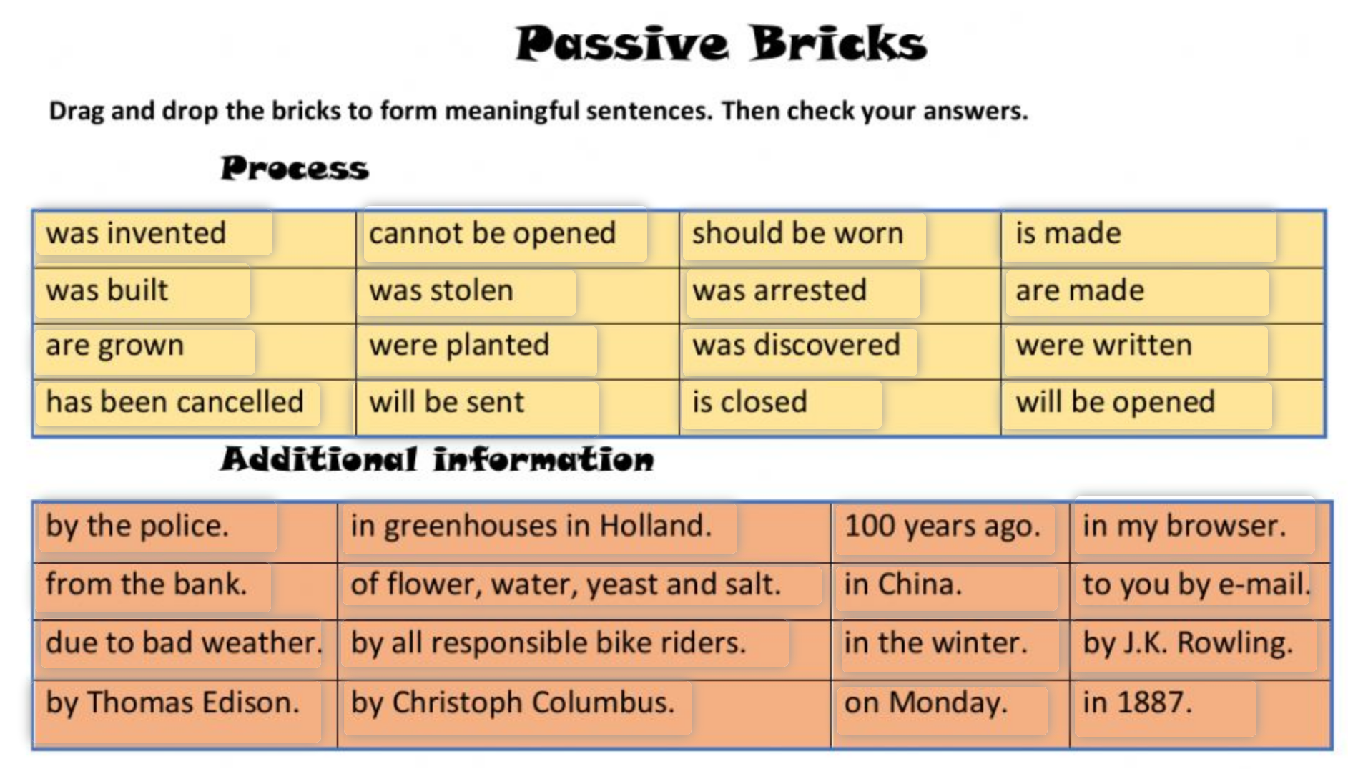 | 
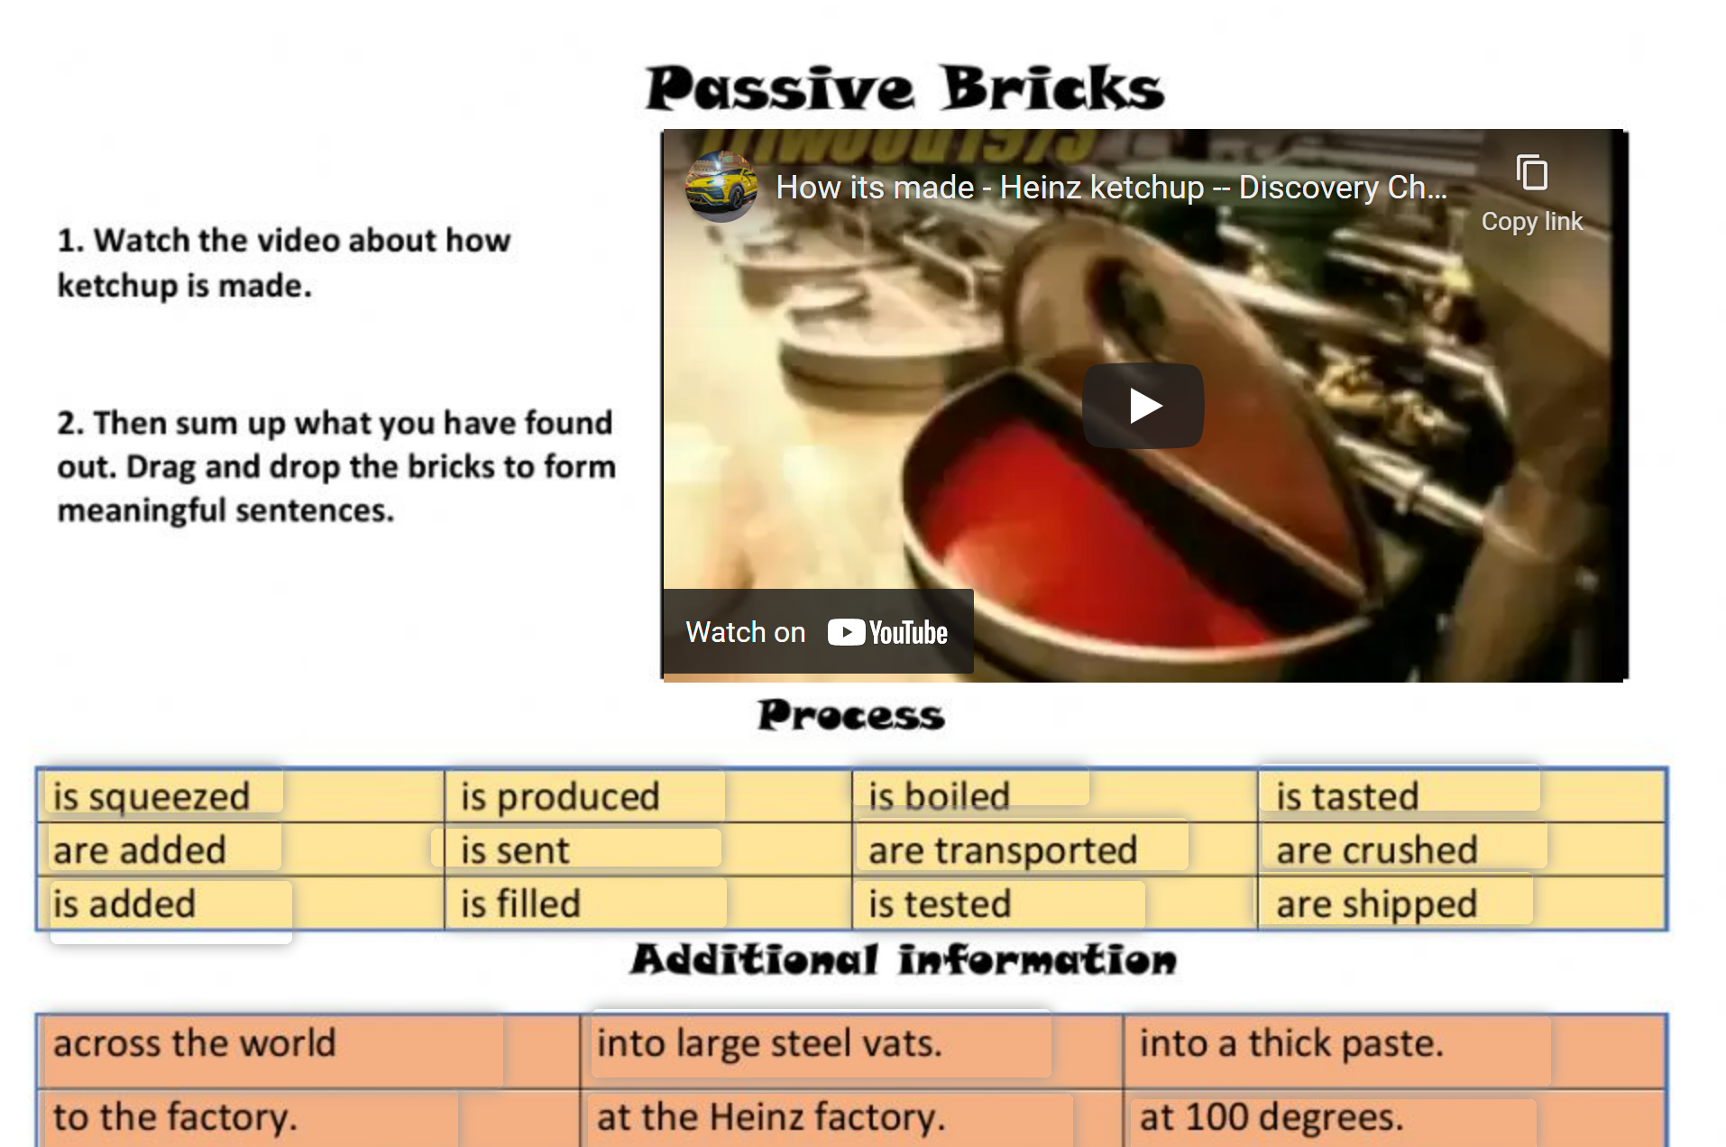 | 
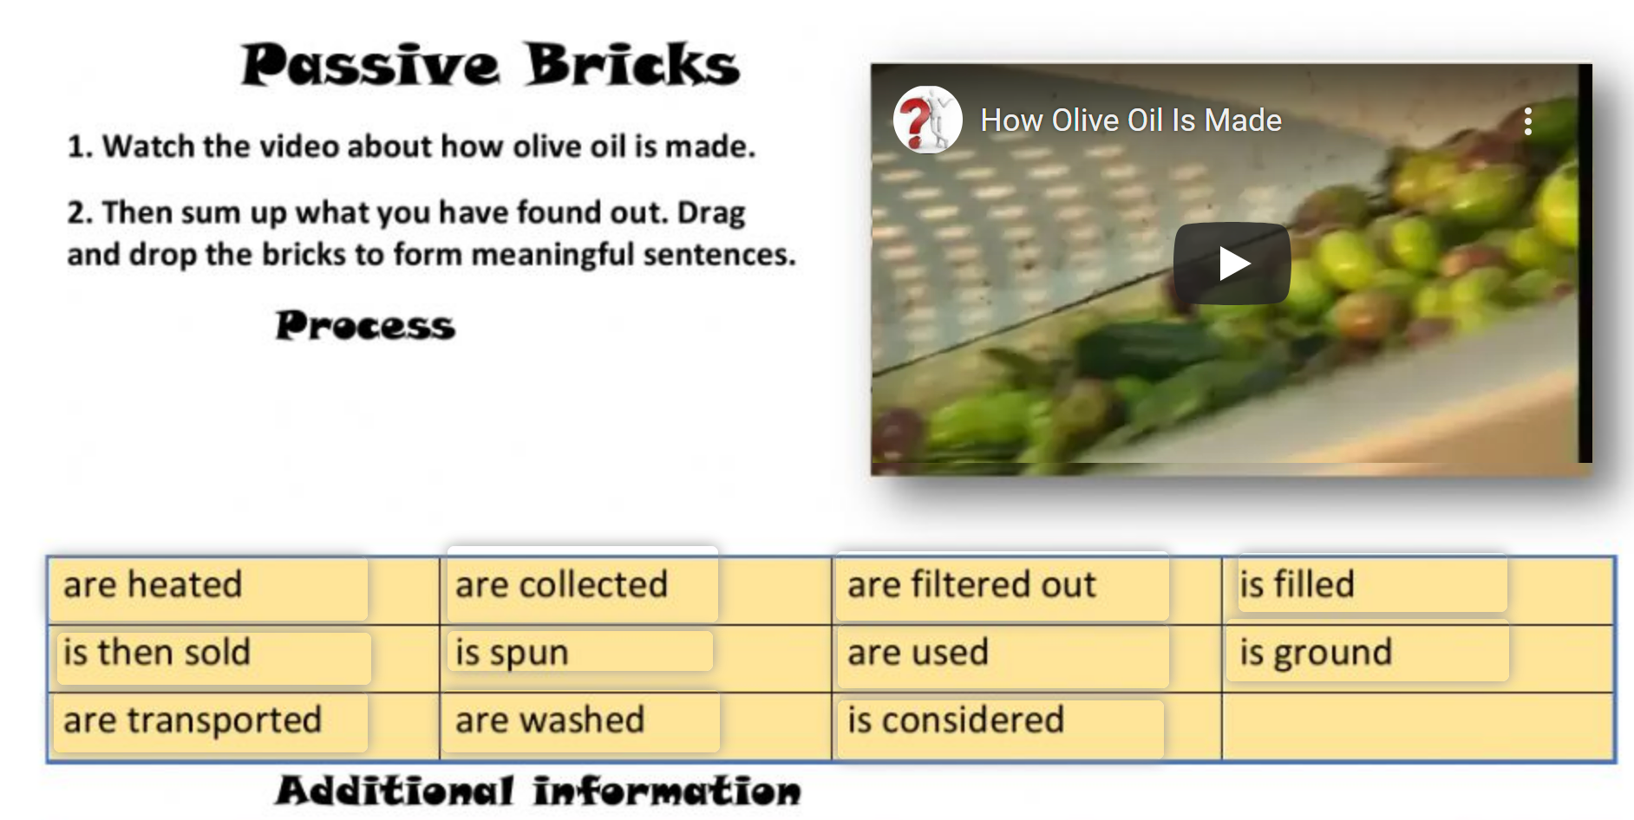 | 

