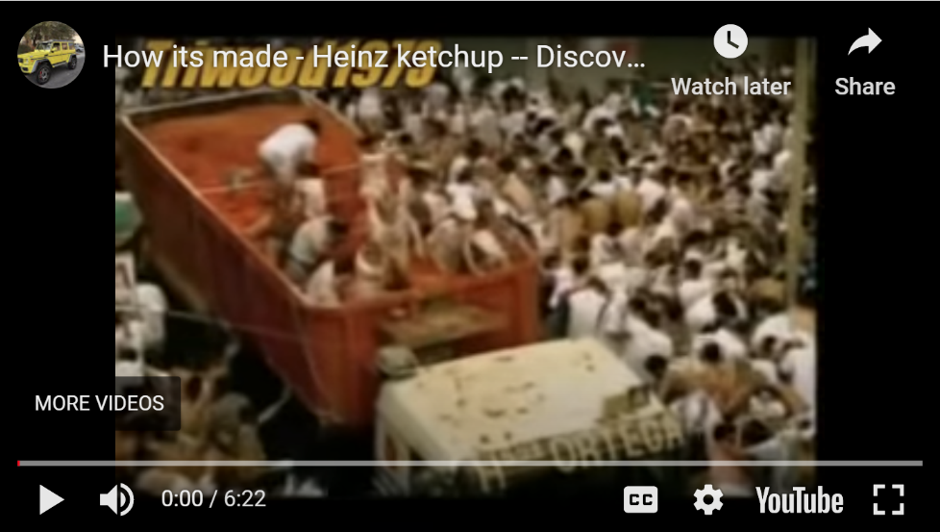
Passive Bricks

1. Watch the video about how ketchup is made.

2. Then sum up what you have found out. Drag and drop the bricks to form meaningful sentences.

Process
is squeezed | is produced | is boiled | is tasted
are added | is sent | are transported | are crushed
is added | is filled | is tested | are shipped
Additional information
across the world | into large steel vats. | into a thick paste.
to the factory. | at the Heinz factory. | at 100 degrees.
by the Heinz taste specialists. | into bottles. | to the mixture.
to the labs and tested for acidity and saltiness. | to the tomato paste. | in a special speed test.

95% of all the ketchup sold in Europe | is produced | at the Heinz factory.
Tomatoes | are crushed | into a thick paste.
Big bags of tomato paste | are transported | to the factory.
The tomato paste | is squeezed | into large steel vats.
Next, vinegar, sugar and salt | are added | to the tomato paste.
Then, the content of the blue bags | is added | to the mixture.
The mixture | is boiled | at 100 degrees.
Then the finished ketchup | is tasted | by the Heinz taste specialists.
Each batch of ketchup | is sent | to the labs and tested for acidity and saltiness.
Then the thickness of the ketchup | is tested | in a special speed test.
Finally, the ketchup | is filled | into bottles.
Every day a million bottles of ketchup | are shipped | across the world.

