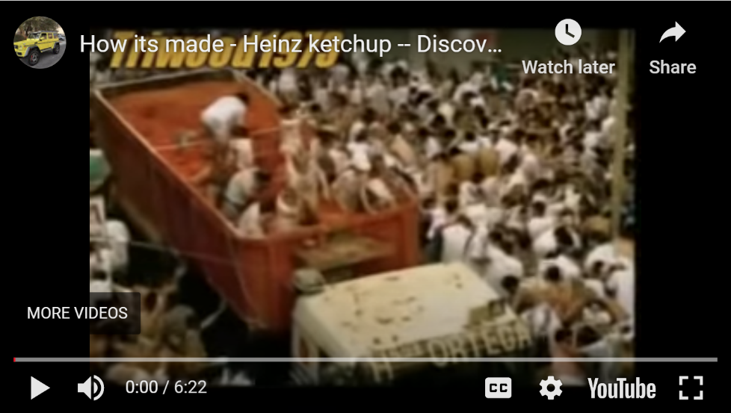
Passive Bricks

1. Watch the video about how ketchup is made.

2. Then sum up what you have found out. Drag and drop the bricks to form meaningful sentences.

Process
is squeezed | is produced | is boiled | is tasted
are added | is sent | are transported | are crushed
is added | is filled | is tested | are shipped
Additional information
across the world | into large steel vats. | into a thick paste.
to the factory. | at the Heinz factory. | at 100 degrees.
by the Heinz taste specialists. | into bottles. | to the mixture.
to the labs and tested for acidity and saltiness. | to the tomato paste. | in a special speed test.

95% of all the ketchup sold in Europe
Tomatoes
Big bags of tomato paste
The tomato paste
Next, vinegar, sugar and salt
Then, the content of the blue bags
The mixture
Then the finished ketchup
Each batch of ketchup
Then the thickness of the ketchup
Finally, the ketchup
Every day a million bottles of ketchup

