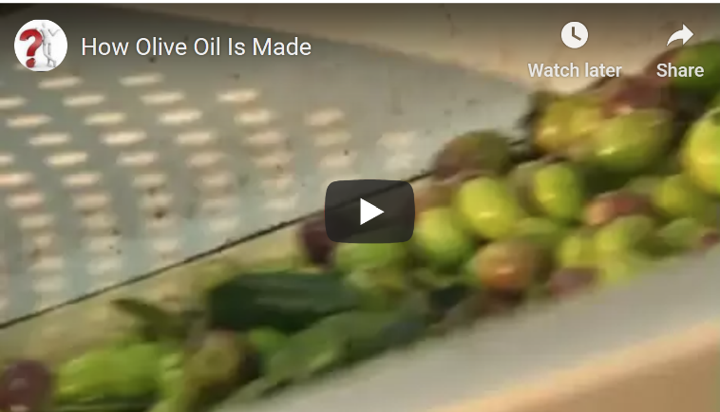
Passive Bricks
1. Watch the video about how olive oil is made.
2. Then sum up what you have found out. Drag and drop the bricks to form meaningful sentences.
Process

are heated | are collected | are filtered out | is filled
is then sold | is spun | are used | is ground
are transported | are washed | is considered
Additional information

Traditionally, olives |  | by using tiny rakes.
Nowadays, automated harvesters |  | to harvest large amounts of olives.
The olives |  | to the oil mill as quickly as possible.
The olives |  | to remove any dirt and leaves.
The last few branches and twigs |  | using a grill that only allows the fruit to pass through.
In a modern olive press the fruit |  | very gently, without heating the fruit.
Olives would lose flavor if they |  | in the process of grinding.
In the modern method the pulp |  | in a centrifuge.
Pure, unfiltered oil |  | the most valuable.
Finally, the oil |  | into green glass bottles or steel containers.
The fresh oil |  | in shops and supermarkets all over the world.

Check your answers. Then try the harder version of this task.

