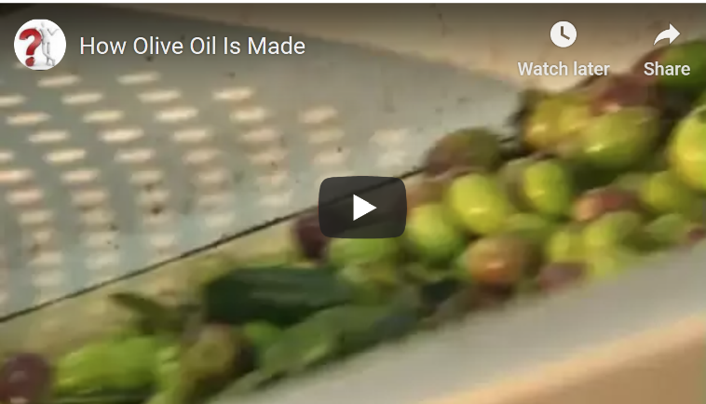
Passive Bricks 2
1. Watch the video about how olive oil is made.
2. Then sum up what you have found out. Drag and drop the bricks to form meaningful sentences.
Process

are heated | are collected | are filtered out | is filled
is then sold | is spun | are used | is ground
are transported | are washed | is considered
Additional information

Traditionally, olives |  | by using tiny rakes.
Nowadays, automated harvesters |  | to harvest large amounts of olives.
The olives |  | to the oil mill as quickly as possible.
The olives |  | to remove any dirt and leaves.
The last few branches and twigs |  | using a grill that only allows the fruit to pass through.
In a modern olive press the fruit |  | very gently, without heating the fruit.
Olives would lose flavor if they |  | in the process of grinding.
In the modern method the pulp |  | in a centrifuge.
Pure, unfiltered oil |  | the most valuable.
Finally, the oil |  | into green glass bottles or steel containers.
The fresh oil |  | in shops and supermarkets all over the world.

Check your answers. Then try the harder version of this task.

