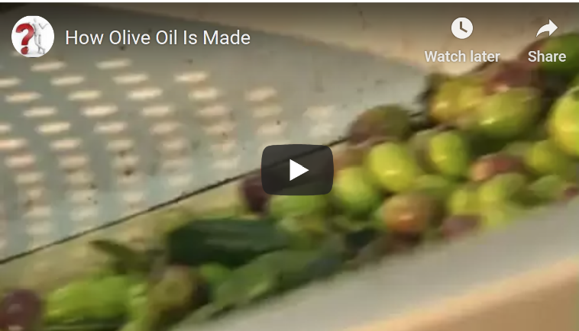
Passive Bricks
1. Watch the video about how olive oil is made.
2. Then sum up what you have found out. Drag and drop the bricks to form meaningful sentences.
Process

Additional information

Traditionally, olives | are collected | by using tiny rakes.
Nowadays, automated harvesters | are used | to harvest large amounts of olives.
The olives | are transported | to the oil mill as quickly as possible.
The olives | are washed | to remove any dirt and leaves.
The last few branches and twigs | are filtered out | using a grill that only allows the fruit to pass through.
In a modern olive press the fruit | is ground | very gently, without heating the fruit.
Olives would lose flavor if they | are heated | in the process of grinding.
In the modern method the pulp | is spun | in a centrifuge.
Pure, unfiltered oil | is considered | the most valuable.
Finally, the oil | is filled | into green glass bottles or steel containers.
The fresh oil | is then sold | in shops and supermarkets all over the world.

