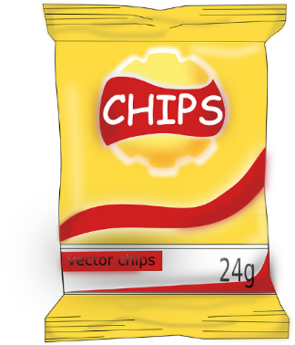
How Pringles are made

Watch the video about how pringles are made from 1:50 on. https://www.youtube.com/watch?v=Xnj1b__5AkM&t=143s
Take a few notes about the process and the verbs that occur.

Now, sum up the most important steps in about 8 to 10 sentences.

Read the text about how pringles are made and mark all verbs. Then, answer the questions in FULL SENTENCES.

Pringles are made from dried potato flakes, not raw slices.
The granulated potato powder is combined with oil, water, and a "top
secret mixture" that ends in a potato paste. The dough is just thick
enough to be poured through a funnel onto a conveyor belt. On the
belt, it is spread into a thin sheet, and then it is passed through a machine that
cuts out oval-shaped slices. The slices are fried in oil for 11 seconds so that they are crispy.
The chips are inspected by a worker. Then, the chips are packed into the cans.

What is the difference between Pringles and normal chips?

How do the Pringles get their oval-shaped slices?

How are Pringles made crispy?

