

Table of Contents
Introduction 2
Lesson Sequence Overview 3
Lesson 1: The Past Progressive in Stories (Setting the Scene) 4
L1 - Activity 1: Simon’s Adventure 4
Assessment – Activity 1 7
L1 - Activity 2: Setting the Scene 8
Assessment – Activity 2 10
L1 - Activity 3: Circle Story 11
Assessment: Activity 3 15
Lesson 2: The Past Progressive for Circumstances (Explaining/Making Excuses) 16
L2 - Activity 1: “Procrastinating Peter” Worksheet 16
Assessment – Activity 1 18
L2 – Activity 2: “Convince Me” Game 19
Assessment – Activity 2 22
L2 – Activity 3/Homework: My Crummy Day 23
Assessment – Activity 3/Homework 25
Lesson 3: Consolidating the Past Progressive for Circumstances & Background in Stories 26
L3 – Activity 1: Past Progressive Charades 26
Assessment: Activity 1 28
L3 – Activity 2: The Alibi Game 29
Assessment – Activity 2 35
L3 – Activity 3/Testing Exercise 36
Assessment: Activity 3/Testing Activity 38
Works Cited 39

Introduction
In the course of this grammar project, the past progressive notions of circumstances for use in background information for stories, making excuses and offering explanations as well as discussing occurrences at particular points in time will be addressed through three sample lessons. These notions are drawn from David Newby’s Grammar for Communication (1998).
The various activities included here are aimed at a 5th grade class and target the abovementioned notions. Each activity is preceded by explanatory remarks and further instructions for the teacher. Where these are absent, it is assumed that the instructions included on the activity sheets themselves are sufficient for completing the activity. Certain activities, in particular L2 Activity 3 and L3 Activity 3, can be used as an in-class activity, homework or testing assignment and the choice lies with the individual instructor in consideration of time constraints and student needs.
The lesson sequence begins with raising awareness of circumstances regarding background in stories and is followed by the second lesson centering on the proceduralization of the past progressive in circumstances requiring excuses and explanations at particular points in time. With some tweaking and additional awareness raising in Lesson 2, the order of the first two lessons can be reversed. After having consolidated knowledge of these notions, Lesson 3 focuses purely on the performance of their grammatical knowledge.
Each activity is followed by an analysis of the pedagogical quality of the exercise. Further reflection or specific considerations can be found in the explanations preceding each activity’s materials. An overview of the lesson sequence can be found below.
It is hoped that this grammar project will provide fellow teachers (or teachers-to-be) with at least some activities that can be implemented to further the communicative grammar knowledge of their students.

Lesson Sequence Overview
Lesson: | Activity: | Grammatical Objective/Learning Aim:
1 – The Past Progressive in Stories | 1 – “Simon’s Adventure” | Past progressive for background information in stories; awareness should be raised of past tense forms in stories
1 – The Past Progressive in Stories | 2 – “Setting the Scene” | Past progressive for background information in stories; proceduralization and scaffolded practice
1 – The Past Progressive in Stories | 3 – Circle Story | Past progressive for background information in stories; performance in real-time context of story-writing involving the aforementioned notion
2 – The Past Progressive for Circumstances Involving Making Excuses and Explanations | 1 – “Procrastinating Peter” worksheet | Past progressive for circumstances—making excuses; students proceduralize their knowledge to make excuses on Peter’s behalf
 | 2 – “Convince Me” game | Past progressive for circumstances—explaining; students proceduralize and perform in real-time offering explanations for actions at a certain point in the past
 | 3 – “My Crummy Day” writing assignment/homework assignment | Past progressive for circumstances—explaining and making excuses; students perform in real-time and can make excuses for past shortcomings
3 – Consolidating Knowledge of the Past Progressive for Circumstances and Background in Stories | 1 – Charades | Past progressive for circumstances; students perform in real-time and can describe the actions of their partner a few moments prior
 | 2 – The “Alibi” game | Past progressive for circumstances, background in stories, making excuses and explaining; students perform in real-time and can try to explain what they were doing at a particular point in the past and describe the scene around them
 | 3 – Photographic essay writing assignment/testing activity | Past progressive for circumstances, what was happening at a particular time; students can write an essay describing a photograph and setting the scene for it

Lesson 1: The Past Progressive in Stories (Setting the Scene)
The initial lesson in this sequence targets raising awareness of the past progressive for use in setting the scene in stories while transitioning to full production and use of the past progressive and the simple past in a storytelling context. Depending on the ability and speed of the students, time constraints may not allow for the final activity, but this can be used in a later lesson.

L1 - Activity 1: Simon’s Adventure
Grammatical Objective/Learning Aim: Past progressive in background information in stories (raising awareness)
The worksheet below is directed at awareness-raising of various past-tense forms but particularly the past progressive as it relates to background information in stories. All instructions should be clearly stated on the worksheet. The initial reading activity can be done individually or read aloud by members of the class.
This activity has been adapted from: Harmer, Jeremy. The Practice of English Language Teaching, 5th ed. Pearson, 2017, pp. 250-251.

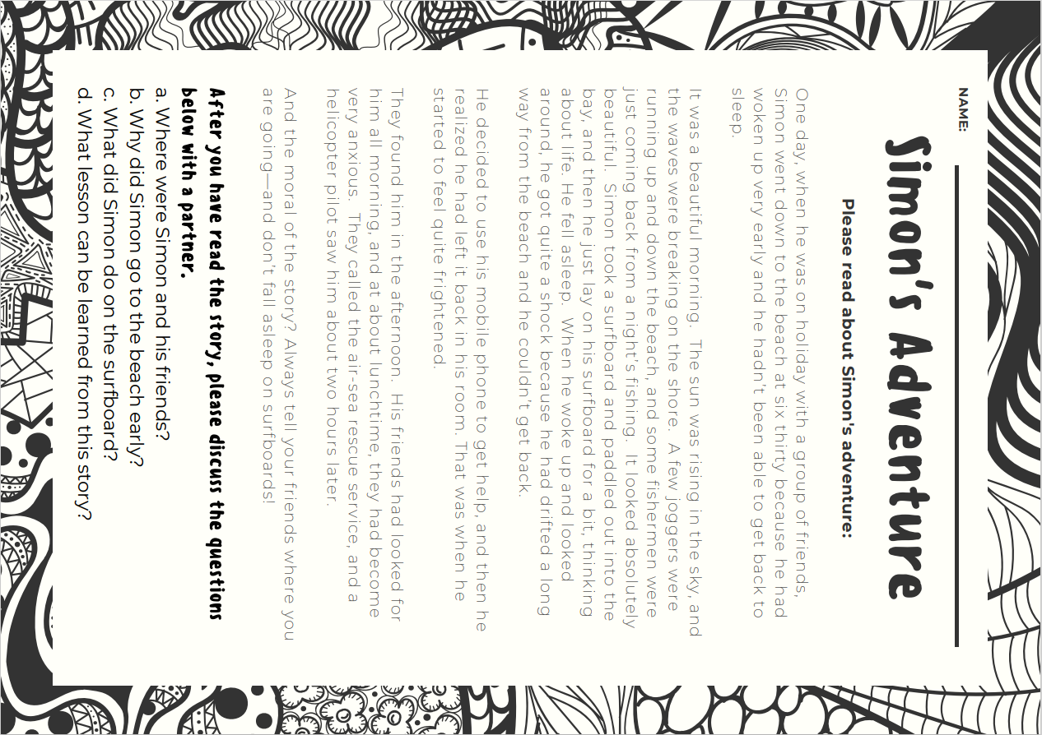
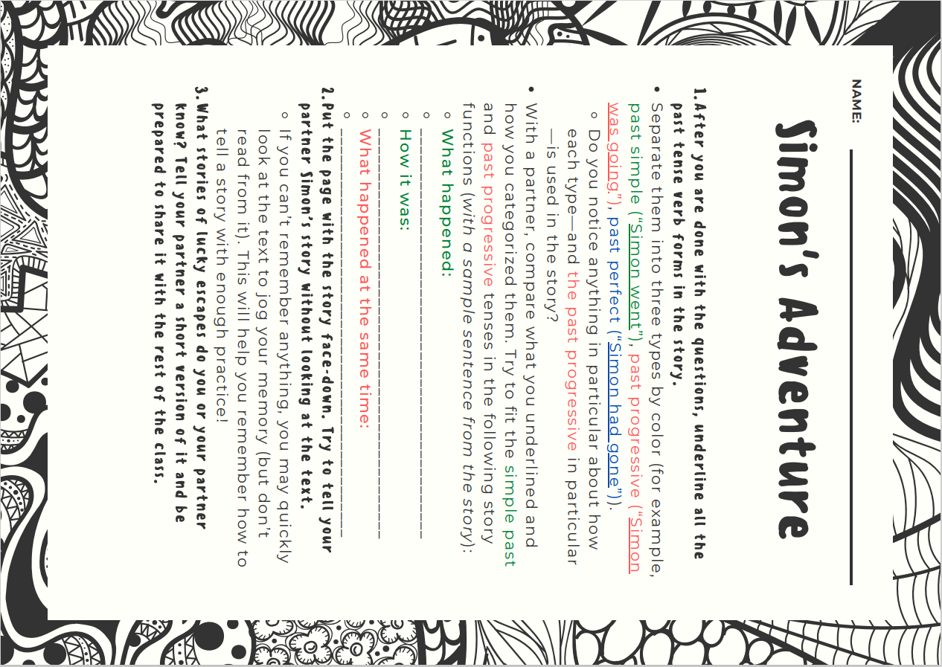

Assessment – Activity 1
 | Quick Check Grammar Chart | - |  | + | Explain why
Learning Stages | Awareness raising |  |  | X | The reading is intended to raise S’s awareness of various past tense forms and the past progressive in particular, but it is expected that S have some degree of familiarity with the tenses already.
Learning Stages | Conceptualization and hypothesis building |  |  | X | By considering the role that a particular past tense form plays in the text, S can hopefully hypothesize the past progressive’s role in storytelling.
Learning Stages | Proceduralization in scaffolded conditions |  |  | X | S move from awareness raising, to analyzing the text, to retelling the text, and finally to telling a text of their own.
Learning Stages | Performance in real-time context |  |  | X | Yes—performance with a partner and/or in front of the class with opportunity for immediate feedback (aside from the underlining exercise).
Pedagogical Principles and Communicative Criteria | Depth of processing and Complex encoding : Will the learners be mentally active and process grammar, lexis and their “world knowledge”? |  |  | X | Yes. S must think critically about the function of the past tenses that are already aware of and their function in a text, while also utilizing this knowledge in the telling of their own story.
Pedagogical Principles and Communicative Criteria | Commitment filter:  Will the learners’ cognitive and affective needs be met? (e.g.: curiosity, problem solving, enjoyment, fun, success) |  |  | X | While the adventure story may not appeal to everyone, it should hopefully pique most S’ interests; the telling of their own exciting story should prove amusing for many.
Pedagogical Principles and Communicative Criteria | Peer and social learning and interaction:  Pair – or groupwork, sharing, oral activities, jigsaw activities… |  |  | X | This is a highly interactive activity within the partner/group.
Pedagogical Principles and Communicative Criteria | Personalisation:  Do the learners have the opportunity to draw on their personal experiences and express their own ideas? |  | X |  | Not the case in each sub-exercise, but exercise 5 allows students to bring in their own perspectives.
Pedagogical Principles and Communicative Criteria | Contextualisation:  Is the exercise embedded in a clear communicative context? |  |  | X | Even though this may not be everyday “reality”-based by nature, the context in which they are speaking is quite clear and it is in most instances with a partner in which they try to practice storytelling.
Pedagogical Principles and Communicative Criteria | Authenticity of process:  Will the learners use language in natural, “language-like” ways (rather than manipulate forms)? |  |  | X | Since storytelling is one of the most basic functions of human language, it is trying to encourage authentic use of the language through varying the tenses used in particular context (as opposed to simply telling it all in the simple past tense).
Pedagogical Principles and Communicative Criteria | Task-based:  Do the students fulfil a purposeful task that will have an outcome or end product? |  |  | X | Yes—hopefully each student will be able to tell a brief lucky escape story of their own by the end of the lesson.
Pedagogical Principles and Communicative Criteria | Testing versus teaching:  Does the exercise support learning or only test it? |  |  | X | I believe this should help to consolidate the use of the past tense structures already learned and in so doing support learning while also providing an opportunity to gauge the students general mastery of past tenses and further underscoring the narrative role of the past progressive.
Pedagogical Principles and Communicative Criteria | This exercise supports learning processes… |  |  |  | 2.5 stars

L1 - Activity 2: Setting the Scene
Grammatical Objective/Learning Aim: past progressive for setting a scene (proceduralization)
Now that the students have familiarized themselves with the past progressive in a storytelling context, they will practice writing setting the scene in various story contexts. To give them some ideas of what options are available to them and why setting the scene is important, you can play the following video for them: https://www.youtube.com/watch?v=3BVOIyUnk6s&ab_channel=TeachingWithoutFrills.
This could be done, in my view, as part of a larger storytelling unit in which students learn about the elements of plot so as to further narrative development in their fiction writing.
Instructions:
Hand out the worksheet to your students, explain the activity and have them complete it. After they are done, you can put them in groups and have them share what they think are their most interesting story settings. If there is one that they particularly like, they can use this as the setting for the next activity, the circle story, and you can directly segue into this.
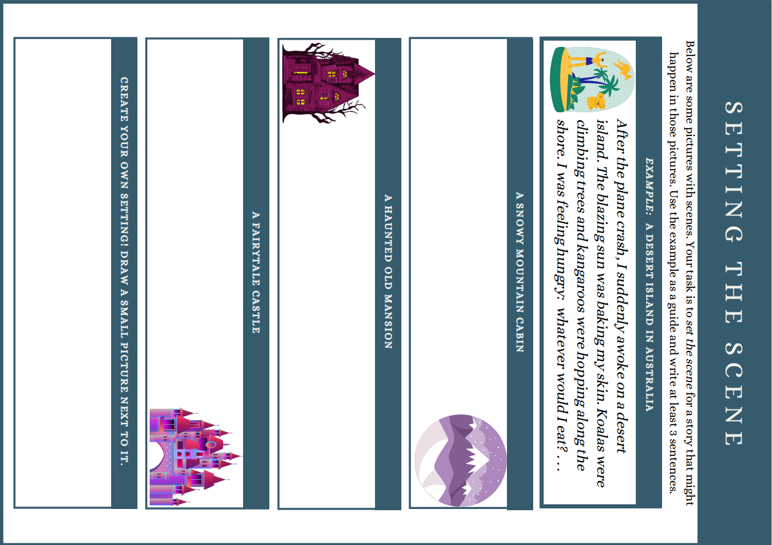

Assessment – Activity 2
 | Quick Check Grammar Chart | - |  | + | Explain why
Learning Stages | Awareness raising | X |  |  | Awareness has ideally been raised in the previous activity.
Learning Stages | Conceptualization and hypothesis building |  | X |  | Conceptualization and hypotheses should have been addressed in the previous activity and further consolidated by this activity.
Learning Stages | Proceduralization in scaffolded conditions |  |  | X | S should now have taken the next step by practicing setting the scene in a structured context where they do not have to write a full story.
Learning Stages | Performance in real-time context |  |  | X | As students write these in real time, this takes place; reading them aloud to their group also helps in this regard.
Pedagogical Principles and Communicative Criteria | Depth of processing and Complex encoding : Will the learners be mentally active and process grammar, lexis and their “world knowledge”? |  |  | X | Yes. By creating their own sentences in entertaining settings, they should be engaged and can use their background knowledge to make their settings interesting.
Pedagogical Principles and Communicative Criteria | Commitment filter:  Will the learners’ cognitive and affective needs be met? (e.g.: curiosity, problem solving, enjoyment, fun, success) |  |  | X | Yes. The open-ended nature of this should make this a fun and challenging exercise.
Pedagogical Principles and Communicative Criteria | Peer and social learning and interaction:  Pair – or groupwork, sharing, oral activities, jigsaw activities… |  |  | X | By sharing their settings afterwards, they can get feedback and a sense of pride in what they have accomplished.
Pedagogical Principles and Communicative Criteria | Personalisation:  Do the learners have the opportunity to draw on their personal experiences and express their own ideas? |  |  | X | Yes. This is open-ended, so their ideas can be expressed.
Pedagogical Principles and Communicative Criteria | Contextualisation:  Is the exercise embedded in a clear communicative context? |  |  | X | Yes. They are communicating a story setting of their choosing.
Pedagogical Principles and Communicative Criteria | Authenticity of process:  Will the learners use language in natural, “language-like” ways (rather than manipulate forms)? |  |  | X | Yes. As opposed to simply setting a scene in the simple past tense, they will use the more native-like past progressive tense to give background in stories.
Pedagogical Principles and Communicative Criteria | Task-based:  Do the students fulfil a purposeful task that will have an outcome or end product? |  |  | X | Yes—they can share their written introductions afterwards.
Pedagogical Principles and Communicative Criteria | Testing versus teaching:  Does the exercise support learning or only test it? |  |  | X | The limited nature of the task should support learning.
Pedagogical Principles and Communicative Criteria | This exercise supports learning processes… |  |  |  | Yes. 2.5 stars.

L1 - Activity 3: Circle Story
Grammatical Objective/Learning Aim: past progressive for background information in stories (performance)
As the final part of Lesson 1, the circle story activity has students produce a full story text in a setting of their choosing that shows their ability to integrate the past progressive for background in stories alongside the past simple tense for events. The interim between Activities 2 and 3 can be used to broach the topic of story structure so as to give them a blueprint for structuring their story. The circular model below can be used to do this. They should have a complete story at the end of the activity which their group can hang on the wall or a pinboard to showcase their work. Alternatively, the students could film themselves reading their story aloud on Flipgrid or illustrate their story scene by scene as part of a multi-lesson unit. The instructions in the worksheet should be sufficient for the students, but you may want to offer a few clear examples beforehand of how the process works to clarify any lingering issues. The final sheet can be optional depending on time constraints and whether or not you would prefer to do the Flipgrid activity with this.
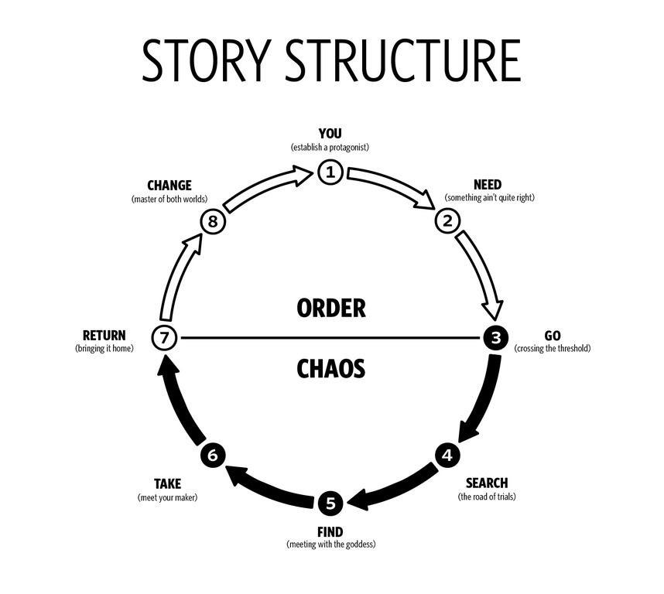





Assessment: Activity 3
 | Quick Check Grammar Chart | - |  | + | Explain why
Learning Stages | Awareness raising | X
Learning Stages | Conceptualization and hypothesis building | X
Learning Stages | Proceduralization in scaffolded conditions | X
Learning Stages | Performance in real-time context |  |  | X | Yes. They write a story in real-time.
Pedagogical Principles and Communicative Criteria | Depth of processing and Complex encoding : Will the learners be mentally active and process grammar, lexis and their “world knowledge”? |  |  | X | Yes. They must use the context clues written by other students to try to create a coherent story that targets the grammatical elements necessary to set scenes and conclude the story.
Pedagogical Principles and Communicative Criteria | Commitment filter:  Will the learners’ cognitive and affective needs be met? (e.g.: curiosity, problem solving, enjoyment, fun, success) |  |  | X | Yes. The open-ended nature of this should provide a challenge and fun.
Pedagogical Principles and Communicative Criteria | Peer and social learning and interaction:  Pair – or groupwork, sharing, oral activities, jigsaw activities… |  |  | X | This is a group activity.
Pedagogical Principles and Communicative Criteria | Personalisation:  Do the learners have the opportunity to draw on their personal experiences and express their own ideas? |  |  | X | This is open-ended, so there are many options to personalize it, especially if the illustration element is included.
Pedagogical Principles and Communicative Criteria | Contextualisation:  Is the exercise embedded in a clear communicative context? |  |  | X | Yes. S are telling a collective story.
Pedagogical Principles and Communicative Criteria | Authenticity of process:  Will the learners use language in natural, “language-like” ways (rather than manipulate forms)? |  | X |  | Unclear. This depends on the ability of S to demonstrate their understanding of the past progressive for background in stories.
Pedagogical Principles and Communicative Criteria | Task-based:  Do the students fulfil a purposeful task that will have an outcome or end product? |  |  | X | Yes. The story can be read aloud to the class or hung on the wall for others to read.
Pedagogical Principles and Communicative Criteria | Testing versus teaching:  Does the exercise support learning or only test it? |  |  | X | It should support learning through their fellow S’s feedback so they write correct sentences.
Pedagogical Principles and Communicative Criteria | This exercise supports learning processes… |  |  |  | Yes. 2.5 stars.

Lesson 2: The Past Progressive for Circumstances (Explaining/Making Excuses)
The second lesson builds upon the awareness raising and production in the first lesson and expands the use of the past progressive to include circumstances involving explaining and making excuses in conjunction with particular points in time. The order of Lessons 1 and 2 could theoretically be reversed, provided that sufficient room for awareness raising and theorization as to the past progressive in terms of circumstances is given. Students move from a more limited initial activity that targets their ability to make excuses to a group activity in which they explain why they did something at a given point in time and closes with a writing activity that can also be assigned as homework.

L2 - Activity 1: “Procrastinating Peter” Worksheet
Grammatical Objective/Learning Aim: past progressive for circumstances, making excuses (awareness raising/proceduralization)
Activity 1 is a worksheet that has students practice giving excuses for particular actions with the past progressive, possibly in combination with the simple past (e.g., “I couldn’t do it because I was walking the dog.”). This should prime students for the second activity. If students find it difficult to offer excuses off the cuff, you may want to consider showing some images of particular activities on the projector so that students can use those as cues for their excuses.

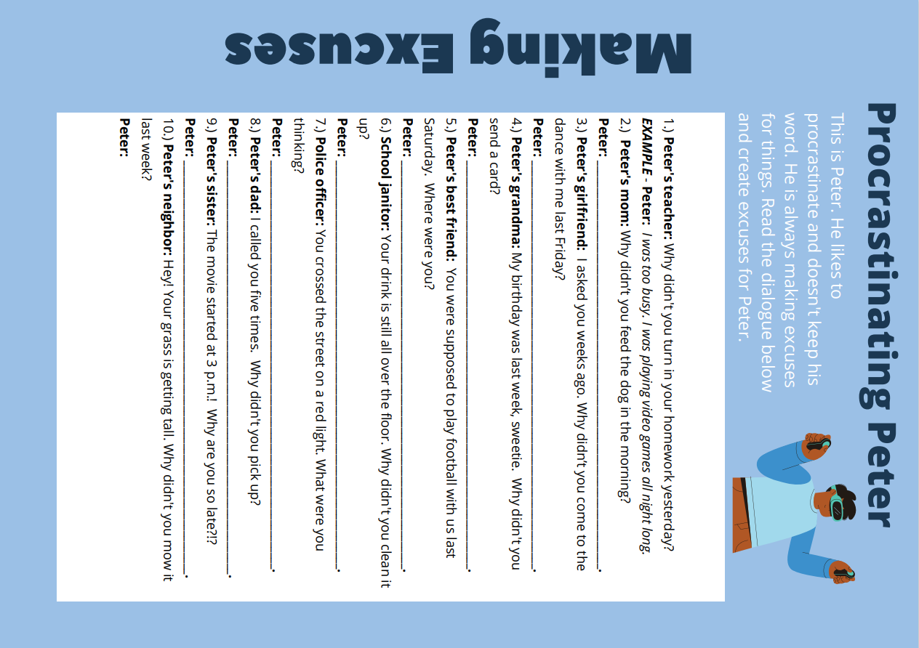

Assessment – Activity 1
 | Quick Check Grammar Chart | - |  | + | Explain why
Learning Stages | Awareness raising | X |  |  | Awareness within this context should hopefully already have been raised so through previous examples (the teacher’s introduction).
Learning Stages | Conceptualization and hypothesis building | X |  |  | As above, S are hopefully beyond this point by now and can put it into practice.
Learning Stages | Proceduralization in scaffolded conditions |  |  | X | The limited nature of this activity should help them use the past progressive for this context.
Learning Stages | Performance in real-time context |  |  | X | Yes, insofar as they are writing and this can be assessed thereafter.
Pedagogical Principles and Communicative Criteria | Depth of processing and Complex encoding : Will the learners be mentally active and process grammar, lexis and their “world knowledge”? |  |  | X | Yes. They must use their world knowledge to create the excuses.
Pedagogical Principles and Communicative Criteria | Commitment filter:  Will the learners’ cognitive and affective needs be met? (e.g.: curiosity, problem solving, enjoyment, fun, success) |  | X |  | While open-ended, this may not fully pique students interest given that it is essentially a sentence-writing worksheet.
Pedagogical Principles and Communicative Criteria | Peer and social learning and interaction:  Pair – or groupwork, sharing, oral activities, jigsaw activities… | X |  |  | No.
Pedagogical Principles and Communicative Criteria | Personalisation:  Do the learners have the opportunity to draw on their personal experiences and express their own ideas? |  |  | X | Yes. They can use their own experiences to create excuses.
Pedagogical Principles and Communicative Criteria | Contextualisation:  Is the exercise embedded in a clear communicative context? |  |  | X | Yes—this helps them practice making excuses (something teachers will clearly appreciate).
Pedagogical Principles and Communicative Criteria | Authenticity of process:  Will the learners use language in natural, “language-like” ways (rather than manipulate forms)? | X |  |  | I’m a bit critical here, as it is unlikely that any one human being would have to offer so many excuses, particularly without being part of a larger context.
Pedagogical Principles and Communicative Criteria | Task-based:  Do the students fulfil a purposeful task that will have an outcome or end product? |  | X |  | While the task is purposeful—to make excuses—the end product (as a worksheet) is not particularly inspiring.
Pedagogical Principles and Communicative Criteria | Testing versus teaching:  Does the exercise support learning or only test it? |  |  |  | Insofar as it is scaffolded, it hopefully supports learning, but is also a means to test that they possess the ability to make the basic forms.
Pedagogical Principles and Communicative Criteria | This exercise supports learning processes… |  |  |  | Yes—2 stars.

L2 – Activity 2: “Convince Me” Game
Grammatical Objective/Learning Aim: past progressive for circumstances at particular points in time, explanations (proceduralization)
This activity further targets the students’ use of the past progressive with regard to circumstances, particularly the Newby subcategory for a particular point in time [“Zu einem bestimmten Zeitpunkt”] (Newby 81). Likewise, this activity also combines this sense of the past progressive with its use in explanations.
The instructions below have been geared towards students. This can simply be read aloud and explained to the students, but, if needs be, this can be printed out and handed to each group in case it is still unclear. You will have to print the proper amount and cut each sheet up, making sure that the time cards and the picture cards are kept separate.
This activity has been adapted from Teach This: ESL/EFL Resources, https://www.teach-this.com/images/resources/convince-me.pdf.
Instructions:
In groups of 4, you will receive two sets of cards. One set has different picture cards with activities while the other is a set of time cards. Place the time cards face-down in a pile. Divide up the picture cards among the group—everyone needs to have the same number of cards. The first person then needs to draw a time card. You will ask the person to your right, “What were you doing at [time on your time card]?” That student has to draw a picture card and give a reasonable response. If that answer is not reasonable (for example, “I was flying a kite at 3 a.m.”), you need to ask for a convincing [überzeugend] response. If that person can’t provide a convincing response, he/she has to keep the picture card. The next person picks up a time card and continues. The first person to get rid of all their cards is the winner.
Sample round:
Student 1: “What were you doing at 4:00 a.m.?”
Student 2: “I was mopping the floor.”
(No convincing reason student 2 keeps the activity card and picks up a time card)
Student 2: “I was mopping the floor at 4 a.m. because my dog knocked over my water in the night.” student 2 can put the activity card down and then picks a time card.


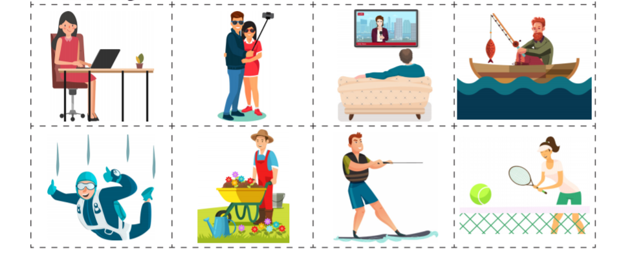


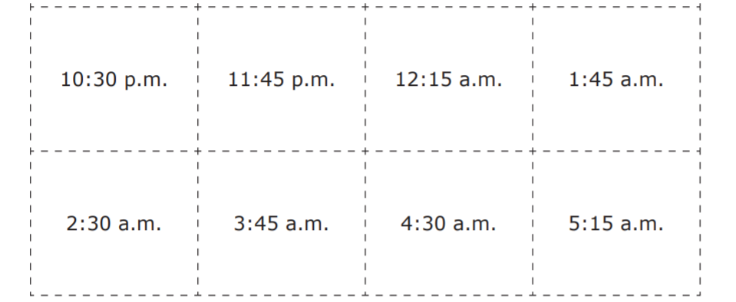

Assessment – Activity 2
 | Quick Check Grammar Chart | - |  | + | Explain why
Learning Stages | Awareness raising | X |  |  | Not the intention of this activity.
Learning Stages | Conceptualization and hypothesis building | X |  |  | Not the intention of this activity.
Learning Stages | Proceduralization in scaffolded conditions |  | X |  | Building on the awareness and conceptualization from the past activity, S must now use the same pattern from excuses for explanations instead. The context is fairly limited.
Learning Stages | Performance in real-time context |  |  | X | Yes. This is performed in real time.
Pedagogical Principles and Communicative Criteria | Depth of processing and Complex encoding : Will the learners be mentally active and process grammar, lexis and their “world knowledge”? |  |  | X | Yes. S need to use the picture cues and times to mentally justify what they have done based on world knowledge.
Pedagogical Principles and Communicative Criteria | Commitment filter:  Will the learners’ cognitive and affective needs be met? (e.g.: curiosity, problem solving, enjoyment, fun, success) |  |  | X | The sheer ridiculousness of justifying some of these actions at particular times should prove amusing for S.
Pedagogical Principles and Communicative Criteria | Peer and social learning and interaction:  Pair – or groupwork, sharing, oral activities, jigsaw activities… |  |  | X | Yes. This is a group activity.
Pedagogical Principles and Communicative Criteria | Personalisation:  Do the learners have the opportunity to draw on their personal experiences and express their own ideas? |  |  | X | S’s explanations should allow students to personalize their responses.
Pedagogical Principles and Communicative Criteria | Contextualisation:  Is the exercise embedded in a clear communicative context? |  |  | X | Yes—giving explanations.
Pedagogical Principles and Communicative Criteria | Authenticity of process:  Will the learners use language in natural, “language-like” ways (rather than manipulate forms)? |  |  | X | Yes—S must freely offer their own customized explanation and use the past progressive properly in stating what they were doing at a given time.
Pedagogical Principles and Communicative Criteria | Task-based:  Do the students fulfil a purposeful task that will have an outcome or end product? |  | X |  | Yes, insofar as it is a game, there will be a winner who is quicker at offering explanations and so gets rid of his cards; however, no tangible product is the outcome.
Pedagogical Principles and Communicative Criteria | Testing versus teaching:  Does the exercise support learning or only test it? |  |  | X | Yes. The limited nature of this task (the formulaic “I was ironing my shirt at 4 a.m. because …) and the customizable explanation should support learning without overwhelming S.
Pedagogical Principles and Communicative Criteria | This exercise supports learning processes… |  |  |  | Yes. 2.5 stars.

L2 – Activity 3/Homework: My Crummy Day
Grammatical Objective/Learning Aim: past progressive for circumstances, making excuses/explaining (performance)
Activity 3 is an activity that can be started in class and finished as homework. Students must write a text about a very bad day in their lives (this can be tweaked to be any day in their lives as opposed to the perhaps less authentic “yesterday” in the instructions). In it, they can offer excuses or explanations about why things were not going their way. Should students manage to complete the activity during class time, students could be asked to record themselves reading their story on Flipgrid to share with their classmates.

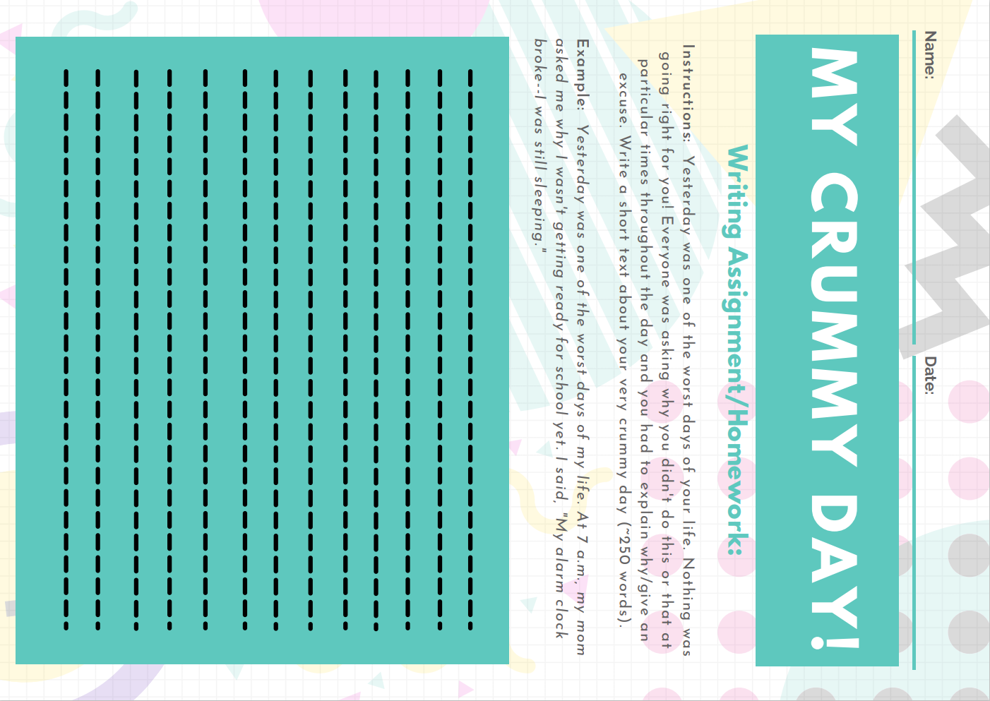

Assessment – Activity 3/Homework
 | Quick Check Grammar Chart | - |  | + | Explain why
Learning Stages | Awareness raising | X |  |  | Not the intention of this activity.
Learning Stages | Conceptualization and hypothesis building | X |  |  | Not the intention of this activity.
Learning Stages | Proceduralization in scaffolded conditions | X |  |  | Not the intention of this activity.
Learning Stages | Performance in real-time context |  |  | X | In writing, they perform in real time.
Pedagogical Principles and Communicative Criteria | Depth of processing and Complex encoding : Will the learners be mentally active and process grammar, lexis and their “world knowledge”? |  |  | X | Yes. They must decide on tense and use their own world knowledge to give explanations/excuses.
Pedagogical Principles and Communicative Criteria | Commitment filter:  Will the learners’ cognitive and affective needs be met? (e.g.: curiosity, problem solving, enjoyment, fun, success) |  |  | X | The open-ended nature of this activity and its degree of personalization should make this enjoyable.
Pedagogical Principles and Communicative Criteria | Peer and social learning and interaction:  Pair – or groupwork, sharing, oral activities, jigsaw activities… |  | X |  | If the Flipgrid post-activity is included, then this allows them to share their crummy day with their fellow students and can receive feedback.
Pedagogical Principles and Communicative Criteria | Personalisation:  Do the learners have the opportunity to draw on their personal experiences and express their own ideas? |  |  | X | Yes—their personal experiences form the basis of this activity.
Pedagogical Principles and Communicative Criteria | Contextualisation:  Is the exercise embedded in a clear communicative context? |  |  | X | Yes—they must offer explanations and excuses for things not going their way.
Pedagogical Principles and Communicative Criteria | Authenticity of process:  Will the learners use language in natural, “language-like” ways (rather than manipulate forms)? |  |  | X | Yes—they must write a full text that should go beyond formulaic responses.
Pedagogical Principles and Communicative Criteria | Task-based:  Do the students fulfil a purposeful task that will have an outcome or end product? |  |  | X | Yes—the written text and hopefully also the Flipgrid video.
Pedagogical Principles and Communicative Criteria | Testing versus teaching:  Does the exercise support learning or only test it? |  | X |  | The writing process should support learning and putting the notions they have learned to use.
Pedagogical Principles and Communicative Criteria | This exercise supports learning processes… |  |  |  | Yes. 2.25 stars.

Lesson 3: Consolidating the Past Progressive for Circumstances & Background in Stories
In this lesson, the students have already had a significant amount of practice with the past progressive for use with circumstances and background in stories. In the course of this lesson, the students will use the past progressive alongside other past forms to explain or excuse their actions at a particular point in time as well as to set the scene at a given moment in telling their story (Activity 2).
Activity 1 is optional if you feel that there is not enough time for Activity 2. Activity 3 is primarily designed as a testing exercise to address the aforementioned notions but could also be used in class or as a homework exercise if needs be.

L3 – Activity 1: Past Progressive Charades
Grammatical Objective/Learning Aim: past progressive for circumstances (proceduralization and performance)
The goal here is to prime the students to use the past progressive for circumstances at particular points in time in the past in anticipation of Activity 2. Because Activity 2 can easily fill an entire lesson, you may or may not want to include this activity. The cards have been left in the infinitive so that students must take an extra step to process the information into the past progressive.
This activity has been adapted from Teflnet, https://www.tefl.net/elt/ideas/grammar/past-continuous-activities/.
Instructions: In this activity, you will print and cut the cards below and distribute them evenly to each pair of students. Each card has a particular activity on it. As in charades, the first student should act out what is on his/her card. The second student shouts “Stop!” when they know what the action is. They have to state, in the past progressive, what the student was doing. For example, “When I said stop, you were hula-hooping.” The students then reverse roles. After they have each gone through their cards, ask them to create two or three actions of their own that their partner has to guess.

Walk the dog | Sing loudly
Mop the floor | Take a shower
Do your homework | Look in the mirror
Play videogames | Cook dinner
Run a race | Read a book
Shop in a store | Play basketball
Call a friend | Mow the lawn

Assessment: Activity 1
 | Quick Check Grammar Chart | - |  | + | Explain why
Learning Stages | Awareness raising | X |  |  | Not the intention of this activity.
Learning Stages | Conceptualization and hypothesis building | X |  |  | Not the intention of this activity.
Learning Stages | Proceduralization in scaffolded conditions |  |  | X | As preparation for the next activity, they are practicing the past progressive to show what they were doing at a particular point in time and in a more limited context based on card cues.
Learning Stages | Performance in real-time context |  |  | X | Yes—performed in real time for their partner.
Pedagogical Principles and Communicative Criteria | Depth of processing and Complex encoding : Will the learners be mentally active and process grammar, lexis and their “world knowledge”? |  |  | X | Guessing the action of their partner should have them mentally active.
Pedagogical Principles and Communicative Criteria | Commitment filter:  Will the learners’ cognitive and affective needs be met? (e.g.: curiosity, problem solving, enjoyment, fun, success) |  |  | X | Acting out the actions should add an element of fun to the activity while challenging them to guess what action it is.
Pedagogical Principles and Communicative Criteria | Peer and social learning and interaction:  Pair – or groupwork, sharing, oral activities, jigsaw activities… |  |  | X | Yes—partner activity.
Pedagogical Principles and Communicative Criteria | Personalisation:  Do the learners have the opportunity to draw on their personal experiences and express their own ideas? |  | X |  | For the last 2-3 charades, S can make up their own actions which adds a degree of personalization.
Pedagogical Principles and Communicative Criteria | Contextualisation:  Is the exercise embedded in a clear communicative context? |  |  | X | Yes. S need to describe their partner’s action.
Pedagogical Principles and Communicative Criteria | Authenticity of process:  Will the learners use language in natural, “language-like” ways (rather than manipulate forms)? | X |  |  | Making sure they include “When I said stop” each time may seem a bit inauthentic, but it helps keep things in the past progressive.
Pedagogical Principles and Communicative Criteria | Task-based:  Do the students fulfil a purposeful task that will have an outcome or end product? |  |  | X | S will hopefully be able to guess the action of their partner and thus will have an outcome.
Pedagogical Principles and Communicative Criteria | Testing versus teaching:  Does the exercise support learning or only test it? |  |  | X | Yes. This helps consolidate their use of the past progressive for past actions at a certain point in time.
Pedagogical Principles and Communicative Criteria | This exercise supports learning processes… |  |  |  | Yes. 2 stars.

L3 – Activity 2: The Alibi Game
Grammatical Objective/Learning Aim: past progressive for circumstances, background in stories, making excuses/offering explanations (performance)
Activity 2 is an incredibly fun but time-consuming game for students. This should be the point where students can put their productive knowledge of the past progressive for explanations, excuses, background in stories at particular times into verbal practice. Depending on student involvement, alibis can be quite elaborate, so time management is of the essence here.
You will need to arrange the classroom a bit to pull this off successfully: one chair should be placed at the front of the class facing the students. Four to five chairs (depending on the number of students in a group) should be placed at the back of the classroom facing the wall for the students who have already been interrogated (this helps limit kibitzing and comments/looks to derail the interrogation process).
Each student in a group will receive the appropriate sheet for their crime (for a total of four groups). Group size can be adjusted based on class size (or additional crimes added), but groups larger than six or less than three are not recommended.
Students should have around 10 minutes to write their alibis. I would recommend telling them to just take bullet-point notes to save space and time. Have groups who finish early think of questions to ask potential criminals, so they are ready to be the “police officers” when the time comes. One group will be interrogated at a time while the rest of the class are the police officers doing the interrogation. Only one student at a time will be interrogated while the other group members wait outside the classroom.
At the end of an interrogation (after all individuals have been interviewed or at least three holes in their stories have been found), the “police” section of the class will present their evidence of a group’s alibi’s holes and see if it’s enough to “charge” them.
Instructions: In groups of approximately four people, write a alibi with which you can defend yourself and your group from the crimes that you have been accused of. Make sure that you all (i.e., each member) have memorized the details of your alibi, i.e., where you were, what you were doing, when you left, if you ate/drank anything, how you traveled there, with whom you talked, etc.
All crimes are reported to have happened on Saturday night between the hours of 7 p.m. and 10 p.m. unless otherwise stated. You will then be interrogated one-by-one by the rest of the class for specific information in order to find "holes" in your alibi.
Your fellow students (the ones not in your group) will be the interrogating police officers who ask a question. Every student must ask at least ONE question! Take notes on the individual crimes on your sheet. The group under interrogation will be examined separately in the “hot seat”—the rest of the group will remain outside the classroom until it is their turn. If one or fewer “holes” in the alibi can be found, the group is “free.”

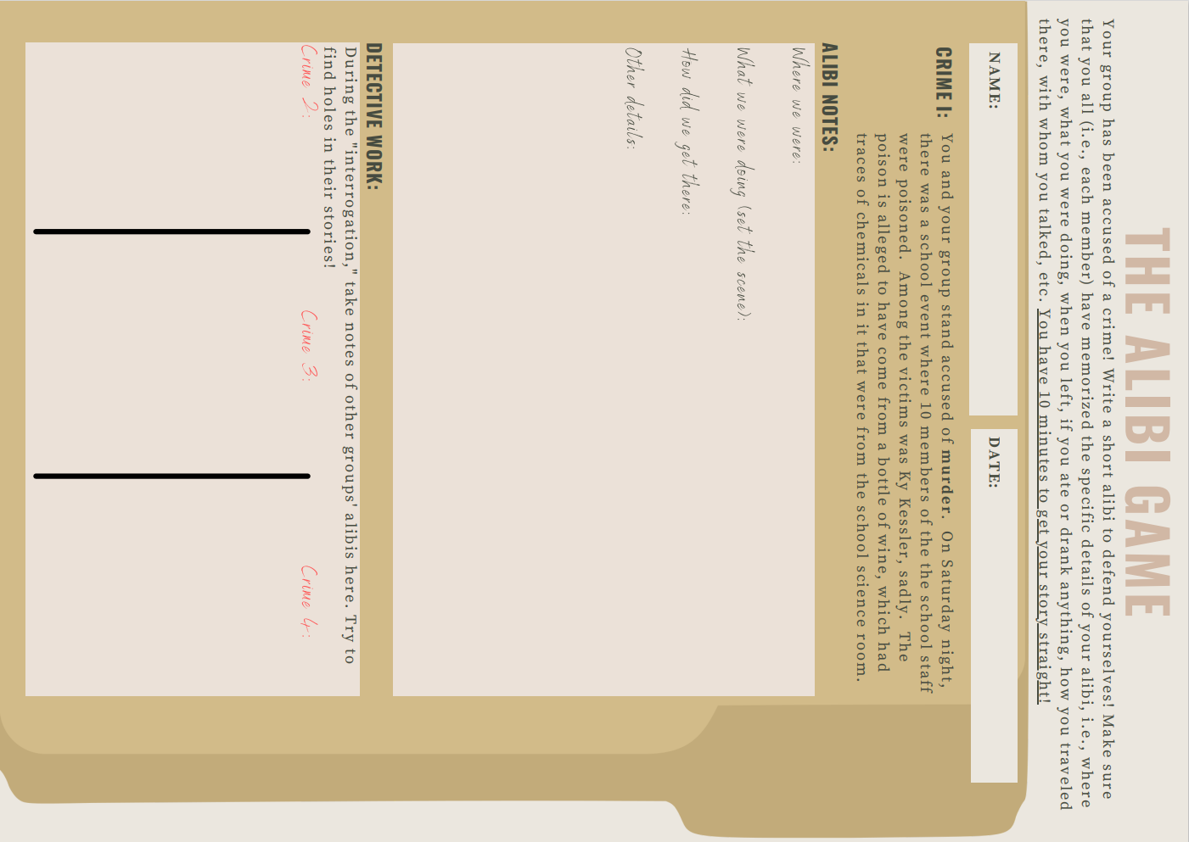
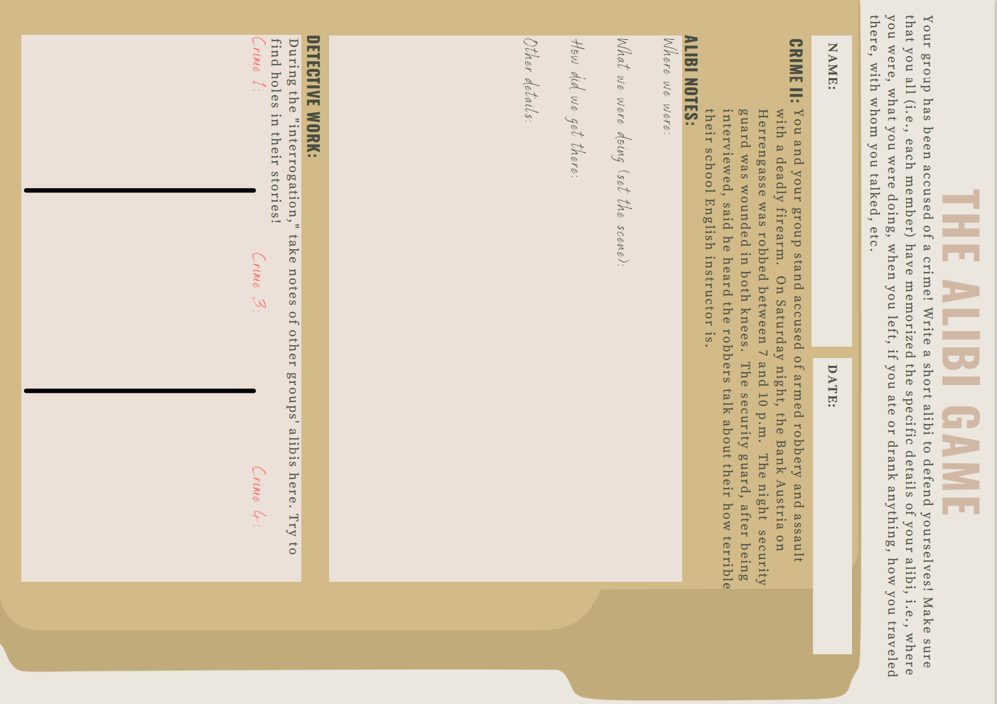
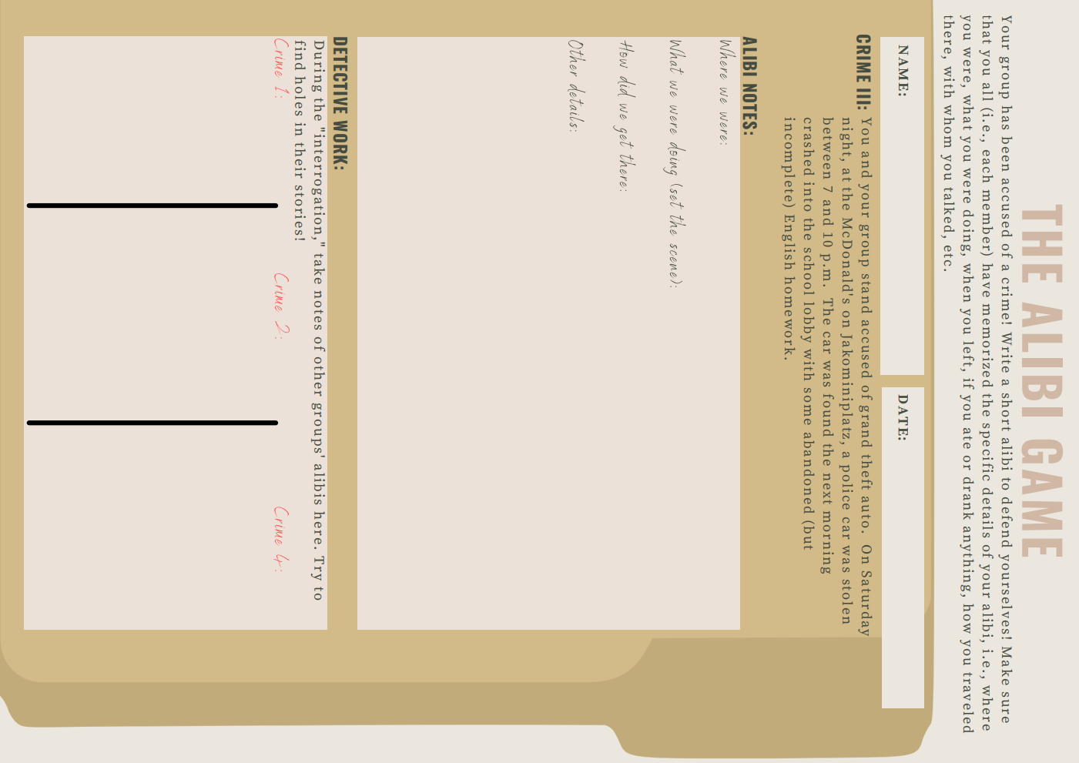
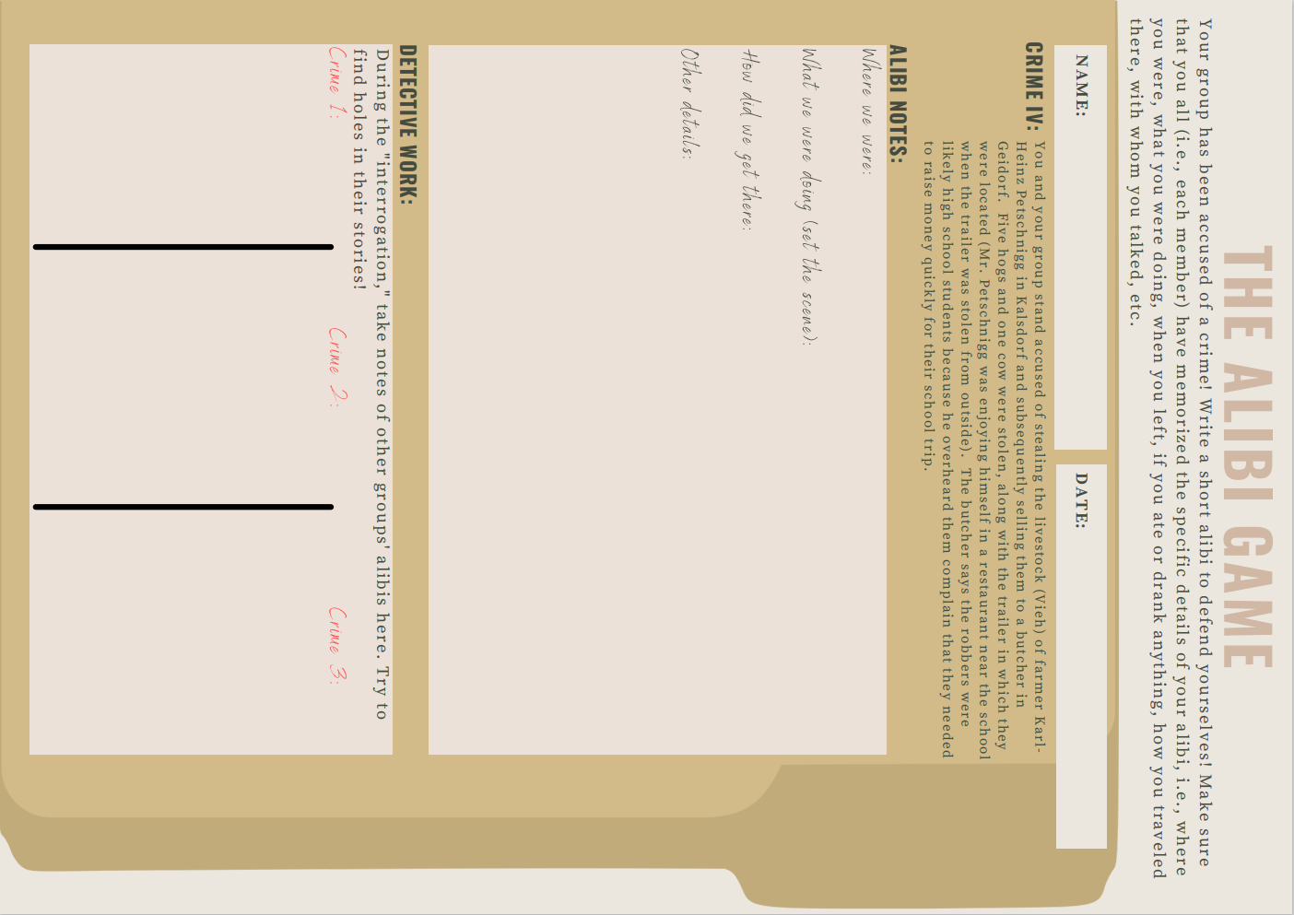

Assessment – Activity 2
 | Quick Check Grammar Chart | - |  | + | Explain why
Learning Stages | Awareness raising |  | X |  | The repeated exposure to question and statement formation in the past tenses should raise some grammatical awareness, but it is expected that S have some degree of familiarity with the tenses already.
Learning Stages | Conceptualization and hypothesis building |  | X |  | S should by this point be able to conceptualize and hypothesize about the past tenses in a mixed use environment.
Learning Stages | Proceduralization in scaffolded conditions |  | X |  | S will be provided with a sample round of the game, but will hopefully have proceduralized the grammatical forms beforehand.
Learning Stages | Performance in real-time context |  |  | X | Yes—performance in front of the class with opportunity for immediate feedback.
Pedagogical Principles and Communicative Criteria | Depth of processing and Complex encoding : Will the learners be mentally active and process grammar, lexis and their “world knowledge”? |  |  | X | Yes. S must integrate the broad outlines of their written alibi in a limited time frame while being able to answer the questions put to them in the proper tense.
Pedagogical Principles and Communicative Criteria | Commitment filter:  Will the learners’ cognitive and affective needs be met? (e.g.: curiosity, problem solving, enjoyment, fun, success) |  |  | X | The open-ended nature of this activity should prove to challenge them cognitively while piquing their interest thematically.
Pedagogical Principles and Communicative Criteria | Peer and social learning and interaction:  Pair – or groupwork, sharing, oral activities, jigsaw activities… |  |  | X | This is a highly interactive activity within the group and in the class as a whole.
Pedagogical Principles and Communicative Criteria | Personalisation:  Do the learners have the opportunity to draw on their personal experiences and express their own ideas? |  |  | X | S can include personal details from their lives that fit their alibi. Other S’s knowledge of their fellow classmates can also play a role.
Pedagogical Principles and Communicative Criteria | Contextualisation:  Is the exercise embedded in a clear communicative context? |  |  | X | Even though this may not be totally “reality”-based, the context in which they are speaking is quite clear.
Pedagogical Principles and Communicative Criteria | Authenticity of process:  Will the learners use language in natural, “language-like” ways (rather than manipulate forms)? |  |  | X | While the scenario is (hopefully) inauthentic, the structures they use can be broadly applied in the language as a whole, i.e., “What were you doing on Saturday night?”
Pedagogical Principles and Communicative Criteria | Task-based:  Do the students fulfil a purposeful task that will have an outcome or end product? |  |  | X | Yes—the overall outcome is to not be charged by the “police” by making sure their stories are consistent.
Pedagogical Principles and Communicative Criteria | Testing versus teaching:  Does the exercise support learning or only test it? |  |  | X | I believe this should help to consolidate the use of the structures already learned and in so doing support learning while also providing an opportunity to gauge the students general mastery of past tenses.
Pedagogical Principles and Communicative Criteria | This exercise supports learning processes… |  |  |  | 2.5 stars

L3 – Activity 3/Testing Exercise
Grammatical Objective/Learning Aim: past progressive for circumstances, background information in stories (performance)
In the unlikely event that the class finishes the previous activities early, Activity 3 can be used in class, as part of a homework exercise, or as a testing exercise. The thematics relate directly to the well-practiced notion of the past progressive for background in stories and should be well within the capabilities of the students by now.
If using this as a homework or testing activity, I would recommend that each person bring a meaningful photograph to class beforehand. This can be integrated into a group discussion or partner work to prime them. Make sure the photograph being referenced is attached to the exam so that you have a frame of reference—unless you want to adopt a Roland Barthes stance and have them invent a meaningful photograph.



Assessment: Activity 3/Testing Activity
 | Quick Check Grammar Chart | - |  | + | Explain why
Learning Stages | Awareness raising | X |  |  | Not the intention of this activity.
Learning Stages | Conceptualization and hypothesis building | X |  |  | Not the intention of this activity.
Learning Stages | Proceduralization in scaffolded conditions | X |  |  | Not the intention of this activity.
Learning Stages | Performance in real-time context |  |  | X | Yes. S will write the essay in real-time.
Pedagogical Principles and Communicative Criteria | Depth of processing and Complex encoding : Will the learners be mentally active and process grammar, lexis and their “world knowledge”? |  |  | X | Yes. They must use their world knowledge to describe the scene they photographed.
Pedagogical Principles and Communicative Criteria | Commitment filter:  Will the learners’ cognitive and affective needs be met? (e.g.: curiosity, problem solving, enjoyment, fun, success) |  |  | X | Yes—as essay writing goes, this should be more enjoyable since it is highly personal.
Pedagogical Principles and Communicative Criteria | Peer and social learning and interaction:  Pair – or groupwork, sharing, oral activities, jigsaw activities… |  | X |  | Depending on how the activity is used in class, this can be integrated with a partner or group exercise before writing so S have some practice sharing their impressions of it. Otherwise, no.
Pedagogical Principles and Communicative Criteria | Personalisation:  Do the learners have the opportunity to draw on their personal experiences and express their own ideas? |  |  | X | Yes. S have to rely solely upon their own personal experiences and ideas to write this.
Pedagogical Principles and Communicative Criteria | Contextualisation:  Is the exercise embedded in a clear communicative context? |  |  | X | Yes—they are writing a photo essay for a contest.
Pedagogical Principles and Communicative Criteria | Authenticity of process:  Will the learners use language in natural, “language-like” ways (rather than manipulate forms)? |  |  | X | Ideally, they will use the language naturally since it is open-ended.
Pedagogical Principles and Communicative Criteria | Task-based:  Do the students fulfil a purposeful task that will have an outcome or end product? |  |  | X | Yes—a finished essay which, depending on how it is used, could be hung on a classroom wall.
Pedagogical Principles and Communicative Criteria | Testing versus teaching:  Does the exercise support learning or only test it? |  | X |  | This is primarily a test aimed at showing their consolidation of the past progressive notions that have been taught.
Pedagogical Principles and Communicative Criteria | This exercise supports learning processes… |  |  |  | Yes. 2.5 stars.

Works Cited
Newby, David. Grammar for Communication [1989]. Österreichischer Bundesverlag GmbH & Co. KG, 1998.

