Murder at the hotel
video to practice past simple and past progressive

https://www.youtube.com/watch?v=zedrT9OHfAg

Activity Three: Don’t break the chain

Stage: Awareness Raising and Conceptualization and hypothesis building
Material:
- None
Procedure: excellent activity
The students are arranged in a circle. The teacher chooses a time in the past and tells the students to think about what they were doing at that time. For example, “8 o’clock last night”. One student begins by telling the class what he/she was doing at that time by making a past progressive sentence. For example, “I was watching a movie at 8 o’clock last night”. The next student repeats the previous student’s sentence using “while” and adds what he/she was doing. For example, “While Tom was watching a movie, I was playing a game on my phone”. Then, each student in turn repeats the previous students’ sentences using “while” and adds his/her own sentence. For example, “While Tom was watching a movie and Sarah was playing a game on her phone, I was waiting for the bus”. If a student cannot remember another student’s sentence or makes a grammar mistake, he/she is out of that round. The round finishes when the turn comes back around to the first student. Students score one point if they manage to stay in the game. Several rounds are played using different times in the past. The student with the most points at the end of the game wins. When you have a very big class the students get together in pairs or have a random order.
Task:
- Take your chairs and form a circle.
- I want you to think about what you were doing at 8 o’clock last night.
- [Student #1], what were you doing at 8 o’clock last night?
- While [student #1] was doing … I was watching a movie.
- (Pointing to the next student) Now you repeat what [student #1] and I said and tell your classmates what you were doing last night at 8 o’clock. And so on and so on…

Material:
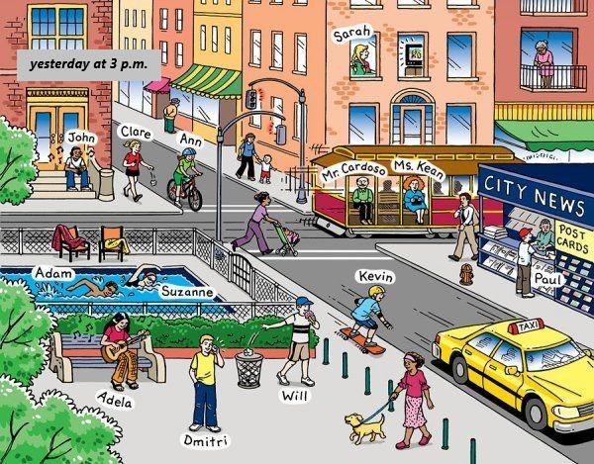
http://englishclassvgp.blogspot.com/2017/02/activities-for-tenth-grade-10th.html
Procedure:
The teacher tells the students that yesterday, around 3 a.m. a burglary happened in the street they live in. The student was looking outside the window when this happened. The teacher tells the student to look at the picture for 90 seconds and remember as much as they can. After 90 seconds, the teacher removes the picture. Then the teacher turns into the role of a policeman and asks the students what they saw. Every detail can help to solve the crime.
After the first part, the students get the picture again and have another 3 minutes to look at the picture. They have to write down three suspects who they think did it. After the three minutes the teacher takes the picture away. The students work with their bench neighbor. They tell each other who they think did it.
Task:
- Look at the picture. You have 90 seconds to remember as many details as possible.
- What do you remember? Tell the policeman as many details as you can remember. Every detail can help solve the case.
- You now have three more minutes to look at the picture again. Come up with three possible suspects and tell your bench neighbour why you think he/she did it.
- Now work with a partner and tell him what you think. Your partner will tell you his thoughts.

Activity 1: Detective game

Stage: Proceduralization in scaffolded conditions & Performance in real-time context
Material:
- Description cards
Procedure:
One student is asked to be the detective in the following game. He/she has to leave the classroom, while the instructions are given to the class. The setting is explained to the students: the students in the classroom are all suspected of having broken a window at the local school [insert school name] the day before. They are given cards with descriptions about their alibi. One of the students is the perpetrator and is forced to lie about his/her alibi. The detective-student enters the classroom and asks the students questions. He/she must ask questions pertaining to the Past Progressive by only asking questions about the time of the murder. For example, he/she could ask questions like: ‘What were you doing yesterday afternoon when the alarm went off?’. The detective should ask further questions, so the students have to be creative answering the questions.
The game is played, until the detective finds out the real perpetrator, or until the game is drawn-out. Different settings may also be played, for example:
  - [Name of teacher] has got five chicken in his/her garden. Yesterday afternoon someone stole all the eggs.
  - [Name of teacher] went home yesterday at five o’clock. Someone threw a bottle of water out of the window of the classroom.
Task:
- Yesterday afternoon, something terrible happened. Someone broke a window with a big rock and ran away. Although the alarm went off immediately, the police was too late. Now, the school wants to find out who did it and needs a detective. Who wants to be the detective?
- (To detective, outside of classroom): Your task is to find out who of your classmates did it. Ask them questions about what they were doing yesterday afternoon when the alarm went off and try to find out who is lying to you.
- (To students inside): You are all suspected of having broken a window at the school. You now get cards with what you were doing when the window was broken. Read them and be able to answer the detective’s questions. One of you actually broke the window, so the person has to lie and come up with an alibi.

I was shopping in town. | I was having a cup of tea in the hall. | I was watching a film in the cinema.
I was staying at home. | I was eating at a fast food restaurant. | I was doing athletics in the gym class.
I was playing chess at my friend’s house. | I was playing football in the park. | I was visiting the museum.
I was cycling to town. | YOU DID IT.  YOU MUST LIE:  I was doing/having/playing … | I was swimming at the pool.
I was playing with my dog in the garden. | I was visiting my grandmother at the hospital. | I was calling my best friend to make plans for the weekend.
I was lying in the garden. | I was playing video games in my room. | I was having an ice cream with my dad.
I was walking my dog in the park. | I was playing darts with my grandfather. | I was cleaning my room.

