
Test 2 3c/Big Nate December 17, 2014

- Award Ceremony of Nate’s Yearbook group:
Who will be this year’s winners: Choose 5 categories and decide who has done relevant things to deserve the prize.
1. Messiest and sloppiest student

Your ideas:
2.
3.
4.
5.

Write a letter to the yearbook group where you suggest winners for the five awards. Describe what they have done to deserve the prizes. Write at least three sentences for each one.
Tip: Use the present perfect tense to describe general experiences, (what they have done many times, a few times… `and the past simple to describe specific events and details.
Start your letter like this:
Dear yearbook team,
We have been asked to suggest names for this year’s school awards. I have observed many extraordinary things this year and would like to suggest the following students for this year’s awards:
…
I am sure all these students deserve to be awarded for their extraordinary behavior. They have made school life more interesting and colorful.
Yours,
Xy

- Job application:
Choose one of the two jobs on the following page and write a letter of application to Mr. Dworak or Frau Gerti. Describe your EXPERIENCES in the field and give a few specific DETAILS.
You can invent a few fitting experiences and details if you do not have enough experience yourself.
Start like this:
Dear ….,
I have read your job advertisement on the school notice board and I think I am the ideal person for this job.
…
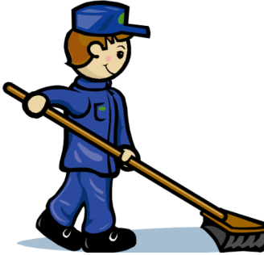
JANITOR ASSISTANTS WANTED

Mr. Töbe and Mr. Dworak are looking for two assistants. Your tasks include:
- gardening
- mowing the lawn
- watering the plants
- technical help (changing light bulbs, dealing with computer problems, ...)
- redecoration work (painting, putting up/down notice boards or paintings, ...)
- maintenance of technical items (drilling machine, lawn mower...)

EXPERIENCE of great ADVANTAGE! In your application, please add all the practical experience that you have!
Very good PAY: 10€/hour

Written application to be handed in at the janitors’ office.

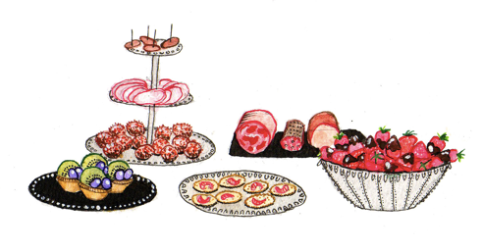
BUFFET ASSISTANTS WANTED

Mrs. Gerti is looking for two assistants to help at the school buffet. Your tasks include:
- preparing sandwiches
- preparing salads
- wiping tables
- organizing shelves and displays
- taking orders
- selling the food
EXPERIENCE of great ADVANTAGE! In your application, please add all the practical experience that you have!
Very good PAY: 10€/hour
Written application to be handed in at the buffet.
Test 2 3c/Wonderstruck December 17, 2014


Task 1: Amazing experiences in New York
In the last few days Ben has experienced many exciting things at the Museum of Natural History and at the Queens Museum of Art. Ben would like to stay in New York a little longer before returning home to Gunflint Lake but he does not want his aunt and uncle to worry about him and decides to write them a letter. In his letter Ben tells them about all the amazing things he has seen and experienced at this wonderful place so far…

Tip: Use the present perfect tense to describe general experiences (I have seen and now I know…) and the past simple to describe specific events or details.

Task 2: Job application:

Choose one of the two jobs on the following page and write a letter of application to Mr. Dworak or Frau Gerti. Describe your EXPERIENCES in the field and give a few specific DETAILS.
You can invent a few fitting experiences and details if you do not have enough experience yourself.
Start like this:

Dear ….,
I have read your job advertisement on the school notice board and I think I am the ideal person for this job.
…

JANITOR ASSISTANTS WANTED

Mr. Töbe and Mr. Dworak are looking for two assistants. Your tasks include:
- gardening
- mowing the lawn
- watering the plants
- technical help (changing light bulbs, dealing with computer problems, ...)
- redecoration work (painting, putting up/down notice boards or paintings, ...)
- maintenance of technical items (drilling machine, lawn mower...)

EXPERIENCE of great ADVANTAGE! In your application, please add all the practical experience that you have!
Very good PAY: 10€/hour

Written application to be handed in at the janitors’ office.

BUFFET ASSISTANTS WANTED
Mrs. Gerti is looking for two assistants to help at the school buffet. Your tasks include:
- preparing sandwiches
- preparing salads
- wiping tables
- organizing shelves and displays
- taking orders
- selling the food
EXPERIENCE of great ADVANTAGE! In your application, please add all the practical experience that you have!
Very good PAY: 10€/hour
Written application to be handed in at the buffet.

