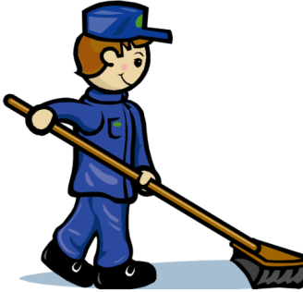
JANITOR ASSISTANTS WANTED

Mr. Töbe and Mr. Dworak are looking for two assistants. Your tasks include:
- gardening
- mowing the lawn
- watering the plants
- technical help (changing light bulbs, dealing with computer problems, ...)
- redecoration work (painting, putting up/down notice boards or paintings, ...)
- maintenance of technical items (drilling machine, lawn mower...)

EXPERIENCE of great ADVANTAGE! In your application, please add all the practical experience that you have!
Very good PAY: 10€/hour

Written application to be handed in at the janitors’ office.

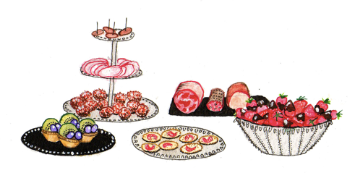
BUFFET ASSISTANTS WANTED

Mrs. Gerti is looking for two assistants to help at the school buffet. Your tasks include:
- preparing sandwiches
- preparing salads
- wiping tables
- organizing shelves and displays
- taking orders
- selling the food

EXPERIENCE of great ADVANTAGE! In your application, please add all the practical experience that you have!
Very good PAY: 10€/hour

Written application to be handed in at the buffet.

