Present Perfect Tense: Experience
Instructions for the TEACHER

Dictate the following text to the learners at high speed. They should be able to take notes, but not write the whole text. Then the learners work in pairs or small groups and try to reconstruct the text. This will most probably lead to interesting discussions concerning the use of the tenses in the original text.

For DICTOGLOSS: Postcard

Dear Sue,
You won't believe it, but I am in New York with my class. I am having the time of my life. We've seen so many great things, I don't know where to start. We've taken a boat trip around Manhattan, we've been on top of the Empire State Building and we've eaten dinner in Chinatown. We've even been to a gospel service in Harlem. Awesome! Last night we were on Times Square and lost 3 of our class. The teacher stayed as cool as a cucumber -- and she was right. The 3 guys turned up at the hotel an hour later. They had been so busy looking up at the lights that they had not seen us walk down to the subway.
See you soon.
X

Tip: Print the following two pages (worksheets for the students) on one sheet. (2-pages-on-one)

General Experience
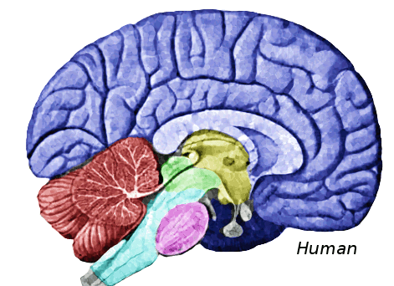I've seen it....
I've been there...
so NOW I KNOW
I've heard about it...
I've done it....
Find someone who

Write down the 5 best movies that you have seen and 5 favorite books that you have read. Then walk around and find classmates who share the same experiences.

Five great movies that I have seen | Friends who have seen these as well | Five great books I have read | Friends who have read these as well

NOTE: When sharing your experiences make sure that every new conversation you start begins with: HAVE YOU...

Game: Find the "chosen"
One student leaves the room while we secretly choose one person inside.
The student is called back in and has to find out who we have chosen by asking questions about his/her experiences.
E.g.:
Has the person ... been to America?
Has the person ever....
Has the person .....

Postcards: Dictogloss:
Sue has written a postcard from New York. Listen and write down as many details as you can possibly catch. Then work with a partner and reconstruct the text on the postcard exactly as you have heard it.

My Favorite Place:
Think of a place you really like. It must be a place that you know well and where you have been several times. Then complete these sentences.
I've known this place for
I've been there______________________________________times.
I've liked this place since
I've often_____________________________________________________there
I've never _________________________________________________ in this place
I've always liked this place but
I've

Share your results with your friends and guess what places you are referring to.

Let's find Mr./Miss Strinex

...that is the person with the strangest and most interesting experiences in our class.

- On your own: You have two minutes to brainstorm and list a number of interesting or strange experiences you have had in your life. They need not be big things, think of small but intereresting things you have seen, heard, people you have met...
- In groups of four: Share your experiences IN ENGLISH!!! Remember to use the present perfect tense (I have seen, I have heard, I have been,...) to talk about such general experiences and the simple past to give further details and talk about specific events. (I met him in London last summer.)
- Group voting: After sharing your strange and interesting experiences vote your group's candidate for the Mr/Miss Strinex award.
- Election: Group candidates: Briefly present your strange and interesting experiences in the plenary. Then the class takes a vote and elects the two (or three) students who have had the most interesting experiences.

Christine Frank and Mario Rinvolucri Grammar in Action. Pergamon Press. Oxford. 1983

